Hybrid / On-Prem Architecture
A hybrid / on-prem architecture in which inbound traffic terminates at Internet, HAProxy LB and Reverse proxy, is served by App servers x3 and EKS workloads, and state is held in Oracle RAC and SAN storage. The estate sits inside On-Premises Data Center and AWS.
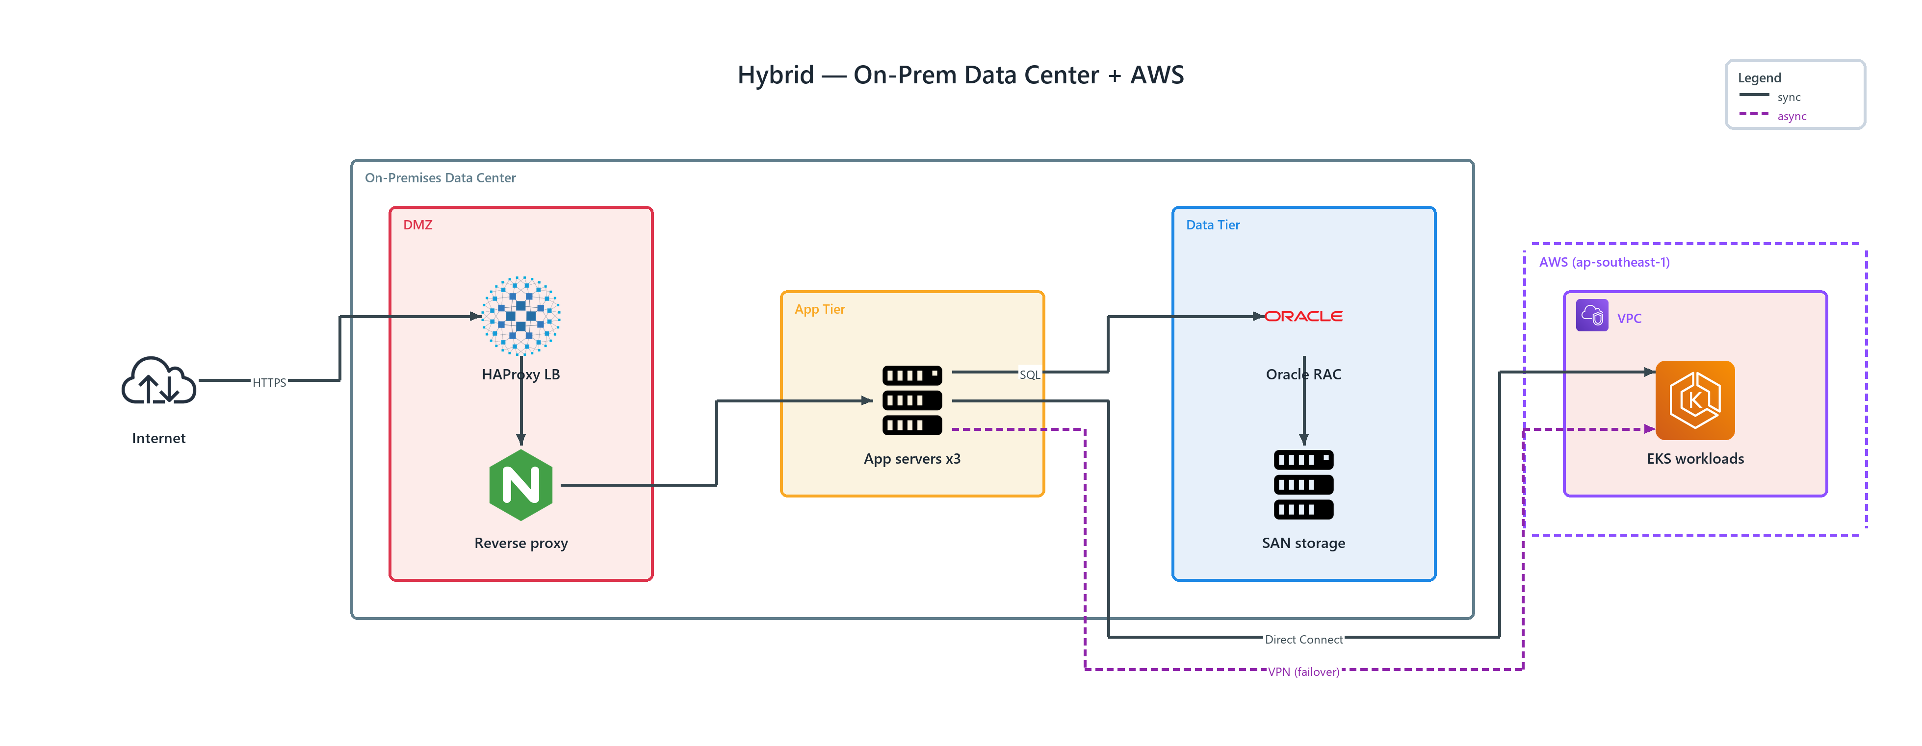
Figure 1: Hybrid — On-Prem Data Center + AWS
- On-Premises Data Center — network boundary spanning the tiers it encloses
- AWS (ap-southeast-1) — transparent, dashed network boundary spanning the tiers it encloses
- Internet — internet (ONPREM); HTTPS to HAProxy LB
- HAProxy LB — haproxy (ONPREM) in DMZ; connects to Reverse proxy
- Reverse proxy — nginx (ONPREM) in DMZ; connects to App servers x3
- App servers x3 — server (ONPREM) in App Tier; SQL to Oracle RAC, Direct Connect to EKS workloads, publishes VPN (failover) to EKS workloads
- Oracle RAC — oracle (ONPREM) in Data Tier; connects to SAN storage
- SAN storage — server (ONPREM) in Data Tier
- EKS workloads — elastic kubernetes service (AWS) in VPC

