State Machine
Order Lifecycle — State Machine traces the flow through 8 states — i, Pending, Paid, Fulfilled, … — and the 8 transitions between them.
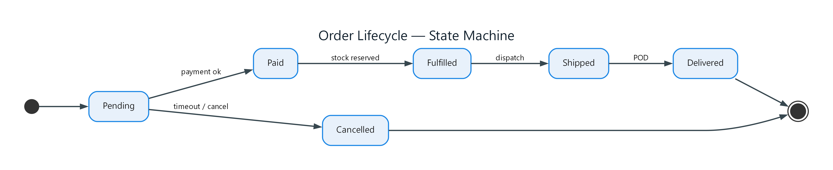
Figure 1: Order Lifecycle — State Machine
- i — initial; connects to Pending
- Pending — state; connects to Paid (payment ok), Cancelled (timeout / cancel)
- Paid — state; connects to Fulfilled (stock reserved)
- Fulfilled — state; connects to Shipped (dispatch)
- Shipped — state; connects to Delivered (POD)
- Delivered — state; connects to f
- Cancelled — state; connects to f
- f — final

