Org Chart
Org Chart — Engineering models 7 roles — CEO, CTO, CFO, Eng Manager, … — and the 6 relationships that connect them.
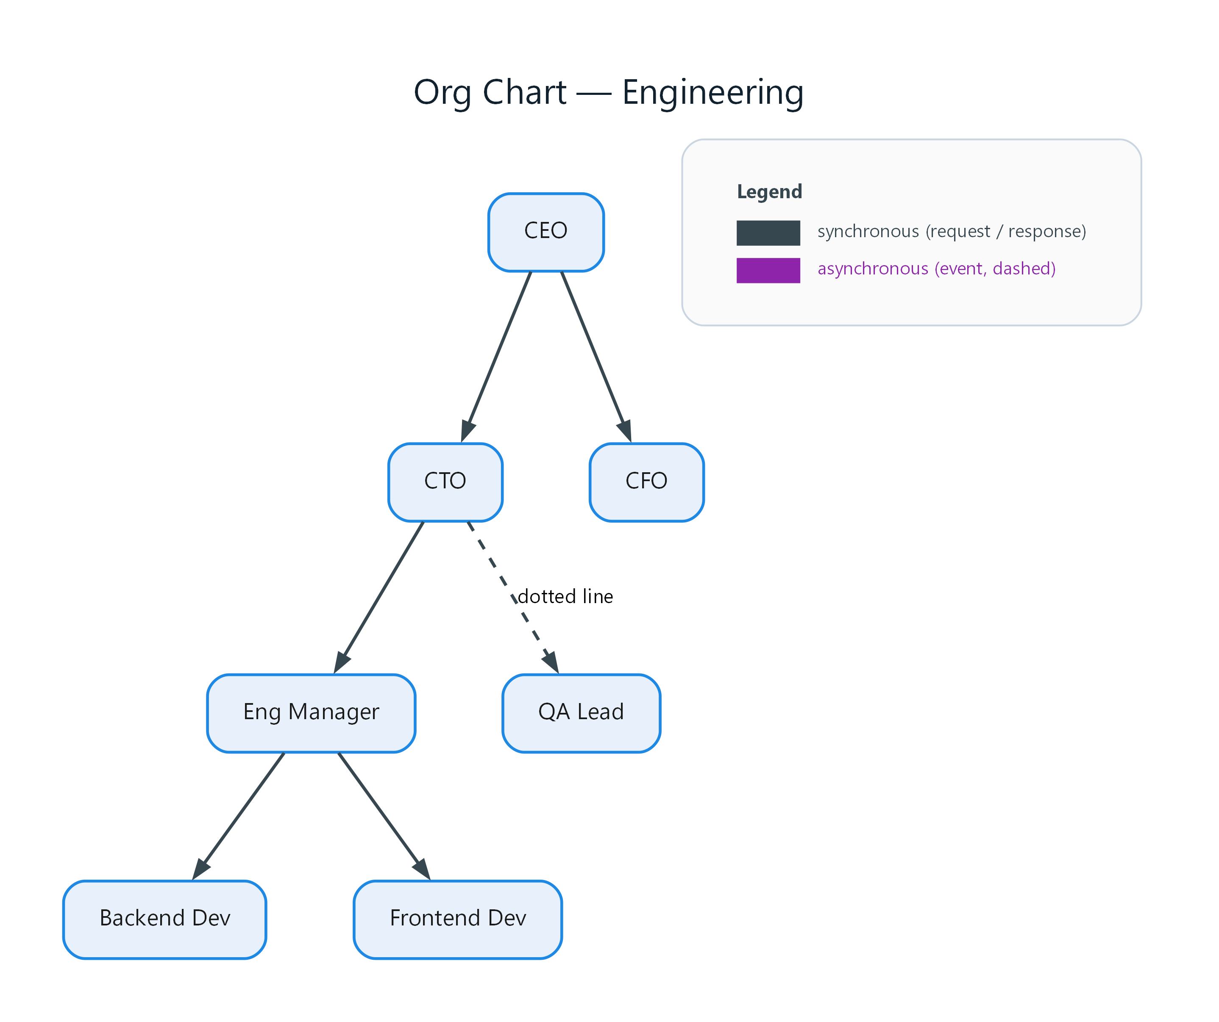
Figure 1: Org Chart — Engineering
- CEO — process; connects to CTO, CFO
- CTO — process; connects to Eng Manager, QA Lead (dotted line)
- CFO — process
- Eng Manager — process; connects to Backend Dev, Frontend Dev
- Backend Dev — process
- Frontend Dev — process
- QA Lead — process

