UML Sequence Diagram
Saga — Order Orchestration with Compensation traces how Saga Orchestrator, Order Svc, Inventory Svc and Payment Svc collaborate, exchanging 8 messages in time order, including 1 conditional or repeated stretch.
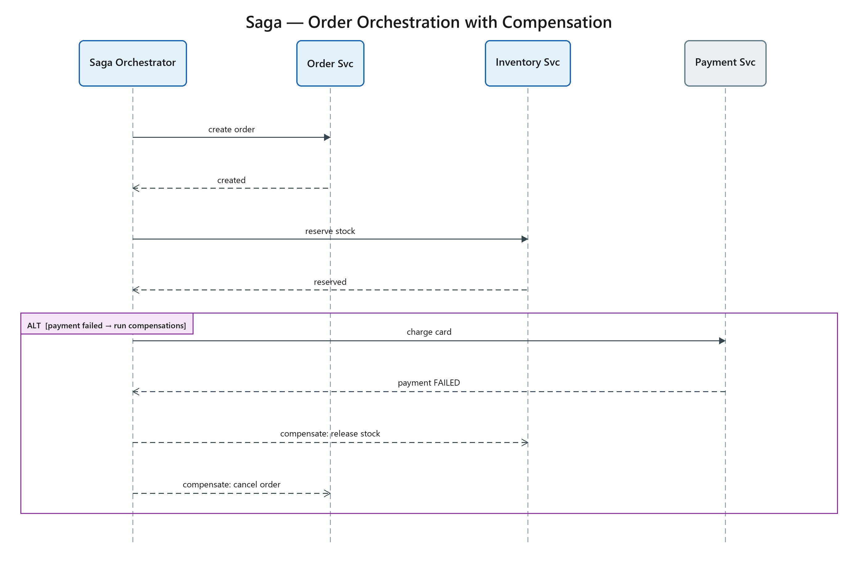
Figure 1: Saga — Order Orchestration with Compensation
- Saga Orchestrator — participant
- Order Svc — participant
- Inventory Svc — participant
- Payment Svc — external
- Step 1 — Saga Orchestrator → Order Svc: create order (sync)
- Step 2 — Order Svc → Saga Orchestrator: created (return)
- Step 3 — Saga Orchestrator → Inventory Svc: reserve stock (sync)
- Step 4 — Inventory Svc → Saga Orchestrator: reserved (return)
- Step 5 — Saga Orchestrator → Payment Svc: charge card (sync)
- Step 6 — Payment Svc → Saga Orchestrator: payment FAILED (return)
- Step 7 — Saga Orchestrator → Inventory Svc: compensate: release stock (async)
- Step 8 — Saga Orchestrator → Order Svc: compensate: cancel order (async)

