Swimlane Process
Swimlane — Purchase Approval traces the flow through 5 activities — Submit request, Review request, Approved?, Create PO, … — and the 4 transitions between them.
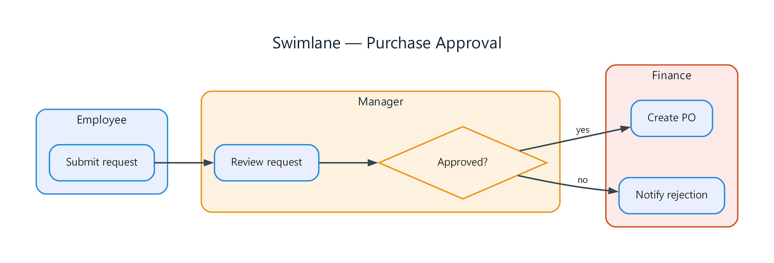
Figure 1: Swimlane — Purchase Approval
- Submit request — process; connects to Review request
- Review request — process; connects to Approved?
- Approved? — decision; connects to Create PO (yes), Notify rejection (no)
- Create PO — process
- Notify rejection — process
- Employee — grouping: a1
- Manager — grouping: m1, g1
- Finance — grouping: f1, f2

