UML Deployment Diagram
A UML deployment diagram in which the workload runs on Node.js, and state is held in PostgreSQL.
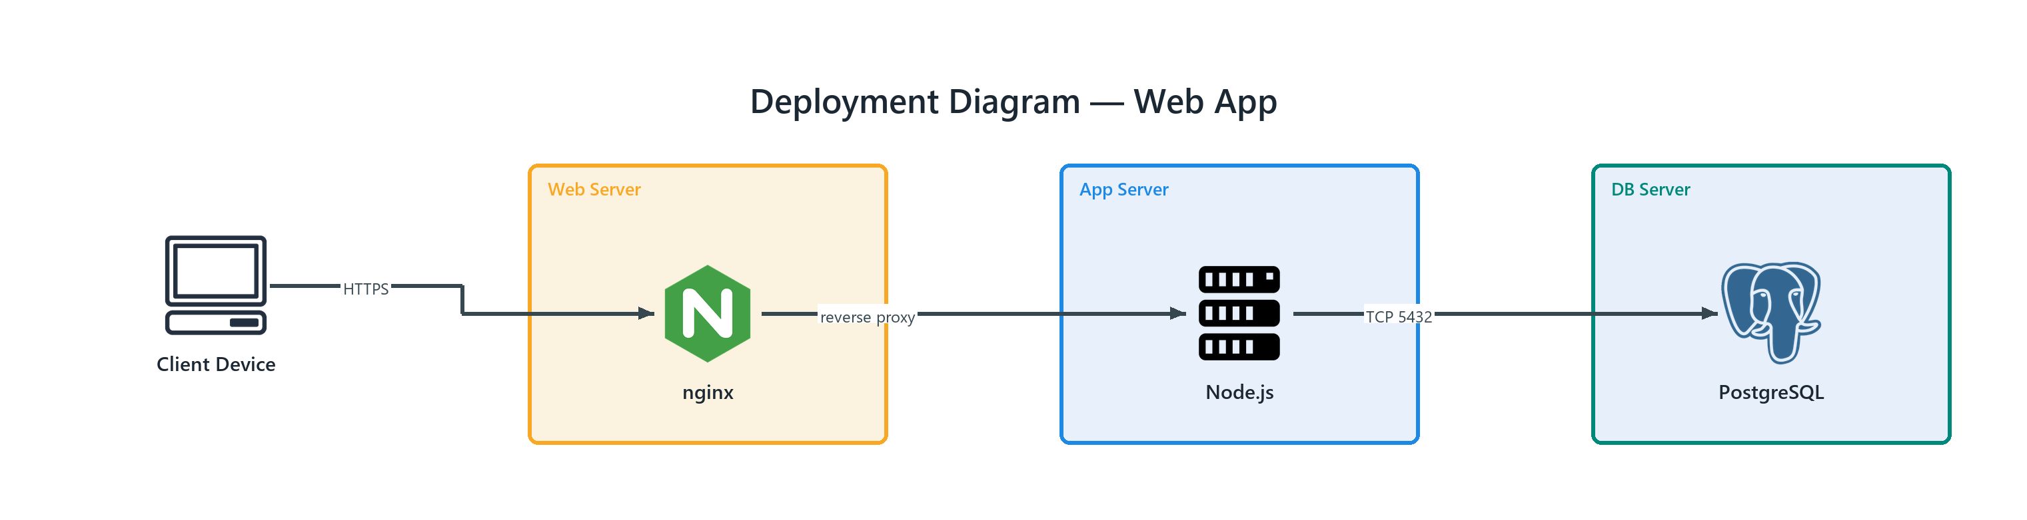
Figure 1: Deployment Diagram — Web App
- Client Device — client (ONPREM); HTTPS to nginx
- nginx — nginx (ONPREM) in Web Server; reverse proxy to Node.js
- Node.js — server (ONPREM) in App Server; TCP 5432 to PostgreSQL
- PostgreSQL — postgresql (ONPREM) in DB Server

