(4 mark, file to be edited: Q1.cpp)
Users are required to enter a integer using the keyboard (STDIN).

Please check that number is a valid Bar code or not.
A Universal Product Code (UPC) bar code consists of 12-digits. The first 6 digits represent the company that produces the product, the next 5 digits represent a unique item number that that company has assigned to the product and the last digit is a check digit. The check digit is used to determine if the code has been properly interpreted by the scanning device.
To determine the expected value of the check digit, use the weighted sum of the other digits:
- multiply the sum of the 1st, 3rd, etc. digits in the code by 3
- add the sum of the 2nd, 4th, etc digits (excluding the check digit)
- add the two sums together to obtain the weighted total
- the expected check digit is the digit that when added to the weighted total results in a number that is divisible by 10
Consider the following example:

UPC 067800001019
|
check digit is 9
add 1st, 3rd, ..., 11th digits
0 7 0 0 1 1 = 9
multiply by 3 = 27
add 2nd, 4th, ..., 10th digits
6 8 0 0 0 = 14
add weighted sum = 41
add check digit 9
total 50
divide by 10 5
remainder 0
Therefore this is a valid UPC

Below is an example of how the program will run:
Enter 067800001019, output as below
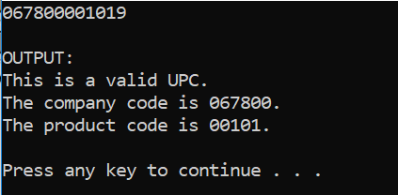

Enter 067800001018, output as below
