(1 mark, file to be edited: Q1.cpp)
Users are required to enter an integer for the total number of items, an integer for the number of items in each group, and a character (‘y’ or ‘n’) indicating the order of the items in a group matters or not using the keyboard (STDIN).
Your program will calculate the number of permutations or combinations of a set of items.
With permutations, the order of items within each group matters. A group with the same items as another group but arranged in a different order is distinct from the other group. With combinations, the order of the items within each group does not matter. A group with the same items as another group but arranged in a different order is the same as the other group.
The general formula for a permutation of n items in groups of k items is given by
_{n}P_{k} = n! / ( n - k )!
The general formula for a combination of n items in groups of k items is given by
_{n}C_{k} = n! / ( k! * ( n - k )! )

where ! denotes factorial. The formula for the factorial of n is given by
n! = n * ( n - 1 ) * ( n - 2 ) * ... * 2 * 1

Below is an example of how the program will run:
Enter 49 for total number of items, 6 for the number of items in each group, and n, indicating the order doesn’t matter, output as below
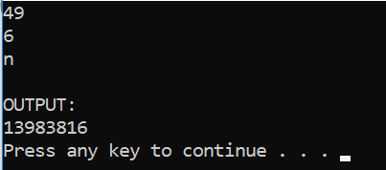
Enter 49 for total number of items, 6 for the number of items in each group, and y, indicating the order matters, output as below

