(1.5 marks, file to be edited: Q5.cpp)
Users are required to enter two integers, numerator and denominator of a fraction using the keyboard (STDIN).
Please display the result of simplifying that fraction.
Below is an example of how the program will run:
If the user enters 4 for numerator, and 16 for denominator, then output as below
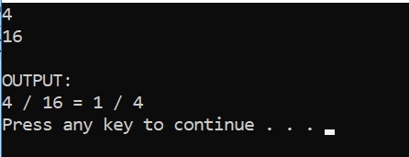
If the user enters 4 for numerator and 0 for denominator, then output as below
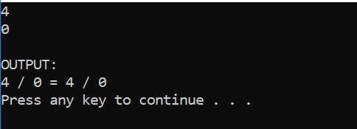
If the user enters -4 for numerator and 16 for denominator, then output as below
