(3 mark, file to be edited: Q1.cpp)
Users are required to enter a integer using the keyboard (STDIN).

Please check that number is a valid ISBN or not.
Publishers and bookstores use a number system called the International Standard Book Number (ISBN) system to identify books. At the start of publication, each book is assigned a unique ISBN. An ISBN, once assigned, can never be re-used.
An ISBN consists of exactly 10 digits. The rightmost digit is the check digit. The check digit is validated modulo 11.
- multiply each digit from the first to the ninth by a weight from 10 to 2 respectively (the first digit by 10, the second by 9,..., the ninth by 2).
- the sum of the products plus the check digit should be divisible without remainder by 11.
- if there is a remainder, the whole number is not a valid ISBN.
Consider the following example:

ISBN 0003194876
|
check digit is 6
add first set of alternates to themselves
0 0 0 3 1 9 4 8 7
10 9 8 7 6 5 4 3 2
0 0 0 21 6 45 16 24 14 = 126
add check digit 6
total 132
divide by 11 12
remainder 0
Therefore this ISBN is valid
Below is an example of how the program will run:
Enter 0003194876, output as below
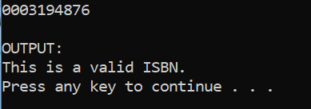

Enter 0003194875, output as below
