(3 mark, file to be edited: Q1.cpp)
Users are required to enter a integer using the keyboard (STDIN).
Please check that number is a valid Sin or not.
The right-most digit is a check digit that enables validation. For the whole number to be a valid SIN, a weighted sum of the other digits plus this check digit must be divisible by 10.
To obtain the weighted sum, take the digit to the left of the check digit and then every second digit leftwards. Add each of these digits to itself. Then, add each digit of each sum to form the weighted sum of the even positioned digits. Add each of the remaining SIN digits (except the check digit) to form the sum of the odd positioned digits. Add the two sums and subtract the next highest number ending in zero from their total. If this number is the check digit, the whole number is a valid SIN; otherwise, the whole number is not a valid SIN.
Consider the following example:

SIN 193456787
|
check digit is 7
add first set of alternates to themselves
9 4 6 8
9 4 6 8
18 8 12 16
add the digits of each sum 1+8+8+1+2+1+6 = 27
add the other alternates 1+3+5+7 = 16
total = 43
Next highest integer multiple of 10 = 50
Difference = 7
Matches the check digit, therefore this SIN is valid

Below is an example of how the program will run:
Enter 193456787, output as below
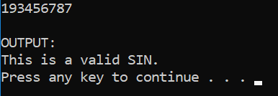

Enter 193456788, output as below
