(1 mark, file to be edited: Q1.cpp)
Users are required to enter a double for a principal amount, a double for an interest rate, an integer for the number of periods and a character for the type of calculation requested (f for future or p for present value) using the keyboard (STDIN).
The formula for future value is
future value = principal * ( 1 + rate ) ^{(number of periods)}
The formula for present value is
present value = principal * ( 1 + rate ) -(number of periods)

Below is an example of how the program will run:
Enter 1000 for principle amount, 0.06 for interest rate, 5 for the number of years, and f for future

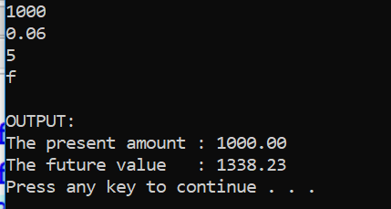

Enter 1000 for principle amount, 0.06 for interest rate, 5 for the number of years, and p for present

