(1 mark, file to be edited: Q1.cpp)
Users are required to enter a double for x, and a double for epsi using the keyboard (STDIN).
Your program will calculate sin(x) using the approximate formula below:

sin(x) = 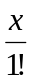- 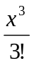 + 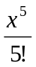 -... +(-1)^{n} 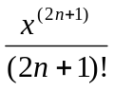
here n is the first integer for which | | ≤ epsi is satisfied.

Below is an example of how the program will run:
Enter the value 1.5 for x and the value 0.00001 for epsi.
