(1.5 mark, file to be edited: Q4.cpp)
Users are required to enter a double b (the initial vertical velocity component) and a double h (the height of a projectile) using the keyboard (STDIN).
The height (in m) of a projectile is given by the formula
h = - g * t² / 2 + b * t
where t is the time from launch, g is the acceleration due to gravity (9.8 m/sec) and b is the initial vertical velocity component (in m/sec).
Please display values of variable t (the time at which a projectile will reach a certain height ).
Below is an example of how the program will run:

If the user enters 20 for b, and 10 for h, then output as below
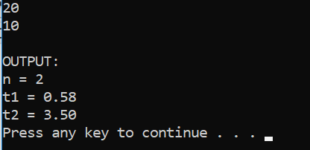

If the user enters 20 for b, and 20.408163265306122 for h, then output as below
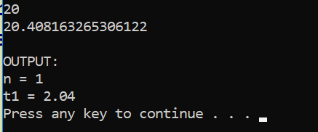

If the user enters 20 for b, and 21 for h, then output as below
