Crack Password:

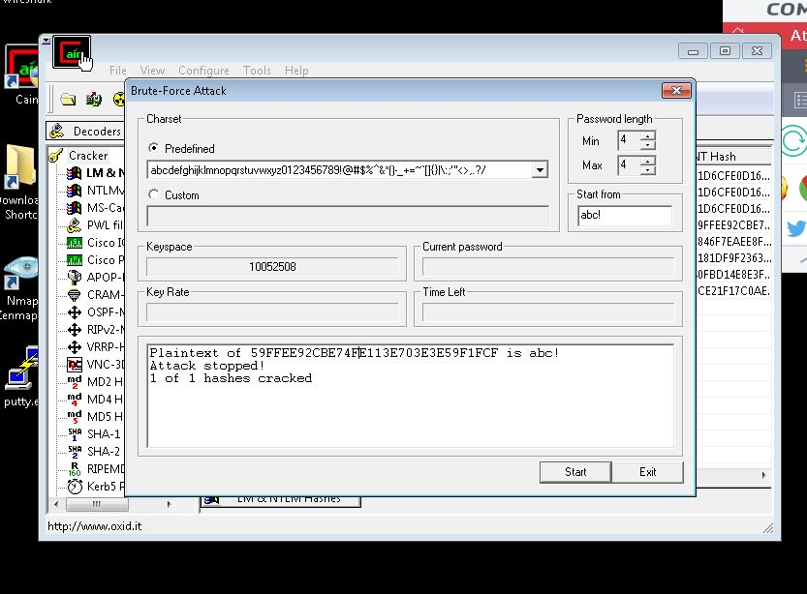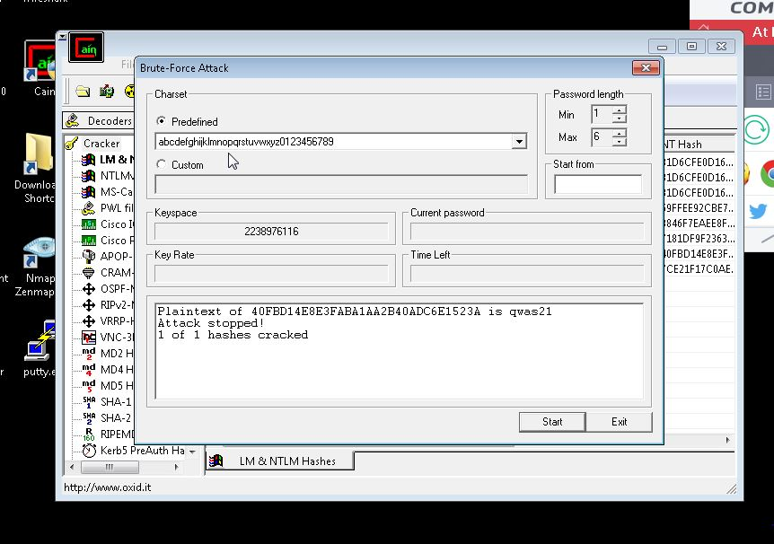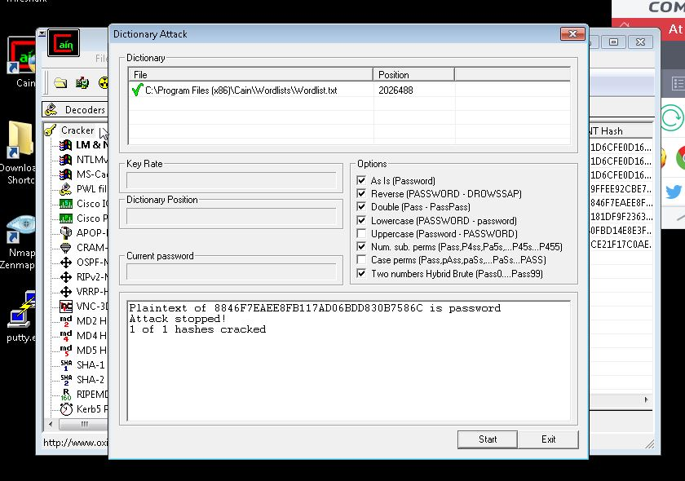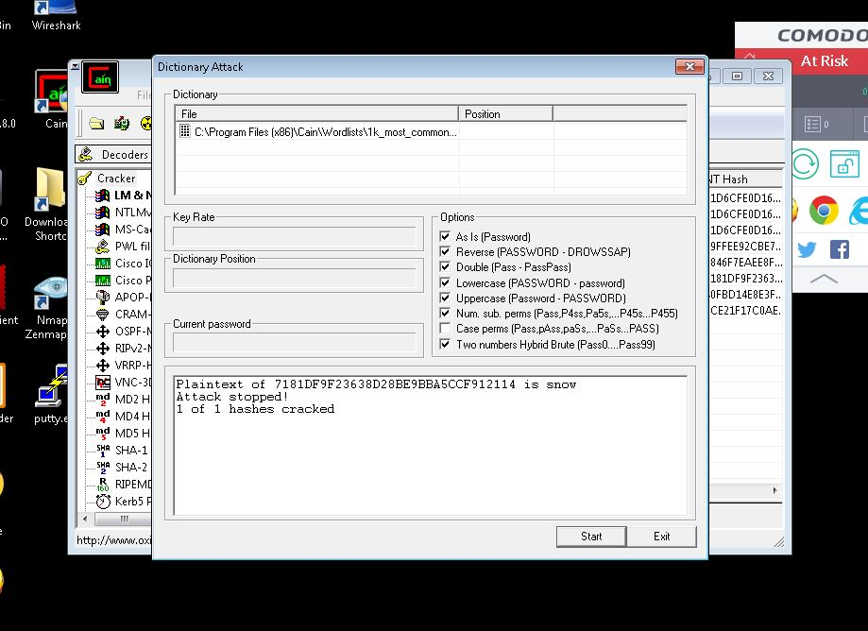

Session Cookies are temporary file whenever you are done using browser. When user close and open the browser again, the browser will no longer save the cookies and ask you again your username and password

The different between session cookies and persistent cookies are session cookies are temporary and erased then you close your browser, while persistent cookies are still staying in the hard drive until user delete it or expire.

Part 5: Website, Access Control and Scripts

