Uninformed Seach

**Question 1.**

Given the graph below, find a tree search and the path from **Start** to **Goal** with:

1. DFS
2. BFS
3. Uniform-cost search

At each step, the node with earlier alphabetical order are expanded first and each node is expanded only once.

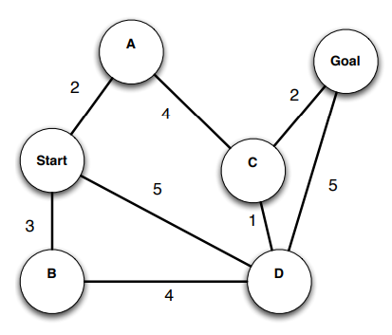

**Question 2.**

In the search problem with no memory usage, each node can be expanded multiple times, leading to the possibility of falling into an infinite loop.

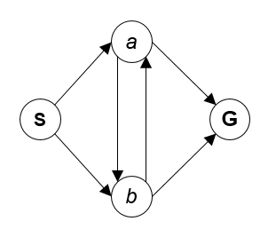

Given the graph above, find the path from S to G.

a) Find the branching factor – b

b) Find the Breath-first tree search with depth = 3

c) Find the Depth-first tree search with depth = 3

Informed search

**Question 1.**

Given the graph below. The length of the edge is the corresponding value on the edge. These heuristics function for the given graph by annotating each node with a value respectively. Find the shortest path from S to F by:

a) Greedy

b) A*

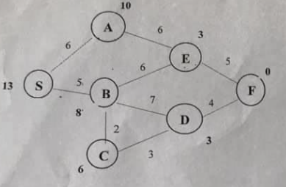

**Question 2.**

Imagine a car-like agent wishes to exit a maze (MxN) like the one shown below:

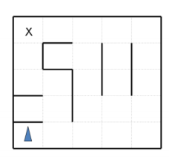

The agent is directional and at all times faces some direction **d ∈ (N, S, E, W)**.

With a single action, the agent can either move forward at an adjustable velocity **v** or turn.

- The turning actions are left and right, which change the agent’s direction by 90 degrees. Turning is only permitted when the **v=0**.

- The moving actions are fast and slow. Fast increments and slow decrements the velocity (**v**) by 1; in both cases the agent then moves a number of squares equal to its NEW adjusted velocity.

**Conditions:** The car is not allowed to go into the wall. velocity **0 <= v <= Vmax**. The agent’s goal is to find a plan which parks it (stationary) on the exit square using as few actions (time steps) as possible.

a) What is the size of the state space? Explain.

b) What is the maximum branching factor of this problem? (You may assume that illegal actions are simply not returned by the successor function).

c) Is the Manhattan distance from the agent’s location to the exit’s location admissible? Why or why not?

d) State and justify a non-trivial admissible heuristic for this problem which is not the Manhattan distance to the exit.

e) If we used an inadmissible heuristic in A* tree search, could it change the completeness of the search?

f) If we used an inadmissible heuristic in A* tree search, could it change the optimality of the search?