Demographic Sentencing Disparities Baseline Switch
September 15, 2024
This document attempts to replicate the Commission’s “refined model” for estimating demographic disparities in sentencing. For more information about the model and for the reference regressions, see “Demographic Disparities Baseline Switch Reference Docs.”
The data runs from the beginning of the PROTECT Act period through to the end of FY 2023.

White Male Baseline Regressions

Post-Protect
 | Estimate | Standard Error | t value | Pr(>|t|)
(Intercept) | 0.562 | 0.028 | 19.982 | 0.0000 | ***
logmin | 0.690 | 0.003 | 268.839 | 0.0000 | ***
drugtraffTRUE | 0.217 | 0.017 | 12.844 | 0.0000 | ***
sexual2TRUE | 0.186 | 0.065 | 2.868 | 0.0041 | **
pornTRUE | 0.216 | 0.051 | 4.188 | 0.0000 | ***
immigrationTRUE | 0.181 | 0.022 | 8.282 | 0.0000 | ***
othtypeTRUE | -0.273 | 0.029 | -9.563 | 0.0000 | ***
whitecollTRUE | -0.350 | 0.020 | -17.409 | 0.0000 | ***
upwardTRUE | 1.093 | 0.056 | 19.464 | 0.0000 | ***
downTRUE | -0.905 | 0.017 | -54.806 | 0.0000 | ***
subasstTRUE | -1.177 | 0.016 | -74.846 | 0.0000 | ***
mandmin2 | 0.109 | 0.018 | 6.045 | 0.0000 | ***
NEWCNVTN | 0.257 | 0.025 | 10.152 | 0.0000 | ***
custody | 0.755 | 0.014 | 55.806 | 0.0000 | ***
relevel(factor(racesex), ref = 8)blackfemale | -0.431 | 0.029 | -15.000 | 0.0000 | ***
relevel(factor(racesex), ref = 8)blackmale | 0.089 | 0.016 | 5.700 | 0.0000 | ***
relevel(factor(racesex), ref = 8)hispfemale | -0.286 | 0.030 | -9.675 | 0.0000 | ***
relevel(factor(racesex), ref = 8)hispmale | -0.011 | 0.017 | -0.647 | 0.5174
relevel(factor(racesex), ref = 8)otherfemale | -0.562 | 0.059 | -9.572 | 0.0000 | ***
relevel(factor(racesex), ref = 8)othermale | -0.067 | 0.031 | -2.177 | 0.0295 | *
relevel(factor(racesex), ref = 8)whitefemale | -0.285 | 0.025 | -11.466 | 0.0000 | ***
agedummyTRUE | 0.035 | 0.013 | 2.800 | 0.0051 | **
educTRUE | -0.064 | 0.014 | -4.719 | 0.0000 | ***
citizenTRUE | -0.017 | 0.016 | -1.066 | 0.2864
Signif. codes: 0 <= '***' < 0.001 < '**' < 0.01 < '*' < 0.05
Residual standard error: 1.328 on 66139 degrees of freedom
Multiple R-squared: 0.7068, Adjusted R-squared: 0.7067
F-statistic: 6932 on 66139 and 23 DF, p-value: 0.0000

Post-Booker
 | Estimate | Standard Error | t value | Pr(>|t|)
(Intercept) | 0.515 | 0.021 | 24.821 | 0.0000 | ***
logmin | 0.696 | 0.002 | 349.587 | 0.0000 | ***
drugtraffTRUE | 0.206 | 0.012 | 16.900 | 0.0000 | ***
sexual2TRUE | 0.108 | 0.044 | 2.424 | 0.0154 | *
pornTRUE | 0.432 | 0.030 | 14.621 | 0.0000 | ***
immigrationTRUE | 0.139 | 0.015 | 8.978 | 0.0000 | ***
othtypeTRUE | -0.463 | 0.021 | -21.757 | 0.0000 | ***
whitecollTRUE | -0.334 | 0.015 | -22.788 | 0.0000 | ***
upwardTRUE | 0.985 | 0.030 | 33.365 | 0.0000 | ***
downTRUE | -0.898 | 0.009 | -95.940 | 0.0000 | ***
subasstTRUE | -1.081 | 0.012 | -90.651 | 0.0000 | ***
mandmin2 | 0.195 | 0.012 | 15.839 | 0.0000 | ***
NEWCNVTN | 0.324 | 0.018 | 18.339 | 0.0000 | ***
custody | 0.770 | 0.010 | 77.310 | 0.0000 | ***
relevel(factor(racesex), ref = 8)blackfemale | -0.304 | 0.022 | -13.942 | 0.0000 | ***
relevel(factor(racesex), ref = 8)blackmale | 0.158 | 0.011 | 13.894 | 0.0000 | ***
relevel(factor(racesex), ref = 8)hispfemale | -0.282 | 0.021 | -13.651 | 0.0000 | ***
relevel(factor(racesex), ref = 8)hispmale | -0.001 | 0.013 | -0.057 | 0.9544
relevel(factor(racesex), ref = 8)otherfemale | -0.320 | 0.040 | -7.939 | 0.0000 | ***
relevel(factor(racesex), ref = 8)othermale | 0.036 | 0.021 | 1.694 | 0.0902 | .
relevel(factor(racesex), ref = 8)whitefemale | -0.221 | 0.018 | -12.135 | 0.0000 | ***
agedummyTRUE | 0.038 | 0.009 | 4.102 | 0.0000 | ***
educTRUE | -0.050 | 0.010 | -5.090 | 0.0000 | ***
citizenTRUE | -0.071 | 0.012 | -6.046 | 0.0000 | ***
Signif. codes: 0 <= '***' < 0.001 < '**' < 0.01 < '*' < 0.05
Residual standard error: 1.351 on 134989 degrees of freedom
Multiple R-squared: 0.6705, Adjusted R-squared: 0.6705
F-statistic: 1.194e+04 on 134989 and 23 DF, p-value: 0.0000

Post-Gall
 | Estimate | Standard Error | t value | Pr(>|t|)
(Intercept) | 0.556 | 0.017 | 32.461 | 0.0000 | ***
logmin | 0.628 | 0.002 | 415.690 | 0.0000 | ***
drugtraffTRUE | 0.148 | 0.010 | 14.643 | 0.0000 | ***
sexual2TRUE | 0.175 | 0.037 | 4.725 | 0.0000 | ***
pornTRUE | 0.568 | 0.021 | 26.790 | 0.0000 | ***
immigrationTRUE | 0.107 | 0.012 | 8.559 | 0.0000 | ***
othtypeTRUE | -0.719 | 0.018 | -41.065 | 0.0000 | ***
whitecollTRUE | -0.369 | 0.012 | -30.358 | 0.0000 | ***
upwardTRUE | 0.885 | 0.021 | 41.273 | 0.0000 | ***
downTRUE | -0.967 | 0.007 | -137.879 | 0.0000 | ***
subasstTRUE | -1.007 | 0.010 | -99.204 | 0.0000 | ***
mandmin2 | 0.422 | 0.010 | 42.565 | 0.0000 | ***
NEWCNVTN | 0.409 | 0.016 | 25.484 | 0.0000 | ***
custody | 0.953 | 0.008 | 114.664 | 0.0000 | ***
relevel(factor(racesex), ref = 8)blackfemale | -0.403 | 0.019 | -21.488 | 0.0000 | ***
relevel(factor(racesex), ref = 8)blackmale | 0.181 | 0.010 | 19.030 | 0.0000 | ***
relevel(factor(racesex), ref = 8)hispfemale | -0.209 | 0.016 | -12.898 | 0.0000 | ***
relevel(factor(racesex), ref = 8)hispmale | 0.013 | 0.010 | 1.349 | 0.1773
relevel(factor(racesex), ref = 8)otherfemale | -0.429 | 0.035 | -12.305 | 0.0000 | ***
relevel(factor(racesex), ref = 8)othermale | -0.002 | 0.018 | -0.089 | 0.9291
relevel(factor(racesex), ref = 8)whitefemale | -0.376 | 0.015 | -25.496 | 0.0000 | ***
agedummyTRUE | 0.040 | 0.008 | 5.299 | 0.0000 | ***
educTRUE | -0.057 | 0.008 | -7.064 | 0.0000 | ***
citizenTRUE | -0.092 | 0.010 | -9.624 | 0.0000 | ***
Signif. codes: 0 <= '***' < 0.001 < '**' < 0.01 < '*' < 0.05
Residual standard error: 1.496 on 264887 degrees of freedom
Multiple R-squared: 0.6009, Adjusted R-squared: 0.6009
F-statistic: 1.734e+04 on 264887 and 23 DF, p-value: 0.0000

Post-Report
 | Estimate | Standard Error | t value | Pr(>|t|)
(Intercept) | 0.248 | 0.018 | 14.130 | 0.0000 | ***
logmin | 0.618 | 0.001 | 413.684 | 0.0000 | ***
drugtraffTRUE | 0.180 | 0.010 | 18.494 | 0.0000 | ***
sexual2TRUE | 0.234 | 0.030 | 7.683 | 0.0000 | ***
pornTRUE | 0.626 | 0.019 | 32.124 | 0.0000 | ***
immigrationTRUE | -0.041 | 0.012 | -3.348 | 0.0008 | ***
othtypeTRUE | -0.614 | 0.017 | -36.155 | 0.0000 | ***
whitecollTRUE | -0.217 | 0.012 | -18.547 | 0.0000 | ***
upwardTRUE | 0.684 | 0.020 | 34.382 | 0.0000 | ***
downTRUE | -1.041 | 0.007 | -154.761 | 0.0000 | ***
subasstTRUE | -1.089 | 0.010 | -107.816 | 0.0000 | ***
mandmin2 | 0.491 | 0.010 | 49.992 | 0.0000 | ***
NEWCNVTN | 0.509 | 0.017 | 30.701 | 0.0000 | ***
custody | 1.323 | 0.008 | 160.550 | 0.0000 | ***
relevel(factor(racesex), ref = 8)blackfemale | -0.349 | 0.018 | -19.246 | 0.0000 | ***
relevel(factor(racesex), ref = 8)blackmale | 0.181 | 0.010 | 18.747 | 0.0000 | ***
relevel(factor(racesex), ref = 8)hispfemale | -0.183 | 0.015 | -12.210 | 0.0000 | ***
relevel(factor(racesex), ref = 8)hispmale | 0.055 | 0.010 | 5.568 | 0.0000 | ***
relevel(factor(racesex), ref = 8)otherfemale | -0.453 | 0.032 | -14.287 | 0.0000 | ***
relevel(factor(racesex), ref = 8)othermale | -0.048 | 0.017 | -2.773 | 0.0056 | **
relevel(factor(racesex), ref = 8)whitefemale | -0.351 | 0.015 | -24.122 | 0.0000 | ***
agedummyTRUE | 0.030 | 0.008 | 3.780 | 0.0002 | ***
educTRUE | -0.005 | 0.008 | -0.621 | 0.5349
citizenTRUE | -0.051 | 0.010 | -5.389 | 0.0000 | ***
Signif. codes: 0 <= '***' < 0.001 < '**' < 0.01 < '*' < 0.05
Residual standard error: 1.622 on 326917 degrees of freedom
Multiple R-squared: 0.5658, Adjusted R-squared: 0.5658
F-statistic: 1.852e+04 on 326917 and 23 DF, p-value: 0.0000

Present
 | Estimate | Standard Error | t value | Pr(>|t|)
(Intercept) | 0.197 | 0.017 | 11.693 | 0.0000 | ***
logmin | 0.506 | 0.001 | 369.208 | 0.0000 | ***
drugtraffTRUE | 0.249 | 0.009 | 28.530 | 0.0000 | ***
sexual2TRUE | 0.387 | 0.027 | 14.507 | 0.0000 | ***
pornTRUE | 0.725 | 0.018 | 40.479 | 0.0000 | ***
immigrationTRUE | -0.330 | 0.011 | -29.824 | 0.0000 | ***
othtypeTRUE | -0.646 | 0.016 | -40.269 | 0.0000 | ***
whitecollTRUE | -0.147 | 0.011 | -13.109 | 0.0000 | ***
upwardTRUE | 0.806 | 0.016 | 49.042 | 0.0000 | ***
downTRUE | -1.009 | 0.006 | -159.516 | 0.0000 | ***
subasstTRUE | -0.954 | 0.010 | -92.055 | 0.0000 | ***
mandmin2 | 0.684 | 0.009 | 75.480 | 0.0000 | ***
NEWCNVTN | 0.611 | 0.017 | 35.844 | 0.0000 | ***
custody | 1.699 | 0.008 | 220.966 | 0.0000 | ***
relevel(factor(racesex), ref = 8)blackfemale | -0.595 | 0.019 | -31.901 | 0.0000 | ***
relevel(factor(racesex), ref = 8)blackmale | 0.158 | 0.009 | 17.523 | 0.0000 | ***
relevel(factor(racesex), ref = 8)hispfemale | -0.126 | 0.014 | -9.147 | 0.0000 | ***
relevel(factor(racesex), ref = 8)hispmale | 0.125 | 0.010 | 12.975 | 0.0000 | ***
relevel(factor(racesex), ref = 8)otherfemale | -0.561 | 0.030 | -18.700 | 0.0000 | ***
relevel(factor(racesex), ref = 8)othermale | -0.062 | 0.016 | -3.840 | 0.0001 | ***
relevel(factor(racesex), ref = 8)whitefemale | -0.408 | 0.014 | -28.252 | 0.0000 | ***
agedummyTRUE | 0.096 | 0.008 | 12.412 | 0.0000 | ***
educTRUE | -0.018 | 0.007 | -2.454 | 0.0141 | *
citizenTRUE | -0.074 | 0.009 | -8.273 | 0.0000 | ***
Signif. codes: 0 <= '***' < 0.001 < '**' < 0.01 < '*' < 0.05
Residual standard error: 1.714 on 414886 degrees of freedom
Multiple R-squared: 0.527, Adjusted R-squared: 0.5269
F-statistic: 2.009e+04 on 414886 and 23 DF, p-value: 0.0000

Demographic Disparities in Sentencing: Bar Graphs

White Male Baseline
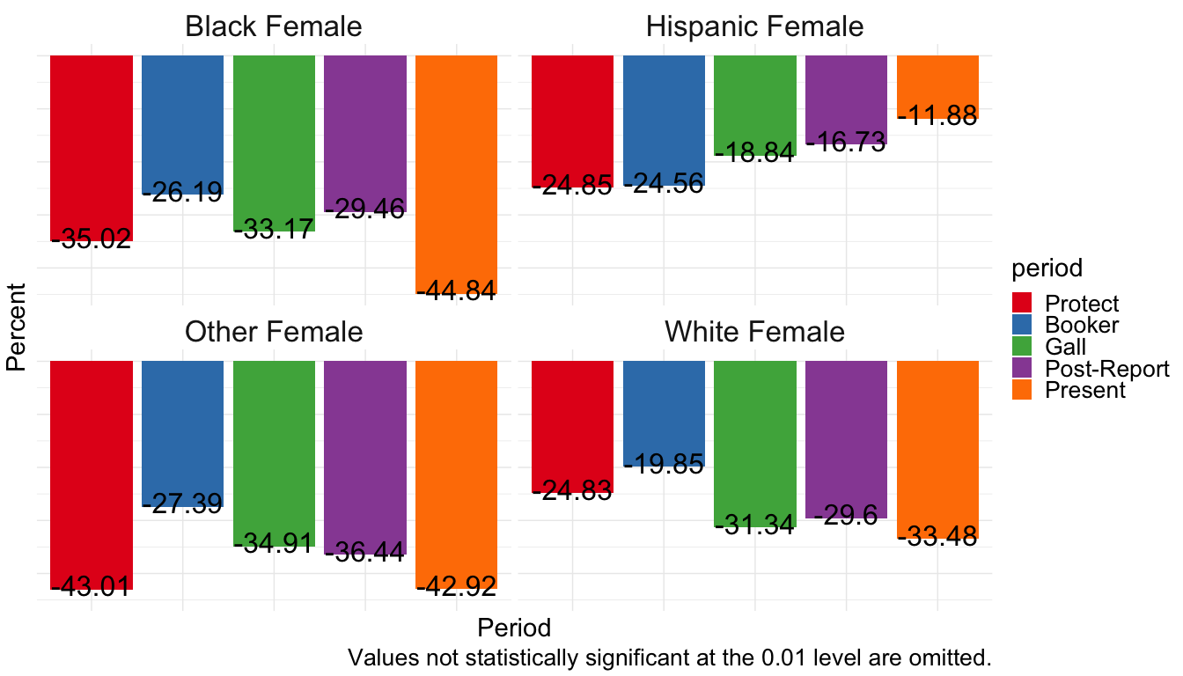
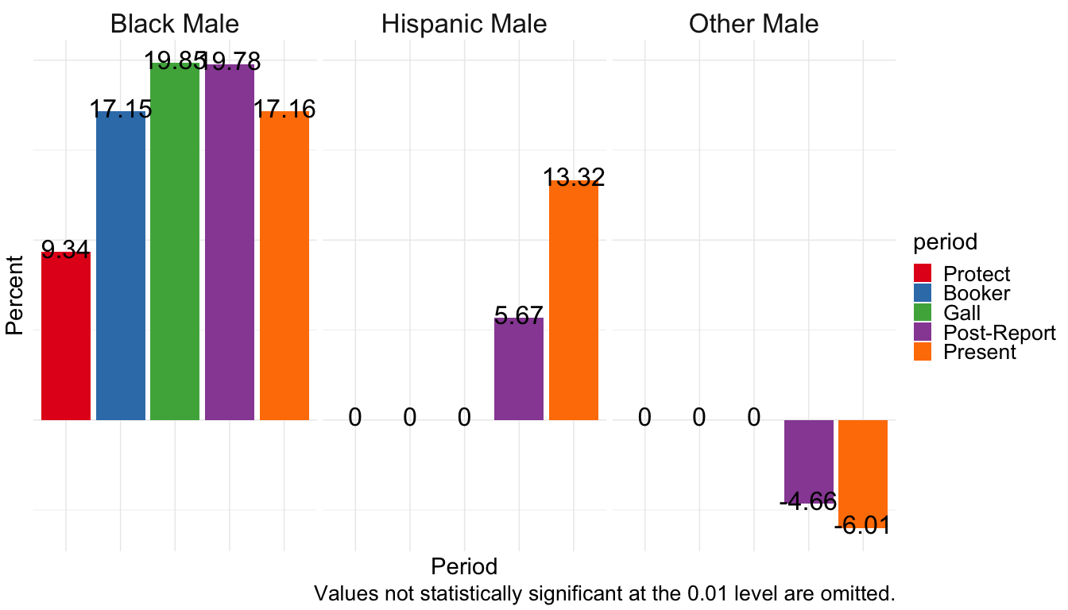

White Female Baseline
Note the colors are scrambled slightly where no statistically significant difference in groups exists during the Protect period.
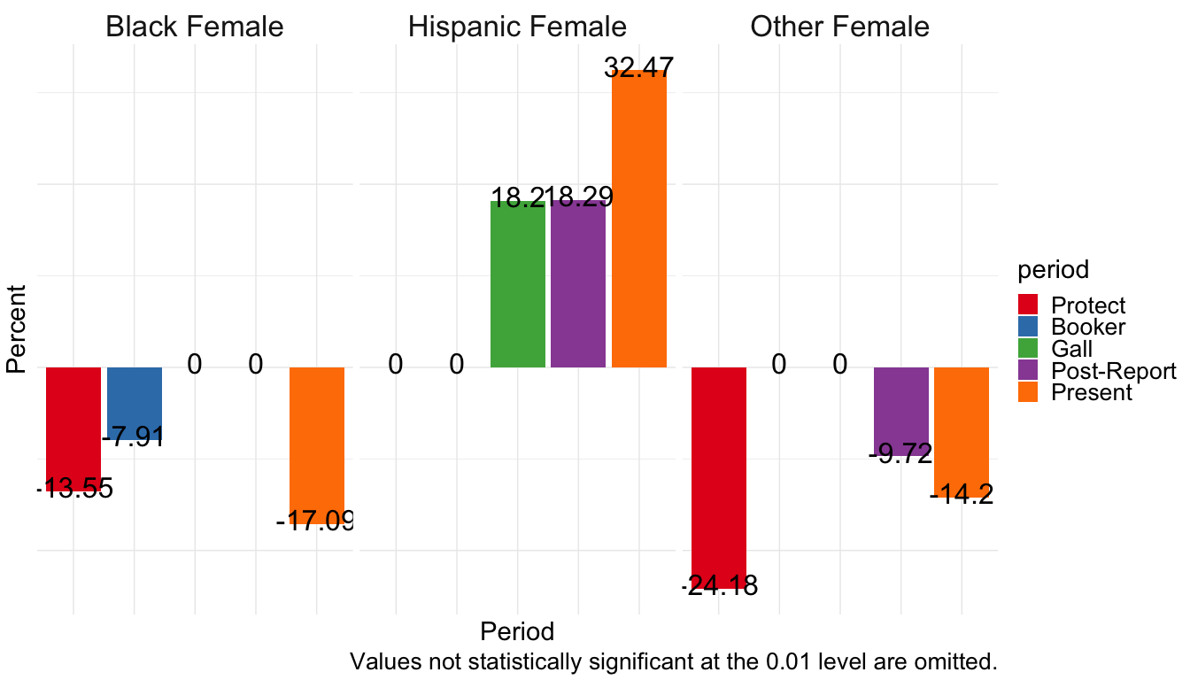
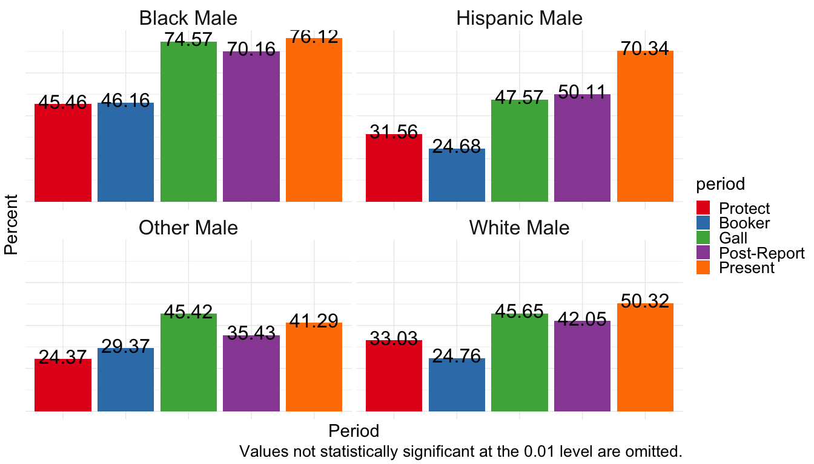

Hispanic Female Baseline
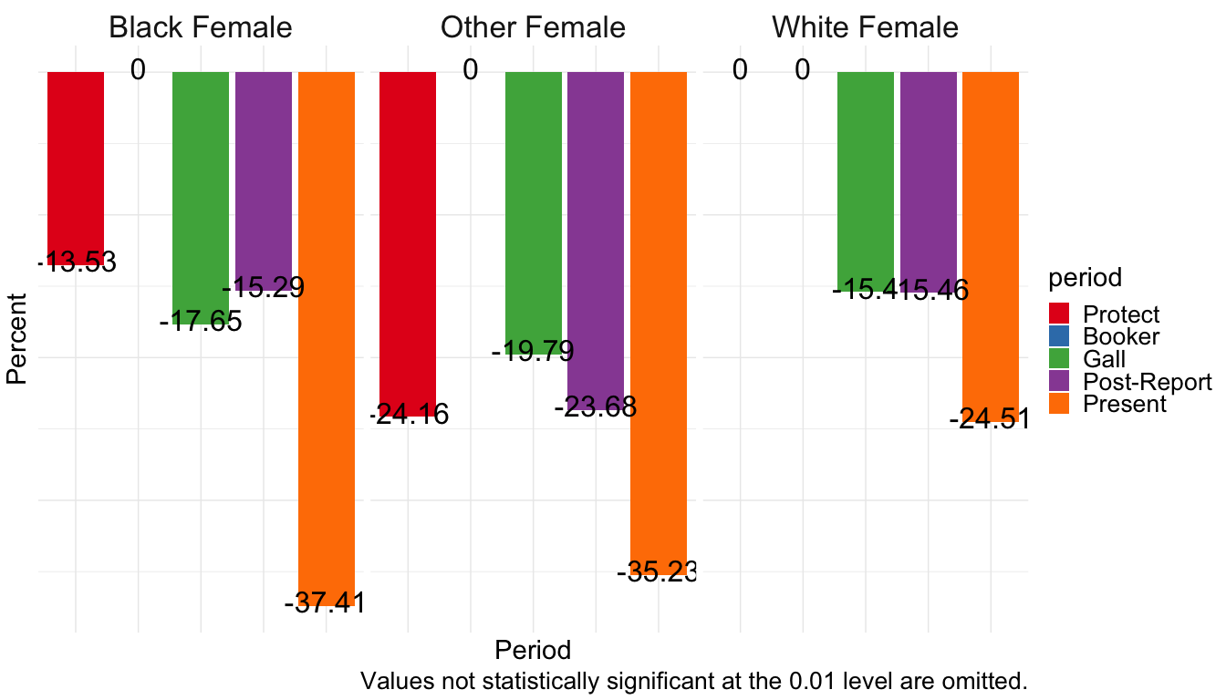
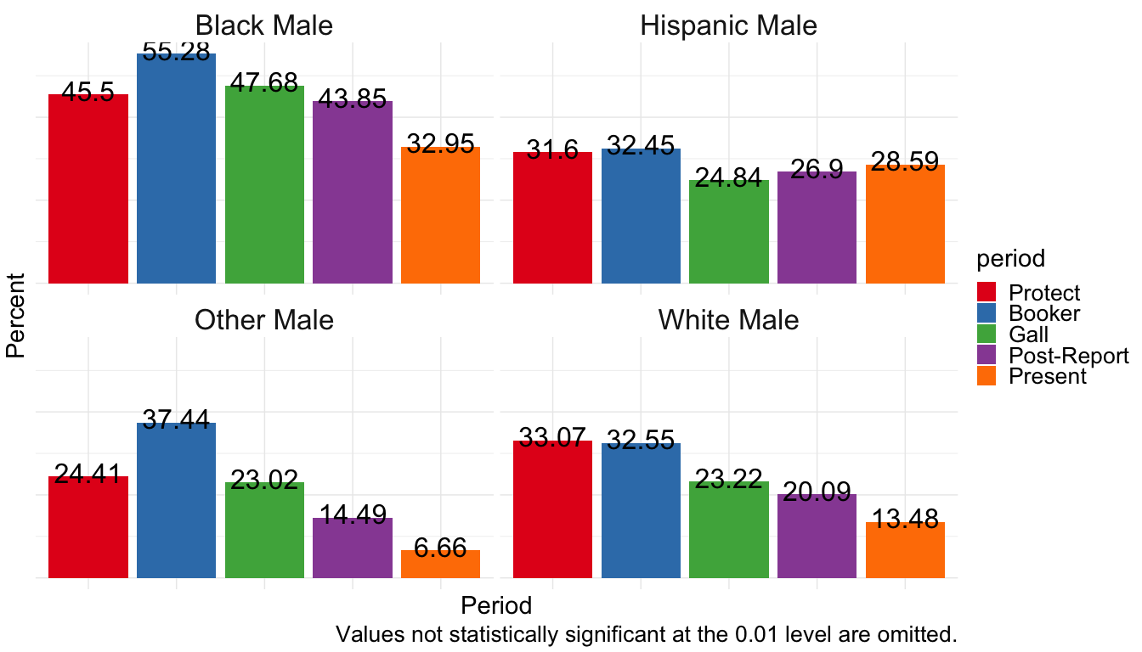

Black Female Baseline
