Demographic Disparities Year by Year
September 17, 2024
This year-by-year breakdown of the Commission’s “refined model” of demographic disparities in sentencing is updated using the latest changes to our replication, stemming from our conversation over email with Ryan Cotter in summer of 2023. The refined model was current as of the Commission’s 2017 report, but has been superseded by a more complex model in the 2023 report.

White Male Baseline
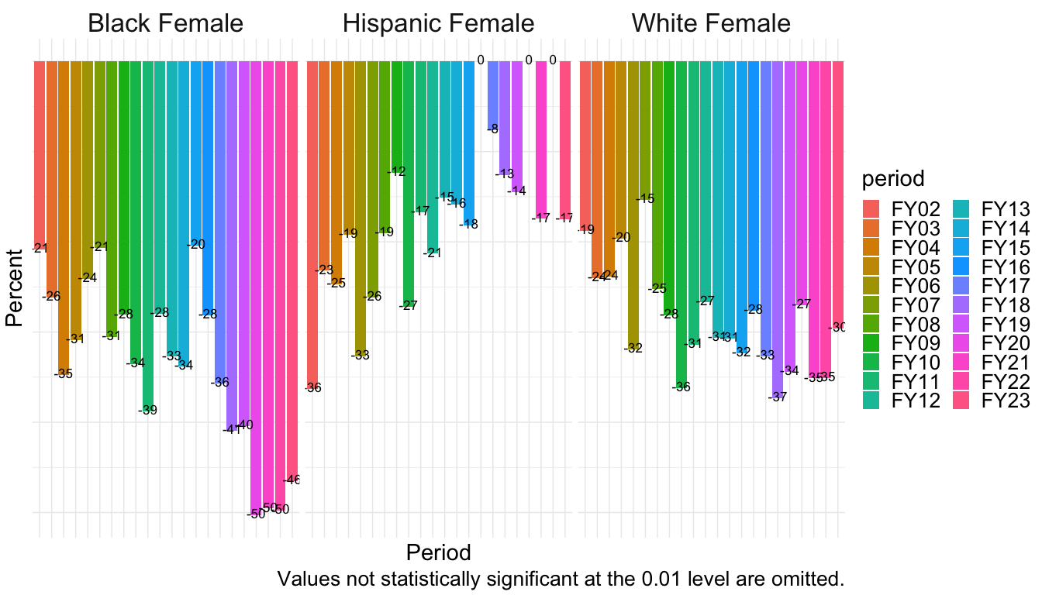
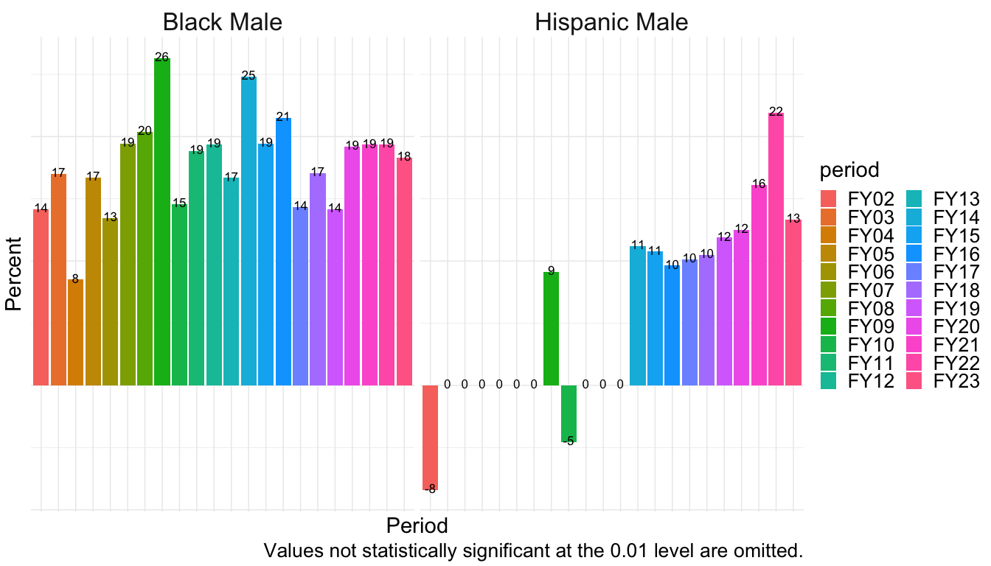

White Female Baseline
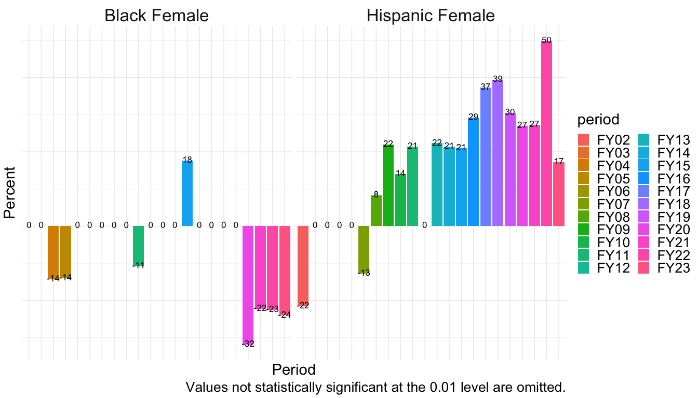
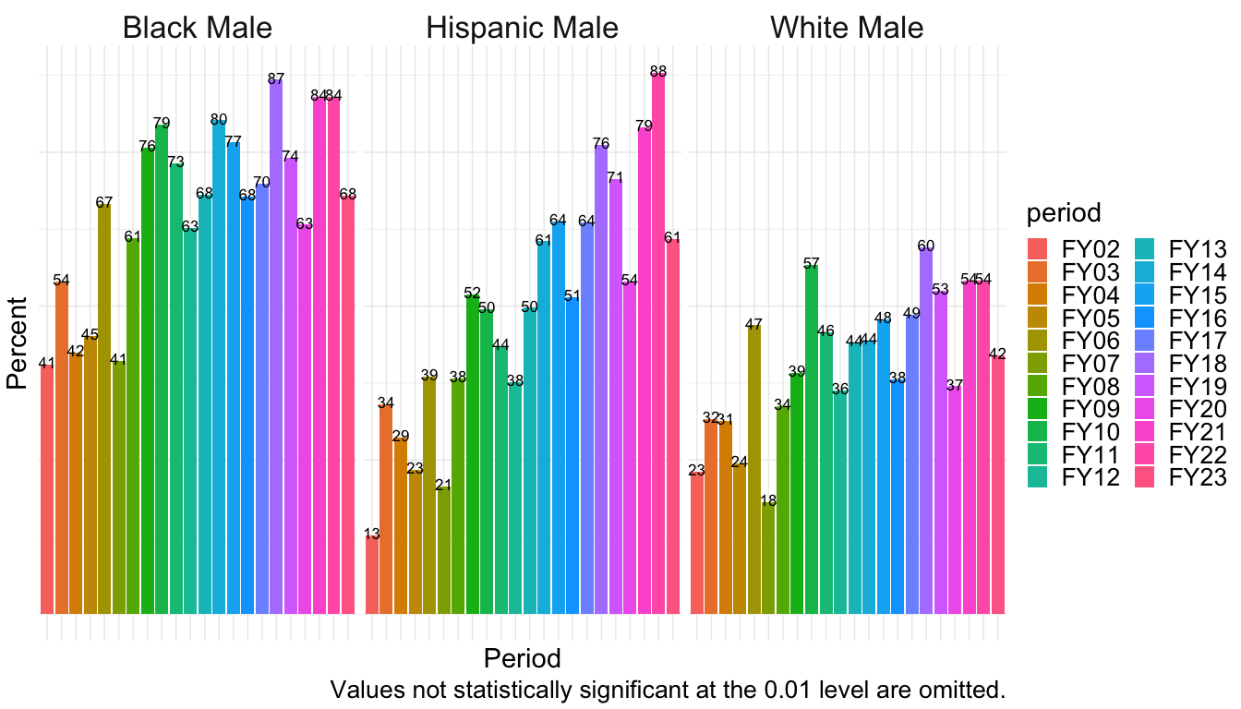

Hispanic Female Baseline
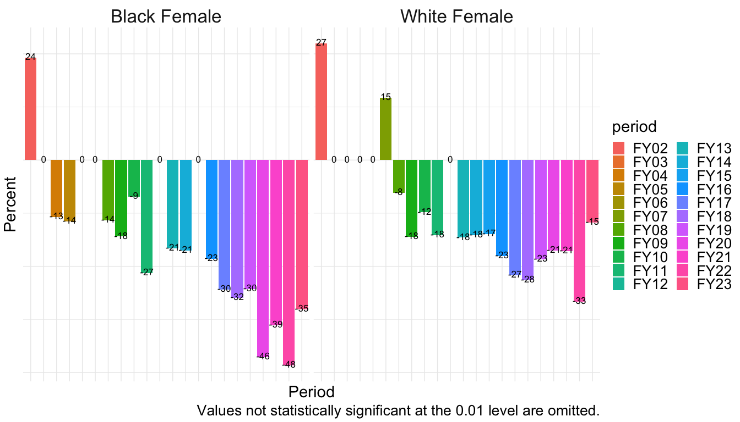
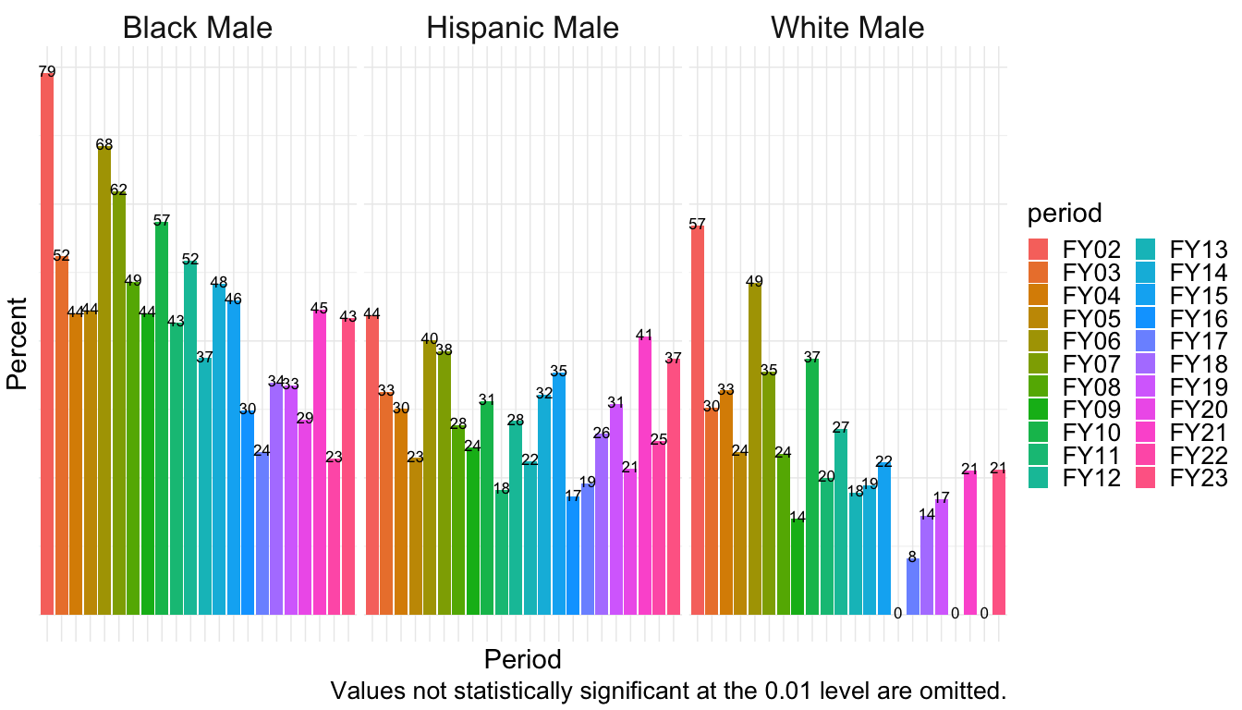

Black Female Baseline
