

|  |  |
| --- | --- |
|  | **FPT ACADEMY INTERNATIONAL FPT – APTECH COMPUTER EDUCATION** |

**A1 UNIFORM EPROJECT-SEMESTER 1**

|  |  |  |  |
| --- | --- | --- | --- |
| **Center Name** | | ACE-HCMC-2-FPT  Address: 590 Cach Mang Thang Tam, District 3, Ho Chi  Minh City | |
| **Instructor** | | Mr. Nguyen Ngo Phuoc | |
| **Class** | | E1.2005.T1 | |
| **Group** | | 1 | |
| **Group members** | | **Name** | **Student ID** |
| TRAN VU LINH | Student1268266 |
| VU HOANG THACH | Student1248880 |
| NGUYEN NGOC THIEN NGAN | Student1262864 |
| HA TAN PHAT | Student1248886 |
| **Duration** | **Start**  **date** | 29th July 2020 | |
| **End**  **date** | 01st August 2020 | |

## This is to certify that

**Mr./Ms.:**

TRAN VU LINH

VU HOANG THACH

NGUYEN NGOC THIEN NGAN

HA TAN PHAT

**has successfully designed & developed**

eProject: A1 UNIFORM

**Submitted by:**

TRAN VU LINH

**Date of issue:** July 29th 2020

## Authorized Signature:

# ACKNOWLEDGEMEN

First of all, we are thankful to Mr. Nguyen Ngo Phuoc for supporting us on the project and the cooperation of each team’s member. The project couldn’t be finished without their hard work. The project help us get more experience in team working and problem solving. It gives us a lot of confidence to face an interview as us have worked on a project.

Finally, we express our gratitude toward our families and colleagues for their kind cooperation and encouragement which help us in completion of this project.

# PROBLEM STATEMENT

A-1 uniforms was founded in 2016 and since then they have been one of the leading **Uniform Manufacturers in the country.** they supply many schools in country and they give them the best uniforms. They supply affordable school uniforms for girls and boys. When clients come, they cater to client’s vision. As a team of professionals they understand what clients want and deliver the best results.

At A-1 uniform designs are innovative and there are always fresh and new ideas for each and every client. The textiles are of excellent quality and they make each uniform according to the size requirements given. The fit is ingenious and they provide with the best. A-1 Uniform is a part of a continuous strategic process of creative inputs from experts in the field. They consider each client differently and ensure the satisfaction with the end results. Each client is given the uttermost importance.

The entire team works together to achieve the same goal.

# REQUIREMENT SPECIFICATION

Looking at the demands and increasing power of web, the management of A-1 are looking for hosting a website of their products which will be easier to reach to them.

You are being approached for developing the site “A1uniforms.com”

The Web site is to be created based on the following requirements.

1. The home page must describe the keywords or highlight of the shop along with all navigation link defined.
2. Products should be categorized as
   1. Shirts
   2. Skirts
   3. Frocks
   4. P.T. T-shirts
   5. P.T. shorts
   6. P.T. track pants
   7. Belts
   8. Ties
   9. Logos
   10. Socks
3. The “Contact Us” page should have the Address of the Company and the mail address which when clicked will invoke the local mail client from where they can send an email. Address of the Company should be displayed using GeoLocation API (e.g. GoogleMaps).
4. Contact Us page should also include the address and contact details of various outlets of A-1 uniforms in the city.
5. About us page
6. Feedback
7. Navigation must be smooth.
8. Color combination must be uniform throughout the project.

# HARDWARE/ SOFTWARE REQUIREMENTS

### For webmaster Hardware

* Intel Pentium 4 processor or higher
* 1 Gigabytes of RAM or higher

### Software

* Windows 7 OS or higher
* Sublime Text 3, Visual Studio Code
* Bootstrap 3, jQuery.
* HTML5 and Javascript supporting web browsers such as IE, Chrome, Firefox, Opera…

### For web users Hardware

* Intel Pentium 4 processor or higher
* 512 Megabytes of RAM or higher

### Software

* Windows 7 OS or higher
* HTML5 and Javascript supporting web browsers such as IE, Chrome, Firefox,

Opera… *(Website best running on Chrome browser).*

**SCOPE OF THE WORK (IN BRIEF)**

After discussion, our group has decided to create a website contain the following webpages:

1. Homepage: Describe the keywords or highlight of the shop along with all navigation link defined.
2. Products: Display all of products on this tag menu.
3. Contact Us: Display an address, phone number to contact with us. Display the address and contact details of various outlets of A1 uniforms in the city. Address of the Company should be displayed using GeoLocation API (e.g. Google Maps).
4. About Us: Introduce about the main information, history and achievements of A1 Uniform. Introduce 4 members.
5. Feedback: Get the feedback from users.

**ARCHITECTURE AND DESIGN OF THE SYSTEM**

# DIAGRAM OF THE WEBSITE

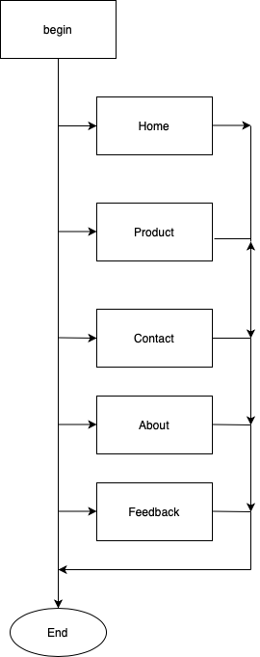

# TASK SHEET REVIEW 1

|  |  |  |  |  |  |  |  |
| --- | --- | --- | --- | --- | --- | --- | --- |
| **Project Ref. No.:**  **eP/Advertisement Portal Management System/01** | | **Project Title:** | **Activity Plan Prepared By:** | **Date of Preparation of Activity Plan:** | | | |
| **Sr.**  **No.** | **Task** | **Actual Start Date** | **Actual Days** | **Team Mate Names** | **Status** |
| 1 | Problem Statement | A1  Uniforms | Linh | 30/7/2020 | 1 | Linh | Completed |
| 2 | Analysis of A1Uniforms requirements about the website | 30/7/2020 | 1 | Ngan | Completed |
| 3 | The scope of the work (in brief) | 31/7/2020 | 1 | Phat | Completed |
| 4 | Architecture and design of the system | 31/7/2020 | 1 | Ngan | Completed |
| 5 | Diagram of the website | 31/7/2020 | 1 | Thach | Completed |
| 6 | Task Sheet | 31/7/2020 | 1 | Phat | Completed |
|  | | | | | | | |
| **Date:** | | | | | | | |
| Signature of Instructor:  **Mr. Nguyen Ngo Phuoc** | | | | Signature of Team Leader:  **Tran Vu Linh** | | | |

# SITE MAP

# MOCK OF THE WEBSITE

## Home Page

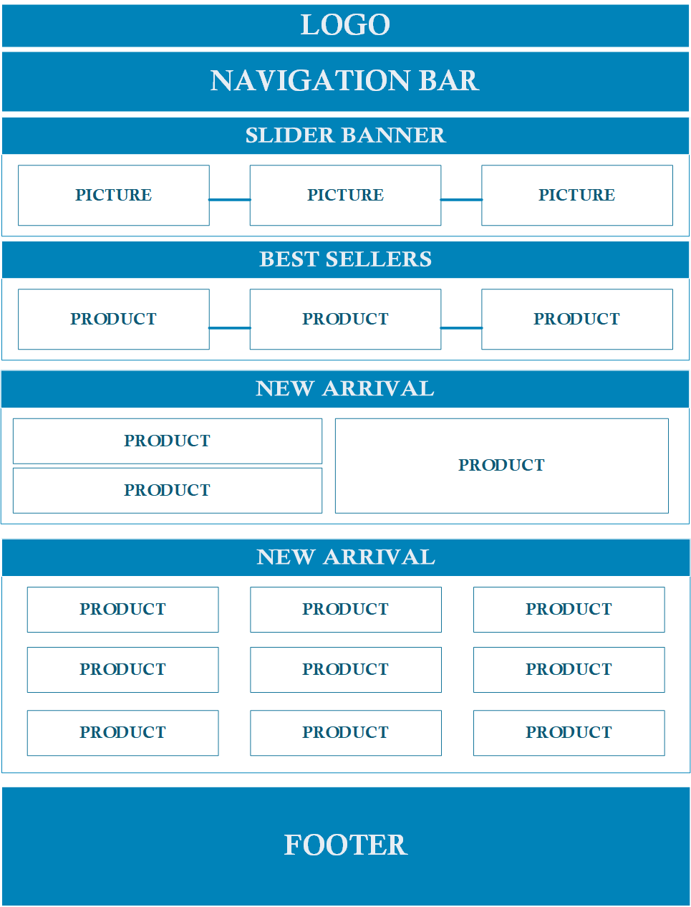

## Product

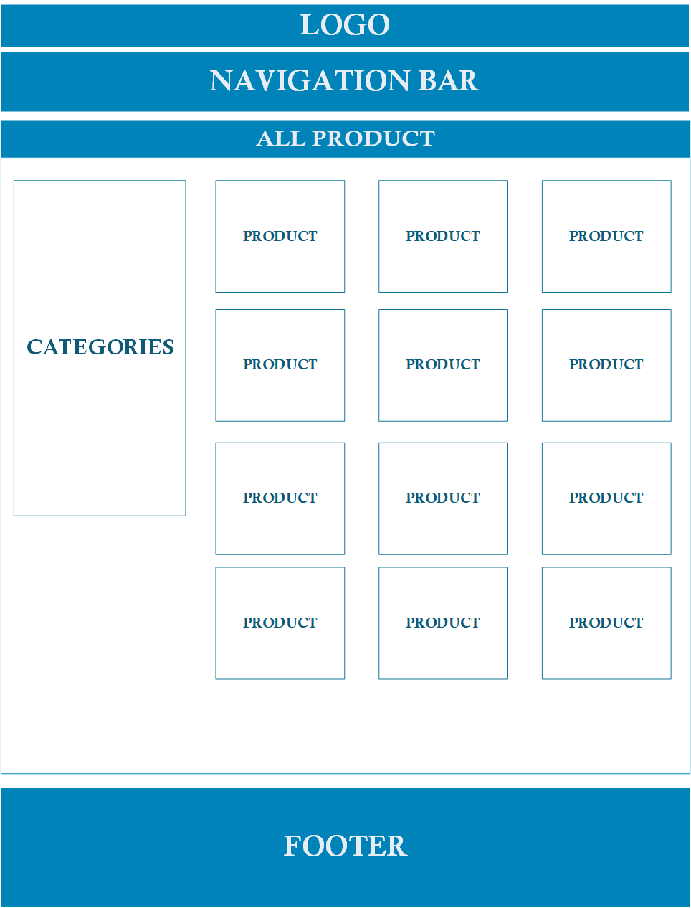

## Product Detail

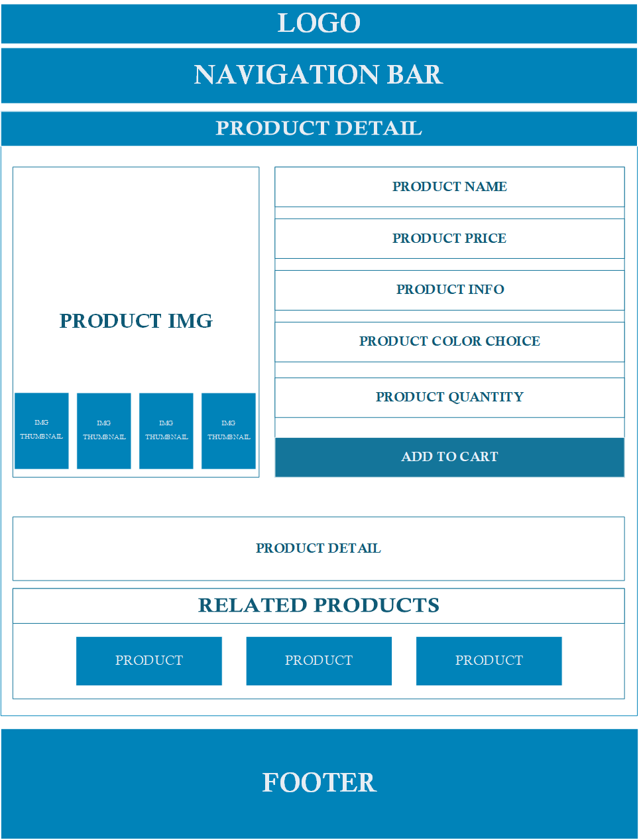

1. **Contact**

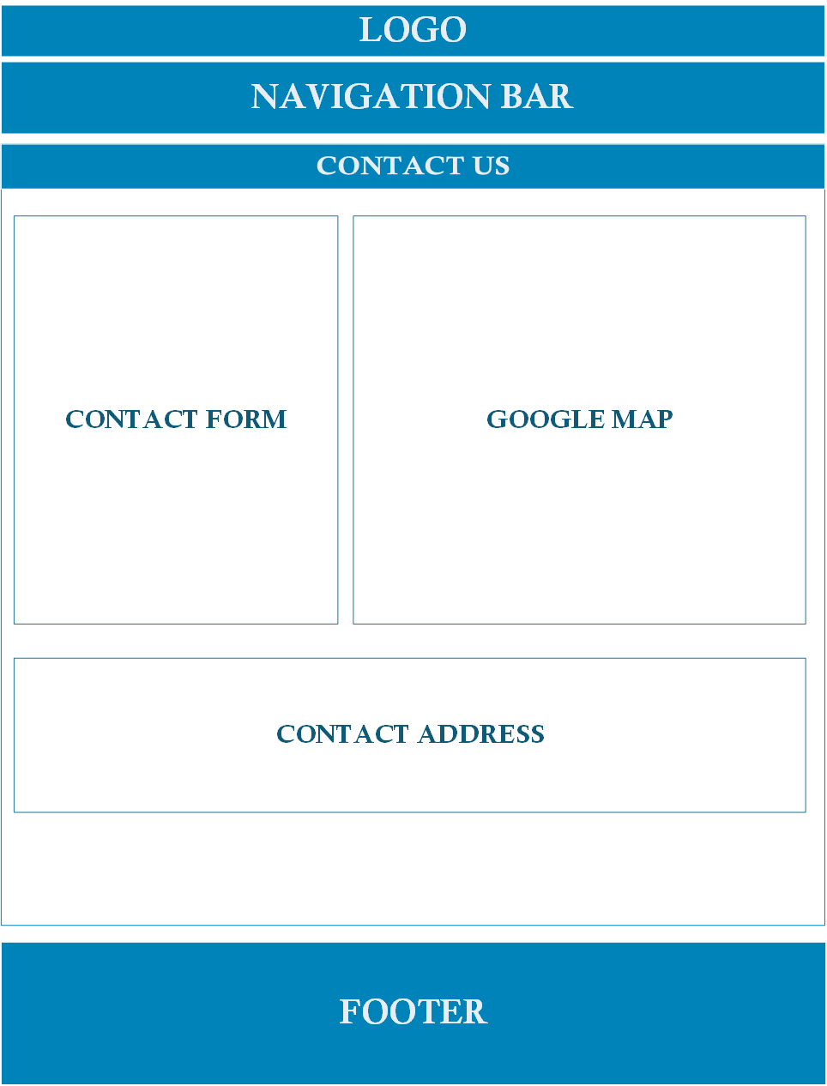

1. **About**

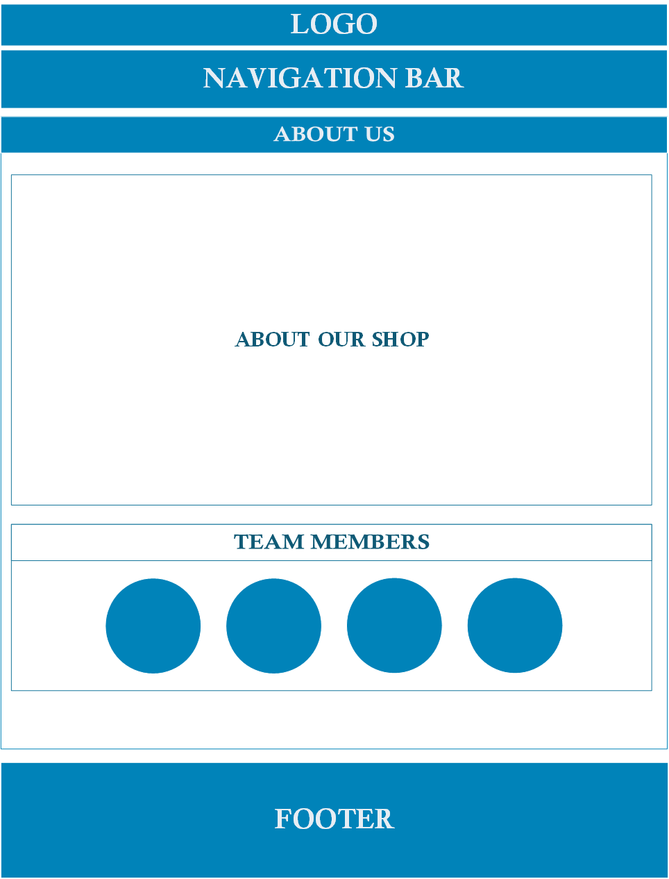

1. **Feedback**

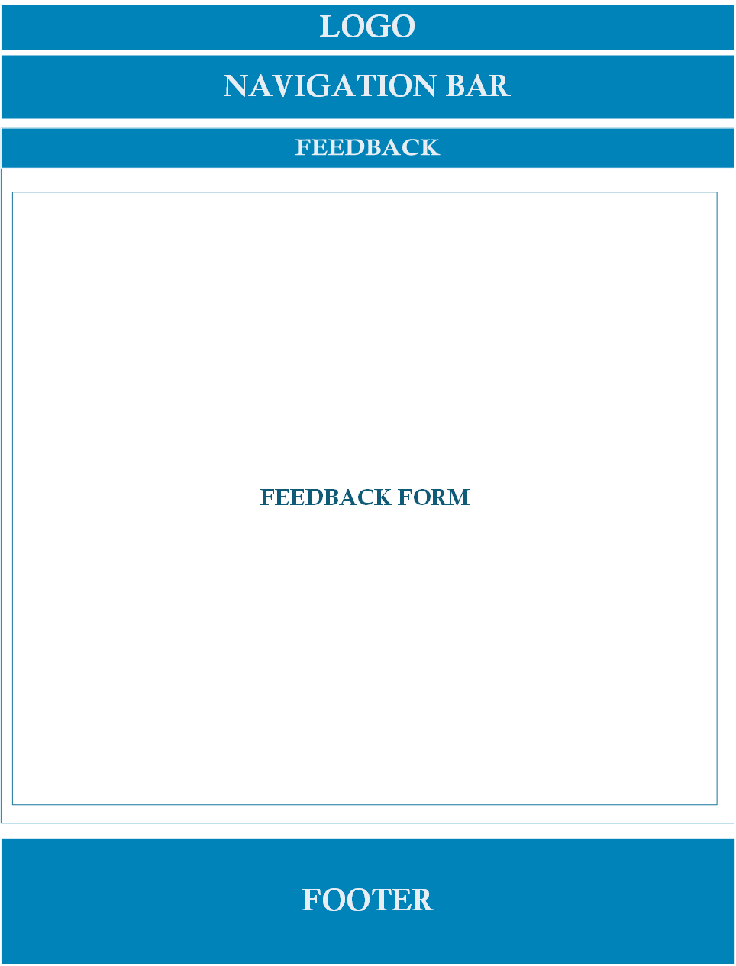

**TASK SHEET REVIEW 2**

|  |  |  |  |  |  |  |  |
| --- | --- | --- | --- | --- | --- | --- | --- |
| **Project Ref. No.:**  **eP/Advertisement Portal Management System/01** | | **Project Title:** | **Activity Plan Prepared By:** | **Date of Preparation of Activity Plan:** | | | |
| **Sr.**  **No.** | **Task** | **Actual Start Date** | **Actual Days** | **Team Mate Names** | **Status** |
| 1 | Site Map | A1 Uniform | Linh | 11/8/2020 | 1 | Linh | Completed |
| 2 | Mock of the website | 11/8/2020 | 1 | Ngan | Completed |
| 3 | Task Sheet | 11/8/2020 | 1 | Phat | Completed |
|  | | | | | | | |
| **Date:** | | | | | | | |
| Signature of Instructor:  **Mr. Nguyen Ngo Phuoc** | | | | Signature of Team Leader:  **Tran Vu Linh** | | | |