Tên : Trần Ngọc Phương Linh
Lớp :11CNPM2
MSSV : 1150080103
Môn : Phương pháp phát triển phần mềm hướng đối tướng
Thực hành 1: Hiển thị dữ liệu trên control DataGridView
Đầu tiên
File New Project
Ở Create a new project chọn Windows From App (.NET Framework)
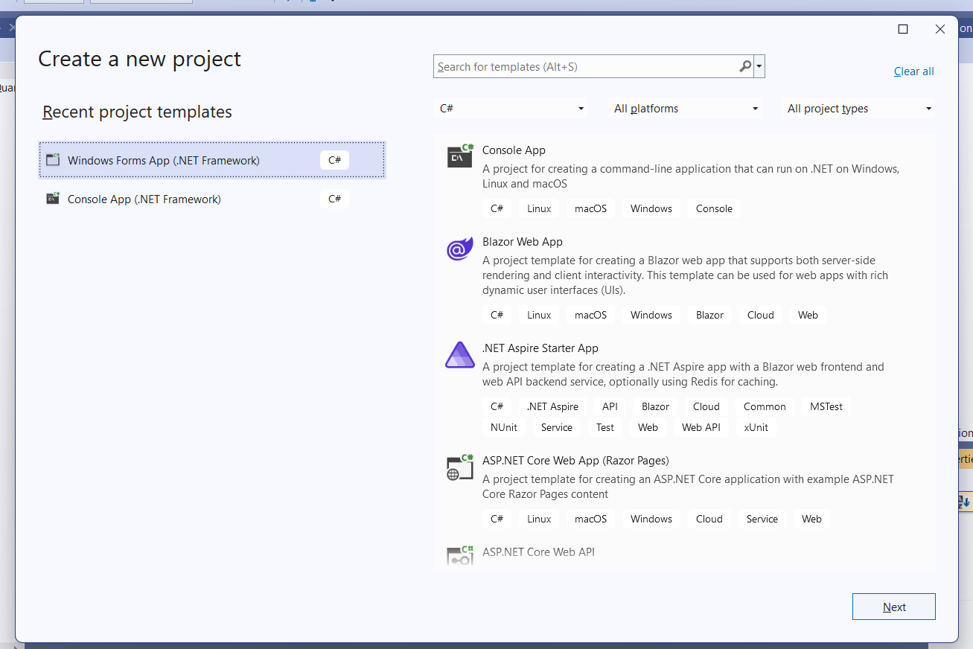
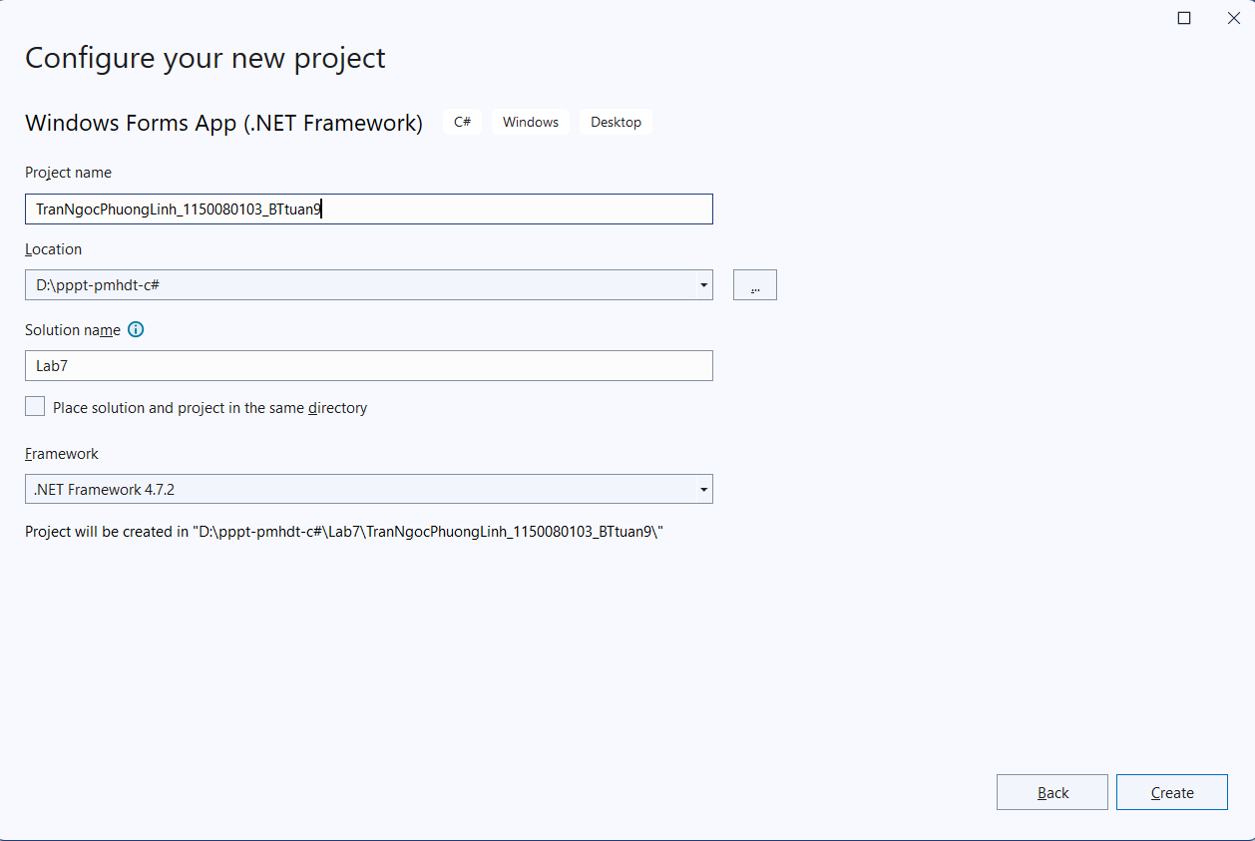
Chuột phải ở project Add Service-based database
Tạo QuanLyBanSach.mdf
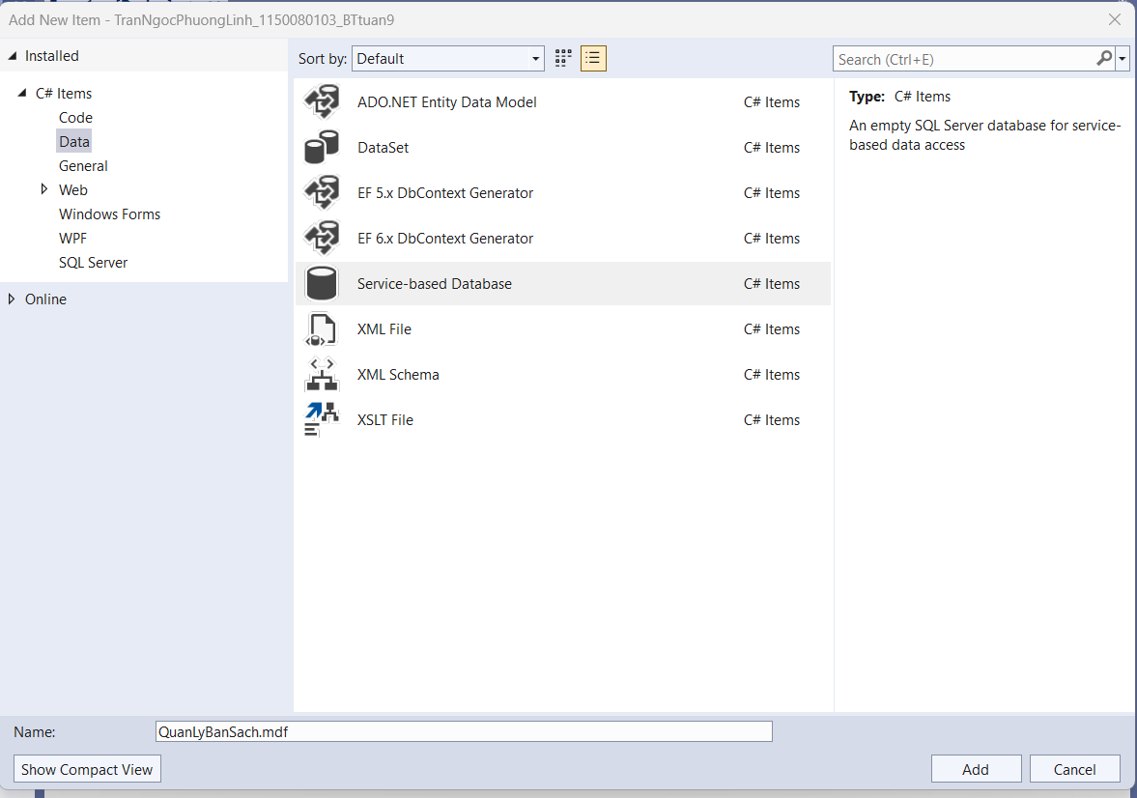

Do là chưa có bảng và dữ liệu để hiển thị nên ta phải thêm vào
CREATE TABLE dbo.NhaXuatBan(
MaXB NVARCHAR(10) NOT NULL PRIMARY KEY,
TenXB NVARCHAR(100) NULL,
DiaChi NVARCHAR(200) NULL
);

INSERT INTO dbo.NhaXuatBan (MaXB, TenXB, DiaChi) VALUES
(N'NXB01', N'Kim Đồng', N'248 CMT8, TP.HCM'),
(N'NXB02', N'Giáo Dục', N'101 Trần Hưng Đạo, Hà Nội'),
(N'NXB03', N'Văn Hóa', N'12 Nguyễn Trãi, TP.HCM');

Form1.cs
using System;
using System.Data;
using System.Data.SqlClient;
using System.Windows.Forms;

namespace TranNgocPhuongLinh_1150080103_BTtuan9
{
public partial class Form1 : Form
{
private readonly string strCon =
@"Data Source=(LocalDB)\MSSQLLocalDB;AttachDbFilename=D:\pppt-pmhdt-c#\Lab7\TranNgocPhuongLinh_1150080103_BTtuan9\QuanLyBanSach.mdf;Integrated Security=True";

private SqlConnection sqlCon = null;

public Form1()
{
InitializeComponent();
}

private void Form1_Load(object sender, EventArgs e)
{

}

private void MoKetNoi()
{
if (sqlCon == null)
sqlCon = new SqlConnection(strCon);

if (sqlCon.State == ConnectionState.Closed)
sqlCon.Open();
}

private void DongKetNoi()
{
if (sqlCon != null && sqlCon.State == ConnectionState.Open)
sqlCon.Close();
}

private void btnHienThi_Click(object sender, EventArgs e)
{
try
{
MoKetNoi();

string sql = "SELECT * FROM NhaXuatBan";

SqlDataAdapter adapter = new SqlDataAdapter(sql, sqlCon);
DataSet ds = new DataSet();
adapter.Fill(ds, "tblNhaXuatBan");

dgvDanhSach.DataSource = ds.Tables["tblNhaXuatBan"];

DongKetNoi();
}
catch (Exception ex)
{
MessageBox.Show("Lỗi: " + ex.Message);
}
}
}

Form1.cs.desginer

namespace TranNgocPhuongLinh_1150080103_BTtuan9
{
partial class Form1
{
private System.ComponentModel.IContainer components = null;

protected override void Dispose(bool disposing)
{
if (disposing && (components != null))
{
components.Dispose();
}
base.Dispose(disposing);
}

#region Windows Form Designer generated code

private void InitializeComponent()
{
this.btnHienThi = new System.Windows.Forms.Button();
this.dgvDanhSach = new System.Windows.Forms.DataGridView();
((System.ComponentModel.ISupportInitialize)(this.dgvDanhSach)).BeginInit();
this.SuspendLayout();
//
// btnHienThi
//
this.btnHienThi.Font = new System.Drawing.Font("Microsoft Sans Serif", 12F);
this.btnHienThi.Location = new System.Drawing.Point(181, 12);
this.btnHienThi.Name = "btnHienThi";
this.btnHienThi.Size = new System.Drawing.Size(416, 60);
this.btnHienThi.TabIndex = 0;
this.btnHienThi.Text = "Hiển thị danh sách";
this.btnHienThi.UseVisualStyleBackColor = true;
this.btnHienThi.Click += new System.EventHandler(this.btnHienThi_Click);
//
// dgvDanhSach
//
this.dgvDanhSach.ColumnHeadersHeightSizeMode = System.Windows.Forms.DataGridViewColumnHeadersHeightSizeMode.AutoSize;
this.dgvDanhSach.Location = new System.Drawing.Point(50, 110);
this.dgvDanhSach.Name = "dgvDanhSach";
this.dgvDanhSach.RowHeadersWidth = 51;
this.dgvDanhSach.Size = new System.Drawing.Size(700, 350);
this.dgvDanhSach.TabIndex = 1;
//
// Form1
//
this.AutoScaleDimensions = new System.Drawing.SizeF(8F, 16F);
this.AutoScaleMode = System.Windows.Forms.AutoScaleMode.Font;
this.ClientSize = new System.Drawing.Size(800, 500);
this.Controls.Add(this.dgvDanhSach);
this.Controls.Add(this.btnHienThi);
this.Name = "Form1";
this.Text = "1150080103_TranNgocPhuongLinh";
this.Load += new System.EventHandler(this.Form1_Load);
((System.ComponentModel.ISupportInitialize)(this.dgvDanhSach)).EndInit();
this.ResumeLayout(false);

}

#endregion

private System.Windows.Forms.Button btnHienThi;
private System.Windows.Forms.DataGridView dgvDanhSach;
}
}

Chạy thử
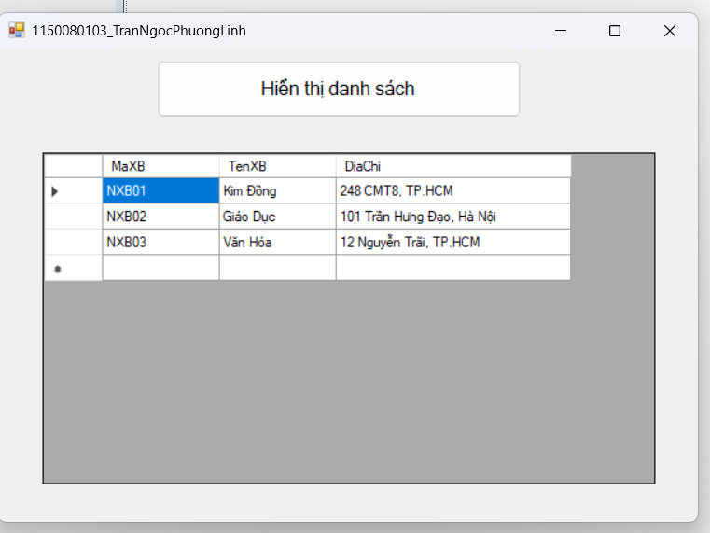
Thực hành 2: Thêm dữ liệu cho bảng Nhà xuất bản
Form2.cs
using System;
using System.Data;
using System.Data.SqlClient;
using System.Windows.Forms;

namespace TranNgocPhuongLinh_1150080103_BTtuan9
{
public partial class Form2 : Form
{
string strCon =
@"Data Source=(LocalDB)\MSSQLLocalDB;AttachDbFilename=D:\pppt-pmhdt-c#\Lab7\TranNgocPhuongLinh_1150080103_BTtuan9\QuanLyBanSach.mdf;Integrated Security=True";

SqlConnection sqlCon = null;
SqlDataAdapter adapter = null;
DataSet ds = null;

public Form2()
{
InitializeComponent();
}

private void MoKetNoi()
{
if (sqlCon == null)
sqlCon = new SqlConnection(strCon);
if (sqlCon.State == ConnectionState.Closed)
sqlCon.Open();
}

private void DongKetNoi()
{
if (sqlCon != null && sqlCon.State == ConnectionState.Open)
sqlCon.Close();
}

private void LoadData()
{
MoKetNoi();
string sql = "SELECT * FROM NhaXuatBan";

adapter = new SqlDataAdapter(sql, sqlCon);
adapter.MissingSchemaAction = MissingSchemaAction.AddWithKey;

SqlCommandBuilder builder = new SqlCommandBuilder(adapter);

ds = new DataSet();
adapter.Fill(ds, "NXB");

dgvDanhSach.DataSource = ds.Tables["NXB"];

DongKetNoi();
}

private void ClearForm()
{
txtMaXB.Text = "";
txtTenXB.Text = "";
txtDiaChi.Text = "";
txtMaXB.Focus();
}

private void Form2_Load(object sender, EventArgs e)
{
LoadData();
ClearForm();
}

private void btnThemDL_Click(object sender, EventArgs e)
{
if (string.IsNullOrWhiteSpace(txtMaXB.Text))
{
MessageBox.Show("Vui lòng nhập Mã NXB");
return;
}

DataTable tbl = ds.Tables["NXB"];

DataRow found = tbl.Rows.Find(txtMaXB.Text.Trim());
if (found != null)
{
MessageBox.Show("Mã NXB đã tồn tại!");
return;
}

DataRow row = tbl.NewRow();
row["MaXB"] = txtMaXB.Text.Trim();
row["TenXB"] = txtTenXB.Text.Trim();
row["DiaChi"] = txtDiaChi.Text.Trim();
tbl.Rows.Add(row);

int result = adapter.Update(tbl);
if (result > 0)
{
MessageBox.Show("Thêm thành công!");
LoadData();
ClearForm();
}
else
{
MessageBox.Show("Thêm thất bại!");
}
}
}
}

Form2.desginer.cs
namespace TranNgocPhuongLinh_1150080103_BTtuan9
{
partial class Form2
{
private System.ComponentModel.IContainer components = null;

protected override void Dispose(bool disposing)
{
if (disposing && (components != null))
{
components.Dispose();
}
base.Dispose(disposing);
}

#region Windows Form Designer generated code

private void InitializeComponent()
{
this.dgvDanhSach = new System.Windows.Forms.DataGridView();
this.lblDanhSach = new System.Windows.Forms.Label();
this.lblInfo = new System.Windows.Forms.Label();
this.lblMaXB = new System.Windows.Forms.Label();
this.lblTenXB = new System.Windows.Forms.Label();
this.lblDiaChi = new System.Windows.Forms.Label();
this.txtMaXB = new System.Windows.Forms.TextBox();
this.txtTenXB = new System.Windows.Forms.TextBox();
this.txtDiaChi = new System.Windows.Forms.TextBox();
this.btnThemDL = new System.Windows.Forms.Button();
this.splitBar = new System.Windows.Forms.Label();
((System.ComponentModel.ISupportInitialize)(this.dgvDanhSach)).BeginInit();
this.SuspendLayout();
//
// dgvDanhSach
//
this.dgvDanhSach.ColumnHeadersHeightSizeMode = System.Windows.Forms.DataGridViewColumnHeadersHeightSizeMode.AutoSize;
this.dgvDanhSach.Location = new System.Drawing.Point(20, 60);
this.dgvDanhSach.Name = "dgvDanhSach";
this.dgvDanhSach.RowHeadersWidth = 51;
this.dgvDanhSach.RowTemplate.Height = 24;
this.dgvDanhSach.Size = new System.Drawing.Size(430, 360);
this.dgvDanhSach.TabIndex = 0;
//
// lblDanhSach
//
this.lblDanhSach.AutoSize = true;
this.lblDanhSach.Location = new System.Drawing.Point(17, 25);
this.lblDanhSach.Name = "lblDanhSach";
this.lblDanhSach.Size = new System.Drawing.Size(139, 16);
this.lblDanhSach.TabIndex = 1;
this.lblDanhSach.Text = "Danh sách nhà xuất bản:";
//
// lblInfo
//
this.lblInfo.AutoSize = true;
this.lblInfo.Location = new System.Drawing.Point(495, 25);
this.lblInfo.Name = "lblInfo";
this.lblInfo.Size = new System.Drawing.Size(97, 16);
this.lblInfo.TabIndex = 2;
this.lblInfo.Text = "Nhập thông tin:";
//
// lblMaXB
//
this.lblMaXB.AutoSize = true;
this.lblMaXB.Location = new System.Drawing.Point(495, 80);
this.lblMaXB.Name = "lblMaXB";
this.lblMaXB.Size = new System.Drawing.Size(54, 16);
this.lblMaXB.TabIndex = 3;
this.lblMaXB.Text = "Mã NXB:";
//
// lblTenXB
//
this.lblTenXB.AutoSize = true;
this.lblTenXB.Location = new System.Drawing.Point(495, 140);
this.lblTenXB.Name = "lblTenXB";
this.lblTenXB.Size = new System.Drawing.Size(59, 16);
this.lblTenXB.TabIndex = 4;
this.lblTenXB.Text = "Tên NXB:";
//
// lblDiaChi
//
this.lblDiaChi.AutoSize = true;
this.lblDiaChi.Location = new System.Drawing.Point(495, 200);
this.lblDiaChi.Name = "lblDiaChi";
this.lblDiaChi.Size = new System.Drawing.Size(50, 16);
this.lblDiaChi.TabIndex = 5;
this.lblDiaChi.Text = "Địa chỉ:";
//
// txtMaXB
//
this.txtMaXB.Location = new System.Drawing.Point(575, 77);
this.txtMaXB.Name = "txtMaXB";
this.txtMaXB.Size = new System.Drawing.Size(220, 22);
this.txtMaXB.TabIndex = 6;
//
// txtTenXB
//
this.txtTenXB.Location = new System.Drawing.Point(575, 137);
this.txtTenXB.Name = "txtTenXB";
this.txtTenXB.Size = new System.Drawing.Size(220, 22);
this.txtTenXB.TabIndex = 7;
//
// txtDiaChi
//
this.txtDiaChi.Location = new System.Drawing.Point(575, 197);
this.txtDiaChi.Name = "txtDiaChi";
this.txtDiaChi.Size = new System.Drawing.Size(220, 22);
this.txtDiaChi.TabIndex = 8;
//
// btnThemDL
//
this.btnThemDL.Font = new System.Drawing.Font("Microsoft Sans Serif", 10F);
this.btnThemDL.Location = new System.Drawing.Point(575, 250);
this.btnThemDL.Name = "btnThemDL";
this.btnThemDL.Size = new System.Drawing.Size(220, 45);
this.btnThemDL.TabIndex = 9;
this.btnThemDL.Text = "Thêm dữ liệu";
this.btnThemDL.UseVisualStyleBackColor = true;
this.btnThemDL.Click += new System.EventHandler(this.btnThemDL_Click);
//
// splitBar
//
this.splitBar.BackColor = System.Drawing.SystemColors.ControlDark;
this.splitBar.Location = new System.Drawing.Point(470, 10);
this.splitBar.Name = "splitBar";
this.splitBar.Size = new System.Drawing.Size(2, 440);
this.splitBar.TabIndex = 10;
//
// Form2
//
this.ClientSize = new System.Drawing.Size(830, 450);
this.Controls.Add(this.splitBar);
this.Controls.Add(this.btnThemDL);
this.Controls.Add(this.txtDiaChi);
this.Controls.Add(this.txtTenXB);
this.Controls.Add(this.txtMaXB);
this.Controls.Add(this.lblDiaChi);
this.Controls.Add(this.lblTenXB);
this.Controls.Add(this.lblMaXB);
this.Controls.Add(this.lblInfo);
this.Controls.Add(this.dgvDanhSach);
this.Controls.Add(this.lblDanhSach);
this.Name = "Form2";
this.Text = "1150080103_TranNgocPhuongLinh";
this.Load += new System.EventHandler(this.Form2_Load);
((System.ComponentModel.ISupportInitialize)(this.dgvDanhSach)).EndInit();
this.ResumeLayout(false);
this.PerformLayout();
}

#endregion

private System.Windows.Forms.DataGridView dgvDanhSach;
private System.Windows.Forms.Label lblDanhSach;
private System.Windows.Forms.Label lblInfo;
private System.Windows.Forms.Label lblMaXB;
private System.Windows.Forms.Label lblTenXB;
private System.Windows.Forms.Label lblDiaChi;
private System.Windows.Forms.TextBox txtMaXB;
private System.Windows.Forms.TextBox txtTenXB;
private System.Windows.Forms.TextBox txtDiaChi;
private System.Windows.Forms.Button btnThemDL;
private System.Windows.Forms.Label splitBar;
}
}

Chạy thử
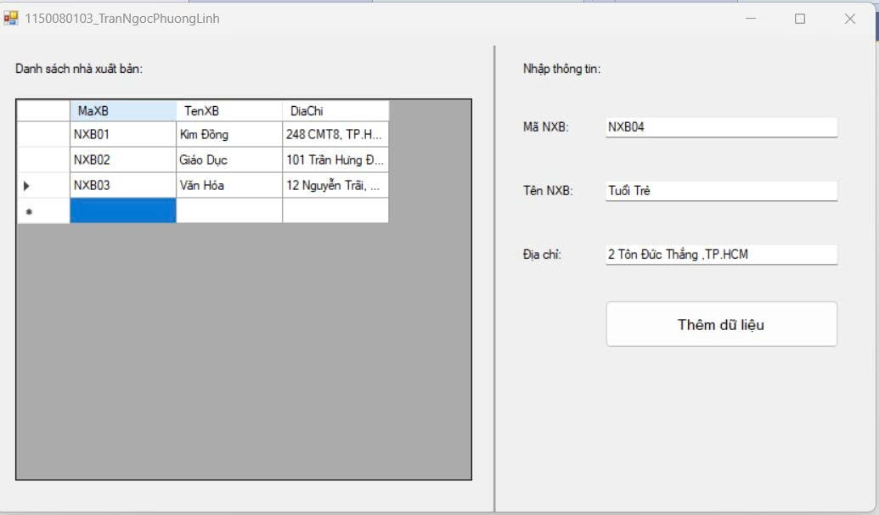
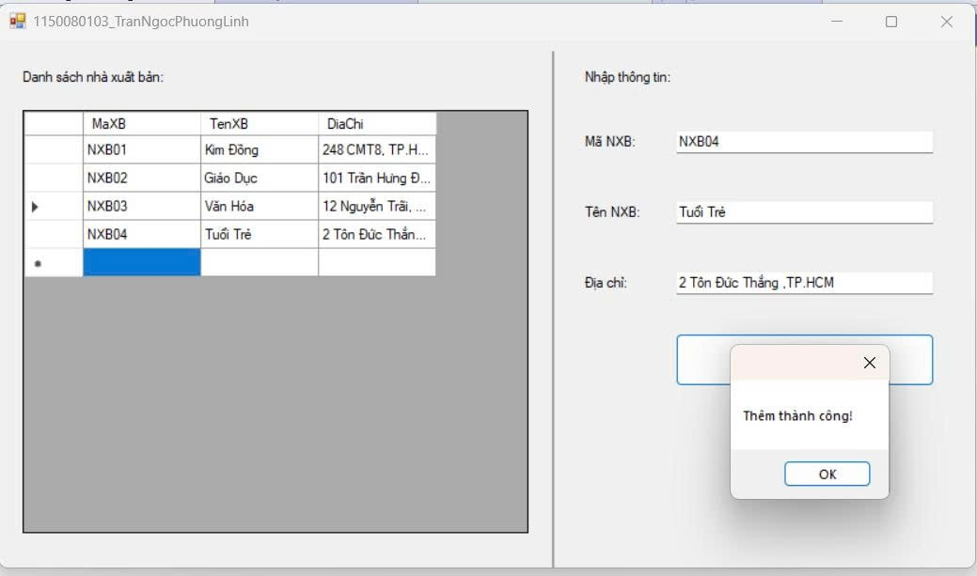

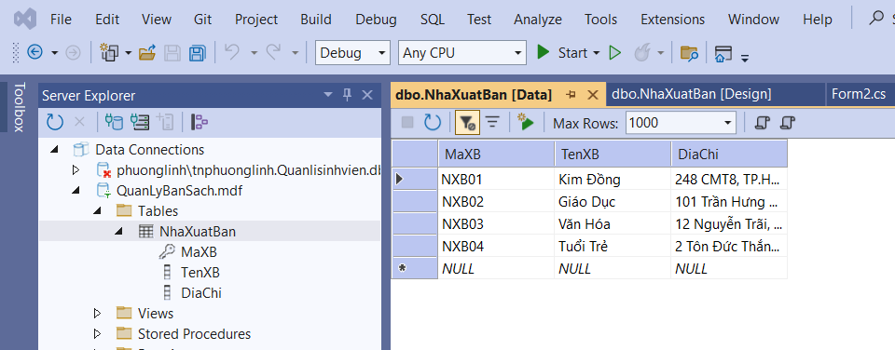
Thực hành 3: Cập nhật dữ liệu cho bảng Nhà xuất bản

Form3.cs
using System;
using System.Data;
using System.Data.SqlClient;
using System.Windows.Forms;

namespace TranNgocPhuongLinh_1150080103_BTtuan9
{
public partial class Form3 : Form
{
private readonly string strCon =
@"Data Source=(LocalDB)\MSSQLLocalDB;AttachDbFilename=D:\pppt-pmhdt-c#\Lab7\TranNgocPhuongLinh_1150080103_BTtuan9\QuanLyBanSach.mdf;Integrated Security=True";

private SqlConnection sqlCon;
private SqlDataAdapter adapter;
private DataSet ds;

public Form3()
{
InitializeComponent();
}

// ===== Helpers =====
private void MoKetNoi()
{
if (sqlCon == null) sqlCon = new SqlConnection(strCon);
if (sqlCon.State == ConnectionState.Closed) sqlCon.Open();
}

private void DongKetNoi()
{
if (sqlCon != null && sqlCon.State == ConnectionState.Open)
sqlCon.Close();
}

private void LoadData()
{
MoKetNoi();
string sql = "SELECT * FROM NhaXuatBan";
adapter = new SqlDataAdapter(sql, sqlCon);

adapter.MissingSchemaAction = MissingSchemaAction.AddWithKey;

SqlCommandBuilder builder = new SqlCommandBuilder(adapter);

ds = new DataSet();
adapter.Fill(ds, "NXB");

dgvDanhSach.DataSource = ds.Tables["NXB"];
DongKetNoi();
}

private void ClearEdit()
{
txtMaXB.Text = "";
txtTenXB.Text = "";
txtDiaChi.Text = "";
}

// ===== Events =====
private void Form3_Load(object sender, EventArgs e)
{
LoadData();
ClearEdit();
txtMaXB.ReadOnly = true;
}

private void dgvDanhSach_CellClick(object sender, DataGridViewCellEventArgs e)
{
if (e.RowIndex < 0) return;
var rowView = dgvDanhSach.Rows[e.RowIndex].DataBoundItem as DataRowView;
if (rowView == null) return;

txtMaXB.Text = rowView["MaXB"].ToString();
txtTenXB.Text = rowView["TenXB"].ToString();
txtDiaChi.Text = rowView["DiaChi"].ToString();
}

private void btnChinhSua_Click(object sender, EventArgs e)
{
if (string.IsNullOrWhiteSpace(txtMaXB.Text))
{
MessageBox.Show("Hãy chọn 1 dòng ở danh sách để chỉnh sửa.");
return;
}

try
{
DataTable tbl = ds.Tables["NXB"];
DataRow row = tbl.Rows.Find(txtMaXB.Text.Trim());
if (row == null)
{
MessageBox.Show("Không tìm thấy bản ghi cần cập nhật.");
return;
}

row.BeginEdit();
row["TenXB"] = txtTenXB.Text.Trim();
row["DiaChi"] = txtDiaChi.Text.Trim();
row.EndEdit();

int kq = adapter.Update(tbl);
if (kq > 0)
{
MessageBox.Show("Cập nhật thành công!");
LoadData();
}
else
{
MessageBox.Show("Cập nhật không thành công!");
}
}
catch (Exception ex)
{
MessageBox.Show("Lỗi khi cập nhật:\n" + ex.Message,
"Lỗi", MessageBoxButtons.OK, MessageBoxIcon.Error);
}
}
}
}

Form3.Designer.cs
namespace TranNgocPhuongLinh_1150080103_BTtuan9
{
partial class Form3
{
private System.ComponentModel.IContainer components = null;

protected override void Dispose(bool disposing)
{
if (disposing && (components != null)) components.Dispose();
base.Dispose(disposing);
}

#region Windows Form Designer generated code

private void InitializeComponent()
{
this.lblTitle = new System.Windows.Forms.Label();
this.lblDanhSach = new System.Windows.Forms.Label();
this.dgvDanhSach = new System.Windows.Forms.DataGridView();
this.sep = new System.Windows.Forms.Label();
this.lblPanel = new System.Windows.Forms.Label();
this.lblMa = new System.Windows.Forms.Label();
this.lblTen = new System.Windows.Forms.Label();
this.lblDiaChi = new System.Windows.Forms.Label();
this.txtMaXB = new System.Windows.Forms.TextBox();
this.txtTenXB = new System.Windows.Forms.TextBox();
this.txtDiaChi = new System.Windows.Forms.TextBox();
this.btnChinhSua = new System.Windows.Forms.Button();
((System.ComponentModel.ISupportInitialize)(this.dgvDanhSach)).BeginInit();
this.SuspendLayout();
//
// lblTitle
//
this.lblTitle.Anchor = System.Windows.Forms.AnchorStyles.Top;
this.lblTitle.AutoSize = true;
this.lblTitle.Font = new System.Drawing.Font("Microsoft Sans Serif", 11F, System.Drawing.FontStyle.Bold);
this.lblTitle.Location = new System.Drawing.Point(250, 12);
this.lblTitle.Name = "lblTitle";
this.lblTitle.Size = new System.Drawing.Size(214, 24);
this.lblTitle.TabIndex = 0;
this.lblTitle.Text = "Chỉnh sửa thông tin dữ liệu";
//
// lblDanhSach
//
this.lblDanhSach.AutoSize = true;
this.lblDanhSach.Location = new System.Drawing.Point(20, 50);
this.lblDanhSach.Name = "lblDanhSach";
this.lblDanhSach.Size = new System.Drawing.Size(139, 16);
this.lblDanhSach.TabIndex = 1;
this.lblDanhSach.Text = "Danh sách nhà xuất bản:";
//
// dgvDanhSach
//
this.dgvDanhSach.AllowUserToAddRows = false;
this.dgvDanhSach.AllowUserToDeleteRows = false;
this.dgvDanhSach.ColumnHeadersHeightSizeMode = System.Windows.Forms.DataGridViewColumnHeadersHeightSizeMode.AutoSize;
this.dgvDanhSach.Location = new System.Drawing.Point(23, 75);
this.dgvDanhSach.MultiSelect = false;
this.dgvDanhSach.Name = "dgvDanhSach";
this.dgvDanhSach.ReadOnly = true;
this.dgvDanhSach.RowHeadersWidth = 51;
this.dgvDanhSach.RowTemplate.Height = 24;
this.dgvDanhSach.SelectionMode = System.Windows.Forms.DataGridViewSelectionMode.FullRowSelect;
this.dgvDanhSach.Size = new System.Drawing.Size(430, 330);
this.dgvDanhSach.TabIndex = 2;
this.dgvDanhSach.CellClick += new System.Windows.Forms.DataGridViewCellEventHandler(this.dgvDanhSach_CellClick);
//
// sep
//
this.sep.BackColor = System.Drawing.SystemColors.ControlDark;
this.sep.Location = new System.Drawing.Point(470, 45);
this.sep.Name = "sep";
this.sep.Size = new System.Drawing.Size(2, 370);
this.sep.TabIndex = 3;
//
// lblPanel
//
this.lblPanel.AutoSize = true;
this.lblPanel.Location = new System.Drawing.Point(495, 50);
this.lblPanel.Name = "lblPanel";
this.lblPanel.Size = new System.Drawing.Size(110, 16);
this.lblPanel.TabIndex = 4;
this.lblPanel.Text = "Chỉnh sửa thông tin:";
//
// lblMa
//
this.lblMa.AutoSize = true;
this.lblMa.Location = new System.Drawing.Point(495, 95);
this.lblMa.Name = "lblMa";
this.lblMa.Size = new System.Drawing.Size(54, 16);
this.lblMa.TabIndex = 5;
this.lblMa.Text = "Mã NXB:";
//
// lblTen
//
this.lblTen.AutoSize = true;
this.lblTen.Location = new System.Drawing.Point(495, 145);
this.lblTen.Name = "lblTen";
this.lblTen.Size = new System.Drawing.Size(59, 16);
this.lblTen.TabIndex = 6;
this.lblTen.Text = "Tên NXB:";
//
// lblDiaChi
//
this.lblDiaChi.AutoSize = true;
this.lblDiaChi.Location = new System.Drawing.Point(495, 195);
this.lblDiaChi.Name = "lblDiaChi";
this.lblDiaChi.Size = new System.Drawing.Size(50, 16);
this.lblDiaChi.TabIndex = 7;
this.lblDiaChi.Text = "Địa chỉ:";
//
// txtMaXB
//
this.txtMaXB.Location = new System.Drawing.Point(575, 92);
this.txtMaXB.Name = "txtMaXB";
this.txtMaXB.ReadOnly = true;
this.txtMaXB.Size = new System.Drawing.Size(220, 22);
this.txtMaXB.TabIndex = 8;
//
// txtTenXB
//
this.txtTenXB.Location = new System.Drawing.Point(575, 142);
this.txtTenXB.Name = "txtTenXB";
this.txtTenXB.Size = new System.Drawing.Size(220, 22);
this.txtTenXB.TabIndex = 9;
//
// txtDiaChi
//
this.txtDiaChi.Location = new System.Drawing.Point(575, 192);
this.txtDiaChi.Name = "txtDiaChi";
this.txtDiaChi.Size = new System.Drawing.Size(220, 22);
this.txtDiaChi.TabIndex = 10;
//
// btnChinhSua
//
this.btnChinhSua.Font = new System.Drawing.Font("Microsoft Sans Serif", 10F);
this.btnChinhSua.Location = new System.Drawing.Point(575, 240);
this.btnChinhSua.Name = "btnChinhSua";
this.btnChinhSua.Size = new System.Drawing.Size(220, 45);
this.btnChinhSua.TabIndex = 11;
this.btnChinhSua.Text = "Chỉnh sửa thông tin";
this.btnChinhSua.UseVisualStyleBackColor = true;
this.btnChinhSua.Click += new System.EventHandler(this.btnChinhSua_Click);
//
// Form3
//
this.AutoScaleDimensions = new System.Drawing.SizeF(8F, 16F);
this.AutoScaleMode = System.Windows.Forms.AutoScaleMode.Font;
this.ClientSize = new System.Drawing.Size(830, 430);
this.Controls.Add(this.btnChinhSua);
this.Controls.Add(this.txtDiaChi);
this.Controls.Add(this.txtTenXB);
this.Controls.Add(this.txtMaXB);
this.Controls.Add(this.lblDiaChi);
this.Controls.Add(this.lblTen);
this.Controls.Add(this.lblMa);
this.Controls.Add(this.lblPanel);
this.Controls.Add(this.sep);
this.Controls.Add(this.dgvDanhSach);
this.Controls.Add(this.lblDanhSach);
this.Controls.Add(this.lblTitle);
this.Name = "Form3";
this.Text = "1150080103-TranNgocPhuongLinh";
this.Load += new System.EventHandler(this.Form3_Load);
((System.ComponentModel.ISupportInitialize)(this.dgvDanhSach)).EndInit();
this.ResumeLayout(false);
this.PerformLayout();
}

#endregion

private System.Windows.Forms.Label lblTitle;
private System.Windows.Forms.Label lblDanhSach;
private System.Windows.Forms.DataGridView dgvDanhSach;
private System.Windows.Forms.Label sep;
private System.Windows.Forms.Label lblPanel;
private System.Windows.Forms.Label lblMa;
private System.Windows.Forms.Label lblTen;
private System.Windows.Forms.Label lblDiaChi;
private System.Windows.Forms.TextBox txtMaXB;
private System.Windows.Forms.TextBox txtTenXB;
private System.Windows.Forms.TextBox txtDiaChi;
private System.Windows.Forms.Button btnChinhSua;
}
}

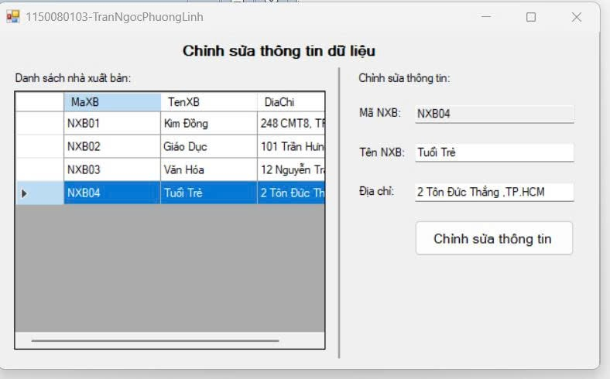

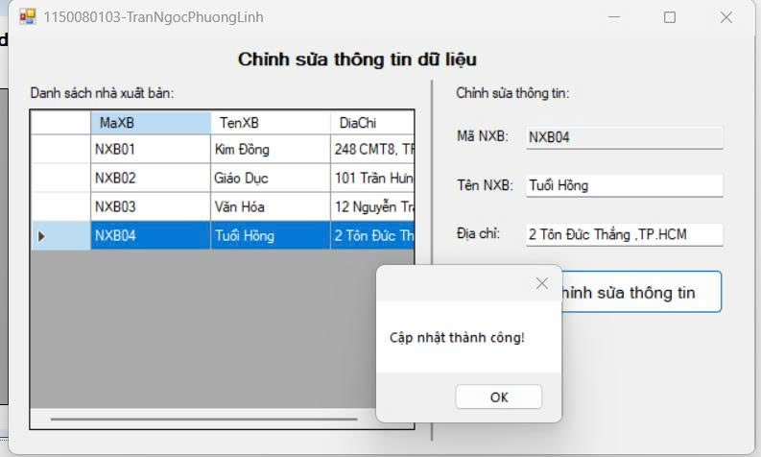
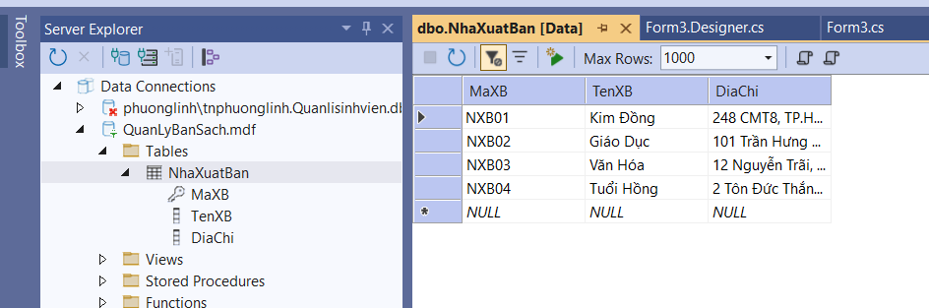
Thực hành 4: Xóa dữ liệu cho bảng Nhà xuất bản
Form4.cs
using System;
using System.Data;
using System.Data.SqlClient;
using System.Windows.Forms;

namespace TranNgocPhuongLinh_1150080103_BTtuan9
{
public partial class Form4 : Form
{
private readonly string strCon =
@"Data Source=(LocalDB)\MSSQLLocalDB;AttachDbFilename=D:\pppt-pmhdt-c#\Lab7\TranNgocPhuongLinh_1150080103_BTtuan9\QuanLyBanSach.mdf;Integrated Security=True";

private SqlConnection sqlCon;
private SqlDataAdapter adapter;
private DataSet ds;

public Form4()
{
InitializeComponent();
}

// ===== Helpers =====
private void MoKetNoi()
{
if (sqlCon == null) sqlCon = new SqlConnection(strCon);
if (sqlCon.State == ConnectionState.Closed) sqlCon.Open();
}

private void DongKetNoi()
{
if (sqlCon != null && sqlCon.State == ConnectionState.Open)
sqlCon.Close();
}

private void LoadData()
{
MoKetNoi();
adapter = new SqlDataAdapter("SELECT * FROM NhaXuatBan", sqlCon);
adapter.MissingSchemaAction = MissingSchemaAction.AddWithKey; // lấy PK

// Tự sinh Insert/Update/Delete
var builder = new SqlCommandBuilder(adapter);

ds = new DataSet();
adapter.Fill(ds, "NXB");

dgvDanhSach.DataSource = ds.Tables["NXB"];
DongKetNoi();
}

private DataRow GetSelectedRow()
{
if (dgvDanhSach.CurrentRow == null) return null;
var drv = dgvDanhSach.CurrentRow.DataBoundItem as DataRowView;
return drv?.Row;
}

// ===== Events =====
private void Form4_Load(object sender, EventArgs e)
{
LoadData();
}

private void btnXoa_Click(object sender, EventArgs e)
{
try
{
var tbl = ds.Tables["NXB"];
var rowUI = GetSelectedRow();
if (rowUI == null)
{
MessageBox.Show("Vui lòng chọn 1 dòng trong danh sách để xóa.");
return;
}

// tìm theo PK để chắc chắn
var ma = rowUI["MaXB"].ToString();
var row = tbl.Rows.Find(ma);
if (row == null)
{
MessageBox.Show("Không tìm thấy bản ghi cần xóa.");
return;
}

if (MessageBox.Show($"Xóa NXB có mã: {ma} ?", "Xác nhận",
MessageBoxButtons.YesNo, MessageBoxIcon.Warning) != DialogResult.Yes)
return;

row.Delete(); // xóa trên DataTable
int kq = adapter.Update(tbl); // đẩy xuống DB

if (kq > 0)
{
MessageBox.Show("Xóa dữ liệu thành công!");
LoadData();
}
else
{
MessageBox.Show("Xóa dữ liệu không thành công!");
}
}
catch (Exception ex)
{
MessageBox.Show("Lỗi khi xóa dữ liệu:\n" + ex.Message,
"Lỗi", MessageBoxButtons.OK, MessageBoxIcon.Error);
}
}
}
}

Form4.Desginer.cs

namespace TranNgocPhuongLinh_1150080103_BTtuan9
{
partial class Form4
{
private System.ComponentModel.IContainer components = null;

protected override void Dispose(bool disposing)
{
if (disposing && (components != null)) components.Dispose();
base.Dispose(disposing);
}

#region Windows Form Designer generated code

private void InitializeComponent()
{
this.lblTitle = new System.Windows.Forms.Label();
this.lblDanhSach = new System.Windows.Forms.Label();
this.dgvDanhSach = new System.Windows.Forms.DataGridView();
this.sep = new System.Windows.Forms.Label();
this.btnXoa = new System.Windows.Forms.Button();
((System.ComponentModel.ISupportInitialize)(this.dgvDanhSach)).BeginInit();
this.SuspendLayout();
//
// lblTitle
//
this.lblTitle.Anchor = System.Windows.Forms.AnchorStyles.Top;
this.lblTitle.AutoSize = true;
this.lblTitle.Font = new System.Drawing.Font("Microsoft Sans Serif", 11F, System.Drawing.FontStyle.Bold);
this.lblTitle.Location = new System.Drawing.Point(270, 12);
this.lblTitle.Name = "lblTitle";
this.lblTitle.Size = new System.Drawing.Size(210, 24);
this.lblTitle.TabIndex = 0;
this.lblTitle.Text = "Xóa dữ liệu trong database";
//
// lblDanhSach
//
this.lblDanhSach.AutoSize = true;
this.lblDanhSach.Location = new System.Drawing.Point(20, 50);
this.lblDanhSach.Name = "lblDanhSach";
this.lblDanhSach.Size = new System.Drawing.Size(139, 16);
this.lblDanhSach.TabIndex = 1;
this.lblDanhSach.Text = "Danh sách nhà xuất bản:";
//
// dgvDanhSach
//
this.dgvDanhSach.AllowUserToAddRows = false;
this.dgvDanhSach.AllowUserToDeleteRows = false;
this.dgvDanhSach.ColumnHeadersHeightSizeMode = System.Windows.Forms.DataGridViewColumnHeadersHeightSizeMode.AutoSize;
this.dgvDanhSach.Location = new System.Drawing.Point(23, 75);
this.dgvDanhSach.MultiSelect = false;
this.dgvDanhSach.Name = "dgvDanhSach";
this.dgvDanhSach.ReadOnly = true;
this.dgvDanhSach.RowHeadersWidth = 51;
this.dgvDanhSach.RowTemplate.Height = 24;
this.dgvDanhSach.SelectionMode = System.Windows.Forms.DataGridViewSelectionMode.FullRowSelect;
this.dgvDanhSach.Size = new System.Drawing.Size(740, 300);
this.dgvDanhSach.TabIndex = 2;
//
// sep
//
this.sep.BackColor = System.Drawing.SystemColors.ControlDark;
this.sep.Location = new System.Drawing.Point(23, 385);
this.sep.Name = "sep";
this.sep.Size = new System.Drawing.Size(740, 2);
this.sep.TabIndex = 3;
//
// btnXoa
//
this.btnXoa.Font = new System.Drawing.Font("Microsoft Sans Serif", 10F);
this.btnXoa.Location = new System.Drawing.Point(320, 395);
this.btnXoa.Name = "btnXoa";
this.btnXoa.Size = new System.Drawing.Size(160, 40);
this.btnXoa.TabIndex = 4;
this.btnXoa.Text = "Xóa dữ liệu";
this.btnXoa.UseVisualStyleBackColor = true;
this.btnXoa.Click += new System.EventHandler(this.btnXoa_Click);
//
// Form4
//
this.AutoScaleDimensions = new System.Drawing.SizeF(8F, 16F);
this.AutoScaleMode = System.Windows.Forms.AutoScaleMode.Font;
this.ClientSize = new System.Drawing.Size(790, 450);
this.Controls.Add(this.btnXoa);
this.Controls.Add(this.sep);
this.Controls.Add(this.dgvDanhSach);
this.Controls.Add(this.lblDanhSach);
this.Controls.Add(this.lblTitle);
this.Name = "Form4";
this.Text = "1150080103-Trần Ngọc Phương Linh";
this.Load += new System.EventHandler(this.Form4_Load);
((System.ComponentModel.ISupportInitialize)(this.dgvDanhSach)).EndInit();
this.ResumeLayout(false);
this.PerformLayout();
}

#endregion

private System.Windows.Forms.Label lblTitle;
private System.Windows.Forms.Label lblDanhSach;
private System.Windows.Forms.DataGridView dgvDanhSach;
private System.Windows.Forms.Label sep;
private System.Windows.Forms.Button btnXoa;
}
}

Chạy thử

