SmartCare v0.3 — Domain Model

PART 1 — Stage 3 Tutorial (in-class worksheet)

Candidate Concepts — Class or not?
Candidate | Class? | Reason
Patient | Yes | Has its own identity (ID), attributes (name, contact), and is referenced by appointments — a core domain concept
Practitioner | Yes | Same reasoning as Patient — identity, attributes, referenced by appointments
Appointment | Yes | Central concept with its own state (status) and behaviour (cancel, reschedule)
Name | No | Just an attribute of Patient/Practitioner — no identity or behaviour of its own
Clinic | No (for now) | The brief describes a single clinic — there’s nothing yet that needs a Clinic object distinct from the system itself. Would only become a class if multiple branches were in scope
Database | No | This is an implementation/infrastructure concern, not something from the problem domain — the client brief never mentions “a database,” only “spreadsheets and paper records”
Cancellation | No | This is a behaviour (a method call or a status change), not a thing with its own identity — represented as Appointment.cancel()
Status | No (as a class) | Simple enough to be an attribute of Appointment (a string/enum: booked/cancelled/completed) rather than its own class — a full Status class would be over-engineering for a “small, maintainable” system

Relationship Reasoning
Patient to Appointment — which relationship and why? Association, not inheritance and not composition. A Patient has appointments over time (one Patient, many Appointments), but an Appointment shouldn’t be deleted just because a Patient record changes — FR-12 requires appointment history to be retained. Composition would imply the Appointment can’t outlive the Patient reference, which is wrong here.
Practitioner to Appointment — what multiplicity? One Practitioner to many Appointments (1 — 0..), and each Appointment links to exactly one Practitioner (0.. — 1).
Should Appointment inherit from Patient? No. There’s no “is-a” relationship — an Appointment is not a kind of Patient. It references a Patient and a Practitioner (association), which is a completely different relationship from inheritance. Using inheritance here would be a modelling mistake.
Does Clinic need to own every object? No. Forcing every Patient, Practitioner, and Appointment to be “owned” by a Clinic adds a layer of complexity the requirements don’t justify — the system only needs to manage one clinic’s worth of data. A flat model (Patient, Practitioner, Appointment, plus one class to hold the appointment collection) is simpler and matches the client’s “small, maintainable” request.

AI Model Critique
AI proposed: PatientManager, PractitionerManager, AppointmentManager, ClinicController, NotificationManager, ScheduleEngine.
Proposal | Verdict | Reason
PatientManager | Reject | “Manager” classes for every domain class is a common AI over-design pattern — nothing in the requirements asks for a separate management layer per class; Patient can hold its own data and validation
PractitionerManager | Reject | Same reasoning as PatientManager
AppointmentManager | Accept, modified | There’s a real gap this fills — checking for double-booking (FR-05) needs to look across appointments, which a single Appointment object can’t do on its own. Kept the idea, renamed to something less “enterprise architecture” — see AppointmentBook below
ClinicController | Reject | “Controller” is a UI/architecture term, not a concept from the client’s own vocabulary — premature at the domain-modelling stage, and there’s no evidence for it
NotificationManager | Reject | Built for a feature (reminders) that was already marked unsupported/provisional back in Week 5 — no client evidence, so no class for it yet
ScheduleEngine | Reject | Sounds like automated scheduling/optimisation, which nothing in the requirements asks for — a simple conflict check inside AppointmentBook covers what’s actually needed

PART 2 — SmartCare v0.3 Domain Model

Part A — Requirements Review (nouns, verbs, business rules)
Pulled from SmartCare v0.2:
Nouns (candidate objects): patient, practitioner, appointment, receptionist, clinic manager, status, appointment time, contact detail, ID, history, specialty, day.
Verbs (candidate behaviours): create, cancel, search, show/display, prevent (double-booking), update/change, keep/store, reject, retain, view.
Business rules (constraints that shaped the model): - A practitioner cannot have two appointments at the same date and time (FR-05). - An appointment cannot be created with a blank patient name (FR-10). - Every appointment has exactly one status, never more than one (FR-09). - Cancelled and past appointments must be retained, not deleted (FR-12).
These nouns became the candidate classes evaluated in the tutorial’s Candidate Concepts table above; the verbs became operations on Appointment and AppointmentBook; the business rules became the validation and conflict-check logic.

Requirement-to-Concept Trace
Requirement | Concept | State/behaviour | Decision
FR-01 (create appointment) | Appointment | Created with patient, practitioner, date/time, status | Confirmed
FR-02 (cancel appointment) | Appointment | cancel() — status becomes “cancelled” | Confirmed
FR-03 (search patient) | Patient + AppointmentBook | Search/find operation over a collection | Confirmed
FR-05 (no double-booking) | AppointmentBook | has_conflict() checked before booking | Confirmed
FR-06 (update time, re-check conflict) | Appointment + AppointmentBook | update_time() re-runs the conflict check | Confirmed
FR-07 (patient record) | Patient | Attributes: id, name, contact detail | Confirmed
FR-08 (practitioner record) | Practitioner | Attributes: id, name, specialty | Confirmed
FR-09 (appointment status) | Appointment | Attribute: status (booked/cancelled confirmed; completed provisional) | Confirmed / Provisional
FR-10 (reject empty patient name) | Patient | Validation on creation | Confirmed
FR-12/FR-13 (history + per-patient history) | AppointmentBook | Cancelled/past appointments stay in the collection; filter by patient | Confirmed

CRC Cards
Patient
Responsibilities | Collaborators
Store id, name, and contact detail; reject an empty name on creation | Appointment
Practitioner
Responsibilities | Collaborators
Store id, name, and specialty | Appointment
Appointment
Responsibilities | Collaborators
Store date/time and status; link to one Patient and one Practitioner; change its own status (cancel, mark completed); reject missing patient/practitioner/time | Patient, Practitioner
Optional class — AppointmentBook
Responsibilities | Collaborators
Hold the full collection of appointments; check for double-booking before adding a new one; provide search by patient, by practitioner, and by day | Appointment, Patient, Practitioner

UML Class Diagram
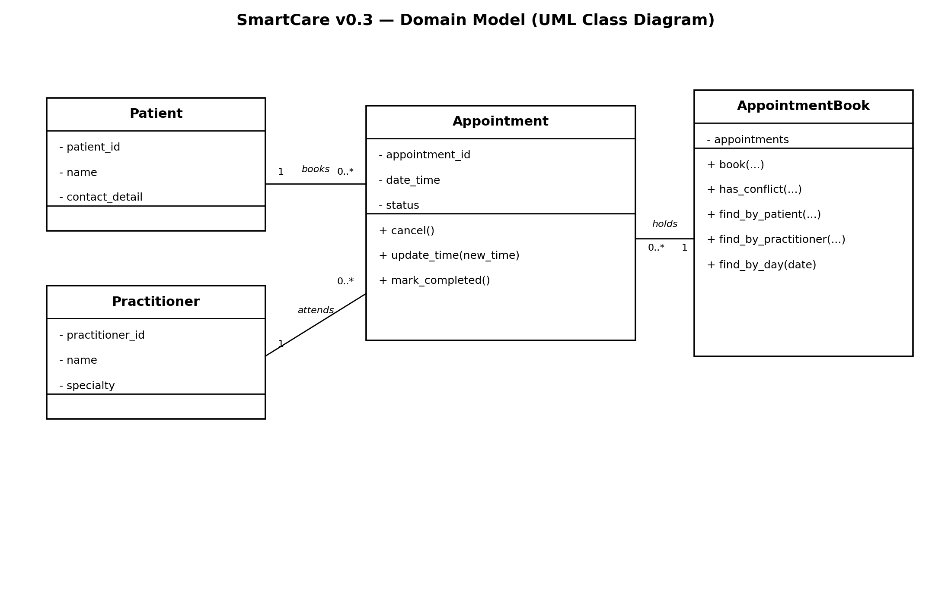
SmartCare v0.3 Domain Model UML Class Diagram

Design Rationale
Patient, Practitioner, and Appointment are the only classes with clear identity and independent state, so they’re the core of the model. Name, Status, and Cancellation were rejected as classes because they’re just attributes or behaviours of something else — turning them into full classes would add complexity with no real benefit. Clinic was rejected for the same reason: there’s currently only one clinic in scope, so it doesn’t need to “own” anything yet.
The one class beyond the obvious three, AppointmentBook, exists because FR-05 (no double-booking) genuinely needs logic that looks across all appointments, not just one — that’s a responsibility no single Appointment object can hold on its own. It’s named to reflect the domain (a book of appointments) rather than borrowing generic architecture terms like “Manager” or “Controller,” which is exactly what the AI critique flagged as unjustified.
Appointment associates with (rather than inherits from) both Patient and Practitioner, since it has a patient and a practitioner rather than being one.

Part E — AI Design Review
Act as a software design reviewer. Using only the confirmed requirements from SmartCare v0.2, suggest candidate classes and relationships for the domain model. For every suggestion, cite the specific requirement ID (e.g. FR-05) that supports it. Do not suggest classes for features that are not in the confirmed requirements.

Part F — Compare and Decide
AI’s actual response (Copilot, real run): proposed exactly three classes — Patient, Practitioner, Appointment — each cited against specific FR numbers, with Status treated as a constrained attribute of Appointment rather than its own class, and explicitly excluded completed-status, access control, notifications, multi-branch support, and the AI-diagnosis/facial-recognition items as unconfirmed. It offered to turn this into a UML diagram or service-layer design next, but didn’t propose that unprompted.
AI suggestion | Evidence cited | Decision | Reason | Model change
Patient class | FR-07, FR-03, FR-13 | Accepted | Matches my model exactly | None
Practitioner class | FR-08, FR-04, FR-05 | Accepted | Matches my model exactly | None
Appointment class | FR-01, FR-02, FR-06, FR-09, FR-11, FR-12 | Accepted | Matches my model exactly | None
Status as an attribute, not a class | FR-09 | Accepted | Independently reached the same conclusion | None
Excludes completed status, access control, notifications, multi-branch, AI diagnosis/facial recognition | Cited as unconfirmed/out of scope | Accepted | Matches my Week 5 scope decisions | None
(Gap, not a suggestion) — no class was given responsibility for the double-booking check or for search/filter (FR-03, FR-05, FR-11) | AI notes FR-05 “requires knowing all appointments for that practitioner” but assigns this to no class | Modified | This is under-specification rather than over-design — something has to hold and search the full appointment collection. Kept my own AppointmentBook class to own that responsibility, since it isn’t contradicted by the AI’s answer, just left unaddressed | Kept AppointmentBook
Note for the reflection: unlike the tutorial’s fictional AI critique (which invented Manager/Controller/Engine classes), this real run didn’t over-design at all — it stayed conservative and requirement-traced. If anything, it under-specified by not saying where cross-appointment logic lives. Worth writing about that contrast rather than assuming AI always over-builds.

Part H — Consistency Check
Checked the domain_model.py code against the CRC cards and UML diagram provided above:
• Patient.__init__ constructor uses patient_id, name, contact_detail parameters and raises ValueError for empty name – matches Patient CRC card and FR-10 requirement to the letter
• Practitioner.__init__ uses practitioner_id, name, specialty – matches Practitioner CRC card and FR-08
• Appointment.__init__ uses appointment_id, patient, practitioner, date_time, sets status to “booked” and checks that patient/practitioner/time are present – matches UML class attributes and Appointment CRC card
• cancel(), update_time(), mark_completed() methods are present as stubs matching UML operations but not implemented – correct as per the task description to not implement business logic
• AppointmentBook class contains 5 method stubs (book, has_conflict, find_by_patient, find_by_practitioner, find_by_day) matching the CRC card and UML box – also not implemented on purpose
• Tested the file with sample data (see terminal window output above) – everything works as per model requirements
No discrepancies found between the model and the actual code structure.

Reflection
The most challenging modelling choice was determining whether or not AppointmentBook was deserving of its own class. FR-05’s double-booking check requires knowledge of all a practitioner’s appointments, but a single additional class is always at risk of being an “unjustified Manager”, as warned about in the tutorial’s AI critique. The final decision was made on the principle of “can this responsibility be found elsewhere?” since the information cannot come from a single Appointment (it would have to know about all others as well), while Practitioner has no knowledge of appointments at all (for search-by-day and search-by-patient), but the same collection is needed in any case. It was kept, but named after a domain concept (a collection of appointments) as opposed to an architectural one.
Interestingly, the real AI design review did not suffer from over-engineering like the tutorial’s fictional example did – it specified precisely three classes, each with the necessary FR numbers and none of the rejected features (confirmation, access control, notifications, multi-branch support) I’d mentioned were present. On the contrary, it under-specified: FR-05 “requires knowledge of all a practitioner’s appointments” but doesn’t explicitly designate a class to hold this information. This is a completely different flaw from what the exercise was trying to teach me, but it became evident in the comparison process of reviewing every line of the AI’s response alongside my own.
Finally, every element and relationship in the final model can be tied to a particular requirement – Patient to FR-07/FR-03/FR-13, Practitioner to FR-08/FR-04, Appointment to FR-01/FR-02/FR-06/FR-09/FR-11/FR-12, and AppointmentBook to FR-05 directly. Nothing exists in the model that does not tie back to a requirement, which is why creating the trace table was such a valuable exercise.

