**Lesson 8**

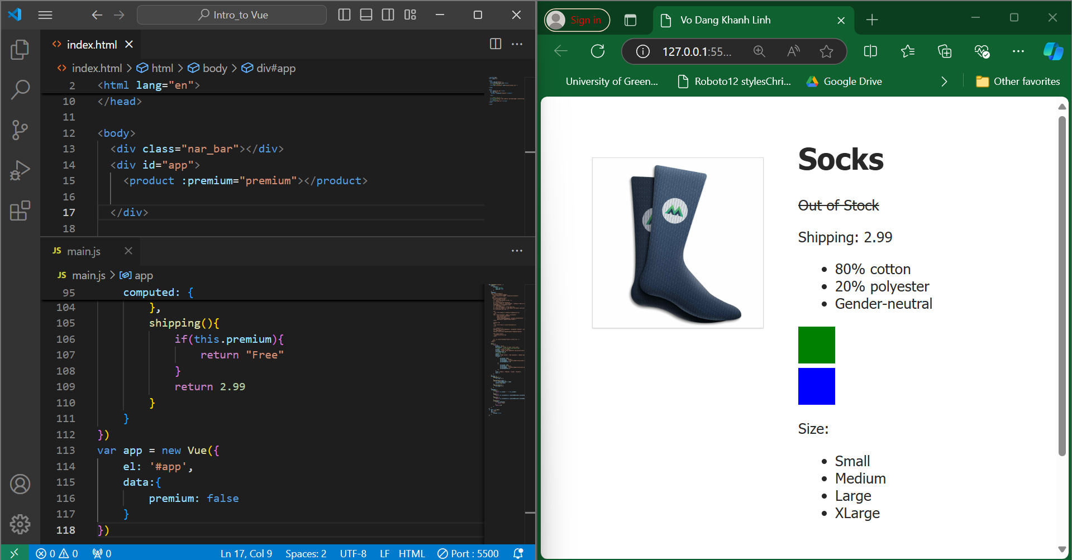

This lesson talks about components can communicate with each other using events. A child component can use the $emit method to send an event to its parent, along with optional data. The parent component can listen for this event using the v-on directive (or its shorthand @) and trigger a method in response. This allows for a more flexible and modular way to build Vue.js applications.

**Lesson 9**

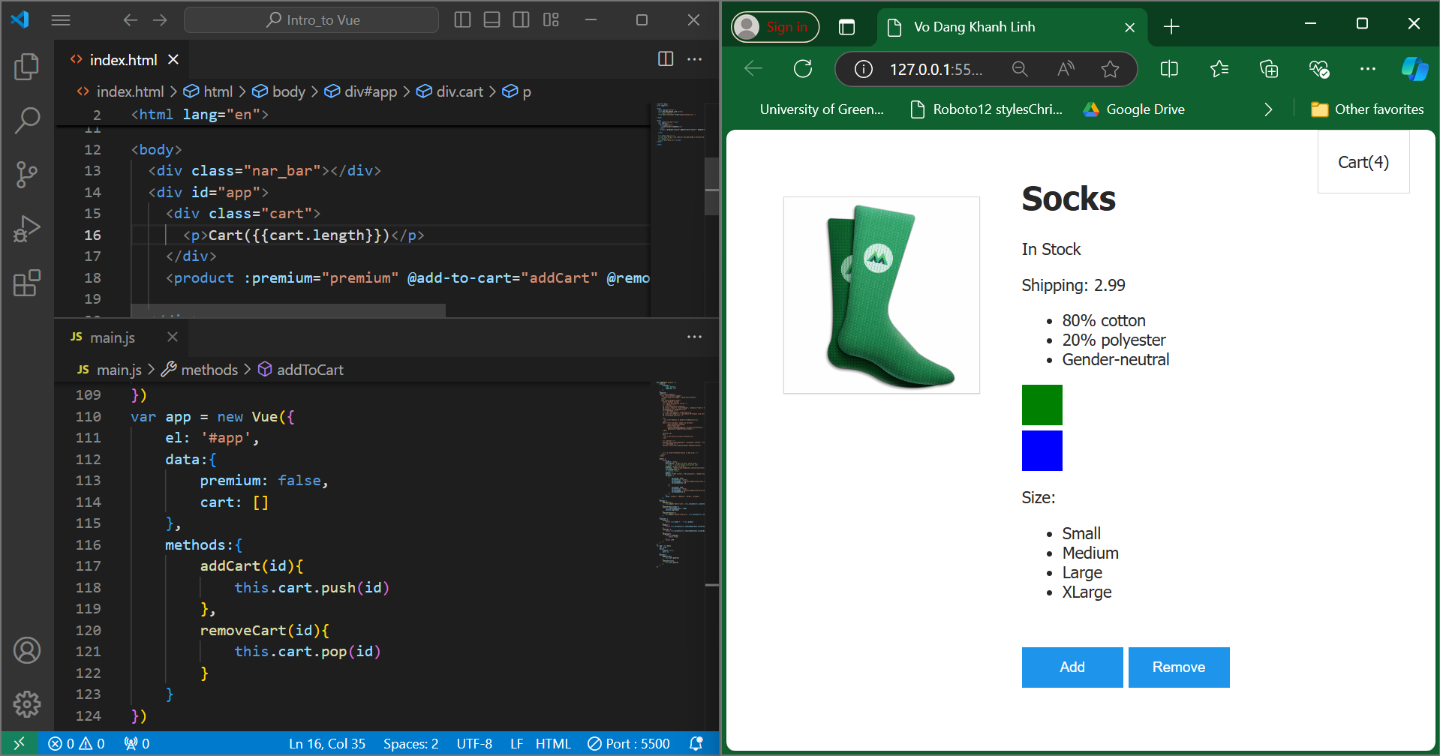

This lesson talks about components are reusable building blocks that encapsulate HTML, CSS, and JavaScript code. They help organize and maintain complex applications by dividing them into smaller, manageable parts. Components can receive data from their parents through props, which can be dynamically bound to the parent's data. By using Vue dev tools, developers can inspect and debug components to better understand their structure and behavior.