Project UML Documentation - Slotify
This document provides a technical overview of the Slotify project architecture and data model using Mermaid diagrams.

1. Entity Relationship Diagram (ERD)
The following diagram illustrates the backend data model and the relationships between core entities.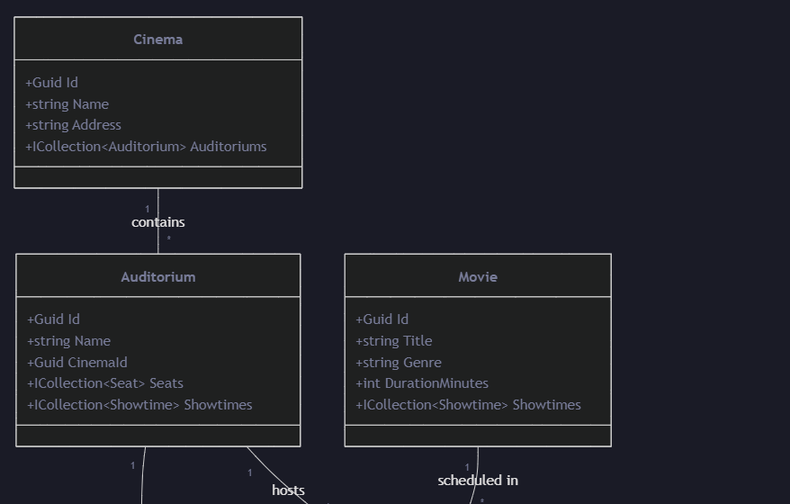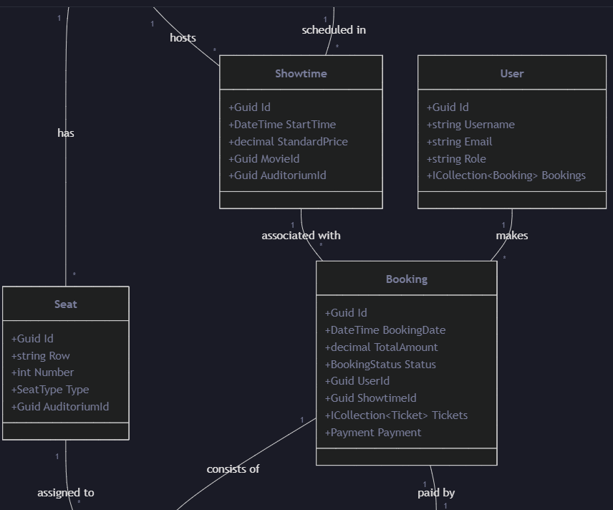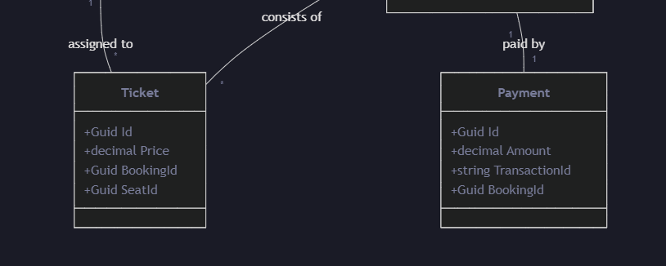
2. System Architecture
Slotify follows a modern full-stack architecture with a React frontend and a .NET 8 backend.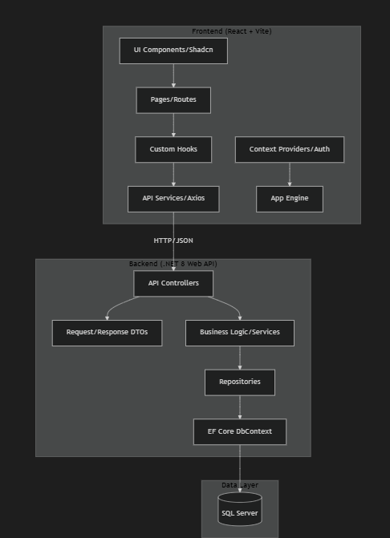
3. Booking & Payment Sequence
This sequence diagram shows the flow of booking a ticket and processing payment via SePay.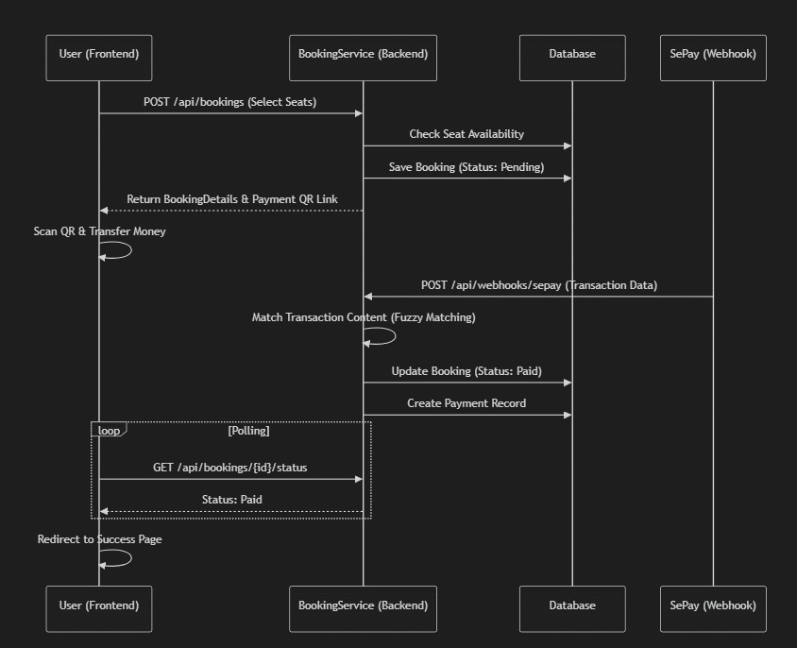
4. Key Statuses
Booking Status
• Pending: Order created, awaiting payment.
• Paid: Payment confirmed via webhook.
• Confirmed: Manually confirmed or final state.
• Cancelled: Expired or user cancelled.
Seat Types
• Standard: Regular seat.
• VIP: Premium seat with higher price.
• Couple: Double seat for two people.
s

