1. Run application:

Open CMD and run:

Java -jar legalfab-google-storage-demo-1.0-SNAPSHOT.jar

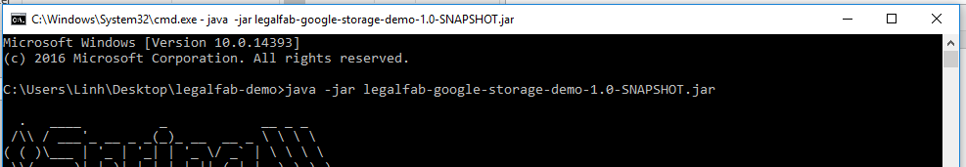

1. Access application at:

<http://localhost:8080/legalfab/>

1. Input required fields and Save:

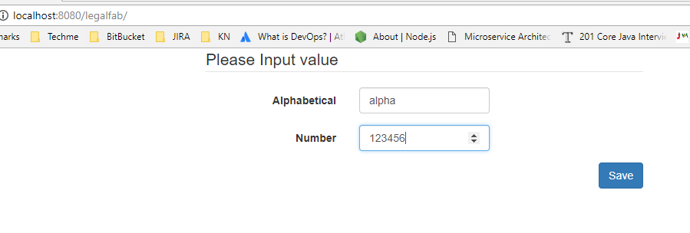

1. A PDF file will be generated and uploaded to Google Storage, click View File to open file on Google server: 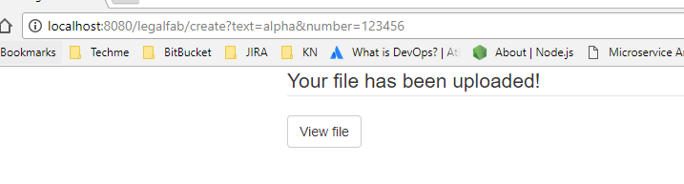
2. The generated file look like this:

