

Charity Organization’s Finance Management System Software Requirement Specification

Project Code: SWR302

Document Code: SRS – v 1.0

**FPT University, 03/03/2021**

Record of change

*A - Added M - Modified D - Deleted

|  |  |  |  |  |
| --- | --- | --- | --- | --- |
| Effective Date | Changed Items | A* M, D | Change Description | New Version |
| 19/01/2021 | Initial | A | Add project overview |  |
| 20/01/2021 | Add Use Case Diagram | A | Add Use Case Diagram |  |
| 29/01/2021 | Add important Use case’s Details | A | Add use case Create Campaign, Update Campaign, Add accountant to Campaign, Add Supervisor to campaign, Create Team, Update Team, Create Finance Request, Add Leader to Team |  |
| 03/02/2021 | Add others and update added Use case’s Detail | A, M | Update use case Create Finance Request, Update Team  Add use case Update accountant of Campaign, Update supervisor of Campaign, View Accepted and Denied Request of Supervisor, View Donation, View Budget History of Accountant, Update Leader of Team, View Transaction’s History of Leader, View Transaction’s Detail of Leader, View Request from Leader, View Request from Leader’s Detail, Deny Leader’s Request, Accept Leader’s Request. |  |
| 24/02/2021 | Add all Use case’s Detail | A | Add all Use case’s Detail |  |
| 05/03/2021 | Update Use case Diagram, add Use case’s Details of Donator | M, A | Use case Diagram: Add Donator actor and functions  Add use case Donate to Campaign, Choose to Anonymize |  |
| 12/03/2021 | Update Use case Diagram, add new Use case’s Details | M | Add use case Register to be Donator |  |
| 15/03/2021 | Add new Use case’s Detail | A | Add use case View Report from Supporter, Ban User, Unban User |  |
| 16/03/2021 | Group review |  | Group review all use case |  |

SIGNATURE PAGE

**ORIGINATOR:** Nguyen Quoc Vinh

Vu Thi Thuy Linh

Hoang Gia Thien Phuc

Le Minh Tuan

Nguyen Duy Bao

**REVIEWERS:**

**APPROVAL:**

TABLE OF CONTENTS

1 Introduction 6

1.1 Purpose 6

1.2 Scope 6

1.3 Definitions, Acronyms, and Abbreviations 6

1.4 References 6

1.5 Overview 7

2 Overall Description 8

3 FUNCTIONAL Requirements 9

3.1 Use Cases Diagram 9

3.2 Use Case Request to create organization 10

3.3 Use Case Verify create organization requirement 12

3.4 Use Case Create Campaign 14

3.5 Use Case Update Campaign 16

3.6 Use Case Create Team 18

3.7 Use Case Add accountant to Campaign 20

3.8 Use Case Add Supervisor to Campaign 22

3.9 Use Case Add Leader to Team 24

3.10 Use Case Update Team 26

3.11 Use Case Update accountant of Campaign 28

3.12 Use Case Update Supervisor of Campaign 30

3.13 Use Case Create Request for Charity Support 32

3.14 Use Case View Accepted and Cancel Request History of Supervisor 34

3.15 Use Case View Budget history of Accountant 36

3.16 Use Case View donation 38

3.17 Use Case Update Leader of Team 40

3.18 Use Case View Transaction's History of Leader 42

3.19 Use Case View Transaction's Detail of Leader 44

3.20 Use Case View Request from Leader 46

3.21 Use Case View Request from Leader 's Detail 48

3.22 Use Case Deny Leader's Request 50

3.23 Use Case Accept Leader's Request 52

3.24 Use Case View Accepted Request 54

3.25 Use Case View Request's Detail 56

3.26 Use Case Transfer money to request 58

3.27 Use Case Deny transfer money request 60

3.28 Use Case View Transaction History 62

3.29 Use Case View Transaction's Detail 64

3.30 Use Case Link bank account 66

3.31 Use Case Add Supporter to Team 68

3.32 Use Case Add Remove Supporter from Team 70

3.33 Use Case Create Activity 72

3.34 Use Case Update Activity 74

3.35 Use Case Report cheating 76

3.36 Use Case View Activities 78

3.37 Use Case View Activity's Detail 80

3.38 Use Case Confirm that activity has done 82

3.39 Use Case Register Account 84

3.40 Use Case Login 86

3.41 Use Case View Profile 88

3.42 Use Case Edit Profile 90

3.43 Use Case Logout 92

3.44 Use Case Register to be Donator 94

3.45 Use Case View Campaigns 96

3.46 Use Case View Campaign’s Detail 98

3.47 Use Case View Activites Of Campaign 100

3.48 Use Case Donate to Campaign 102

3.49 Use Case Choose to Anonymize 104

3.50 Use Case View your own Donation 106

3.51 Use Case Search Organizaion 108

3.52 Use Case View Report from Supporter 110

3.53 Use Case Ban User 112

3.54 Use Case Unban User 114

4 NON-FUNCTIONAL Requirements 116

4.1 Usability 116

4.2 Reliability 116

4.3 Performance 117

4.4 Supportability 117

# Introduction

## Purpose

The purpose of this SRS is to present a detailed description of functional requirements and non-functional requirements of Charity Organization’s Finance Management System application. It will explain the purpose and the feature of system, what the system will do, business rule for each feature. It also contains diagram that let reader have overview of system and see how actors interact with system.

## Scope

This document specifies requirements for an application for Charity Organization’s Finance Management System.

This application allows users to:

* Manage finance of charity organization
* View history of charity’s organization activities with change of money in organization
* Create and manage charity’s campaigns
* Donate with public information or anonymous
* Manage members of groups (Leader, Supervisor, Supporter)
* Report cheating or not clearly finance problems.

## Definitions, Acronyms, and Abbreviations

**DB:** Database

**GUI:** Graphic User Interface

**UI:** User Interface

**SRS:** Software Requirement Specification

**Transaction**: a record of money that has moved in and out of your bank account

**Authenticated User**: User already login to system

## References

Karl Wiegers and Joy Beatty. (2013). Chapter 8 Understanding user requirements. Software Requirements, Third Edition (149-160).

Example Software Requirement Specification (SRS Example). 25/02/2021.

<https://www.reqview.com/doc/iso-iec-ieee-29148-srs-example>

## Overview

The next chapter, the Overall Description section, of this document gives an overview of the functionality of the product. It describes the informal requirements and is used to establish a context for the technical requirements specification in the next chapter.

The third chapter, Functional Requirement section, of this document describes in details functional requirements of system.

The last chapter, Non-functional Requirement section, of this document describes in details non-functional requirements of system.

# Overall Description

## Product Perspective

**Manage Organization:** Manage by manager who create organization, in organization has campaigns that have accountant, supervisor, leader, and supporter participated.

**Manage Campaign:** Includes support area, member, date started, description.

**Manage member of Campaign:** Actor with more power can add, update and remove member of Campaign

**Manage Activities of Campaign:** Include location, list of receivers where activities are. Leader can add and update activities.

**Manage Finance of Campaign:** allow to view transaction history, money in and out of bank account of Accountant, Leader and Donator

## User Characteristics

User of this system should be able to view organization’s information like who manage this, which activities in campaign, location of operation. This system will support 8 roles: guest, admin, donator, supervisor, manager, leader, accountant, supporter.

The guest should be able to do following functions:

* Resign a new account with information like username, password, name, phone number, email
* Login to the system to get authenticated with specific information
* Search organization by a name
* View campaign from organization, then guest can view campaign in more detail and view campaign consuming either.

When guest login, it become authenticated user that have some more functions:

* View own profiles and able to edit it
* Resign to be a donator
* Ask for permission to create an organization
* Logout current account become a guest

Donator should be able to do following functions:

* Donate to campaign and donator could decide to donate anonymous
* View own donation for which campaign
* Link bank account

Admin should be able to do following functions:

* Verify “create organization” permission from authenticated user to decide create organization or not
* Warn authenticated user that do some critical activities
* Ban and unban authenticated user that serious offense

When admin accept create organization permission, the authenticated user who send permission will become manager then get following function:

* Create campaign and decide who are the team leader, accountant, supervisor. Could edit, update campaign later
* View donate money receive from donator
* View history of campaigns spend that report by accountant
* View supervisor’s choice for leader’s proposal

Supervisor should be able to do following functions:

* Replace leader, add leader, delete leader if necessary
* View leader transaction history
* View and decide leader’s request/proposal
* Receive leader report from supporter

Accountant must be able to do following functions:

* Link bank account
* Receive leader’s proposal which supervisor accepted and operation proposal
* Transfer money to leader base on accepted proposal
* View transaction history

Leader must be able to do following functions:

* View transaction history
* Link bank account
* Create and update activities by send permission to supervisor
* Add or remove supporter in team

Supporter must be able to do following function:

* View activities in campaign
* Confirm activities process
* Report leader to supervisor

# FUNCTIONAL Requirements

## Diagram, engineering drawing Description automatically generatedUse Cases Diagram

## Use Case Send Request to Create Organization

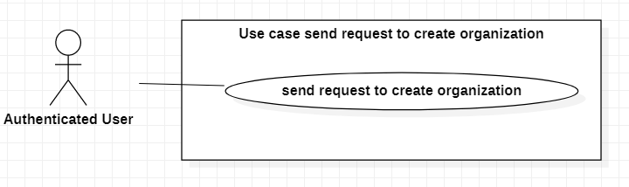

|  |  |  |  |  |
| --- | --- | --- | --- | --- |
| **USE CASE-1 SPECIFICATION** | | | | |
| **Use-case No.** | UC001 | **Use-case Version** | | 1.0 |
| **Use-case Name** | Send request to create organization | | | |
| **Author** | Le Minh Tuan | | | |
| **Date** | 24/02/2021 | **Priority** | High | |
| **Actor:**  Authenticated User.  **Summary:**  Authenticated User sends the request to admin for creating the charity organization.  **Goal:**  Request will be sent to Admin for verifying organization.  **Triggers:**  Authenticated User wants to create charity organization.  **Preconditions:**  PRE-1. User’s identity has been authenticated.  **Post Conditions:**  POST-1. Admin can view request in request list for creating new organization.  **Main Success Scenario:**   |  |  | | --- | --- | | Authenticated User | System | | 1. Authenticated User click “Create new organization” | System navigates to new organization creating page | | 2. Authenticated User fill all information to form for request:  - Name of charity organization  - Description of organization  - Email of organization  - Phone of organization |  | | 3. Authenticated User clicks “Send” to submit form information to the system | System will send OTP code to email and show input box for verifying OTP code | | 4. Authenticated User inputs OTP code |  | | 5. Authenticated User clicks “Verify” button | System shows successful notification on screen |   **Alternative Scenario:**   |  |  | | --- | --- | | Actor Action | System Response | | 1. Authenticated User click “Create new organization” | System navigates to new organization creating page | | 2. Manager clicks “Back” button | System goes back to “Home” page |   **Exceptions:**   |  |  | | --- | --- | | Cause | System response | | 1. Name of organization is invalid | Show error message “Name of organization is invalid” | | 2. Description of organization is blank | Show error message “Description of organization cannot be blank” | | 3. Email of organization is invalid | Show error message “Email of organization is invalid” | | 4. Phone of organization is invalid | Show error message “Phone of organization is invalid” | | 5. OTP code is incorrect | Show error message “OTP code is incorrect” |   **Relationships:**  N/A.  **Business Rules:**  Email must be verified by OTP code before request is sent to admin. | | | | |

## Use Case Verify Create Organization Requirement

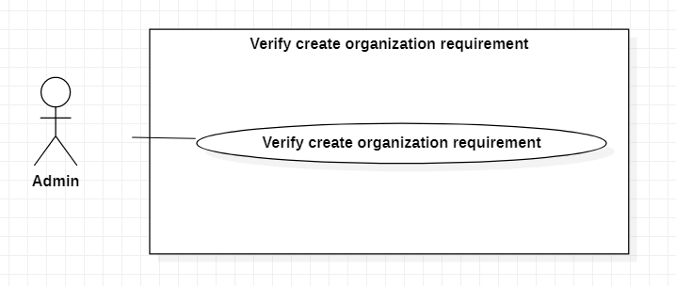

|  |  |  |  |  |
| --- | --- | --- | --- | --- |
| **USE CASE-2 SPECIFICATION** | | | | |
| **Use-case No.** | UC002 | **Use-case Version** | | 1.0 |
| **Use-case Name** | Verify Create Organization Requirement | | | |
| **Author** | Nguyen Duy Bao | | | |
| **Date** | 05/03/2021 | **Priority** | High | |
| **Actor:**  Admin.  **Summary:**  Admin verifies whether the organization to be created is reputable.  **Goal:**  To verify create organization requirement.  **Triggers**  Admin open permission box.  **Preconditions:**  PRE-1. User’s identity has been authenticated.  PRE-2. User is authorized to Admin role.  **Post Conditions:**  POST-1. Accepted request: Organization information inserted into DB and the user who sent request updated to be manager of organization.  POST-2. Deny request: The user who sent request receives notification that request is rejected.  **Main Success Scenario:**   |  |  |  | | --- | --- | --- | | No | Admin | System | | 1 |  | Display list of “create organization” request which have no status | | 2 | Admin select a “create organization” request in list of requests | Display information of selected request | | 3 | Admin chooses to accept “create organization” request | System inserts organization information (name, description) and the user who sent request updated to be manager of organization and Set request status as Accepted |   **Alternative Scenario:**   |  |  |  | | --- | --- | --- | | No | Admin | System | | 1 |  | Display list of “create organization” request which have no status | | 2 | Admin select a “create organization” request in list of requests | Display information of selected request | | 3 | Admin chooses to deny “create organization” request | Set request status as denied |   **Exceptions:**   |  |  |  | | --- | --- | --- | | No | Cause | System response | | 1 | Admin does not choose a “create organization” request in list of requests | Won't display any request information | | 2 | Admin does not choose accept request | Request status won’t change to accepted | | 3 | Admin does not choose deny request | Request status won’t change to denied |   **Relationships:**  N/A  **Business Rules:**  Admin must carefully in checking information and have no bias. | | | | |

## Use Case Create Campaign

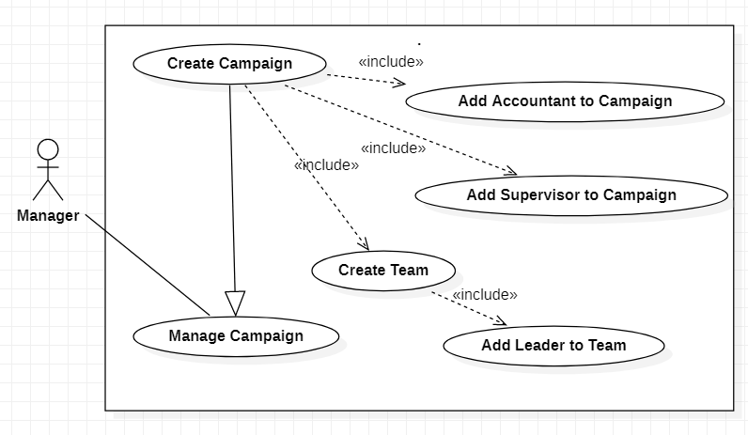

|  |  |  |  |  |
| --- | --- | --- | --- | --- |
| **USE CASE-3 SPECIFICATION** | | | | |
| **Use-case No.** | UC003 | **Use-case Version** | | 1.0 |
| **Use-case Name** | Create Campaign | | | |
| **Author** | Hoang Gia Thien Phuc | | | |
| **Date** | 29/01/2021 | **Priority** | High | |
| **Actor:**  Manager  **Summary:**  This use case allows manager to create campaign about charity activity.  **Goal:**  To create campaign  **Triggers**  Manager chooses to create campaign.  **Preconditions:**  PRE-1. User’s identity has been authenticated  PRE-2. User is authorized to Manager role  **Post Conditions:**  POST-1. New campaign is created  **Main Success Scenario:**   |  |  |  | | --- | --- | --- | | No. | Actor Action | System Response | | 1 | Manager chooses to create campaign | System shows a page:  - Name of Campaign: required  - Area in need of assistance  +Hamlet: drop down list  +Commune: drop down list  +District: drop down list, required  +Province/City: drop down list, required  - Start Time: required, date  - Duration: required, months/years  - Budget Guess of Campaign  - “Create Team”: button  - “Add Accountant”: button  - “Add Supervisor”: button  - “Create Campaign”: button  - “Exit”: button | | 2 | Manager inputs information of campaign |  | | 3 | Manager click “Create Campaign” button  [Alternative 1] | System validates information and save campaign information  [Exception 1] |   **Alternative Scenario:**   |  |  |  | | --- | --- | --- | | No. | Actor Action | System Response | | 1 | Manager click “Exit” button | If manager haven’t created any campaigns  - Display “No campaign yet”  If already have a list of campaigns  - Show list of campaigns |   **Exceptions:**   |  |  |  | | --- | --- | --- | | No. | Actor Action | System Response | | 1 | Required field is empty | System shows error message |   **Relationships:**  includes Create Team, includes Add Accountant to Campaign, include use case Add Supervisor to Campaign  **Business Rules:**  Campaign created must have start time after current date at least 5 days. | | | | |

## Use Case Update campaign

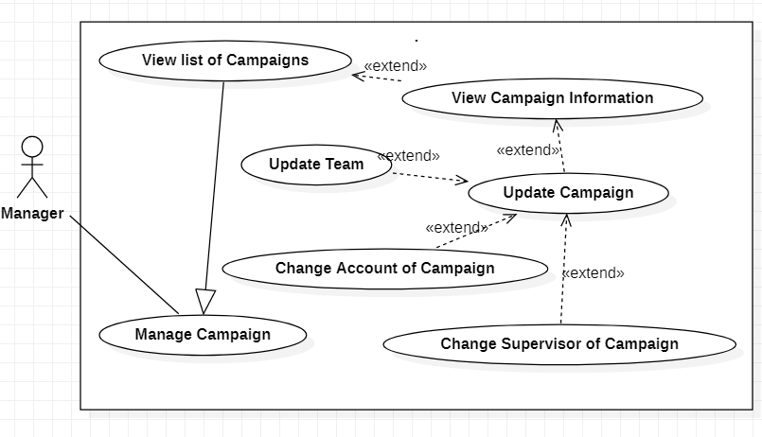

|  |  |  |  |  |
| --- | --- | --- | --- | --- |
| **USE CASE-4 SPECIFICATION** | | | | |
| **Use-case No.** | UC004 | **Use-case Version** | | 1.0 |
| **Use-case Name** | Update campaign | | | |
| **Author** | Hoang Gia Thien Phuc | | | |
| **Date** | 29/01/2021 | **Priority** | High | |
| **Actor:**  Manager  **Summary:**  This use case allows manager to update campaign information.  **Goal:**  To update campaign  **Triggers**  - Manager chooses a campaign in list of campaign  - Manager clicks “Update” button  **Preconditions:**  PRE-1. User’s identity has been authenticated  PRE-2. User is authorized to Manager role  PRE-3. Organization has at least one campaign  **Post Conditions:**  POST-1. Updated campaign information is saved.  POST-2. Show success message  **Main Success Scenario:**     |  |  |  | | --- | --- | --- | | No. | Actor Action | System | | 1 | Manager clicks “Update” button | System shows a page include campaign information:  - Name of Campaign: required  - Area in need of assistance  +Hamlet: drop down list  +Commune: drop down list  +District: drop down list, required  +Province/City: drop down list, required  - Start Time: required, date  - Duration: required, months/years  - Budget Guess of Campaign  - “Update Team”: button  - “Change Accountant”: button  - “Change Supervisor”: button  - “Save”: button  - “Exit”: button | | 2 | Manager inputs new information of campaign |  | | 3 | Manager clicks “Save” button  [Alternative 1] | System validates information and save information  [Exception 1, 2] |   **Alternative Scenario:**   |  |  |  | | --- | --- | --- | | No. | Actor Action | System Response | | 1 | Manager click “Exit” button | System goes back to list of campaigns screen. |   **Exceptions:**   |  |  |  | | --- | --- | --- | | No. | Actor Action | System Response | | 1 | Manager inputs the same information for campaign | Show message “Nothing is change” | | 2 | Required information is empty | System shows error message |   **Relationships:** extend for View Campaign Information, extended by Update Team, extended by Change Accountant of Campaign, extended by Change Supervisor of Campaign  **Business Rules:**  Can not update when campaign has donation | | | | |

## Use Case Create Team

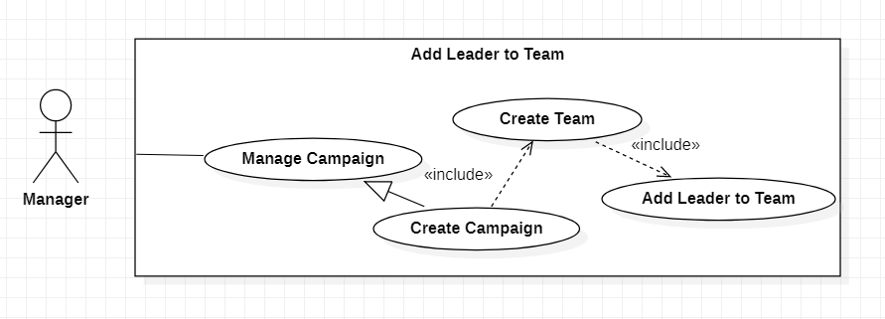

|  |  |  |  |  |
| --- | --- | --- | --- | --- |
| **USE CASE-5 SPECIFICATION** | | | | |
| **Use-case No.** | UC005 | **Use-case Version** | | 1.0 |
| **Use-case Name** | Create Team | | | |
| **Author** | Hoang Gia Thien Phuc | | | |
| **Date** | 29/01/2021 | **Priority** | High | |
| **Actor:**  Manager  **Summary:**  This use case allows manager to create team of campaign  **Goal:**  To create team of campaign  **Triggers**  Manager clicks “Create Team button” when creating campaign  **Preconditions:**  PRE-1. User’s identity has been authenticated  PRE-2. User is authorized to Manager role  **Post Conditions:**  POST-1. Entered team information is saved with campaign information.  **Main Success Scenario:**     |  |  |  | | --- | --- | --- | | No. | Actor Action | System Response | | 1 | Manager clicks “Create Team” button | System shows a page:  - Name of Team: textbox, required  - Mission: textbox, required  - Support scope:  +Hamlet: drop down list  +Commune: drop down list  - “Add Leader”: button  - “Save”: button  - “Exit”: button | | 2 | Manager inputs information of team |  | | 3 | Manager clicks “Save” button  [Alternative 1] | System validates information, save information and add team to the campaign  [Exception 1] |   **Alternative Scenario:**   |  |  |  | | --- | --- | --- | | No. | Actor Action | System Response | | 1 | Manager click “Exit” button | System goes back to “Create campaign screen”. |   **Exceptions:**   |  |  |  | | --- | --- | --- | | No. | Actor Action | System Response | | 1 | Required information is empty | System shows error message |   **Relationships:** included by Create Campaign, includes Add Leader to Team  **Business Rules:**  *N/A* | | | | |

## Use Case Add accountant to Campaign

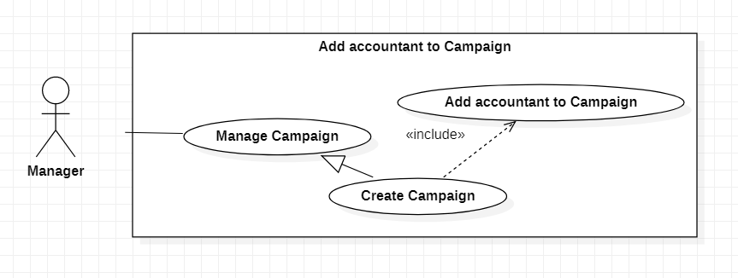

|  |  |  |  |  |
| --- | --- | --- | --- | --- |
| **USE CASE-6 SPECIFICATION** | | | | |
| **Use-case No.** | UC006 | **Use-case Version** | | 1.0 |
| **Use-case Name** | Add accountant to Campaign | | | |
| **Author** | Hoang Gia Thien Phuc | | | |
| **Date** | 29/01/2021 | **Priority** | High | |
| **Actor:**  Manager  **Summary:**  This use case allows manager to add accountant to campaign  **Goal:**  To add accountant to campaign  **Triggers**  Manager clicks “Add Accountant” button when creating campaign.  **Preconditions:**  PRE-1. User’s identity has been authenticated  PRE-2. User is authorized to Manager role  **Post Conditions:**  POST-1. Selected user is added to campaign with Accountant role  **Main Success Scenario:**   |  |  |  | | --- | --- | --- | | No. | Actor Action | System | | 1 | Manager clicks “Add Accountant” button | System shows a page:  - Search: textbox, required  - “Search”: button  - “Exit”: button | | 2 | Manager inputs phone or email to search user and clicks “Search” button  [Alternative 1] | If system found user, system shows a frame  - Name: label  - “Add”: button  If system not found user  - Display message “Not found any user”  [Exception 1] | | 3 | Manager clicks “Add” button | System validates information and add selected user to campaign with Accountant role.  [Exception 2] |   **Alternative Scenario:**   |  |  |  | | --- | --- | --- | | No. | Actor Action | System Response | | 1 | Manager clicks “Exit” button | System goes back to “Create Campaign Screen” |   **Exceptions:**   |  |  |  | | --- | --- | --- | | No. | Actor Action | System Response | | 1 | Required information is empty | System shows message “Please input phone or email to search user” | | 2 | Manager selects user is already in another organization and in an active campaign | System shows message “Can’t add because user is in another organization and in an active campaign” |   **Relationships:** included by Create Campaign  **Business Rules:**  Selected user can't be in another organization and in an active campaign. | | | | |

## Use Case Add Supervisor to Campaign

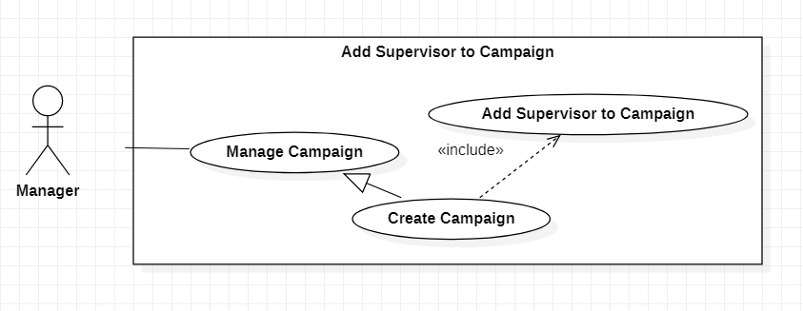

|  |  |  |  |  |
| --- | --- | --- | --- | --- |
| **USE CASE-7 SPECIFICATION** | | | | |
| **Use-case No.** | UC007 | **Use-case Version** | | 1.0 |
| **Use-case Name** | Add Supervisor to Campaign | | | |
| **Author** | Hoang Gia Thien Phuc | | | |
| **Date** | 29/01/2021 | **Priority** | <High> | |
| **Actor:**  Manager  **Summary:**  This use case allows manager to add supervisor to campaign  **Goal:**  To add supervisor to campaign  **Triggers**  Manager clicks “Add Supervisor” button when creating campaign.  **Preconditions:**  PRE-1. User’s identity has been authenticated  PRE-2. User is authorized to Manager role  **Post Conditions:**  POST-1. Selected user is added to campaign with Supervisor role with teams that supervise by added Supervisor  **Main Success Scenario:**   |  |  |  | | --- | --- | --- | | No. | Actor Action | System | | 1 | Manager clicks “Add Supervisor” button | System shows a page:  - Search: textbox, required  - “Search”: button  - “Exit”: button | | 2 | Manager inputs phone or email to search user and clicks “Search” button  [Alternative 1] | If system found user, system shows a frame  - Name: label  - “Add”: button  If system not found user  - Display message “Not found any user”  [Exception 1] | | 3 | Manager clicks “Add” button | System validates information and add selected user to campaign with Supervisor role.  [Exception 2] | | 4 |  | System shows a page:  - List of Team: list, data from created teams of campaign  - “Save”: button | | 5 | Manager chooses teams that supervise by added Supervisor and clicks “Save” button | System validates information and save teams that supervise by added Supervisor  [Exception 3, 4] |   **Alternative Scenario:**   |  |  |  | | --- | --- | --- | | No. | Actor Action | System Response | | 1 | Manager clicks “Exit” button | System goes back to “Create Campaign Screen” |   **Exceptions:**   |  |  |  | | --- | --- | --- | | No. | Actor Action | System Response | | 1 | Required information is empty | System shows message “Please input phone or email to search user” | | 2 | Manager selects user is already in another organization and in an active campaign | System shows message “Can’t add because user is in another organization and in an active campaign” | | 3 | Manager does not choose team | System shows message “Please choose at least one team” | | 4 | Manager chooses team that another Supervisor monitored | System shows message “Selected team is monitored by another Supervisor” |   **Relationships:** included by Create Campaign  **Business Rules:**  Selected user can't be in another organization and in an active campaign. | | | | |

## Use Case Add Leader to Team



|  |  |  |  |  |
| --- | --- | --- | --- | --- |
| **USE CASE-8 SPECIFICATION** | | | | |
| **Use-case No.** | UC008 | **Use-case Version** | | 1.0 |
| **Use-case Name** | Add Leader to Team | | | |
| **Author** | Hoang Gia Thien Phuc | | | |
| **Date** | 29/01/2021 | **Priority** | High | |
| **Actor:**  Manager  **Summary:**  Manager adds leader to team  **Goal:**  To add leader to team  **Triggers**  Manager chooses add Leader to Team when creating team.  **Preconditions:**  PRE-1. User’s identity has been authenticated  PRE-2. User is authorized to Manager role  **Post Conditions:**  POST-1. Selected user is added to team with Leader role and saved with team information  **Main Success Scenario:**   |  |  |  | | --- | --- | --- | | No. | Actor Action | System | | 1 | Manager clicks “Add Leader” button | System shows a page:  - Search: textbox, required  - “Search”: button  - “Exit”: button | | 2 | Manager inputs phone or email to search user and clicks “Search” button  [Alternative 1] | If system found user, system shows a frame  - Name: label  - “Add”: button  If system not found user  - Display message “Not found any user”  [Exception 1] | | 3 | Manager clicks “Add” button | System validates information and add selected user to team with Leader role.  [Exception 2] |   **Alternative Scenario:**   |  |  |  | | --- | --- | --- | | No. | Actor Action | System Response | | 1 | Manager clicks “Exit” button | System goes back to “Create Team Screen” |   **Exceptions:**   |  |  |  | | --- | --- | --- | | No. | Actor Action | System Response | | 1 | Required information is empty | System shows message “Please input phone or email to search user” | | 2 | Manager selects user is already in another organization and in an active campaign and in another team | System shows message “Can’t add because user is in another organization and in an active campaign and in another team” |   **Relationships:** included by Create Team  **Business Rules:**  Selected user can't be in another organization and in an active campaign and in another team | | | | |

## Use Case Update Team

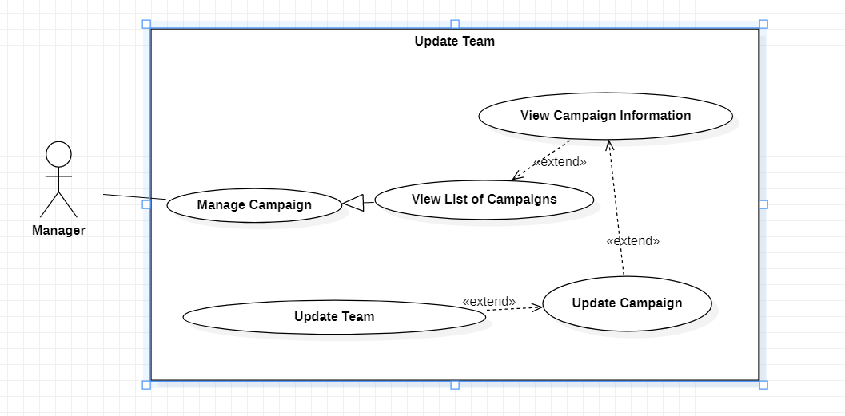

|  |  |  |  |  |
| --- | --- | --- | --- | --- |
| **USE CASE-9 SPECIFICATION** | | | | |
| **Use-case No.** | UC009 | **Use-case Version** | | 1.0 |
| **Use-case Name** | Update Team | | | |
| **Author** | Vu Thi Thuy Linh | | | |
| **Date** | 29/01/2021 | **Priority** | High | |
| **Actor:**  Manager  **Summary:**  This use case allows manager to update team in campaign.  **Goal:**  Manager can update team.  **Triggers**  Manager touches “update team” button.  **Preconditions:**  PRE-1. User’s identity has been authenticated  PRE-2. User is authorized to Manager role  **Post Conditions:**  POST-1. Information of team is updated.  **Main Success Scenario:**   |  |  | | --- | --- | | Manager | System | | 1. Manager click on update team | Show fields such as: name, activity location, etc. | | 1. Manager input (name of team, activity location, etc.) |  | | 1. Manager click on Update button | System update information of team |   **Alternative Scenario:**  N/A  **Exceptions:**   |  |  | | --- | --- | | Manager | System | | 1. Manager does not input name, activity location, etc. | System shows error message |   **Relationships:**  Extend update campaign  **Business Rules:**  The team chosen by manager is the team that is participating in that campaign | | | | |

## Use Case Change accountant of Campaign

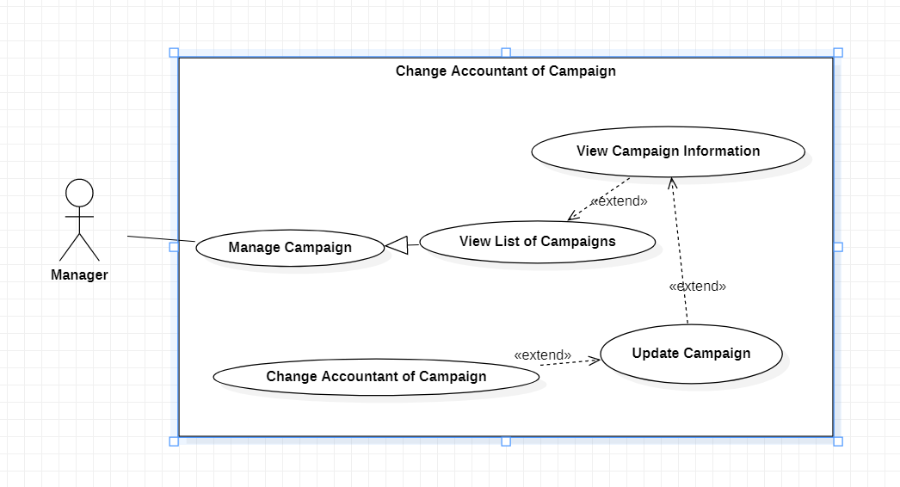

|  |  |  |  |  |
| --- | --- | --- | --- | --- |
| **USE CASE-10 SPECIFICATION** | | | | |
| **Use-case No.** | UC010 | **Use-case Version** | | 1.0 |
| **Use-case Name** | Change accountant of Campaign | | | |
| **Author** | Vu Thi Thuy Linh | | | |
| **Date** | 24/02/2021 | **Priority** | High | |
| **Actor:**  Manager  **Summary:**  This use case allows manager to change accountant in campaign.  **Goal:**  Manager can change accountant.  **Triggers**  Manager touches “change accountant” button.  **Preconditions:**  PRE-1. User’s identity has been authenticated.  PRE-2. User is authorized to Manager role.  **Post Conditions:**  POST-1. The old accountant was replaced  POST-2. Nominee is added to campaign with Accountant role.  **Main Success Scenario:**   |  |  | | --- | --- | | Manager | System | | 1. Manager click on change Accountant | System shows a form to input id or email or phone | | 1. Manager input id (or email or phone number) of user who manager wants to change | System shows name, phone, address, ... of user | | 1. Manager click on change button | System updates the new accountant |   **Alternative Scenario:**  N/A  **Exceptions:**   |  |  | | --- | --- | | Manager | System | | 1. Manager does not input id or email or phone and click Save | System shows error message |   **Relationships:**  Extend for Update campaign.  **Business Rules:**  Nominee has not participated in any campaign. | | | | |

## Use Case Change Supervisor of Campaign

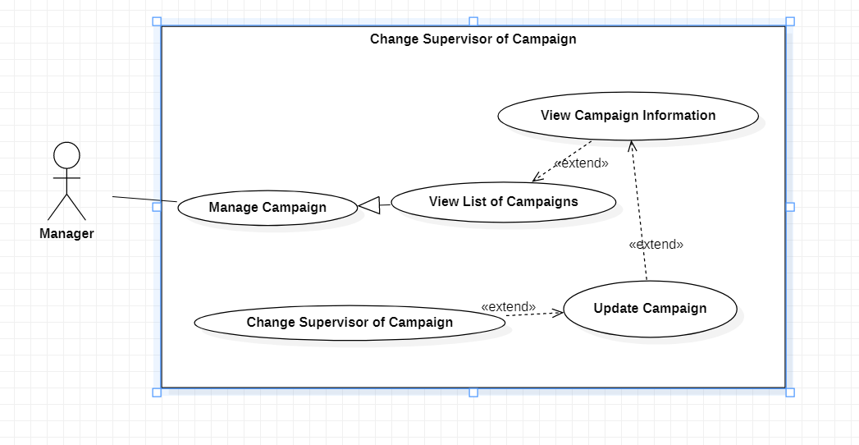

|  |  |  |  |  |
| --- | --- | --- | --- | --- |
| **USE CASE-11 SPECIFICATION** | | | | |
| **Use-case No.** | UC011 | **Use-case Version** | | 1.0 |
| **Use-case Name** | Change Supervisor of Campaign | | | |
| **Author** | Vu Thi Thuy Linh | | | |
| **Date** | 24/02/2021 | **Priority** | High | |
| **Actor:**  Manager  **Summary:**  This use case allows manager to change supervisor in campaign.  **Goal:**  Manager can change supervisor.  **Triggers**  Manager touches “change supervisor” button.  **Preconditions:**  PRE-1. User’s identity has been authenticated.  PRE-2. User is authorized to Manager role.  **Post Conditions:**  POST-1. The old supervisor was replaced  POST-2. Nominee is added to campaign with Supervisor role.  **Main Success Scenario:**   |  |  | | --- | --- | | Manager | System | | 1. Manager click on change Supervisor | System shows a form to input id or email or phone | | 1. Manager input id (or email or phone number) of user who manager wants to change | System shows name, phone, address, … of user | | 1. Manager click on change button | System updates the new supervisor |   **Alternative Scenario:**  N/A  **Exceptions:**   |  |  | | --- | --- | | Manager | System | | 1. Manager does not input id or email or phone and click Save | System shows error message |   **Relationships:**  Extend for Update campaign.  **Business Rules:**  Nominee has not participated in any campaign. | | | | |

## Use Case Create Financial Request

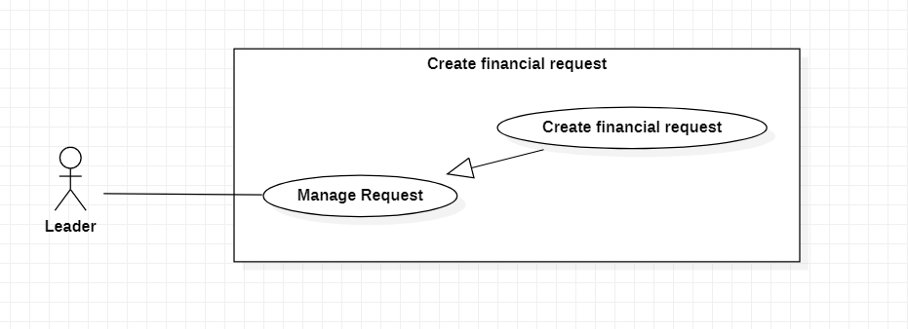

|  |  |  |  |  |
| --- | --- | --- | --- | --- |
| **USE CASE-12 SPECIFICATION** | | | | |
| **Use-case No.** | UC012 | **Use-case Version** | | 1.0 |
| **Use-case Name** | Create Financial Request | | | |
| **Author** | Nguyen Quoc Vinh | | | |
| **Date** | 29/01/2021 | **Priority** | High | |
| **Actor:**  Leader  **Summary:**  Leader creates request to get money based on list of items will be bought, list of receivers.  **Goal:**  To create request to get money  **Triggers**  Leader click “create request” button  **Preconditions:**  PRE-1. User’s identity has been authenticated  PRE-2. User is authorized to Leader role  **Post Conditions:**  POST-1. Show successful message  **Main Success Scenario:**   |  |  | | --- | --- | | Manager | System | | 1. Leader clicks “create request” button | 1. System displays the request form to input information:  - Active scope: the charity position (ex: Tp HCM, 9 District, Long Thanh My...)  - Amount of money for charity  - Blank text for importing the link contains the list of items  - Blank text for importing the link contains the list of receivers. | | 2. Leader inputs the information | 2. System will check valid of input: - Amount of money is a positive number  - Not blank link of the list of items  - Not blank link of the list of receivers | | 3. Leader clicks “create” button | 3. System reads form, get list of items will be bought, get list of receivers. After that, system sends this request to Supervisor and shows successful message to Leader. |   **Alternative Scenario:**  *N/A*  **Exceptions:**   |  |  | | --- | --- | | Cause | System | | 1. Leader inputs the character or negative number in amount of money input field | 1. System will show message on screen: “Not correct the number format” | | 2. Leader does not import file contains list of items | 2. System will show message on screen: “Not import the list of items file” | | 3. Leader not attach file contains list of receivers | 3. System will show message on screen: “Not import the list of receivers file” |     **Relationships:**  *N/A*  **Business Rules:**  1. Creating only one request in a period time (can create again when request is denied).  2. Can’t create request again when another request hasn’t been done yet (all the activity of this request must be done and then Leader create another request). | | | | |

## Use Case View Accepted and Denied Request History of Supervisor

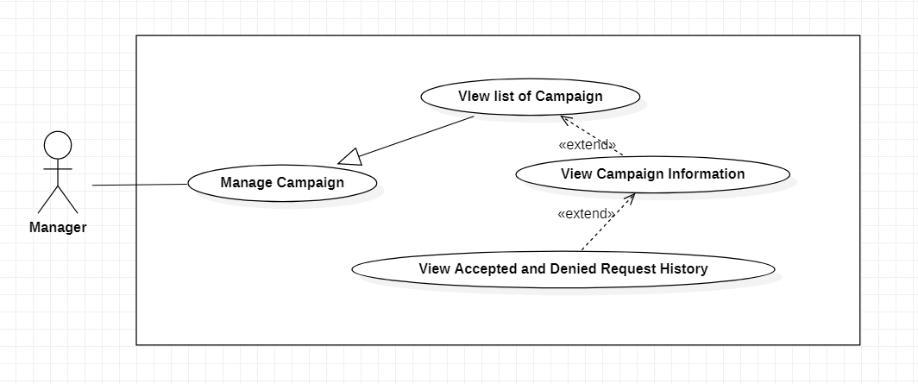

|  |  |  |  |  |
| --- | --- | --- | --- | --- |
| **USE CASE-13 SPECIFICATION** | | | | |
| **Use-case No.** | UC013 | **Use-case Version** | | 1.0 |
| **Use-case Name** | View Accepted and Denied Request History | | | |
| **Author** | Hoang Gia Thien Phuc | | | |
| **Date** | 03/02/2021 | **Priority** | Normal | |
| **Actor:**  Manager  **Summary:**  Manager view requests that were accepted or denied by specific Supervisor  **Goal:**  To view request history of Supervisor and keep track of work process  **Triggers**  Manager clicks “View request history”  **Preconditions:**  PRE-1. User’s identity has been authenticated  PRE-2. User is authorized to Manager role  PRE-3. Organization has at least one campaign  **Post Conditions:**  POST-1. Display list request history  **Main Success Scenario:**   |  |  |  | | --- | --- | --- | | No. | Actor Action | System | | 1 | Manager clicks “View request history” | System shows a list of accepted and denied request includes:  - Request content  - Is Accepted/Is Denied  - Reason to accept/deny  - Created Date  - Accept/Deny Date  - Accept/Deny by |   **Alternative Scenario:**  *N/A*  **Exceptions:**  *N/A*  **Relationships:** extend for View Campaign Information  **Business Rules:**  *N/A* | | | | |

## Use Case View Budget History

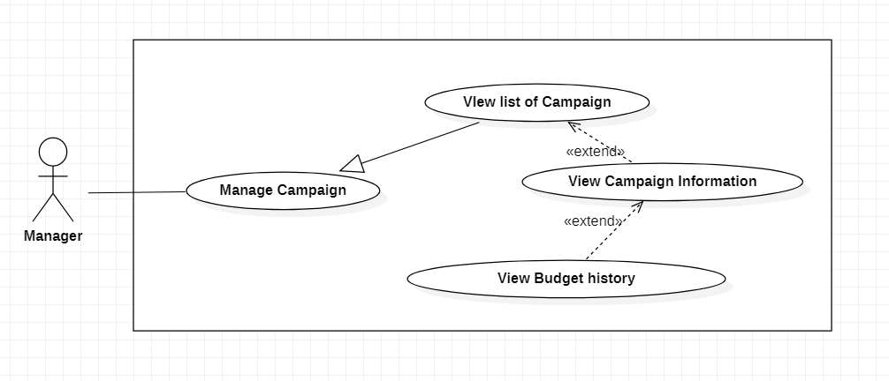

|  |  |  |  |  |
| --- | --- | --- | --- | --- |
| **USE CASE-14 SPECIFICATION** | | | | |
| **Use-case No.** | UC014 | **Use-case Version** | | 1.0 |
| **Use-case Name** | View Budget History | | | |
| **Author** | Hoang Gia Thien Phuc | | | |
| **Date** | 03/02/2021 | **Priority** | Normal | |
| **Actor:**  Manager  **Summary:**  This use case allows manager to view budget history to detect cheating or something’s wrong  **Goal:**  To view budget history  **Triggers**  Manager clicks “View budget history”  **Preconditions:**  PRE-1. User’s identity has been authenticated  PRE-2. User is authorized to Manager role  PRE-3. Organization has at least one campaign  **Post Conditions:**  POST-1. Display list budget history  **Main Success Scenario:**   |  |  |  | | --- | --- | --- | | No. | Actor Action | System | | 1 | Manager clicks “View budget history” | System shows a list of budget history includes:  - Receiver  - Sent date  - Amount of money  - Send for which request  - Sender |   **Alternative Scenario:**  *N/A*  **Exceptions:**  *N/A*  **Relationships:** extend for View Campaign Information  **Business Rules:**  *N/A* | | | | |

## Use Case View Donation

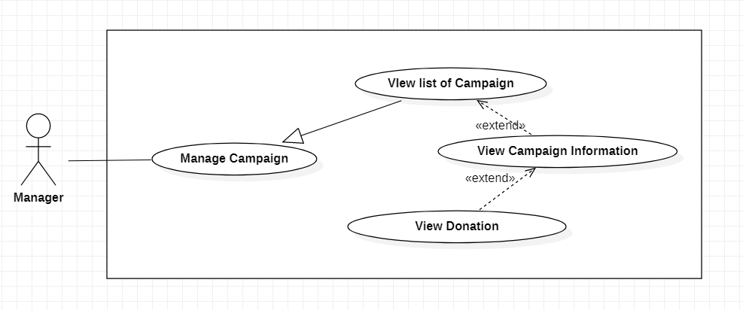

|  |  |  |  |  |
| --- | --- | --- | --- | --- |
| **USE CASE-14 SPECIFICATION** | | | | |
| **Use-case No.** | UC015 | **Use-case Version** | | 1.0 |
| **Use-case Name** | View donation | | | |
| **Author** | Hoang Gia Thien Phuc | | | |
| **Date** | 03/02/2021 | **Priority** | Normal | |
| **Actor:**  Manager  **Summary:**  This use case allows manager to view donation of a campaign  **Goal:**  To view donation of a campaign  **Triggers**  Manager clicks to “View Donation” button  **Preconditions:**  PRE-1. User’s identity has been authenticated  PRE-2. User is authorized to Manager role  PRE-3. Organization has at least one campaign  **Post Conditions:**  POST-1. Display list of donations and total of donation  **Main Success Scenario:**   |  |  |  | | --- | --- | --- | | No. | Actor Action | System | | 1 | Manager clicks “View Donation” button | System shows a page includes:  - List of donations:  + Donator  + Amount of Money  + Donated date  - Total of donation |   **Alternative Scenario:**  *N/A*  **Exceptions:**  *N/A*  **Relationships:** extend for View Campaign Information  **Business Rules:**  *N/A* | | | | |

## Use Case Change Leader of Team

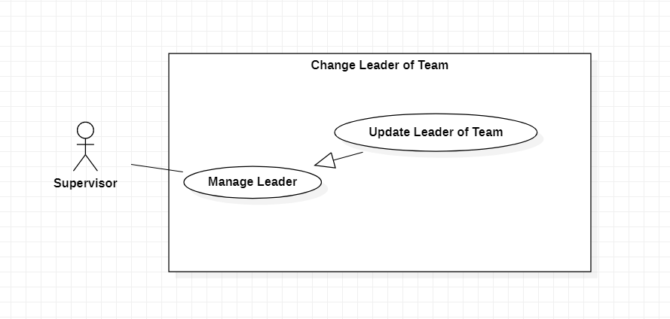

|  |  |  |  |  |
| --- | --- | --- | --- | --- |
| **USE CASE-16 SPECIFICATION** | | | | |
| **Use-case No.** | UC016 | **Use-case Version** | | 1.0 |
| **Use-case Name** | Change Leader of Team | | | |
| **Author** | Vu Thi Thuy Linh | | | |
| **Date** | 03/02/2021 | **Priority** | Normal | |
| **Actor:**  Supervisor  **Summary:**  This use case allows supervisor to change leader in team.  **Goal:**  Supervisor can change leader.  **Triggers**  Supervisor touches “change leader” button.  **Preconditions:**  PRE-1. User’s identity has been authenticated  PRE-2. User is authorized to Supervisor role  **Post Conditions:**  POST-1. The old leader was replaced  POST-2. Nominee is added to campaign with Leader role.  **Main Success Scenario:**   |  |  | | --- | --- | | Manager | System | | 1. Supervisor click on change Leader | System shows a form to input id or email or phone | | 1. Supervisor input id (or email or phone number) of user who Supervisor wants to change | System shows name, phone, address, … of user | | 1. Supervisor click on change button | System updates the new leader |   **Alternative Scenario:**  N/A  **Exceptions:**   |  |  | | --- | --- | | Manager | System | | 1. Supervisor does not input id or email or phone and click Save | System shows error message |   **Relationships:**  Specialized for Manage Leader  **Business Rules:**  Nominee has not participated in any campaign. | | | | |

## Use Case View Transaction's History of Leader

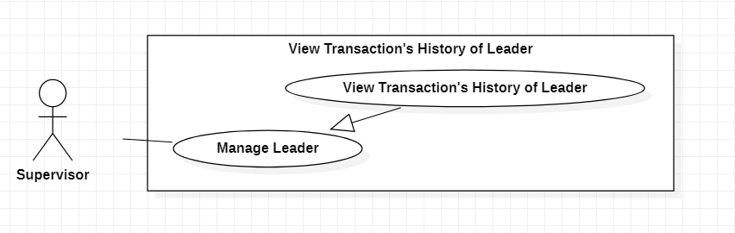

|  |  |  |  |  |
| --- | --- | --- | --- | --- |
| **USE CASE-17 SPECIFICATION** | | | | |
| **Use-case No.** | UC017 | **Use-case Version** | | 1.0 |
| **Use-case Name** | View Transaction’s History of Leader | | | |
| **Author** | Vu Thi Thuy Linh | | | |
| **Date** | 03/02/2021 | **Priority** | Normal | |
| **Actor:**  Supervisor  **Summary:**  This use case allows supervisor to view transaction’s history of leader.  **Goal:**  Supervisor can view transaction’s history of leader.  **Triggers**  Supervisor touches “view transaction’s history” button.  **Preconditions:**  PRE-1. User’s identity has been authenticated  PRE-2. User is authorized to Supervisor role  **Post Conditions:**  POST-1. Show list transaction history of leader.  **Main Success Scenario:**   |  |  | | --- | --- | | Supervisor | System | | 1. Supervisor click on view transaction’s history | System shows leader list. | | 1. Supervisor chooses a leader to view transaction’s history | System shows transaction’s history list. |   **Alternative Scenario:**  N/A  **Exceptions:**  N/A  **Relationships:**  Generalize to Manage Leader  **Business Rules:**  N/A | | | | |

## Use Case View Transaction’s Detail of Leader

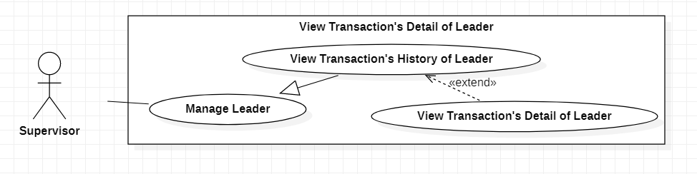

|  |  |  |  |  |
| --- | --- | --- | --- | --- |
| **USE CASE-18 SPECIFICATION** | | | | |
| **Use-case No.** | UC018 | **Use-case Version** | | 1.0 |
| **Use-case Name** | View Transaction’s Detail of Leader | | | |
| **Author** | Vu Thi Thuy Linh | | | |
| **Date** | 03/02/2021 | **Priority** | Normal | |
| **Actor:**  Supervisor  **Summary:**  This use case allows supervisor to view transaction’s detail of leader.  **Goal:**  Supervisor can view transaction’s detail of leader.  **Triggers**  Supervisor touches “view transaction’s detail” button.  **Preconditions:**  PRE-1. User’s identity has been authenticated  PRE-2. User is authorized to Supervisor role  **Post Conditions:**  POST-1. Show information of a transaction of leader  **Main Success Scenario:**   |  |  | | --- | --- | | Supervisor | System | | 1. Supervisor click on view transaction’s history | System shows leader list. | | 1. Supervisor chooses a leader to view transaction’s history | System shows transaction’s history list. | | 1. Supervisor click on 1 row of list transaction’s | System shows information of transaction detail |   **Alternative Scenario:**  N/A  **Exceptions:**  N/A  **Relationships:**  Extend for View transaction’s history of leader  **Business Rules:**  N/A | | | | |

## Use case View Request from Leader

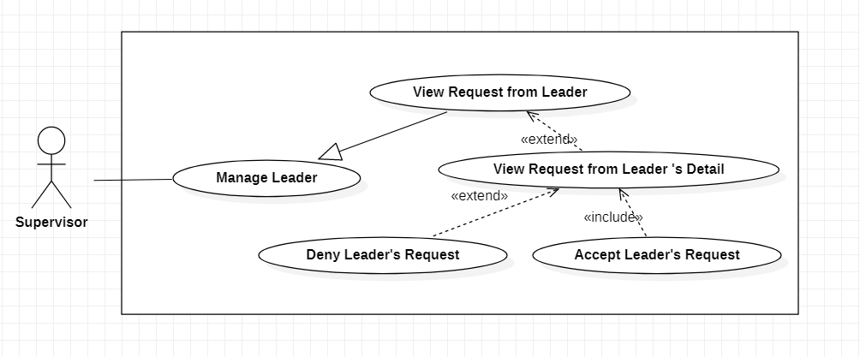

|  |  |  |  |  |
| --- | --- | --- | --- | --- |
| **USE CASE-19 SPECIFICATION** | | | | |
| **Use-case No.** | UC019 | **Use-case Version** | | 1.0 |
| **Use-case Name** | View request from Leader | | | |
| **Author** | Hoang Gia Thien Phuc | | | |
| **Date** | 03/02/2021 | **Priority** | Normal | |
| **Actor:**  Supervisor  **Summary:**  Supervisor view list of requests from selected Leader  **Goal:**  To view list of requests from selected Leader  **Triggers**  Supervisor chooses a Leader and clicks “View list of requests”  **Preconditions:**  PRE-1. User’s identity has been authenticated  PRE-2. User is authorized to Supervisor role  **Post Conditions:**  POST-1. Display list of requests from selected Leader  **Main Success Scenario:**     |  |  |  | | --- | --- | --- | | No. | Actor Action | System | | 1 | 1. Supervisor chooses a Leader and clicks “View list of requests” | System displays list of requests from selected Leader includes:  - Request’s content  - Sent by  - Sent date  - “View Detail”: button |   **Alternative Scenario:**  *N/A*  **Exceptions:**  *N/A*  **Relationships:** extended by View Request from Leader’s Detail  **Business Rules:**  *N/A* | | | | |

## Use case View Request from Leader’s Detail



|  |  |  |  |  |
| --- | --- | --- | --- | --- |
| **USE CASE-20 SPECIFICATION** | | | | |
| **Use-case No.** | UC020 | **Use-case Version** | | 1.0 |
| **Use-case Name** | View Request from Leader’s Detail | | | |
| **Author** | Hoang Gia Thien Phuc | | | |
| **Date** | 03/02/2021 | **Priority** | Normal | |
| **Actor:**  Supervisor  **Summary:**  Supervisor view detail of selected request  **Goal:**  To view detail of selected request  **Triggers**  Supervisor clicks “View Detail” button of request on list of requests  **Preconditions:**  PRE-1. User’s identity has been authenticated  PRE-2. User is authorized to Supervisor role  **Post Conditions:**  POST-1. Display detail of selected request  **Main Success Scenario:**   |  |  |  | | --- | --- | --- | | No. | Supervisor | System | | 1 | Supervisor clicks “View Detail” button of request on list of requests | System display detail of selected request includes:  - List of items: table  + Product Name  + Quantity  + Price  - List of receivers: table  + Receiver name  + Address  + Phone number (optional)  - Purpose  - Notes/ Other information |   **Alternative Scenario:**  *N/A*  **Exceptions:**  *N/A*  **Relationships:** extended by Deny Leader’s Request, extended by Accept Leader’s Request  **Business Rules:**  *N/A* | | | | |

## Use Case Deny Leader’s Request

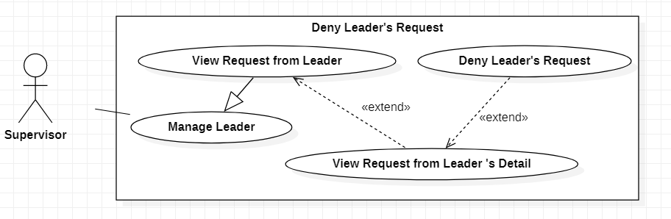

|  |  |  |  |  |
| --- | --- | --- | --- | --- |
| **USE CASE-21 SPECIFICATION** | | | | |
| **Use-case No.** | UC021 | **Use-case Version** | | 1.0 |
| **Use-case Name** | Deny Leader’s Request | | | |
| **Author** | Vu Thi Thuy Linh | | | |
| **Date** | 03/02/2021 | **Priority** | Normal | |
| **Actor:**  Supervisor  **Summary:**  This use case allows supervisor to deny leader’s request.  **Goal:**  Supervisor can deny leader’s request.  **Triggers**  Supervisor touches “deny leader’s request” button.  **Preconditions:**  PRE-1. User’s identity has been authenticated  PRE-2. User is authorized to Supervisor role  **Post Conditions:**  POST-1. Notify to leader sending the request that the request has been denied.  **Main Success Scenario:**   |  |  | | --- | --- | | Supervisor | System | | 1. Supervisor chooses a request detail of leader | System shows content of request | | 1. Supervisor choose to deny request | System notifies to the leader sending the request that the request has been denied |   **Alternative Scenario:**  N/A  **Exceptions:**  N/A  **Relationships:**  Extend for View Request from Leader’s Detail  **Business Rules:**  N/A | | | | |

## Use Case Accept Leader’s Request

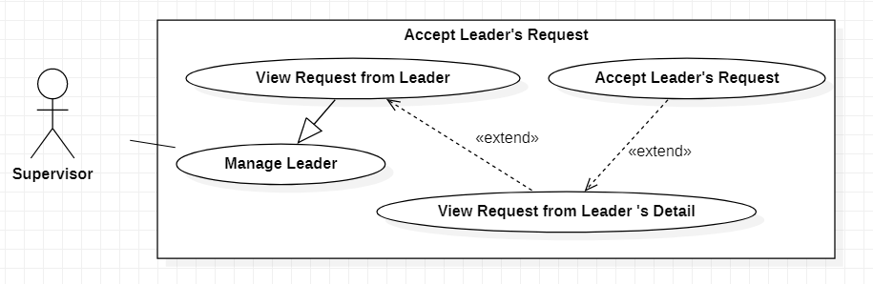

|  |  |  |  |  |
| --- | --- | --- | --- | --- |
| **USE CASE-22 SPECIFICATION** | | | | |
| **Use-case No.** | UC022 | **Use-case Version** | | 1.0 |
| **Use-case Name** | Accept Leader’s Request | | | |
| **Author** | Vu Thi Thuy Linh | | | |
| **Date** | 03/02/2021 | **Priority** | Normal | |
| **Actor:**  Supervisor  **Summary:**  This use case allows supervisor to accept leader’s request.  **Goal:**  Supervisor can accept leader’s request.  **Triggers**  Supervisor touches “accept leader’s request” button.  **Preconditions:**  PRE-1. User’s identity has been authenticated  PRE-2. User is authorized to Supervisor role  **Post Conditions:**  POST-1. Notify to leader sending the request that the request has been accepted.  **Main Success Scenario:**   |  |  | | --- | --- | | Supervisor | System | | * 1. Supervisor chooses a request detail of leader | System shows content of request | | * 1. Supervisor choose to accept request | System notifies to the leader sending the request that the request has been denied |   **Alternative Scenario:**  N/A  **Exceptions:**  N/A  **Relationships:**  Extend for View Request from Leader’s Detail  **Business Rules:**  accept. | | | | |

## Use Case View Confirmed Request by Supervisor

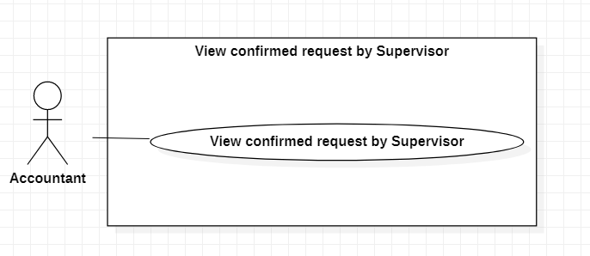

|  |  |  |  |  |
| --- | --- | --- | --- | --- |
| **USE CASE-23 SPECIFICATION** | | | | |
| **Use-case No.** | UC023 | **Use-case Version** | | 1.0 |
| **Use-case Name** | View confirmed request by Supervisor | | | |
| **Author** | Le Minh Tuan | | | |
| **Date** | 24/02/2021 | **Priority** | High | |
| **Actor:**  Accountant  **Summary:**  Accountant view requests which were confirmed by specific Supervisor.  **Goal:**  View requests which were confirmed by specific Supervisor for making decision to deny or accept to transfer money.  **Triggers**  Accountant wants to view requests which were confirmed by Supervisor of each group.  **Preconditions:**  PRE-1. User’s identity has been authenticated.  PRE-2. User is authorized to Accountant role.  **Post Conditions:**  POST-1. Display list requests which were accepted by selected Supervisor.  **Main Success Scenario:**   |  |  | | --- | --- | | Accountant | System | | 1. Accountant click “View requests list” button | System display requests list which was confirmed by selected Supervisor of each group |     **Alternative Scenario:**  N/A.  **Exceptions:**   |  |  | | --- | --- | | Cause | System | | 1. Request list is empty | System will show message on screen: “Request list is empty” |   **Relationships:**  Be extended by View Request’s Details.  **Business Rules:**  Request must be confirmed by Supervisor of each group before showing to Accountant. | | | | |

## Use Case View Request’s Details

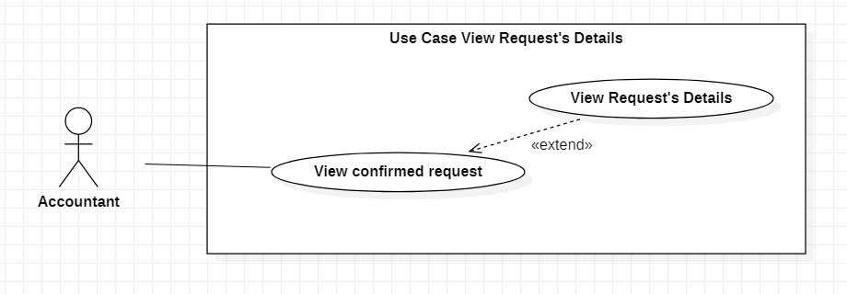

|  |  |  |  |  |
| --- | --- | --- | --- | --- |
| **USE CASE-20 SPECIFICATION** | | | | |
| **Use-case No.** | UC024 | **Use-case Version** | | 1.0 |
| **Use-case Name** | View Request’s Details | | | |
| **Author** | Le Minh Tuan | | | |
| **Date** | 24/02/2021 | **Priority** | Normal | |
| **Actor:**  Accountant.  **Summary:**  Accountant view request’s details.  **Goal:**  Accountant can view details of request sent from groups before deciding to transfer money or deny.  **Triggers**  Accountant wants to view request’s details these are in list of confirmed requests by Supervisor of each group.  **Preconditions:**  PRE-1. User’s identity has been authenticated.  PRE-2. User is authorized to Accountant role.  **Post Conditions:**  POST-1. Display request’s details of selected request.  **Main Success Scenario:**   |  |  | | --- | --- | | Accountant | System | | 1. Accountant click “View requests list” button | System display requests list which was confirmed by selected Supervisor of each group | | 2. Accountant chooses a request in request list to view details | System shows request’s details of selected request |   **Alternative Scenario:**   |  |  | | --- | --- | | Accountant | System | | 1. Accountant click “View requests list” button | System display requests list which was confirmed by selected Supervisor of each group | | 1. Accountant click “Back” button | System navigates to “home” page |     **Exceptions:**   |  |  | | --- | --- | | Cause | System | | 1. Request list is empty | System will show message on screen: “Request list is empty” |   **Relationships:**  1. Be extended with use case Transfer Money to Request.  2. Extend with use case Deny Transfer Money Request.  **Business Rules**  Request must be confirmed by Supervisor of each group before showing to Accountant. | | | | |
|  | | | | |

## Use Case Transfer Money for Accepted Request

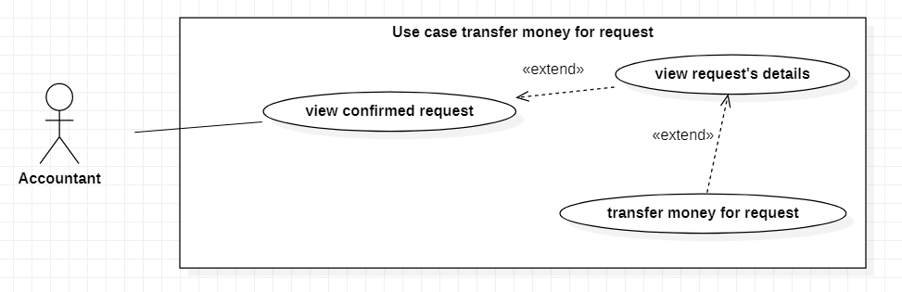

|  |  |  |  |  |
| --- | --- | --- | --- | --- |
| **USE CASE-25 SPECIFICATION** | | | | |
| **Use-case No.** | UC025 | **Use-case Version** | | 1.0 |
| **Use-case Name** | Transfer Money for accepted Request | | | |
| **Author** | Le Minh Tuan | | | |
| **Date** | 24/02/2021 | **Priority** | Normal | |
| **Actor:**  Accountant.  **Summary:**  Accountant chooses to transfer money for selected request.  **Goal:**  Groups can receive money from accountant for charity purpose.    **Triggers**  Accountant wants to transfer money for selected request.  **Preconditions:**  PRE-1. User’s identity has been authenticated.  PRE-2. User is authorized to Accountant role.  **Post Conditions:**  POST-1. Transaction information inserted into DB.  **Main Success Scenario:**   |  |  | | --- | --- | | Accountant | System | | 1. Accountant click “View requests list” button | System displays requests list which was confirmed by selected Supervisor of each group | | 2. Accountant chooses a request in request list to view details | System shows request’s details of selected request | | 3. Accountant chooses to transfer money to selected request | System link to bank application of Accountant. | | 4. Accountant transfers money to group on bank application | System receives successful transferring signal and display successful message |   **Alternative Scenario:**   |  |  | | --- | --- | | Accountant | System | | 1. Accountant click “View requests list” button | System display requests list which was confirmed by selected Supervisor of each group | | 2. Accountant chooses a request in request list to view details | System shows request’s details of selected request | | 3. Accountant click “Back” button | System navigates to “home” page |   **Exceptions:**   |  |  | | --- | --- | | Cause | System | | 1. Request list is empty | System will show message on screen: “Request list is empty” | | 2. System receives fail transferring signal | System shows error message “Transfer money fail” on screen |   **Relationships:**  Extend to use case View Request’s Detail.  **Business Rules:**  Bank account of accountant must be linked to application before making transaction. | | | | |

## Use Case Deny Transfer Money

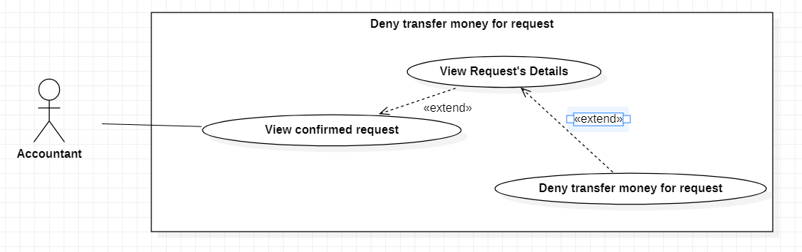

|  |  |  |  |  |
| --- | --- | --- | --- | --- |
| **USE CASE-26 SPECIFICATION** | | | | |
| **Use-case No.** | UC026 | **Use-case Version** | | 1.0 |
| **Use-case Name** | Deny Transfer Money for Request | | | |
| **Author** | Le Minh Tuan | | | |
| **Date** | 24/02/2021 | **Priority** | Normal | |
| **Actor:**  Accountant  **Summary:**  Accountant chooses to deny transfer money to selected request.  **Goal:**  Deny transfer money for selected request because of out of money or some specific reason.  **Triggers**  Accountant wants to deny transfer money for selected request.  **Preconditions:**  PRE-1. User’s identity has been authenticated.  PRE-2. User is authorized to Accountant role.  **Post Conditions:**  POST-1. Status of request is set “Denied” in list request.  POST-2. Supervisor receives notification about denying action of accountant.  **Main Success Scenario:**   |  |  | | --- | --- | | Accountant | System | | 1. Accountant click “View requests list” button | System display requests list which was confirmed by selected Supervisor of each group | | 2. Accountant chooses a request in request list to view details | System shows request’s details of selected request | | 3. Accountant click “Deny” of selected request deny transfer money for selected request | System shows reason box for denying request action | | 4. Accountant input reason for denying action | System display notification successfully and insert “denied” status for request into DB then notified to Supervisor. | | 5. Accountant click “verify” button | System set status of request is “Denied” and save reason for denying action. |   **Alternative Scenario:**   |  |  | | --- | --- | | Accountant | System | | 1. Accountant click “View requests list” button | System display requests list which was confirmed by selected Supervisor of each group | | 2. Accountant click “Back” button | System navigates to “home” page |   **Exceptions:**   |  |  | | --- | --- | | Cause | System | | 1. Request list is empty | System will show message on screen: “Request list is empty” | | 2. Reason for denying action is empty | System shows error message: “Reason for denying action” cannot be empty |   **Relationships:**  Extend from use case View Request’s Detail.  **Business Rules:**  Request must be confirmed by Supervisor of group. | | | | |

## Use Case View Transaction History

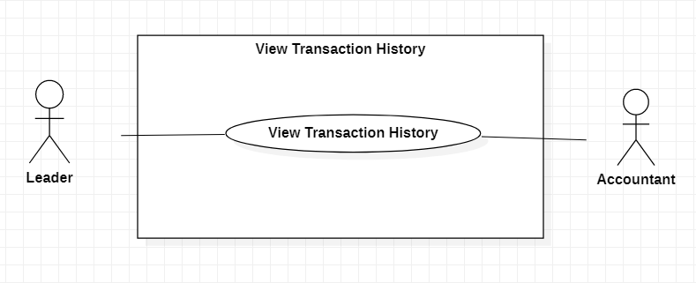

|  |  |  |  |  |
| --- | --- | --- | --- | --- |
| **USE CASE-27 SPECIFICATION** | | | | |
| **Use-case No.** | UC027 | **Use-case Version** | | 1.0 |
| **Use-case Name** | View Transaction History | | | |
| **Author** | Le Minh Tuan | | | |
| **Date** | 24/02/2021 | **Priority** | Normal | |
| **Actor:**  Leader, Accountant  **Summary:**  Leader, Accountant can view transaction history.  **Goal:**  Leader, Accountant can view transaction history for management of organization’s finance.  **Triggers**  Leader, Account needs information about transaction history.  **Preconditions:**  PRE-1. User’s identity has been authenticated.  PRE-2. User is authorized to Accountant or Leader role.  **Post Conditions:**  POST-1. Transaction history list will be showed on screen.  **Main Success Scenario:**   |  |  | | --- | --- | | Accountant | System | | 1. Accountant, Leader clicks “View transaction” button | System display transaction history list |   **Alternative Scenario:**  N/A  **Exceptions:**     |  |  | | --- | --- | | Cause | System | | 1. List of transaction is empty | System will show error message: “This transaction list is empty” |     **Relationships:**  N/A  **Business Rules:**  - Leader just only can view transactions of his group.  - Accountant can view all transactions of campaign. | | | | |

## Use Case View Transaction’s Details

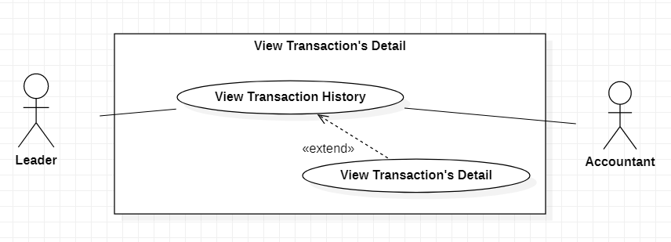

|  |  |  |  |  |
| --- | --- | --- | --- | --- |
| **USE CASE-28 SPECIFICATION** | | | | |
| **Use-case No.** | UC028 | **Use-case Version** | | 1.0 |
| **Use-case Name** | View Transaction’s Details | | | |
| **Author** | Le Minh Tuan | | | |
| **Date** | 24/02/2021 | **Priority** | Normal | |
| **Actor:**  Accountant, Leader  **Summary:**  With the existed transaction in each bank account, the Accountant or Leader can view the details of it.  **Goal:**  Accountant or leader needs the information of transaction’ details for management of organization.  **Triggers**  Accountant, Leader wants to view the details of it.  **Preconditions:**  PRE-1. User’s identity has been authenticated.  PRE-2. User’s is authorized to Accountant role or Leader role.  **Post Conditions:**  POST-1. The details of transaction will be shown on screen.  **Main Success Scenario:**   |  |  | | --- | --- | | Accountant, Leader | System | | 1. Accountant, Leader clicks “View transaction” button | System displays transaction history list | | 2. Accountant or Leader selects the transaction that wants to view the details. | System shows details of selected transaction history |   **Alternative Scenario:**   |  |  | | --- | --- | | Accountant, Leader | System | | 1. Accountant, Leader clicks “View transaction” button | System displays transaction history list | | 2. Accountant or Leader click “Back button” | System navigates to “home” page |   **Exceptions:**     |  |  | | --- | --- | | Cause | System | | 1. Transaction list is empty | System displays message: “The transaction list is empty” |   **Relationships:**  Extends from use case “View transaction History”.  **Business Rules:**  -Leader just only can view transactions’ details of his/her group.  - Accountant can view all transactions’ details of campaign. | | | | |

## Use Case Link Bank Account

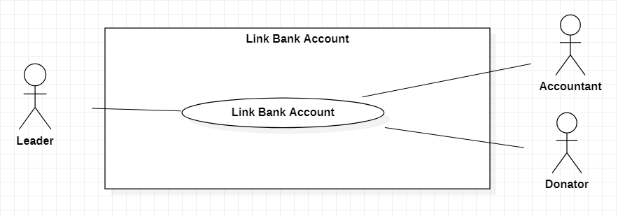

|  |  |  |  |  |
| --- | --- | --- | --- | --- |
| **USE CASE-29 SPECIFICATION** | | | | |
| **Use-case No.** | UC029 | **Use-case Version** | | 2.0 |
| **Use-case Name** | Link Bank Account | | | |
| **Author** | Le Minh Tuan | | | |
| **Date** | 24/02/2021 | **Priority** | Normal | |
| **Actor:**  Leader, Accountant, Donator.  **Summary:**  Linking bank account with application makes transaction history management easier.  **Goal:**  To link bank account to application for statistical management in charity campaign through application.  **Triggers**  Leader, Accountant, Donator wants to link bank account with application.  **Preconditions:**  PRE-1. User’s identity has been authenticated.  PRE-2. User is authorized to Leader, Accountant, Donator role.  PRE-3. The bank card is active.  **Post Conditions:**  POST-1. Bank account is linked to app.  **Main Success Scenario:**   |  |  | | --- | --- | | Leader, Accountant, Donator | System | | 1. Leader, Accountant, Donator chooses to link bank card | System navigates to Bank Card linking page includes:  - Bank chooser  - Card number text box  - Card holder text box  - Effective date text box | | 2. Leader, Accountant, Donator selects the bank that they want to link |  | | 3. Leader, Accountant, Donator inputs their card number, card holder and effective date of bank card (if have) |  | | 4. Leader, Accountant, Donator chooses send information to system | System sends OTP code to phone number of bank account | | 6. Leader, Accountant, Donator input OTP code and click “Verify” | System show message:” Link account with application successfully”. |   **Alternative Scenario:**   |  |  | | --- | --- | | Leader, Accountant, Donator | System | | 1. Leader, Accountant, Donator click to “Back” button | System navigates to "home” page |   **Exceptions:**   |  |  | | --- | --- | | Cause | System | | 1. Leader, Accountant, Donator does not select the bank | System shows error message “Please choose bank” | | 2. Card number is incorrect | System shows error message “Card number is incorrect” | | 3. Card holder is incorrect | System shows error message “Card holder is incorrect” | | 4. Effective date of bank card is incorrect | System shows error message “Effective date is incorrect” | | 5. OTP code is incorrect | System shows error message “OTP code is incorrect” |     **Relationships:**  N/A  **Business Rules:**  Can link only one bank account to each Leader, Accountant, Donator account. | | | | |

## Use Case Add Supporter to Team

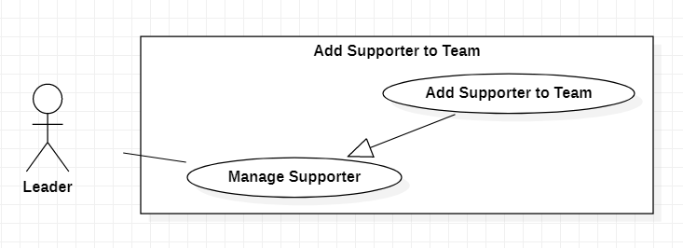

|  |  |  |  |  |
| --- | --- | --- | --- | --- |
| **USE CASE-30 SPECIFICATION** | | | | |
| **Use-case No.** | UC030 | **Use-case Version** | | 1.0 |
| **Use-case Name** | Add Supporter to Team | | | |
| **Author** | Nguyen Quoc Vinh | | | |
| **Date** | 24/02/2021 | **Priority** | Normal | |
| **Actor:**  Leader  **Summary:**  Leader adds Supporter to Team  **Goal:**  Leader can add Supporter to Team  **Triggers**  Leader click “add Supporter” button  **Preconditions:**  PRE-1. User’s identity has been authenticated  PRE-2. User is authorized to Leader role  **Post Conditions:**  POST-1. Show successful message  POST-2. A new Supporter is added to the list of members in Leader’s team.  **Main Success Scenario:**   |  |  | | --- | --- | | Leader | System | | 1. Leader clicks “add Supporter” button | 1. System shows the add form that contains some option to input information: - option 1: Phone - option 2: Email | | 2. Leader chooses an option to input information. | 2. System will check valid of input field: - option 1: Phone is a phone number and not a blank text. - option 2: Email must be in correct email format and not be blank text. | | 3. Leader inputs the information. |  | | 4. Leader click “add” button | 4. System will check whether this Supporter exists or not. - Exist: System shows successful message and adds Supporter to Leader’s team. - Not Exist: System show “not found Supporter” message to Leader. |   **Alternative Scenario:**  *N/A*  **Exceptions:**   |  |  | | --- | --- | | Cause | System | | 1. Leader does not choose the option | 1. System will show message on screen: “Choose the option please” | | 2. Leader does not input any character in input field | 2. System will show message on screen: “Not empty input fields” | | 3. Leader does not input the correct format phone number if the phone option is selected. | 3. System will show message on screen: “Not correct the phone format” | | 4. Leader does not input the correct format email if the email option is selected. | 4. System will show message on screen: “Not correct the email format” |   **Relationships:**  *N/A*  **Business Rules:**  *N/A* | | | | |

## Use Case Remove Supporter from Team

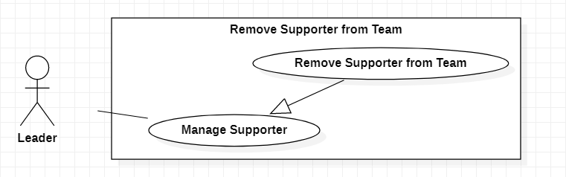

|  |  |  |  |  |
| --- | --- | --- | --- | --- |
| **USE CASE-31 SPECIFICATION** | | | | |
| **Use-case No.** | UC031 | **Use-case Version** | | 1.0 |
| **Use-case Name** | Remove Supporter from Team | | | |
| **Author** | Nguyen Quoc Vinh | | | |
| **Date** | 24/02/2021 | **Priority** | Normal | |
| **Actor:**  Leader  **Summary:**  Leader remove Supporter from Team when Supporter made mistakes many times and did not complete activities.  **Goal:**  Leader can remove Supporter from team.  **Triggers**  Leader click “remove Supporter” button  **Preconditions:**  PRE-1. User’s identity has been authenticated  PRE-2. User is authorized to Leader role  **Post Conditions:**  POST-1. Show successful message  POST-2. A Supporter is removed from the list of members in Leader’s team.  **Main Success Scenario:**   |  |  | | --- | --- | | Leader | System | | 1. Leader click “remove Supporter” button | 1. System shows the list of members in Leader’s team. | | 2. Leader selects the Supporters in the list. | 2. System focuses the selected Supporters. | | 3. Leader clicks “remove” button | 3. System display “confirm” button | | 4. Leader clicks “confirm” button | 4. System checks whether Leader has selected the Supporters and then: - Show successful message (if selected) - Show error message (if not selected) |   **Alternative Scenario:**  *N/A*  **Exceptions:**   |  |  | | --- | --- | | Cause | System | | 1. Leader does not select the Supporters | 1. System will show message on screen: “select the Supporter please” |   **Relationships:**  *N/A*  **Business Rules:**  1. A confirm step is required before the system can remove the Supporter. | | | | |

## Use Case Create Activity

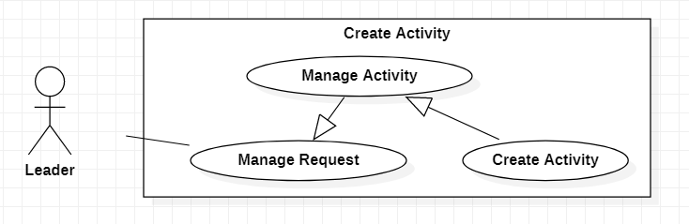

|  |  |  |  |  |
| --- | --- | --- | --- | --- |
| **USE CASE-32 SPECIFICATION** | | | | |
| **Use-case No.** | UC032 | **Use-case Version** | | 1.0 |
| **Use-case Name** | Create Activity | | | |
| **Author** | Nguyen Quoc Vinh | | | |
| **Date** | 24/02/2021 | **Priority** | High | |
| **Actor:**  Leader  **Summary:**  Leader creates activity for Team  **Goal:**  Leader can create activity for Team  **Triggers**  Leader clicks “create activity” button  **Preconditions:**  PRE-1. User’s identity has been authenticated  PRE-2. User is authorized to Leader role  PRE-3. The financial request must be accepted  **Post Conditions:**  POST-1. Show successful message  POST-2. A new activity is added to the list of activities of Leader’s team.  **Main Success Scenario:**   |  |  | | --- | --- | | Leader | System | | 1. Leader clicks “create activity” button | 1. System checks whether there is existed a financial request or not in the Leader’s team: - If existed, system shows the list of financial requests that will be selected to create activity.  - If not existed, system show “There aren’t any financial requests” message. | | The steps below are valid when the financial request existed. | | | 2. Leader selects the financial request | 2. System focuses the selected request and shows “create” button. | | 3. Leader clicks “create” button | 3. System shows the activity form to input information:  - Location: not be blank. - Start time: not be blank and be correct “day-month-year” date format. - Expected end time: not be blank, be correct “day-month-year” date format and be larger than start time. - What team needs to do: not be blank. | | 4. Leader inputs the information of activity. |  | | 5. Leader clicks “confirm” button | 5. System checks valid and then show message based on: - Not follow constraints: “Error for creating activity” message. - follow constraints: “create successfully” message. |   **Alternative Scenario:**  *N/A*  **Exceptions:**     |  |  | | --- | --- | | Cause | System | | 1. There aren’t any financial requests | 1. System will show message on screen: “your team must have at least one financial request” | | 2. Leader does not input the location field. | 2. System will show message on screen: “Not empty location fields” | | 3. Leader does not input start time or start time isn’t be correct format | 3. System will show message on screen: “Not input start time or correct the date format” | | 4. Leader does not input end time or end time isn’t be correct format. | 4. System will show message on screen: “Not correct the date format”. | | 5. Leader does not input end time or not larger than start time. | 5. System will show message on screen: “Not larger than start time”. | | 6. Leader does not input "What team needs to do” field. | 6. System will show message on screen: “Not empty What team needs to do field”. |   **Relationships:**  *N/A*  **Business Rules:**  *N/A* | | | | |

## Use Case Update Activity

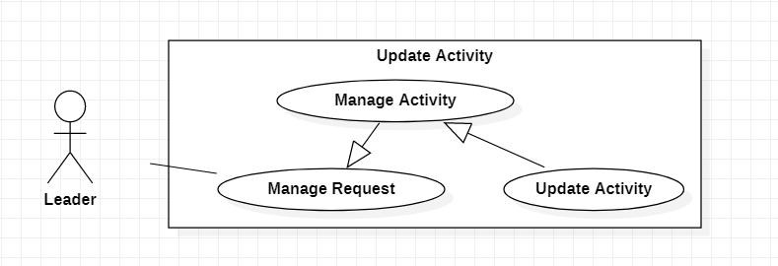

|  |  |  |  |  |
| --- | --- | --- | --- | --- |
| **USE CASE-33 SPECIFICATION** | | | | |
| **Use-case No.** | UC033 | **Use-case Version** | | 1.0 |
| **Use-case Name** | Update Activity | | | |
| **Author** | Nguyen Quoc Vinh | | | |
| **Date** | 24/02/2021 | **Priority** | High | |
| **Actor:**  Leader  **Summary:**  Leader updates activity in Leader’s team that may have entered the incorrect information.  **Goal:**  Leader can update activity in Leader’s team  **Triggers**  Leader clicks “update activity” button  **Preconditions:**  PRE-1. User’s identity has been authenticated  PRE-2. User is authorized to Leader role  PRE-3. Leader’s team must have at least an activity.  **Post Conditions:**  POST-1. Show successful message  POST-2. An updated activity is refreshed to the list of activities of Leader’s team.  **Main Success Scenario:**   |  |  | | --- | --- | | Leader | System | | 1. Leader clicks “update activity” button | 1. System checks whether there is existed a financial request or not in the Leader’s team: - If existed, system shows the list of financial requests that will be selected to create activity.  - If not existed, system show “There aren’t any financial requests” message. | | The steps below are valid when the financial request existed | | | 2. Leader selects the financial request | 2. System checks whether there is existed an activity or not in the financial request: - If existed, system shows the list of activities  - If not existed, system show “There aren’t any activities” message. | | The steps below are valid when the activities existed | | | 3. Leader selects an activity | 3. System focuses the selected activity and shows “update” button | | 4. Leader clicks “update” | 4. System shows the activity form to update information:  - Location: not be blank. - Start time: not be blank and be correct “day-month-year” date format. - Expected end time: not be blank, be correct “day-month-year” date format and be larger than start time. - What team needs to do: not be blank. | | 5. Leader inputs the information |  | | 6. Leader clicks “confirm” button | 6. System checks valid and then show message based on: - Not follow constraints: “Error for updating activity” message. - follow constraints: “update successfully” message. |   **Alternative Scenario:**  *N/A*  **Exceptions:**   |  |  | | --- | --- | | Cause | System | | 1. There aren’t any financial requests or activities. | 1. System will show message on screen: “your team must have at least one financial request and one activity in request.” | | 2. Leader does not input the location field. | 2. System will show message on screen: “Not empty location fields” | | 3. Leader does not input start time or start time isn’t be correct format | 3. System will show message on screen: “Not input start time or correct the date format” | | 4. Leader does not input end time or end time isn’t be correct format. | 4. System will show message on screen: “Not correct the date format”. | | 5. Leader does not input end time or not larger than start time. | 5. System will show message on screen: “Not larger than start time”. | | 6. Leader does not input "What team needs to do” field. | 6. System will show message on screen: “Not empty What team needs to do field”. |   **Relationships:**  *N/A*  **Business Rules:**  1. Update is not possible when the Supporter confirmed that this activity has been done. | | | | |

## Use Case Report Cheating

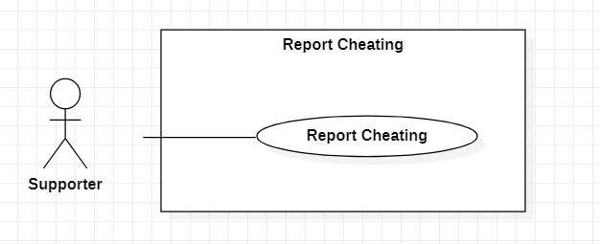

|  |  |  |  |  |
| --- | --- | --- | --- | --- |
| **USE CASE-34 SPECIFICATION** | | | | |
| **Use-case No.** | UC034 | **Use-case Version** | | 1.0 |
| **Use-case Name** | Report Cheating | | | |
| **Author** | Nguyen Quoc Vinh | | | |
| **Date** | 24/02/2021 | **Priority** | Normal | |
| **Actor:**  Supporter  **Summary:**  If Supporter detects the cheating in team, Supporter can create a report for cheating with some information and evidence.  **Goal:**  To report the Leader for Supervisor  **Triggers**  Supporter clicks “report cheating” button  **Preconditions:**  PRE-1. User’s identity has been authenticated  PRE-2. User is authorized to Supporter role  **Post Conditions:**  POST-1. Show successful message  **Main Success Scenario:**     |  |  | | --- | --- | | Supporter | System | | 1. Supporter click “report cheating” button | 1. System shows the list of teams that Supporter belongs to. | | 2. Supporter selects a team | 2. System focuses the selected team shows “report” button | | 3. Supporter clicks “report” button | 3. System displays the request form to input information:  - Reason: not be blank text  - Blank text for importing the link contains the evidences: not be blank text. | | 4. Supporter inputs the information |  | | 5. Supporter clicks “confirm” button | 5. System checks valid and then shows message based on: - Not follow constraints: “Error for reporting” message. - follow constraints: “report successfully” message. |   **Alternative Scenario:**  N/A  **Exceptions:**   |  |  | | --- | --- | | Cause | System | | 1. Supporter doesn’t input reason. | 1. System will show message on screen: “Please input the reason” | | 2. Supporter doesn’t import the evidence link. | 2. System will show message on screen: “Please import the evidence link” |   **Relationships:**  N/A  **Business Rules:**  1. One Supporter can report only if the previous report has been solved. | | | | |

## Use Case View Activities

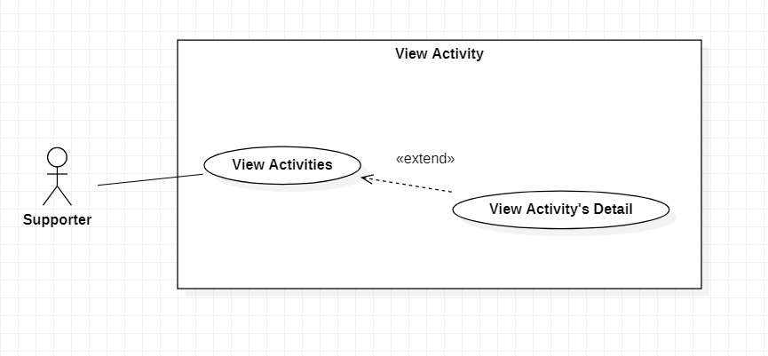

|  |  |  |  |  |
| --- | --- | --- | --- | --- |
| **USE CASE-35 SPECIFICATION** | | | | |
| **Use-case No.** | UC035 | **Use-case Version** | | 1.0 |
| **Use-case Name** | View Activities | | | |
| **Author** | Nguyen Quoc Vinh | | | |
| **Date** | 24/02/2021 | **Priority** | Low | |
| **Actor:**  Supporter  **Summary:**  Supporter can view the activities of team  **Goal:**  To view the activities of team  **Triggers**  Supporter clicks “view activities” button  **Preconditions:**  PRE-1. User’s identity has been authenticated  PRE-2. User is authorized to Supporter role  **Post Conditions:**  POST-1. Display the list of activities  **Main Success Scenario:**     |  |  | | --- | --- | | Supporter | System | | 1. Supporter clicks “view activities” button | 1. System checks whether there is existed an activity: - If existed, system shows the list of activities  - If not existed, system show “There aren’t any activities” message. |   **Alternative Scenario:**  *N/A*  **Exceptions:**   |  |  | | --- | --- | | Cause | System | | 1. There aren’t any activities in Supporter’s team. | 1. System will show message on screen: “your team must have at least one activity” |   **Relationships:**  Be extended with View Activity’s Detail  **Business Rules:**  *N/A* | | | | |
|  | | | | |

## Use Case View Activity’s Detail

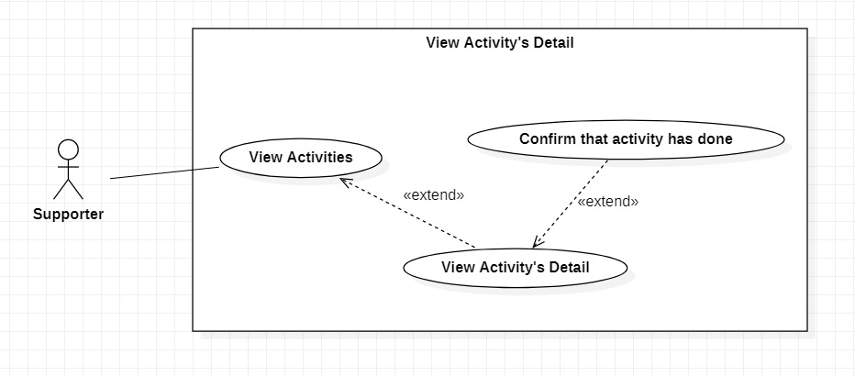

|  |  |  |  |  |
| --- | --- | --- | --- | --- |
| **USE CASE-36 SPECIFICATION** | | | | |
| **Use-case No.** | UC036 | **Use-case Version** | | 1.0 |
| **Use-case Name** | View Activity’s Detail | | | |
| **Author** | Nguyen Quoc Vinh | | | |
| **Date** | 24/02/2021 | **Priority** | Low | |
| **Actor:**  Supporter  **Summary:**  Supporter can view the detail of activities.  **Goal:**  To view the detail of activities  **Triggers**  Supporter clicks “view details” button  **Preconditions:**  PRE-1. User’s identity has been authenticated  PRE-2. User is authorized to Supporter role  PRE-4. Team has at least one activity.  **Post Conditions:**  POST-1. The detail of activity will be shown on screen.  **Main Success Scenario:**     |  |  | | --- | --- | | Supporter | System | | 1. Supporter clicks “view activities” button | 1. System checks whether there is existed an activity: - If existed, system shows the list of activities  - If not existed, system show “There aren’t any activities” message. | | The steps below are valid when the activities existed | | | 2. Supporter selects an activity | 2. System focuses the selected activity and shows “view” button. | | 3. Supporter clicks “view” button. | 3. System shows the detail form in screen that contains some information:  - Location - Start time - Expected end time - What team needs to do |   **Alternative Scenario:**  N/A  **Exceptions:**   |  |  | | --- | --- | | Cause | System | | 1. There aren’t any activities in Supporter’s team. | 1. System will show message on screen: “your team must have at least one activity” |   **Relationships:**  1. Extend View Activities use case  2. Be extended with Confirm that Activity has done use case  **Business Rules:**  N/A | | | | |

## Use Case Confirm that Activity has done

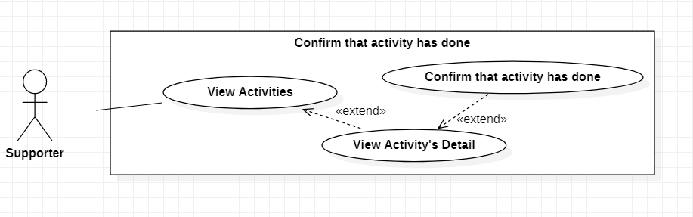

|  |  |  |  |  |
| --- | --- | --- | --- | --- |
| **USE CASE-37 SPECIFICATION** | | | | |
| **Use-case No.** | UC037 | **Use-case Version** | | 1.0 |
| **Use-case Name** | Confirm that Activity has done | | | |
| **Author** | Nguyen Quoc Vinh | | | |
| **Date** | 24/02/2021 | **Priority** | Low | |
| **Actor:**  Supporter  **Summary:**  When Supporter has completed his task, Supporter can confirm to inform the Team's process.  **Goal:**  To confirm that activity has done  **Triggers**  Supporter clicks “finish” button  **Preconditions:**  PRE-1. User’s identity has been authenticated  PRE-2. User is authorized to Supporter role  PRE-4. Team has at least one unfinished activity.  **Post Conditions:**  POST-1. The activity is marked as done.  **Main Success Scenario:**     |  |  | | --- | --- | | Supporter | System | | 1. Supporter clicks “view activities” button | 1. System checks whether there is existed an activity: - If existed, system shows the list of activities  - If not existed, system show “There aren’t any activities” message. | | The steps below are valid when the activities existed | | | 2. Supporter selects the filter to show unfinished activities. | 1. System checks whether there is existed an unfinished activity: - If existed, system shows the list of unfinished activities  - If not existed, system show “There aren’t any unfinished activities” message | | The steps below are valid when the unfinished activities existed | | | 3. Supporter selects activities | 3. System focuses the selected activities | | 4. Supporter clicks “finish” button. | 4. System shows successful message and marks done for the selected activities. |   **Alternative Scenario:**  N/A  **Exceptions:**   |  |  | | --- | --- | | Cause | System | | 1. There aren’t any unfinished activities in Supporter’s team. | 1. System will show message on screen: “your team must have at least one unfinished activity” |   **Relationships:**  1. Extend View Activity’s Detail use case  **Business Rules:**  1. An activity is done when all Supporter of Team confirm it done | | | | |

## Use Case Register Account

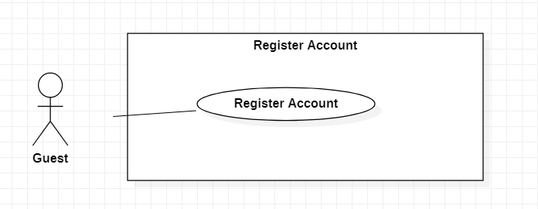

|  |  |  |  |  |
| --- | --- | --- | --- | --- |
| **USE CASE-38 SPECIFICATION** | | | | |
| **Use-case No.** | UC038 | **Use-case Version** | | 1.0 |
| **Use-case Name** | Register Account | | | |
| **Author** | Nguyen Duy Bao | | | |
| **Date** | 24/02/2021 | **Priority** | High | |
| **Actor:**  Guest.  **Summary:**  Create an account with the information that user gave.  **Goal:**  Account’s information that user request will save on database.  **Triggers**  User click on Register button.  **Preconditions:**  PRE-1. User must not be authenticated before.  PRE-2. register information (username, password, full name, phone) must not null.  PRE-3. Register request must be sent.  **Post Conditions:**  Success: Account’s information that user gave is saved on and ready to login.  Failed: Account’s information that user gave isn’t saved and close request.  **Main Success Scenario:**   |  |  |  | | --- | --- | --- | | No | Guest | System | | 1 | Open the register request | Display form with username, password, full name, phone, email | | 2 | Input register information (username, password, full name, phone, email) | Validated input | | 3 | Send the register request | All given information will save on database | | 4 |  | Back to login display |   **Alternative Scenario:**   |  |  |  | | --- | --- | --- | | No | Guest | System | | 1 | Open the register request | Display form with username, password, full name, phone, email | | 2 | Input register information (username, password, full name, phone, email) | Validated input | | 3 | Close the register request | All given information will be cleared | | 4 |  | Back to home page |   **Exceptions:**   |  |  |  | | --- | --- | --- | | No | Cause | System response | | 1 | Username is already existed | Display “username already existed” message and wait for user input another username | | 2 | Username is longer than 10 characters | Display guide message “Username can’t longer than 10 characters” | | 3 | Password is longer than 15 characters | Display guide message “Password can’t longer than 15 characters” | | 4 | Full name is longer than 30 characters | Display guide message “Full name can’t longer than 30 characters” | | 5 | Username, password, full name isn’t alphabet character | Display guide message “Username, password, full name must be alphabet character” | | 6 | Phone number doesn’t start with 0 | Display guide message “Phone must be number and start with 0” |   **Relationships:**  N/A  **Business Rules:**  User can’t create account with a same ID as existed account. | | | | |

## Use Case Login

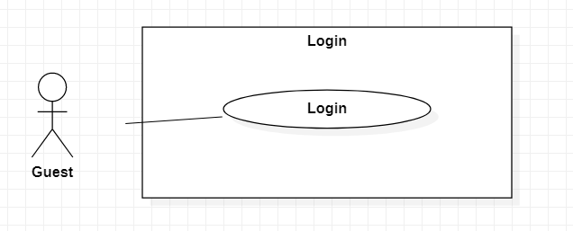

|  |  |  |  |  |
| --- | --- | --- | --- | --- |
| **USE CASE-39 SPECIFICATION** | | | | |
| **Use-case No.** | UC039 | **Use-case Version** | | 1.0 |
| **Use-case Name** | Login | | | |
| **Author** | Nguyen Duy Bao | | | |
| **Date** | 24/02/2021 | **Priority** | High | |
| **Actor:**  Guest.  **Summary:**  User can login to the app.  **Goal:**  User is defined as a donator/admin/manager/Supervisor/Accountant/ Leader or supporter.  **Triggers**  Guest click on login button.  Guest is sent after register.  **Pre conditions:**  PRE-1. User must not be authenticated before.  PRE-2. User name/password must be provided.  **Post Conditions:**  Success: User is authenticated in specific role and provide function base on the role.  Failed: User isn’t authenticated and back to login page.  **Main Success Scenario:**   |  |  |  | | --- | --- | --- | | No | Guest | System | | 1 | Open login request | Display login form (username, password) | | 2 | Input username and password | Validated input | | 3 | Send login request | Check information match with database | | 4 | Become authenticated user | Response success | | 5 |  | Back to home page |   **Alternative Scenario:**   |  |  |  | | --- | --- | --- | | No | Guest | System | | 1 | Select login with Facebook/Google account | Connect with selected platform | | 2 | Input username, password on selected platform | Send request to selected platform | | 3 | Become authenticated user | Receive response |   **Exceptions:**     |  |  |  | | --- | --- | --- | | No | Cause | System response | | 1 | Username or password is null | Display guide message “Username or password must not null” | | 2 | Username or password is not alphabet characters | Display guide message “Username and password must be alphabet character only” | | 3 | Username is longer than 10 characters | Display guide message “Username can’t longer than 10 characters” | | 4 | Password is longer than 15 characters | Display guide message “Password can’t longer than 15 characters” | | 5 | User’s username or password is not match with the one in database | Display “wrong username or password” message |   **Relationships:**  N/A  **Business Rules:**  User can’t access as an identified user without authenticated step.  User input wrong password 5 times – System blocks account for a certain period of time. | | | | |

## Use Case View Profile

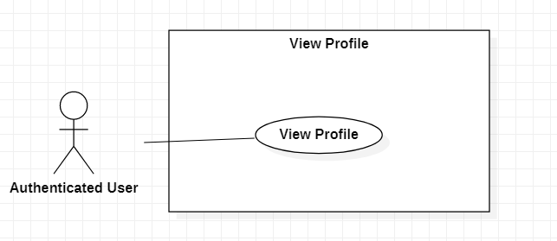

|  |  |  |  |  |
| --- | --- | --- | --- | --- |
| **USE CASE-40 SPECIFICATION** | | | | |
| **Use-case No.** | UC040 | **Use-case Version** | | 1.0 |
| **Use-case Name** | View Profile | | | |
| **Author** | Vu Thi Thuy Linh | | | |
| **Date** | 24/02/2021 | **Priority** | Low | |
| **Actor:**  Authenticated User  **Summary:**  This use case allows Authenticated User to view profile.  **Goal:**  Authenticated User can view profile.  **Triggers**  Authenticated User touches “view profile” button.  **Preconditions:**  PRE-1. User’s identity has been authenticated  **Post Conditions:**  POST-1. System shows a profile information on screen.  **Main Success Scenario:**   |  |  | | --- | --- | | Supervisor | System | | 1. Authenticated user clicks on view profile | System shows profile (name, email, phone, address, etc.) |   **Alternative Scenario:**  N/A  **Exceptions:**  N/A  **Relationships:**  N/A  **Business Rules:**  Authenticated user only view their own profile. | | | | |

## Use Case Edit Profile

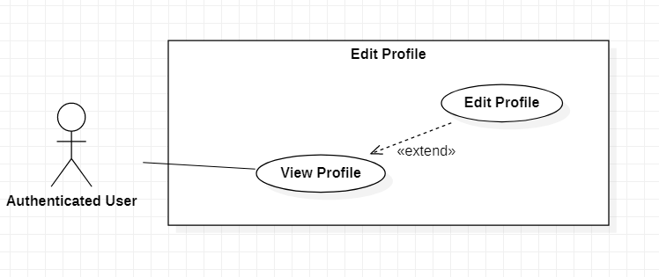

|  |  |  |  |  |
| --- | --- | --- | --- | --- |
| **USE CASE-41 SPECIFICATION** | | | | |
| **Use-case No.** | UC041 | **Use-case Version** | | 1.0 |
| **Use-case Name** | Edit Profile | | | |
| **Author** | Vu Thi Thuy Linh | | | |
| **Date** | 24/02/2021 | **Priority** | Low | |
| **Actor:**  Authenticated User  **Summary:**  This use case allows Authenticated User to edit profile.  **Goal:**  Authenticated User can edit profile.  **Triggers**  Authenticated User touches “edit profile” button.  **Preconditions:**  PRE-1. User’s identity has been authenticated  **Post Conditions:**  POST-1. Information of authenticated user updated  **Main Success Scenario:**   |  |  | | --- | --- | | Supervisor | System | | 1. Authenticated user clicks on edit profile | System shows fields such as email, name, phone, address, etc. | | 1. Authenticated user input information (email, name, phone, address, etc.) which they want to edit |  | | 1. Authenticated user clicks on “Save” button | System update profile |   **Alternative Scenario:**  Null  **Exceptions:**   |  |  | | --- | --- | | Supervisor | System | | 1. Authenticated user does not input email, name, phone, address, etc. And clicks on “Save” button | System shows error message. |   **Relationships:**  Extend for view profile  **Business Rules:**  Authenticated user only edited their own profile. | | | | |

## Use Case Logout

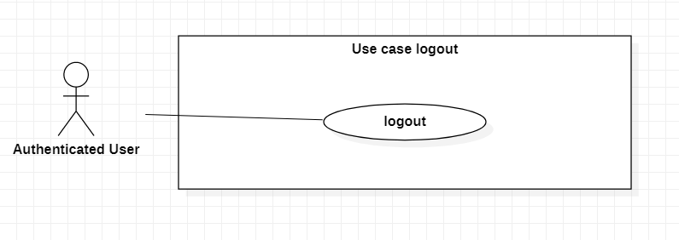

|  |  |  |  |  |
| --- | --- | --- | --- | --- |
| **USE CASE-42 SPECIFICATION** | | | | |
| **Use-case No.** | UC042 | **Use-case Version** | | 1.0 |
| **Use-case Name** | Logout | | | |
| **Author** | Le Minh Tuan | | | |
| **Date** | 24/02/2021 | **Priority** | Low | |
| **Actor:**  Authenticated User.  **Summary:**  Authenticated user (Guest after login) logout from system.  **Goal:**  Authenticated user can end of current session from system.  **Triggers**  Authenticated user (Guest after login) wants to logout from system.  **Preconditions:**  PRE-1. User’s identity has been authenticated.  **Post Conditions:**  POST-1. All information in current session will be deleted.  **Main Success Scenario:**     |  |  | | --- | --- | | Authenticated User | System | | 1. Authenticated user click “Logout” button | System navigates to login page |   **Alternative Scenario:**  N/A  **Exceptions:**  N/A  **Relationships:**  N/A  **Business Rules:**  All information of current authenticated user in session must be cleared. | | | | |

## Use Case Register to be Donator

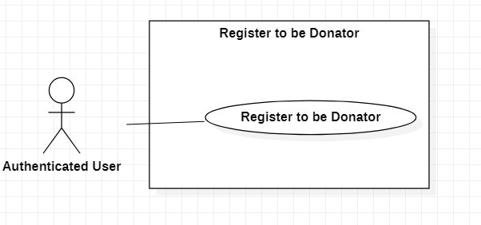

|  |  |  |  |  |
| --- | --- | --- | --- | --- |
| **USE CASE-43 SPECIFICATION** | | | | |
| **Use-case No.** | UC043 | **Use-case Version** | | 1.0 |
| **Use-case Name** | Register to be Donator | | | |
| **Author** | Le Minh Tuan | | | |
| **Date** | 24/02/2021 | **Priority** | Normal | |
| **Actor:**  Authenticated User.  **Summary:**  Authenticated user (Guest after login) can register to become a donator.  **Goal:**  Authenticated user who donated to charity campaign want to view details his/her donation’s history.  **Triggers**  Authenticated user wants to become a donator of a campaign in application.  **Preconditions:**  PRE-1. User’s identity has been authenticated.  **Post Conditions:**  POST-1. Request of registering will be sent to system.  **Main Success Scenario:**     |  |  | | --- | --- | | Accountant | System | | 1. Authenticated user click “Register to be Donator” | System navigates to donator registration page | | 2. Authenticated user fills all information to form for registering to be a donator:  - Name of authenticated user  - Birthday of authenticated user  - Phone of authenticated user |  | | 3. Authenticated user submits registering form to system | System send OTP code to phone number of authenticated users | | 4. Authenticated user input OTP code | System will show successful notification on screen | | 5. Authenticated user click “Verify” button | System show message: “Reister to be donator successfully” |   **Alternative Scenario:**     |  |  | | --- | --- | | Accountant | System | | 1. Authenticated user clicks “Register to be Donator” | System navigates to donator registration page | | 2. Authenticated user click “Back” button | System navigates to “home” page |   **Exceptions:**   |  |  | | --- | --- | | Cause | System | | 1. Name of authenticated user is blank | System shows error message “Name of authenticated user cannot be blank” | | 2. Birthday of authenticated user is blank | System shows error message “Birthday of authenticated user cannot be blank” | | 3. Phone number of authenticated users is invalid | System shows error message “Phone number of authenticated users is invalid” | | 4. OTP code is not correct | System shows error message “OTP code is incorrect” |     **Relationships:**  N/A  **Business Rules:**  N/A | | | | |

## Use Case View Campaigns

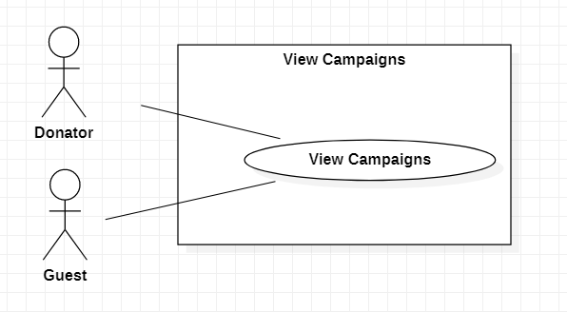

|  |  |  |  |  |
| --- | --- | --- | --- | --- |
| **USE CASE-44 SPECIFICATION** | | | | |
| **Use-case No.** | UC044 | **Use-case Version** | | 1.0 |
| **Use-case Name** | View Campaigns | | | |
| **Author** | Nguyen Duy Bao | | | |
| **Date** | 05/03/2021 | **Priority** | Normal | |
| **Actor:**  Guest, donator.  **Summary:**  View overall campaign of organization.  **Goal:**  List of organization’s campaigns will show up for user.  **Triggers**  User select 1 organization.  **Preconditions:**  PRE-1. User must choose 1 organization.  **Post Conditions:**  POST-1. Go to organization page with list of campaigns displayed.  **Main Success Scenario:**   |  |  |  | | --- | --- | --- | | No | Guest/Donator | System | | 1 | Select organization | Bring user to selected organization page | | 2 |  | display selected organization’s information (name, description) and list of campaigns |   **Alternative Scenario:**  N/A  **Exceptions:**   |  |  |  | | --- | --- | --- | | No | Cause | System response | | 1 | View campaigns while synchronize | Organization page will automatically reload every time update or create a campaign | | 2 | There no campaign in organization | Display “there no campaigns yet” message instead of campaign list |   **Relationships:**  N/A  **Business Rules:**  N/A | | | | |

## Use Case View Campaign’s Detail

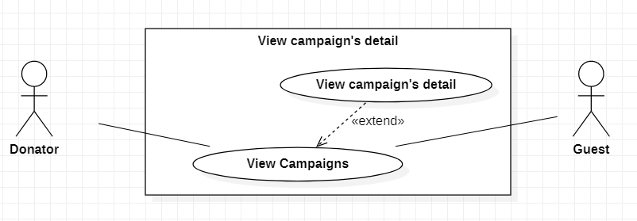

|  |  |  |  |  |
| --- | --- | --- | --- | --- |
| **USE CASE-45 SPECIFICATION** | | | | |
| **Use-case No.** | UC045 | **Use-case Version** | | 1.0 |
| **Use-case Name** | View Campaign’s Detail | | | |
| **Author** | Nguyen Duy Bao | | | |
| **Date** | 05/03/2021 | **Priority** | Normal | |
| **Actor:**  Donator, guest.  **Summary:**  Donator can view organization’s campaign in more detail like campaign’s location, when it starts and end.  **Goal:**  Display for user more detail of the campaign.  **Triggers**  User select campaign on campaign list.  **Preconditions:**  PRE-1. User must choose 1 organization before.  PRE-2. User must choose 1 campaign before.  **Post Conditions:**  POST-1. Location, started date, end date, description of selected campaign will be displayed.  **Main Success Scenario:**   |  |  |  | | --- | --- | --- | | No | Guest/Donator | System | | 1 | Select organization | Bring user to selected organization page | | 2 |  | display selected organization’s information (name, description) and list of campaigns | | 3 | Select campaign | Bring user to selected campaign page | | 4 |  | Display selected campaign information (name, description, start date, end date) |   **Alternative Scenario:**  N/A  **Exceptions:**   |  |  |  | | --- | --- | --- | | No | Cause | System response | | 1 | View campaign’s detail while synchronize | Campaign page will automatically reload every time campaign update |   **Relationships:**  View campaign.  **Business Rules:**  N/A | | | | |

## Use Case View Activities of Campaign

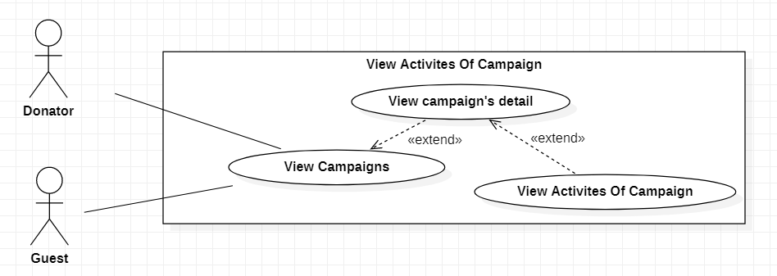

|  |  |  |  |  |
| --- | --- | --- | --- | --- |
| **USE CASE-46 SPECIFICATION** | | | | |
| **Use-case No.** | UC046 | **Use-case Version** | | 1.0 |
| **Use-case Name** | View Activities of Campaign | | | |
| **Author** | Nguyen Duy Bao | | | |
| **Date** | 05/03/2021 | **Priority** | Normal | |
| **Actor:**  Donator, guest.  **Summary:**  Donator can view organization’s schedule in more detail like campaign’s location and which group participate in campaign.  **Goal:**  Donator can see group campaign and location.  **Triggers**  User select activity.  **Preconditions:**  PRE-1. User must choose 1 organization before.  PRE-2. User must choose 1 campaign before.  PRE-3. User must choose 1 activity before.  **Post Conditions:**  POST-1. Location, participant, started date, description of selected campaign will display.  **Main Success Scenario:**   |  |  |  | | --- | --- | --- | | No | Guest/Donator | System | | 1 | Select organization | Bring user to selected organization page | | 2 |  | display selected organization’s information (name, description) and list of campaigns | | 3 | Select campaign | Bring user to selected campaign page | | 4 |  | Display selected campaign information (name, description, start date, end date, participants) | | 5 | Click “view activities” button | Display activity list of selected campaign | | 6 | Select activity | Display selected activity’s information (name, description, location, start date, end date, participants, goods consume) |   **Alternative Scenario:**  N/A  **Exceptions:**   |  |  |  | | --- | --- | --- | | No | Cause | System response | | 1 | View activity while synchronize | Campaign page will automatically reload every time activity update | | 2 | There no activity in the campaign | Display message “there no activity yet” | | 3 | Select another activity | Close previous activity’s information then display current selected activity’s information |   **Relationships:**  View campaign, View campaign’s detail.  **Business Rules:**  N/A | | | | |
|  |  |  |  |  |

## Use Case Donate to Campaign

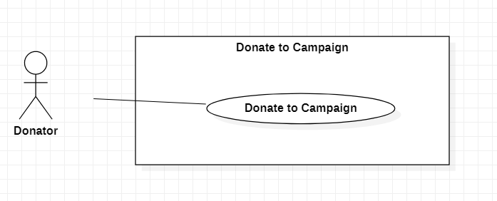

|  |  |  |  |  |
| --- | --- | --- | --- | --- |
| **USE CASE-47 SPECIFICATION** | | | | |
| **Use-case No.** | UC047 | **Use-case Version** | | 1.0 |
| **Use-case Name** | Donate to Campaign | | | |
| **Author** | Nguyen Duy Bao | | | |
| **Date** | 05/03/2021 | **Priority** | High | |
| **Actor:**  Donator.  **Summary:**  Donator transfer money to organization.  **Goal:**  Send money successfully to organization’s bank account.  **Triggers**  User click on “donate” button at organization page.  **Preconditions:**  PRE-1. User must be authenticated as donator.  PRE-2. User must choose 1 organization.  **Post Conditions:**  Success. Money transfer to organization’s account and response “success” to user then saved in user’s donation history.  Failed. Response “failed” then back to home page.  **Main Success Scenario:**   |  |  |  | | --- | --- | --- | | No | Donator | System | | 1 | select organization | Bring user to selected organization page | | 2 | Click “donate” button | Display donate form for user | | 3 | Input amount of money | Validate input | | 4 | Send donate | Send transfer request for linked bank | | 5 |  | Receive transfer success response | | 6 |  | Display “success” message for user and save current donation in user’s donation history bring user back to organization page |   **Alternative Scenario:**   |  |  |  | | --- | --- | --- | | No | Donator | System | | 1 | select organization | Bring user to selected organization page | | 2 | Click “donate” button | Display donate form for user | | 3 | Input amount of money | Validate input | | 4 | Send donate | Send transfer request for linked bank | | 5 |  | Receive transfer failed response | | 6 |  | Display “failed, please try again” message for user |   **Exceptions:**   |  |  |  | | --- | --- | --- | | No | Cause | System response | | 1 | Money input is character | Display guide message “money must be digit only” | | 2 | Money input is a negative | Display guide message “money must be greater than 10.000” | | 3 | Sent request hadn’t been response for 3 minutes | Request will be interrupted and take over as a transfer failed response |   **Relationships:**  N/A  **Business Rules:**  Donator money must be reduced and organization’s account must be increase while transfer success.  Donator money must not be changed either organization’s account while transfer failed. | | | | |
|  |  |  |  |  |

## Use Case Choose to Anonymize

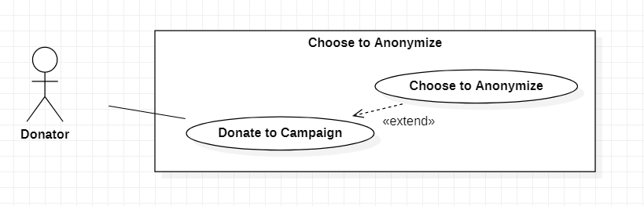

|  |  |  |  |  |
| --- | --- | --- | --- | --- |
| **USE CASE-48 SPECIFICATION** | | | | |
| **Use-case No.** | UC048 | **Use-case Version** | | 1.0 |
| **Use-case Name** | Choose to Anonymize | | | |
| **Author** | Nguyen Duy Bao | | | |
| **Date** | 12/03/2021 | **Priority** | Normal | |
| **Actor:**  Donator.  **Summary:**  Donator can decide their information will public or private.  **Goal:**  User’s name won’t display on organization’s history.  **Triggers**  user check “hidden information” box at donate form.  **Preconditions:**  PRE-1. Must authenticated as donator.  PRE-1. Donation must be opened.  **Post Conditions:**  POST-1. Donation save in organization donation’s history as a hidden name.  **Main Success Scenario:**   |  |  |  | | --- | --- | --- | | No | Donator | System | | 1 | select organization | Bring user to selected organization page | | 2 | Click “donate” button | Display donate form for user | | 3 | Input amount of money | Validate input | | 4 | Check “hidden information” box in donation form | Switch to anonymous mode | | 5 | Send donate | Save in selected organization’s donation history with donator information will be hidden |   **Alternative Scenario:**   |  |  |  | | --- | --- | --- | | No | Donator | System | | 1 | select organization | Bring user to selected organization page | | 2 | Click “donate” button | Display donate form for user | | 3 | Input amount of money | Validate input | | 4 | Send donate | Save in selected organization’s donation history with donator information |     **Exceptions:**   |  |  |  | | --- | --- | --- | | No | Cause | System response | | 1 | Failed donation | Donation will be interrupted and donation won’t be saved in organization's donation history |   **Relationships:**  Donate to Campaign.  **Business Rules:**  It is the user's decision to hide information or not. | | | | |

## Use Case View Your Own Donation

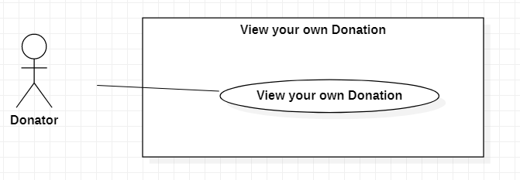

|  |  |  |  |  |
| --- | --- | --- | --- | --- |
| **USE CASE-49 SPECIFICATION** | | | | |
| **Use-case No.** | UC049 | **Use-case Version** | | 1.0 |
| **Use-case Name** | View Your Own Donation | | | |
| **Author** | Nguyen Duy Bao | | | |
| **Date** | 12/03/2021 | **Priority** | Normal | |
| **Actor:**  Guest.  **Summary:**  Donator can view their money which give to organization.  **Goal:**  Donator can see the list organization with amount of given money.  **Triggers**  User click on “view my donation” in user profile.  **Preconditions:**  PRE-1. User must be authenticated as donator.  **Post Conditions:**  POST-1. list of organization receives current user’s donation.  **Main Success Scenario:**   |  |  | | --- | --- | | Donator | System | | 1. Send “view own donate” |  | |  | 1. Search donation by current user in database | |  | 1. Display The list of organization that donator participated with donated money |   **Alternative Scenario:**   |  |  | | --- | --- | | Donator | System | | 1. Send “view own donate” |  | |  | 1. Search donation by current user in database | |  | 1. There no donation | |  | 1. Display The blank list with “no donation currently” |   **Exceptions:**  N/A  **Relationships:**  N/A  **Business Rules:**  N/A | | | | |

## Use Case Search Organization

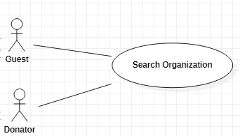

|  |  |  |  |  |
| --- | --- | --- | --- | --- |
| **USE CASE-49 SPECIFICATION** | | | | |
| **Use-case No.** | UC050 | **Use-case Version** | | 1.0 |
| **Use-case Name** | Search Organization | | | |
| **Author** | Nguyen Duy Bao | | | |
| **Date** | 15/03/2021 | **Priority** | Normal | |
| **Actor:**  guest, donator.  **Summary:**  User can search organization.  **Goal:**  List of organization that match with organization’s name user give.  **Triggers**  User input organization name in search bar.  **Preconditions:**  PRE-1. Must give some name or keyword.  **Post Conditions:**  success. Display list of organization with similar with the name that user give.  failed. Display message “there no organization similar with” to user.  **Main Success Scenario:**   |  |  |  | | --- | --- | --- | | No | Guest/Donator | System | | 1 | Give organization name or keyword | Validate input | | 2 | Click “search” button | Search organization by given name/keyword | | 3 |  | Bring user to search page | | 4 |  | Display list of organization have name match with given name/keyword |   **Alternative Scenario:**   |  |  |  | | --- | --- | --- | | No | Guest/Donator | System | | 1 | Give organization name or keyword | Validate input | | 2 | Click “search” button | Search organization by given name/keyword | | 3 |  | There no organization have name match with given name/keyword | | 4 |  | Display message “there no organization similar with” for user |   **Exceptions:**   |  |  |  | | --- | --- | --- | | No | Cause | System response | | 1 | Didn't input character then search | Display guide message “please give some characters before search” for user | | 2 | Input digit instead of character | Display guide message “please give character only” | | 3 | Input 3 character or less | Display guide message “please input more than 3 character” |   **Relationships:**  N/A  **Business Rules:**  Always display organization list from the top to bottom without bias. | | | | |

## Use Case View Report from Supporter

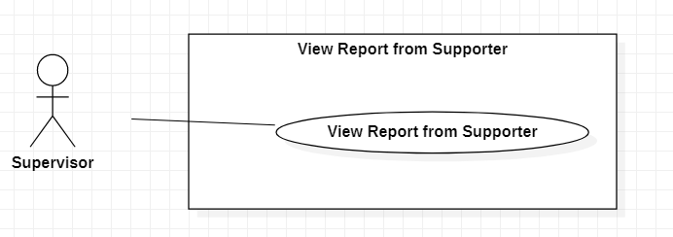

|  |  |  |  |  |
| --- | --- | --- | --- | --- |
| **USE CASE-51 SPECIFICATION** | | | | |
| **Use-case No.** | UC051 | **Use-case Version** | | 1.0 |
| **Use-case Name** | View Report from Supporter | | | |
| **Author** | Nguyen Quoc Vinh | | | |
| **Date** | 15/03/2021 | **Priority** | Low | |
| **Actor:**  Supervisor  **Summary:**  When Supporter sends the report for cheating, then Supervisor can view this report.  **Goal:**  To view the report of Supporter  **Triggers**  Supervisor clicks “view reports” button  **Preconditions:**  PRE-1. User’s identity has been authenticated  PRE-2. User is authorized to Supervisor role  **Post Conditions:**  POST-1. The list of reports will be shown on screen.  **Main Success Scenario:**     |  |  | | --- | --- | | Supervisor | System | | 1. Supervisor clicks “view reports” button | 1. System checks whether there is existed an report: - If existed, system shows the list of reports  - If not existed, system show “There aren’t any reports” message. |   **Alternative Scenario:**  N/A  **Exceptions:**   |  |  | | --- | --- | | Cause | System | | 1. There aren’t any reports from Supporter. | 1. System will show message on screen: “No more report to view from Supporter” |   **Relationships:**  N/A  **Business Rules:**  N/A | | | | |

## Use Case Ban User

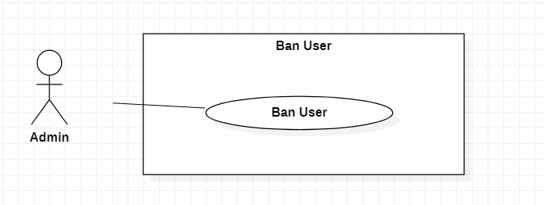

|  |  |  |  |  |
| --- | --- | --- | --- | --- |
| **USE CASE-52 SPECIFICATION** | | | | |
| **Use-case No.** | UC052 | **Use-case Version** | | 1.0 |
| **Use-case Name** | Ban User | | | |
| **Author** | Nguyen Duy Bao | | | |
| **Date** | 15/03/2021 | **Priority** | Low | |
| **Actor:**  Admin.  **Summary:**  Admin can block user’s account.  **Goal:**  Blocked user can not join any activities.  **Triggers**  Admin click on “ban” button in user profile.  **Preconditions:**  PRE-1. Must be authenticated as an admin.  PRE-2. Selected account must be available.  **Post Conditions:**  POST-1. Account’s status set as banned.  **Main Success Scenario:**   |  |  |  | | --- | --- | --- | | No | Admin | System | | 1 | Select user | Display selected user profile | | 2 | Click “ban” button in user profile | Set banned status on user’s information | | 3 |  | Close user profile |   **Alternative Scenario:**   |  |  |  | | --- | --- | --- | | No | Admin | System | | 1 | Open available user list | Search and display users with available status | | 2 | Select user in a list | Display user profile | | 3 | Click “ban” button in user profile | Set banned status on user’s information | | 4 |  | Close user profile |   **Exceptions:**   |  |  |  | | --- | --- | --- | | No | Cause | System response | | 1 | selected user already banned | Display “unban” button instead of “ban” button |   **Relationships:**  N/A  **Business Rules:**  Only ban user that seriously harm for other. | | | | |

## Use Case Unban User

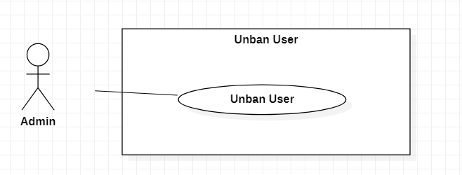

|  |  |  |  |  |
| --- | --- | --- | --- | --- |
| **USE CASE-53 SPECIFICATION** | | | | |
| **Use-case No.** | UC053 | **Use-case Version** | | 1.0 |
| **Use-case Name** | Unban User | | | |
| **Author** | Nguyen Duy Bao | | | |
| **Date** | 15/03/2021 | **Priority** | Low | |
| **Actor:**  Admin.  **Summary:**  Admin can withdraw the ban order from user.  **Goal:**  Allow banned user to operate.  **Triggers**  Admin click on “unban” button in banned user profile.  **Preconditions:**  PRE-1. Must be authenticated as an admin.  PRE-2. Selected account must be banned.  **Post Conditions:**  Account’s status set as available.  **Main Success Scenario:**   |  |  |  | | --- | --- | --- | | No | Admin | System | | 1 | Select banned user | Display selected user profile | | 2 | Click “unban” button in user profile | Remove banned status on user’s information | | 3 |  | Close user profile |   **Alternative Scenario:**   |  |  |  | | --- | --- | --- | | No | Admin | System | | 1 | Open available banned user list | Search and display users with banned status | | 2 | Select user in a list | Display user profile | | 3 | Click “unban” button in user profile | Remove banned status on user’s information | | 4 |  | Close user profile |   **Exceptions:**   |  |  |  | | --- | --- | --- | | No | Cause | System response | | 1 | selected user that didn’t have banned status | Display “ban” button instead of “unban” button |   **Relationships:**  N/A  **Business Rules:**  Make sure user won’t relapse, only unban for once. | | | | |

## Use Case View List of Campaigns

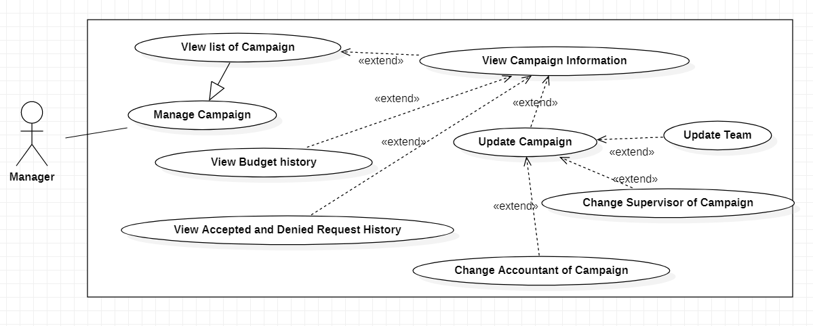

|  |  |  |  |  |
| --- | --- | --- | --- | --- |
| **USE CASE-54 SPECIFICATION** | | | | |
| **Use-case No.** | UC054 | **Use-case Version** | | 1.0 |
| **Use-case Name** | View list of Campaigns | | | |
| **Author** | Hoang Gia Thien Phuc | | | |
| **Date** | 18/03/2021 | **Priority** | High | |
| **Actor:**            Manager  **Summary:**  This use case allows manager to view list of campaigns  **Goal:**  To view list of campaigns  **Triggers**            Manager clicks “View list of Campaigns” button on menu  **Preconditions:**              PRE-1. User’s identity has been authenticated              PRE-2. User is authorized to Manager role  **Post Conditions:**              POST-1.  Display list of campaigns of organization  **Main Success Scenario:**     |  |  |  | | --- | --- | --- | | No. | Actor Action | System | | 1 | Manager clicks “View list of Campaigns” | If organization has at least one campaign:  - System display list of campaigns includes:  + Campaign name  + Start time  + Duration  + “View Campaign Information”: button  If organization has not campaign yet  - System show message “No campaign yet” |     **Alternative Scenario:**  *N/A*  **Exceptions:**  *N/A*  **Relationships:**extend for View Campaign Information  **Business Rules:**  *N/A* | | | | |

## Use Case View Campaign Information



|  |  |  |  |  |
| --- | --- | --- | --- | --- |
| **USE CASE-55 SPECIFICATION** | | | | |
| **Use-case No.** | UC055 | **Use-case Version** | | 1.0 |
| **Use-case Name** | View Campaign Information | | | |
| **Author** | Hoang Gia Thien Phuc | | | |
| **Date** | 18/03/2021 | **Priority** | High | |
| **Actor:**           Manager  **Summary:**  This use case allows manager to view campaign information.  **Goal:**  To update campaign  **Triggers**         - Manager clicks “View Campaign Information” button of a campaign in list of campaign  **Preconditions:**             PRE-1. User’s identity has been authenticated             PRE-2. User is authorized to Manager role             PRE-3. Organization has at least one campaign  **Post Conditions:**             POST-1. Display detail of selected campaign  **Main Success Scenario:**     |  |  |  | | --- | --- | --- | | No. | Actor Action | System | | 1 | Manager clicks “View Campaign Information” button | System shows a page include campaign information:   - Name of Campaign   - Area in need of assistance     +Hamlet: drop down list     +Commune: drop down list     +District: drop down list     +Province/City: drop down list, required   - Start Time: date   - Duration: months/years   - Contact Information   - Budget Guess of Campaign  - “View Donation”: button  - “View Budget History”: button  - “View Request History”: button   - “Update Campaign”: button |     **Alternative Scenario:**  N/A  **Exceptions:**  N/A  **Relationships:**extend for View list of Campaigns, extended by View Budget History, extended by View Donation, extended by View Accepted and Denied Request History, extended by Update Campaign  **Business Rules:**            N/A | | | | |

# NON-FUNCTIONAL Requirements

## Usability

- GUI: using Microsoft’s GUI standards

- Number of pages in guidance document: is not over 150 pages

## Reliability

- Availability: User can access website/mobile app 24/7 except system maintenance time (system will send notification to users 2-3 days in advance of system maintenance time)

- Mean Time Between Failures (MTBF): require not to be less than 120 hours

- Mean Time To Repair (MTTR): the system is allowed to stop working in less than 2 hours after it failed.

- Maximum Bugs or Defect Rate: require less than 2 bugs/function-point

- Bugs or Defect Rate

+ Minor bugs: response time is higher than expectation, UI is not responsive, etc.

+ Significant bugs: function does not behave in the way stated in document, etc.

+ Critical bugs: complete loss of data or a complete inability to use certain parts of the system’s functionality, system stop working, etc.

## Performance

- The website/mobile app should load and be usable within 2 seconds. With banking related function, the website/mobile app should load and be usable within 10 seconds

- The website/mobile app should update the interface on interaction within 2 seconds.

- The website/mobile app should handle over 1,000 requests sent one time.

- The website/mobile app should accommodate over 3000 users on one time.

- The database should be normalized to prevent redundant data and improve performance

## Supportability

- Coding standard:

+ Variable name, the function name must be meaningful

+ Package names must be lowercase

+ The class name must start with the noun, the first letter in uppercase and then use the camel rule to write the remaining components

+ The function name must start with the verb, the first letter in lowercase, then use the camel rule to write the remaining elements.

+ The variable name must be a noun that begins with a lowercase letter, then use the camel rule to write the remaining elements, the next words starting with a capital letter

+ The constant name must be all capital letters, separated words by the underscore character"_"

- Name Conventions: Camel Rule