SOAPSV-Pipeline-Doc
Version 1.02

Name： SOAPSV
Author： Ruibang Luo luoruibang@genomics.org.cn,
Hancheng Zheng zhenghch@genomics.org.cn,

Content

Ⅰ .Pipeline introduction
- Pipeline flow chart
- Pipeline Strategy

Ⅱ .Pipeline steps

  - Preparation for assembly
  - Assembly
  - Soap alignment
- Blat alignment
- Lastz alignment
- SV Calling
- Validation

Main Body

Ⅰ Pipeline introduction

1 Pipeline flow chart
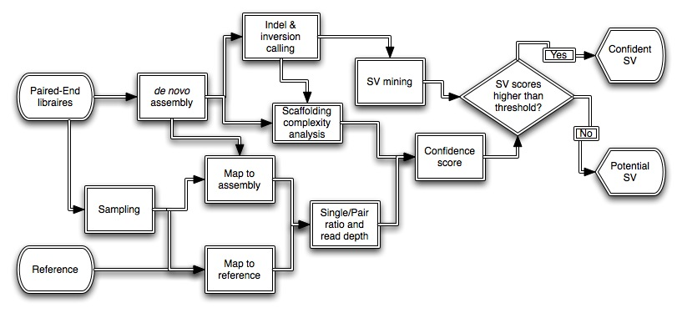

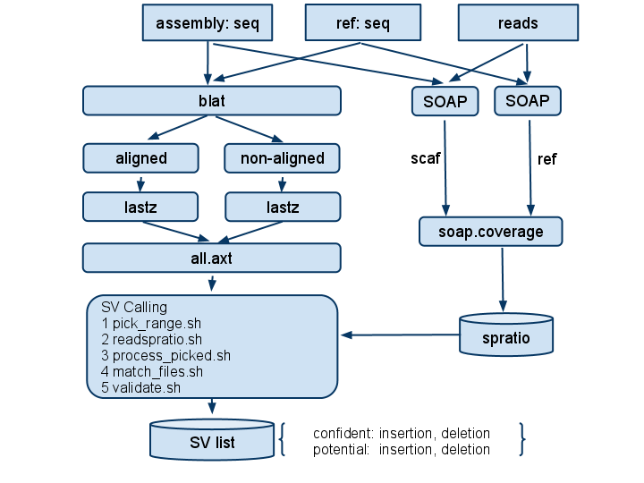

2 Pipeline strategy
- Assembly
- Software：SOAPdenovo
Note：
Do not use –R(dealing with small repeats) and –F(filling gap inside scaf) parameter
The final sv length will depend on the number of -M parameter(0,1,2,3).

- Data preparation (for SV calling)
- blat the scaf to the reference
- For the scaffolds aligned in the blat result(all.psl),lastz these scaffolds to the reference’s chromosome
- For the scaffolds not aligned in the blat result,lastz these scaffolds to the whole reference
- Combine these two lastz result(all.axt) for SV calling
- SV calling
  - Correcting the result：correction,sort
  - call indel
  - detect inversion

- Validation
  - Align the reads to scaffolds and reference by SOAP,getting the spration and read depth
  - Score for the SV
  - Divide the SV in two group confident and potential by threshold

Ⅱ Pipeline steps

1 Preparation
============================================================
- Data preparation
- Assembly result(all the files):
Sequence files: .scafSeq and .contig
Note: For the sequence started with C in the ./scafSeq,we provide SV detection but without pair-end information it will be validated by split read.
- Reference: (including the lastz indexed files,if not see below)
Note: When the reference sequence is large than 300 M base pairs ,it is suggested to be indexed for reference in lastz. Otherwise, for bacteria genome, run lastz directly.
c. Alignment result(gap-align,bam format)

Lastz indexing:
In the directory of reference:
for i in `ls prefix*`; do scrPATH/lastz $i[unmask][multi] --writecapsule=$i.capsule --seed=12of19 --word=31 --step=5; done
ls /FULLPATH/ref/*capsule >capsule.list
Note:
scrPATH is the path of the directory of the scripts file.
If the prefix of chromosome from reference is not ‘prefix’, please modify the command.
Lastz’s parameter target[unmask][multi],unmask means changing all the lowercase to uppercase in case of ignoring the repeat sequence and multi means multiple sequence as target.
Seed: 12of19,14of22,match<length>,half<length>,<pattern>,the default is 12of19
Word: <=31, the large number in the hash string ,default is 28,the smaller number the smaller memory
Step: default is 1
For more information about lastz：http://www.bx.psu.edu/miller_lab/dist/README.lastz-1.01.50/README.lastz-1.01.50.html

- Programs and scripts preparation
Download from: http://yh.genomics.org.cn/download.jsp
- Storage preparation
Creat a directory such as prj_sv_renal

Note: the final directory would be
Prj_sv_renal/
|_ref/
|_asm/
|_ seperate
|_blat/
|_blat/
|_list/
|_fa/
|_ ...
|_result/
|_prefix01/
|_prefix02/
|_......
|_novel/
|_process/
|_sv/

2 Blat alignment : input the reference sequence and the assembly sequence ,output is all.psl
============================================================
- Creat the ref directory , ln or ln –s or cp the ref sequence and generate a file name ref.fa.list (ls *fa > ref.fa.list) and the lastz indexed files and capsule.list
at prj_sv_renal
mkdir ref
cp or ln –s the files…
- Creat the asm directory,for assembly result and preparation of blat step
at prj_sv_renal
mkdir asm
cd asm/
ln –s assembly-result/human* . #files from assembly result
scrPATH/fa_stat.pl human.scafSeq >human.scafSeq.fastat
rm human.newContigIndex #rebuilt this file
scrPATH/Read2Scaff scaff -g human >run.log #a lot of memory

at asm
mkdir seperate
scrPATH/fasta_seperator human.scafSeq human seperate/ 20000000
cd seperate
ls `pwd`/* >fa.list

- Generate the blat script
at prj_sv_renal
mkdir blat
cd blat
mkdir blat
cd blat

cp scrPATH /blat_scriptmaker.* ./
./blat_scriptmaker /FULLPATH/../asm/separate/fa.list /FULLPATH/…/ref/ref.fa.list `pwd` >run.sh

#Seperate the run.sh’s line into many files and run them on multiple computer nodes.That will be faster.
#After running:
cat chr*psl >all.psl
#do not use cat * > all.psl
# blat is finished

3 Lastz alignment: run it for two parts and combine the result together,input is assembly results and all.psl form blat ,output is all.axt
============================================================
For the aligned scaffolds in blat:
at prj_sv_renal/blat
#cp scrPATH/lastz_ scriptmaker.cpp ./
#open lastz_scriptmaker.cpp ,modify ‘-ydrop=50000’,and g++ again
#Open .cpp file to modify targetcapsule value for your capsule.list,if needed.
g++ lastz_scriptmaker.cpp –o lastz_scriptmaker
#the two parameter of the scripts are assembly sequence , lastz output directory.
./ lastz_scriptmaker /FULLPATH/../asm/separate/fa.list `pwd` >run.sh
run run.sh
#Seperate the run.sh’s line into many files and run them on multiple computer nodes.That will be faster.
#memory is about 1.9 G

#Check the result of lastz: if markend parameter is used ,then inside the lastz output files .axt ,the last line should be ‘# lastz end-of-file’ if successfully runned,otherwise another text.
at result/
tail -1 */*axt | perl -e 'while ($i=<>){chomp $i; next if $i=~/^$/;chomp($j=<>); next if $j=~/^$/; $i=~ /==> (.*) <==/;print "$1\n" unless $j=~/^#/;}'

For rerun them:

grep –f `tail -1 */*axt | perl -e 'while ($i=<>){chomp $i; next if $i=~/^$/;chomp($j=<>); next if $j=~/^$/; $i=~ /==> (.*) <==/;print "$1\n" unless $j=~/^#/;}'
` run.sh > rerun.sh

For the un-aligned scaffolds in blat
at prj_sv_renal
mkdir novel
cd novel
cp scrPATH/pipeline.sh .

sh pipeline.sh /FULLPATH/../asm/uhman.scafSeq /FULLPATH/../blat /FULLPATH/../novel/ |sh

#open scriptmaker_new.cpp ,modify ‘-ydrop=50000’,and g++ again
g++ novel_scriptmaker.cpp –o novel_scriptmaker

./novel_scriptmaker /FULLPATH/../asm/human.scafSeq /FULLPATH/../result/ human >run.sh
#the three parameter of the scripts are assembly sequence ,lastz output directory and job name.

run run.sh
#Seperate the run.sh’s line into many files and run them on multiple computer nodes.That will be faster.
#memory is about 1.9 G

4 SV Calling : input all.axt ,assembly results,output is SV files(indel,inversion)
============================================================

- Merge two parts lastz result
at prj_sv_renal
mkdir process
cat /FULLPATH/../blat/*axt >all.axt
cat /FULLPATH/../novel/result/*axt >>all.axt

- call sv ： key steps
at prj_sv_renal/process
cp scrPATH/iter.sh .
sh iter.sh all.axt /FULLPATH/../asm/human.scafSeq.fastat human /FULLPATH/../asm/human.scafSeq > run.sh

# memory is 30G for human and should be finish within an hours
# sv calling is finished

5 Validation
============================================================
Divide the SV result into two parts,longer than 50 bps and shorter than 50bps
For longer than 50 bps:

- soap.coverage : using soap aligner to get the depth result
at prj_sv_renal
mkdir cvg; cd cvg; mkdir ref; mkdir scaf

Note : the single.list and soap.list are coming from SOAP align result : they are reads in fastq format,reference sequence and assembly scaffolds

SOAP pipeline：
reads vs ref

reads vs scaf

in scaf:
single :
scrPATH/soap.coverage -cvg -il single.list -o single.o -depthsingle single.ds -plot single.plot 0 250 -precise -onlyuniq -p 8 -nowarning -refsingle ../../asm/*scafSeq

soap:
scrPATH/soap.coverage -cvg -il soap.list -o soap.o -depthsingle soap.ds -plot soap.plot 0 250 -precise -onlyuniq -p 8 -nowarning -refsingle ../../asm/*scafSeq

scrPATH/singlespratio single.ds soap.ds > spratio

in ref:
# similar to the steps of scaf,modify –refsingle to -reffastat
single :
scrPATH/soap.coverage -cvg -il single.list -o single.o -depthsingle single.ds -plot single.plot 0 250 -precise -onlyuniq -p 8 -nowarning –reffastat /FULLPATH/../ref/human.fastat

#human.fasta can be generate by scrPATH/fa_stat.pl

soap:
scrPATH/soap.coverage -cvg -il soap.list -o soap.o -depthsingle soap.ds -plot soap.plot 0 250 -precise -onlyuniq -p 8 -nowarning –reffastat /FULLPATH/../ref/human.fastat

scrPATH/singlespratio single.ds soap.ds > spratio

Note: parameter of soap.covrage
-cvg choose the coverage mode
-il list files of SOAP result
-o output file name
-depthsingle coverage file
-plot [filename] [x-axis lower] [x-axis upper] output the number of postion of certain depth
-precise precise counting --- ignore mismatch in SOAP
-onlyuniq using the uniq mapping reads
-nowarning nowaring information
-reffastat fasta files of assembly result
-refsingle fasta files of reference

More detail seeing：/panfs/RD/luoruibang/bin/soap.coverage/soap.coverage

- SV validation:
at prj_sv_renal
mkdir sv
cd sv
ln ../process/human_in* .
awk '{print $1,$3,$4}' max_intro_indels > max_intro_indels.scaflist
nohup scrPATH/scafcomplex805 /FULLPATH/../asm/human.scafSeq.fastat human_intro_indels.scaflist /FULLPATH/../asm/readonscaf/ >scresult 2>scerror &

- copy five shell ：
at sv/
cp scrPATH/indel_validation/sh/* .
chmod -w human_in*
#before you run these commands , open the .sh file and modify the scrPATH into your full path.
#perl module for chisquare is needed and modify the full path in scrPATH/indel_validation/indel_validation.pl
sh 1.pick_range.sh 50 human_intro_indels human_inversion | sh #files of indel and inversion
sh 2.readspratio.sh /FULLPATH/../cvg/hg18/spratio /FULLPATH/../cvg/scaf/spratio
sh 3.process_picked.sh
sh 4.match_files.sh

at cvg/
for i in `ls */*plot`; do awk '{if($1!=0&&$2>total){mark=$1;total=$2}}END{print file"\t"mark"\t"total}' file=$i $i; done

scrPATH/sv_validate_combinator human_intro_indels insertion.validated deletion.validated scresult 0 all.validated

sv_validate_combinator parameter：
rgv1 SV list
scaffold81447 Deletion 43 43 chr1 141814174 141814175 G +
scaf_name type s_start s_end ref_name r_start r_end segment strand
argv2 S/P ratio insertion validated
insertion0 chr17 33150964 33150964 scaffold93066 387 390
type ref_name r_start r_end scaf_name s_start s_end
argv3 S/P ratio deletion validated
deletion0 chrX 152679503 15267950 C119122584 42 42
type ref_name r_start r_end scaf_name s_start s_end
argv4 Scaffolding Complexity output
1 scaffold1 3341 3341 5730 3041 3641 6 6705 0.25 1.72 1.05 0.17 0.71
avai_mark scaf_name s_start s_end s_max_len ext_s ext_e ext_type acc. ener. entr. contr. corr. loc.
argv5 Huge_SV Scaffolding Complexity output (0 to bypass)
1 scaffold1 3341 3341 5730 3041 3641 6 6705 0.25 1.72 1.05 0.17 0.71
avai_mark scaf_name s_start s_end s_max_len ext_s ext_e ext_type acc. ener. entr. contr. corr. loc.
argv6 Results output

mkdir validated
cd validated
ln ../all.validated ./
cp scrPATH/callSV/mk_list.sh .
sh mk_list.sh all.validated prefix
nohup scrPATH/sv_trans_dupli/svtd2 human_intro_indels sv_list sv_detail &

# validation is finish for long SV

For the SV shorter than 50 bps
scrPATH/scaf_curation/scaf_restrictor -P 1 -o outfile -b FULLPATH/BAM.file

The overlap between this result and the short SV is the validated result.

Note:
For scaf_restrictor,change the boost path in scrPATH/scaf_curation/Makefile and make again.
If a GPL error happens when compiling the code,please add GPL header to all the source code as SOAPdenovo’s from soap.genomics.org.cn.

# End of the document

