Tutorial --
by:
Muhammad Awais Rafique
Amir Moeini
Linjian Xiang

PX4 platform:

start up:

1. add application
a. create folder and files in px4/src/module
e.g. for the directory of mc_TASK
b. in px4/src/module/ApplicationName add CmakeLists.txt
for example mc_TASK, the mc_TASK_main from mc_TASK_main.cpp will be run
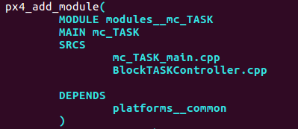

2. write application
a. include topics files that need to be publicated and subscripte to /px4/src/lib/controllib/uorb/blocks.hpp
e.g.
#include <uORB/topics/vehicle_secondary_attitude_setpoint.h>

b. add publication and subscription topics in /px4/src/lib/controllib/uorb/blocks.hpp
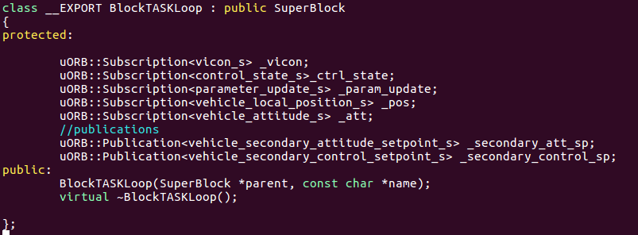
TopicName_s --uORB structures, which is from the included TopicName.h file and that file is created automaticlly by /px4/msg/TopicName.msg
_TopicName – topic names that used in the current application
c. To initialize the class BlockTASKLoop , add the following subscriptions and publications to
/px4/src/lib/controllib/uorb/blocks.cpp
–need to have same order as blocks.hpp

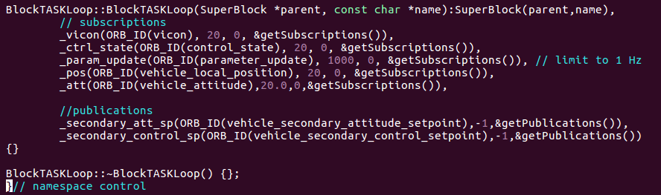
d. create application start up file
e.g.it contains “start”, “status” and “stop” comands and create a thread to run mc_TASK application. Which is samiliar with the project discussed at the last section. See the mc_TASK application for reference, which is under /px4/src/moudule/mc_TASK
e. create paramter file to define parameters
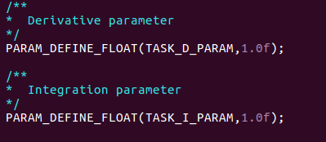
e.g the mc_TASK application has mc_TASK_params.c

this parameters can be get by following command
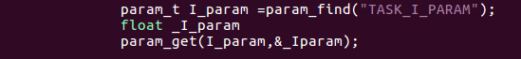

the parameters can also be used directly in Block class, see section f.
f. create BlockName.hpp the header file of BlockName.cpp, where contains the function called by start up file and subfunctions.
e.g. the BlockTASKController.hpp has following class, it has the control::BlockTASKLoop, which has same name class from /px4/src/lib/controllib/uorb/blocks.hpp and blocks.cpp
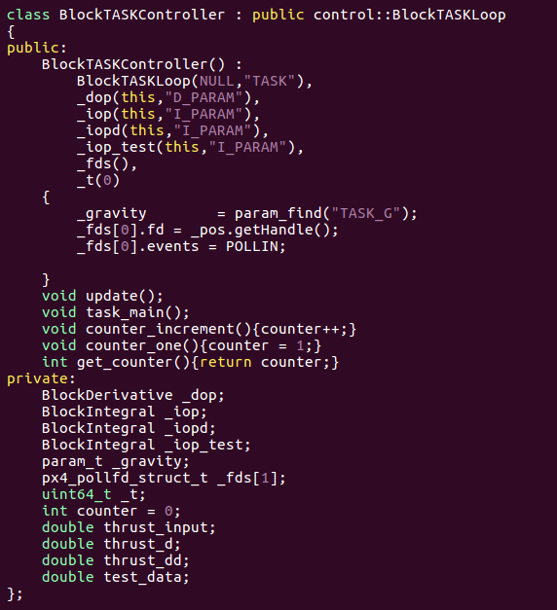
To use the built in block classes to do integrations or deriatives. In private, for example we firstly declear BlockIntegral _iop; the BlockIntegral class has following structure. /px4/src/lib/controllib/blocks.hpp.
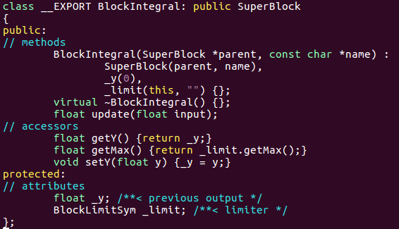
The update function is used to update the integration. It takes the uses the previous value (getY()) to add to the new input (input) times the delta t (getDt()). Then pass the calcualted result to a limiter to get new output and store it by setY(). /px4/src/lib/controllib/blocks.cpp
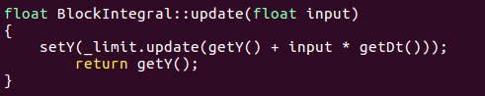

For example, in the BlockTAASKController.cpp the BlockIntegral typed _iop is used to make this->thrust_d is equal to the integration of this->thrust_dd

* There are also BlcokDerivative BlockLowpass BlockHighpass BlockPI BlockPID, they are all use upadate function to get new result.
g. create BlockName.cpp
e.g BlockTASKController.cpp
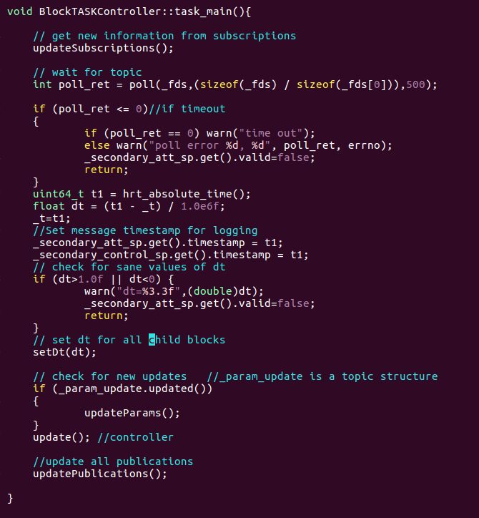
The updateSubscriptions renew subscriptions initialized at /px4/src/lib/controllib/uORB/blocks.hpp. Also for the updatePublications, it updates all publications initialized. These two functions are located at /px4/src/lib/controllib/block/Block.
setDt(dt) will make the dt value used into integrations and derivatives.
update() contains the sfbl controller, which will be discussed afterwards.

3. run the application
i). build and flash the code
a). connet the PX4 and computer with usb micro cable
b). In order to build the new added application, the build configuration should be modified. e.g to build the mc_TASK application to the ancl project for PX4-v2, the modules/mc_task should be added to the file
/px4/cmake/configs/nuttx_px4fmu-v2_ancl.cmake
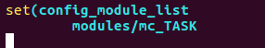

c). build and flash the code: in the dirctory /px4. e.g to build and flash the ancl project on PX4-v2, we run
make px4fmu-v2_ancl upload
ii). control application from system console, for details please see: https://dev.px4.io/en/debug/system_console.html
1.connect serial port 4/5 from px4 to FTDI cable:
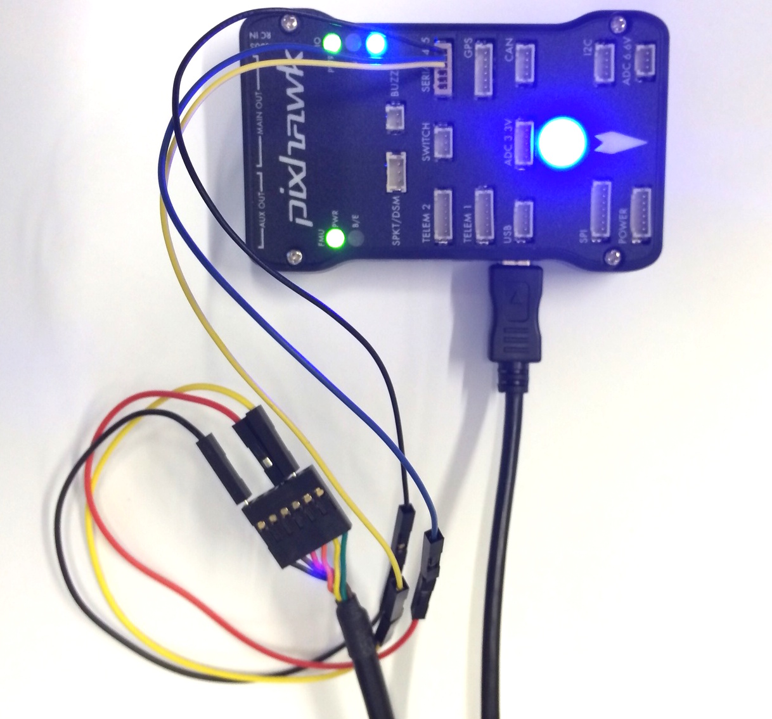
2. install screen on Ubuntu
sudo apt-get install screen
3. start screen:
a) use ls /dev/tty* and watch what changes when unplugging / replugging the USB device. Common names are /dev/ttyUSB0 and /dev/ttyACM0
b) after getting the port which the usb connected to, use command to open screen console. e.g. screen /dev/ttyUSB0 BAUDRATE 8N1
* to start a application, use ApplicationName start, use ApplicationName stop to terminate the application and ApplicationName status to check its status. The functions relates to start, stop, status can be edited at px4/src/module/ApplicationName/ApplicationName_main.cpp

iii) Starts the applications automatically
-the startup settings are located at: /px4/ROMFS/px4fmu_common/init.d
-the startup script for all of the applicatins: /px4/ROMFS/px4fmu_common/init.d/rcS
-the quad apps’ start up: /px4/ROMFS/px4fmu_common/init.d/rc.mc_apps
e.g. after adding the follwing highlighted command, the mc_TASK starts automatically
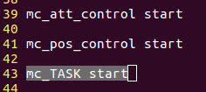

4. get result
1. add PX4_INFO command in the code to return value to screen console
e.g.
2. use Qgroundcontrol to get uORB data
a) install and build qgroundcontrol:
http://wiki/doku.php?id=wiki:ancl_platform:qgc
b) run qgroundcontrol: /qgroundcontrol/build/release/.QgroundControl
topics information can be seen from Widgets->Analyze
c) the relationships between uORB topics and Mavlink messages shown on Qgroundcontrol are defined at: /px4/src/modules/mavlink/mavlink_messages.cpp
e.g. for the topic vehicle_attitude, it is related to the ATTITUDE in Qgroundcontrol. For the following part of the code from mavlink_meesages.cpp, the Qgroundcontrol ATTITUDE.time_boot_ms, rollspeed...they are from the timestamp, rollspeed ... of uORB topic vehicle_attitude
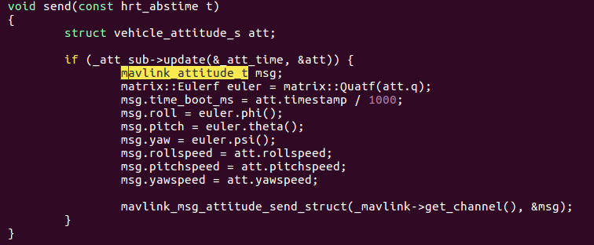

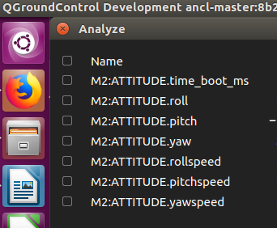

3. log the data
a) write log to the SD card.
Edit log topics to /px4/src/modules/logger/logger.cpp, e.g. use the function add_topic to add topics
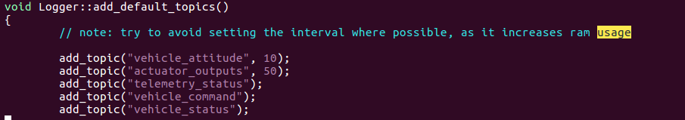

In the screen console, run:
logger start
logger on //start writing to the SD card

b) the PX4 write log into .ulog type files, use the SD card reader to get the ulog files from SD card and use the pyulog build in function to convert ulog files into csv files. Run:
pip install pyulog //install the pyulog
ulog2csv filename.ulog //convert ulog files to csv

4. add topics
1. create new .msg file at /px4/msg, which contains all of the values you want to publish and subscribe. e.g. declear variables that needed
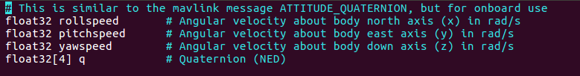
the uint64 timestamp will be added automaticall after generation, which is used for logging
2. add the msg name to CmakeLists.txt under /px4/msg

5. with and without Block

While numbers of the Topics are used in an application, using block will having much neat and smaller program size.

e.g1. for an application to initialize one topic to publish data

struct vehicle_secondary_attitude_setpoint_s quad_input;
memset(&quad_input, 0, sizeof(quad_input));

...

orb_advert_t quad_input_pub = orb_advertise(ORB_ID(vehicle_secondary_attitude_setpoint), &quad_input);
orb_publish(ORB_ID(vehicle_secondary_attitude_setpoint), quad_input_pub, &quad_input);

the above code is equivelent to having:

uORB::Publication<vehicle_secondary_attitude_setpoint_s>_quad_input; // uorb/block.hpp
_quad_input(ORB_ID(vehicle_secondary_attitude_setpoint),-1,&getPublications()), //uorb/block.cpp
...

updatePublications(); //publish all

*To publish a single topic using block structure:
orb_publish(ORB_ID(vehicle_secondary_attitude_setpoint),_quad_input.getHandle(),&_quad_input);

e.g2. for an application to initialize one topic to subscribe data

int pos_fd = orb_subscribe(ORB_ID(vehicle_local_position));
struct vehicle_local_position_s _pos;
memset(&_pos,0,sizeof(_pos));

...
orb_copy(ORB_ID(vehicle_local_position), pos_fd, &_pos);

the above code is equivelent to having:
uORB::Subscription<vehicle_local_position_s> _pos //uorb/block.hpp
_pos(ORB_ID(vehicle_local_position), 20, 0, &getSubscriptions()), //uorb/block.cpp
...
updateSubscriptions();

*To subscribe a single topic using block structure:
orb_copy(_pos.getMeta(), _pos.getHandle(), &_pos);

some of variables are initialized in Class, use build in functions to get those. e.g. use getHandle() to return the _handle.

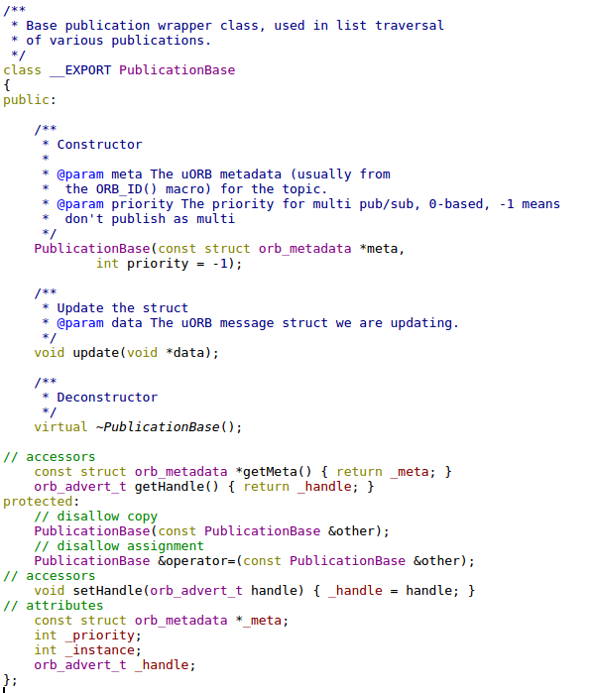

useful console commands:
help--
top--

