The purpose of the AIC_test.py program is to calculate the lag for PCA. The AIC is a method for finding the best order for regression models.

The ARX model can be expressed by:

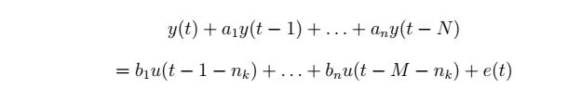

And the predictor can be written as:



Where Phi is:



Theta can be calculated by the LSE

Briefly speaking, the program does following:

1. Get data from CSV file
2. Use AIC to calculate best order to use for ARX model
3. Use the computed order to calculate delays between inputs and outputs
4. Recommended order is equal to the delay + order

For the provided CSTR model signals, the result is following:

Best order: 6

Best delay: 8

Lag to choose: 14

theta: [-0.67708172 -0.32428635 -0.10277041 -0.02439839 0.0028891 0.06289651

-0.02508766 0.00490778 -0.01913426 0.0100583 -0.01254999 -0.02119965]

Reconstructed signal by using theta and delay:

