**Method:**

1. Since the signals we are going to analyse usually have a trend, therefore, finding the frequency of the trend would can be useful for after analysis.
2. Apply the found frequency to the results generated by “damping sin” and “multiple sin” model to see the result.
3. Apply the CSD and CORR method on TE model output data.

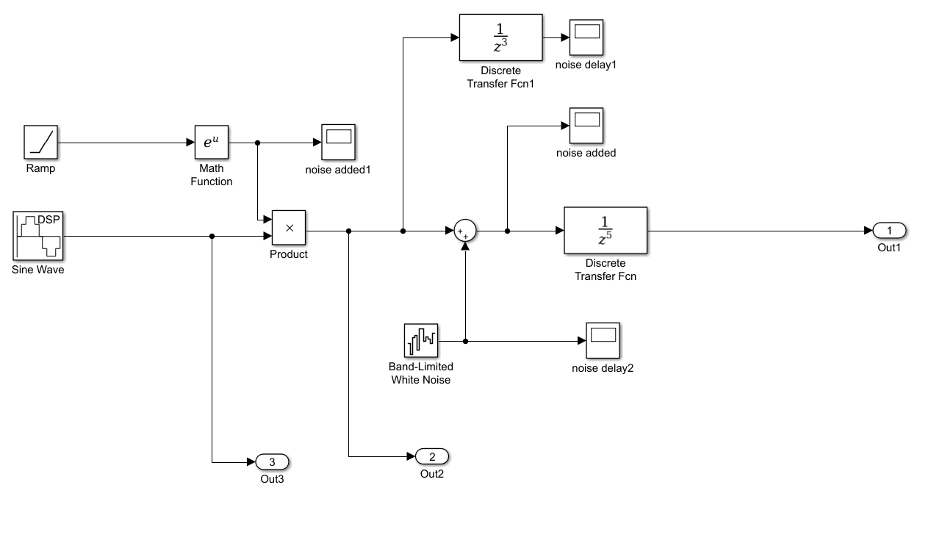

Figure1. Damping sin

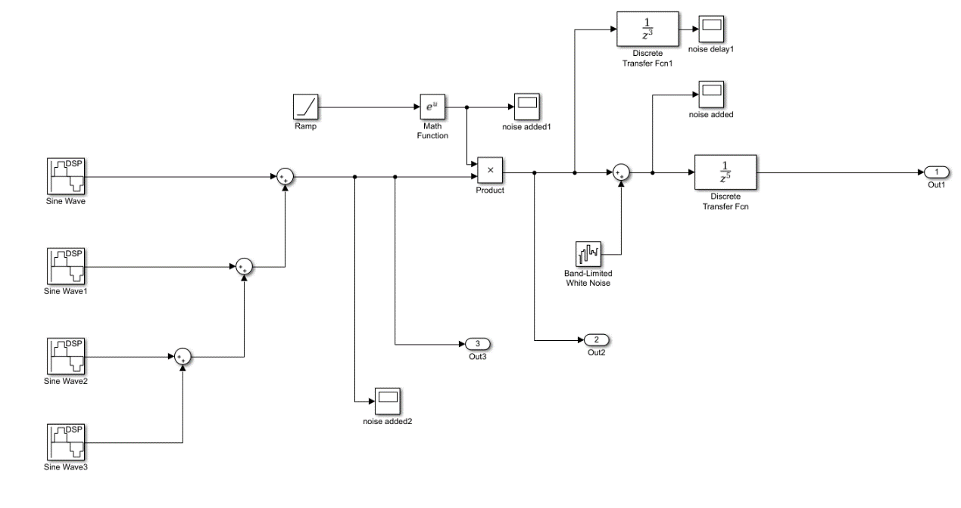

Figure1. multiple sin

**Result:**

1. Find the frequency:

Using magnitude squared coherence estimate

a) Apply the method directly on the signal (matlab command : mscohere)

b) The frequency used is where the magnitude squared coherence has the largest or second largest value.

1. Testing
   1. Testing on damping sin and multi sin data
      1. With 0.005s delay inserted

|  |  |  |  |  |
| --- | --- | --- | --- | --- |
|  | Frequency set | Frequency calculated | Correlation method | CSD method |
| Damping sin data | 10Hz | 9.9975 | 0.005 | 0.0051 |
| 30Hz | 29.9925 | 0.005 | 0.005 |
| 50Hz | 49.9875Hz | 0.005 | 0.0049 |
|  | Frequency set | Frequency calculated |  |  |
| Multi sin data | 10Hz | 9.9975 | 0.005 | 0.0051 |
| 30Hz | 29.9925 | 0.005 | 0.0049 |
| 50Hz | 49.9875Hz | 0.005 | 0.005 |

Both methods worked well on the signals we generated.

* 1. Testing on the TE output signal

There are 15 sets of TE output signals were used for testing. 1s and 0.001s delay was inserted into the signal directly.

Delay calculated on TE data: xmeas 1 2 3 4 7 8 9 10 11 12 14 15 17 23 40



Table 1.

In the table 1, for the first and third rows, 0.01s delay was inserted, for second and fourth rows the 1s delay was inserted.

The first and second rows used the Correlation method and the third and fourth rows used the CSD method.

As we see, most of the time the Correlation method worked well on these signals, and CSD method was way off.

The correlation method works most of the time, which is expected because the delay was directly added onto the signal, and the maximum correlation is where original signal and delayed signal overlaps.

The CSD method doesn’t work for these signals. Reason can be that, these signals are color noised, which means those noise can have very strong correlation and effects the CSD calculation a lot.

**Future testing:**

1. Apply the Multivariable Regression model (MAR).

Basically, the MAR is used to find autoregressive(AR) coefficients. Then those AR coefficients will be transferred into frequency domain and use the AR coefficients in frequency domain to estimate the series’ coherence.  Then we might be able to apply the previous coherence method to find the delay time.

ii) use noised while generating “damping sin” and “multiple sin” signals, the test correlation and CSD method.