ECE 303 Lab #4

(Audio Spectrum Analyser)

Lab section: H4 Bench #03 Date 2016-04-07

# **Abstract**

The goal of this lab was to design an audio spectrum analyzer that could operate in the audio range and drive three LEDs to indicate the presence of input signal in three different frequency bands: less than 1kHz, 2 to 8kHz and greater than 10kHz. In order to achieve this goal, a two-stage cascode current source was designed to provide constant current flowing into the differential amplifier with stability.A differential amplifier was designed to have a variable gain in the range of 2 to 24 V/V which could provide a sufficient drive signal to the filters in the next stage. Low-pass, band-pass and high-pass filters were needed to filter out a signal that fell into the corresponding frequency band. Each filter would then connet with a LED driver indicator so that a LED with unique color would light up if a signal passed through one of those three filters. The objectives of this project were met because the current souce could provide 14.6 mA current with stability; a variable gain between 2 and 24 V/V could be obtained by adjusting the variable resistor connected across the drain side of two BJTs in the differential amplifier; red,yellow, green LED would light up respectively only when the signal in the range of 0~1k Hz, 2 kHz ~ 8k Hz and above 10 kHz was present. LTspice was used to simulate circuit design before the real implementation and the result met the objectives as well. The challenge part of this experiment was about reducing noise. It turned out that three 100 uF capacitors should be connected across +15 V and ground, -15 V and ground, current source base and ground in order to have desired output signal with less distortion.

|  |  |
| --- | --- |
| Name: Linjian Xiang | Name: Lantao Mei |
| Signature: ________________________ | Signature: ________________________ |
| *Our signatures certify that we are submitting our own, original work only, and do so in accordance with the University Code of Student Behaviour and APEGGA’s Code of Ethics.* | |

# **Objectives**

This objective of this lab is to design a simple spectrum analyzer that operates in the audio range and indicates the presence of three frequency bands: “low”, “middle”, and “high”.

This analyzer can be broken down into four major components: “Current Source”, “Differential Amplifier”, “Active Filter”, and “LED Indicator”. The current source is desired to output a constant current with absolute stability. The input signal to the differential amplifier needs to be at least 200mV to get good Signal-to-noise ratio (SNR). The differential amplifier should be designed to have a variable voltage gain between 2 and 24 in order to optimize indicator performance and drive a load of

10k $Ω$. On the next stage, the signal passing through the differential amplifieris is fed into three active filters connected in parallel including low-pass, band-pass, and high pass filters. The low-pass filter should be designed to only pass signal in the frequency range of 0 to 1k Hz with unity gain; The band-pass filter should be designed to pass signal in the frequency range of 2k Hz to 8k Hz with unity gain; The high-pass filter should be able to only pass signal with frequency higher than 10k Hz with unity gain. After that, three LED driver indicators are used to indicate the presence of the designed frequencies: red LED will turn on only when the signal passes through low-pass filter; yellow LED is on only when the signal passes through band-pass filter and green LED is on when the signal passes high-pass filter.

**Design**

Figure 1: Block Diagram of the Design Circuit

Differential Amplifier

Active Filters

LED Indicator

Current Source

The design circuit could be separated into three major part including differential amplifier with current source, active filters and LED indicators as shown in Fig. 1 above. The differential amplifier was used to provide a variable differential gain from 2 to 24 to optimize the performance of LED indicators; Three active filters including low-pass filter, band-pass filter and high-pass filter were designed to provide unity gain for a specific range of frequency respectively but attenuate frequencies outside that range; The LED indicators were used to provide a indication of the low, mid-band or high input frequency. Design details are shown in the paragraphs below:

**Part 1 Differential Amplifier with Current Source**

The differential amplifier was designed using two npn transistors because more experience was on npn than that was on pnp. MPQ2222A quad transistor array was used in our circuit design. For MPQ2222A, four npn BJT were fabricated in one silicon to ensure all the BJTs have the closest parameters such as width, length and also to make sure all BJTs have similar temperature while operating. A passive load was used because there were not many selections of transistors on hand and passive load was easy to implement and test. However, active load could be implemented if the size of our circuit or power consumption became a issue. Two resistors $R_{E1}$ and $R_{E2}$ (with the same resistance) were inserted in the emitter side of two BJTs to stabilize the current.

A two-stage cascode current mirror was designed to provide stable current and to achieve $β$ independence as described in the manual. The schematic for the differntial amplifier with current source is shown in Fig. 2 below.

First the theoretical value of components in the differential amplifier were calculated:

Using a rule of thumb, passive load resistor $R_{C1}$ and $R_{C2}$ were taken to be $\frac{1}{10}$ of $R_{L}$ (which is 10 $kΩ$) to allow greater voltage swing at low current.

$R_{C1}=R_{C2}=\frac{1}{10}R_{L}$ =1000 $Ω$ (1)

To get maximum AC signal swing, collector voltage was chosen to be right in the middle of 15V and 0V, thus:

$V_{C}=\frac{1}{2}V_{cc}$ =7.5 $V$ (2)

Then the current flowed through $R_{C1}$ and $R_{C2}$ could be calculated as:

$I_{C}=\frac{V_{cc}-V_{c}}{1kΩ}$ =7.5 $mA$ (3)

The emitter current $I_{E}$ was equal to $I_{C}$ which was 7.5 mA. So the biased current that flowed through the current source was 2*7.5 mA = 15 mA. This number would be used in the current souce design.

Next, the output resistance of BJT could be calculated as:

$r_{e}=\frac{V_{T}}{I_{E}}$ =3.33 $Ω$ (4)

Where $V_{T}$ is the thermal voltage and $I_{E}$ is the current through the emitter side of BJT.

To determine the value of $R_{E1}$ and $R_{E2}$, the equation for the gain of differential amplifier was used:

$A_{v}=\frac{R_{c}//R_{L}}{2(R_{E}+re)}$ (5)

Based on the manual, the voltage gain should be in the range of 2 to 24. Our $R_{E1}$ and $R_{E2}$ value should meet the upper boundary, therefore we set $A_{v}$ =24. In order to have the gain to be independent of the load resistance, $R_{L}$ was considered to be much larger than $R_{C}$ as shown in Eqn. 1 , therefore Eqn. 5 could be simplified as:

$A_{v}=\frac{R_{c}}{2(R_{E}+re)}$ (6)

Set Eqn.6 to 24 and substituted the value of $r_{e}$ and $R_{C}$:

$R_{E1}=R_{E2}=\frac{R_{c}}{2×24}-r_{e}$ =17.5 $Ω$ (7)

Since there was no 17.5 $Ω$ resistor in the lab, a 17 $Ω$ resistor was for $R_{E1}$ and $R_{E2}$ instead.

Since an amplifier with variable gain was required, a potentiometer was connected between $R_{C1}$ and $R_{C2}$. The voltage gain from 2 to 24 can be obtained by adjusting the resistance value. In order to have short-circuit protection, a resistor in series with the potentiometer was needed. To calculate its resistance, set Eqn. 6 equal to 2 which was the lower boundary of voltage gain. Assume this resistor is called $R_{fixed}$, then for the singled ended output only half of $R_{fixed}$ could be seen and it would parallel with $R_{C}$. Therefore:

$A_{v}=\frac{R_{c}//\frac{1}{2}R_{fixed}}{2(R_{E}+re)}=2$ (8)

From previous calculation, the value of $R_{C}$, $r_{e}$, $R_{E}$ were known, therefore by solving Eqn. 8 , $R_{fixed}$ =181.5 $Ω$. Since there was no 181.5 $Ω$ resistor in the lab, a180 $Ω$ resistor was used as a replacement.

A coupling capacitor of 50 uF was put between amplifier output and active filters to prevent DC variation.

For the current source, since the size of each BJT were the same, the current through $R_{ref}$ was equal to bias current which was 15 mA calculated above. Thus, $R_{ref}$ could be determined using loop ananysis considering the base-emitter ( $V_{BE}$) saturation voltage to be 0.75 V as shown in the 2N4401 BJT manual:

$R_{ref}=\frac{V_{cc}-(-V_{cc}+0.75+0.75)}{15mA}=\frac{30-1.5}{0.015}Ω$ =1900 $Ω$ (9)

## **Part 2 Active Filters**

In this circuit design, the differential amplifier took care of boosting the signal to appropriate values, active filters were responsible for filtering out signal without affecting too much of its value. Therefore all the active filters should have 70% to unity gain during their pass band. In order to have a stable output signal, high input impedance, low output impedance and stable filtering functionality Sallen-Key with feedback topology were used to implement low-pass, high-pass and band-pass filters.

The low pass fitler was composed of four resistors and two capacitors as shown in top of Fig. 3. The high-pass filter also contained four resistors and two capacitors but in different position as shown in the middle of Fig. 3. The band-pass filter could be implemented by connecting the low-pass filter and high-pass filter in series as shown at the bottom of Fig. 3.

In the Sallen-Key topology, the active filter gain could be calculated as:

$A_{v}=$ 1+ $\frac{R_{A}}{R_{B}}$ (10)

Where $R_{A}$ is the resister connected between the negative side of the op-amp and the output of op-amp. $R_{B}$ is the resister that connected between negative side of op-amp and ground. In order to get unity gain, the value of $R_{A}$ should be much smaller than that of $R_{B}$. In this circuit design, $R_{A}$ was taken to be 10 $Ω$ and $R_{B}$ was 10k $Ω$ for all three active filters.

The undamped cutoff frequency $f_{0}$ could be determined using:

$f_{0}=\frac{1}{2π\sqrt{R_{1}R_{2}C_{1}C_{2}}}$ (11)

Where $R_{1}$, $R_{2}$ are the rest two resistors except $R_{A}$ and $R_{B}$ in the active fitler design; $C_{1}$, $C_{2}$ are the capacitors in the active filter design.

The Q factor could be computed by:

$Q=\frac{\sqrt{R_{1}R_{2}C_{1}C_{2}}}{C_{2}(R_{1}+R_{2})}$ (12)

Q factor was used to determine the height and width of the peak of the frequency response of the filter. Ideally, we would like to have maximum flat pass band frequency response with Q value to be $\frac{1}{\sqrt{2}}$. However, to simplify the calculation, we could let Q equal to $\frac{1}{2}$ by setting $R_{1}$ = $R_{2}$ and $C_{1}$ = $C_{2}$. In this filter design, $C_{1}$, $C_{2}$ was chosen to be 1nF.

For the low-pass filter, $R_{1}$ and $R_{2}$ could be determined using Eqn. 11 by setting $f_{0}$ =1000 Hz as stated in the project requirement:

$1000=\frac{1}{2π\sqrt{R_{1}R_{2}}×{10}^{-9}}$ (13)

Since $R_{1}$ = $R_{2}$, $R_{1}$ = $R_{2}$ =159k $Ω$. In the real implementation, $R_{1}$, $R_{2}$ were taken to be 160k $Ω$.

For the high-pass filter, $f_{0}$ was set to 10000 Hz and $R_{1}$, $R_{2}$ would have a resistance of 15.9k $Ω$. In the real implementation, $R_{1}$, $R_{2}$ were taken to be 16k $Ω$.

For the band-pass filter, in order to pass a frequency range of 2k Hz to 8k Hz a low-pass filter with cutoff frequency 8k Hz was in series with a high-pass filter with 2k Hz cutoff frequency. By Eqn. 11, the $R_{1}$, $R_{2}$ value for the low-pass filter was 20k $Ω$, the $R_{1}$, $R_{2}$ value for the high-pass filter was 80k $Ω$.

## **Part 3 LED Driver Indicators**

The driver for each filter could be implemented as shown in Fig. 3. LED and a current limiting resistor ($R_{LED}$)was connected to the collector terminal of an npn (2N4401) BJT. A diode (1N4148) and another limiting resistance ($R_{limit}$) were connected in series to the base terminal of an npn. The emitter node was grounded.

The value of $R_{LED}$ and $R_{limit}$ were computed based on the assumption that the input voltage to the LED driver was 5.0 V and the BJT was in saturation mode.

Therefore, the voltage ($V_{1}$) of the signal that passed through a diode could be calculated as:

$V_{1}=\frac{5V}{2}-0.7V$ =1.8 $V$ (14)

Then as the BJT was in saturation mode, $V_{BE}=0.7 V$ and $V_{CE}=0.2 V$. So $V_{B}=0.7V$, $V_{C}=0.2V$

According to the datasheet, the forward voltage for red,yellow and green LEDs were 1.9 V, 2.1V, 2.2 V respectively and the average current for those three LEDs were 25mA, 20mA, 25mA respectively. To light the LED and simplify the calculation, the collector current $I_{C}$ was taken to be 25mA in all the calculation. Taken $β_{sat}$ to be 100 and the base current could be calculated as:

$I_{B}=\frac{I_{C}}{β_{sat}}$ =0.25 $mA$ (15)

Thus $R_{limit}$ could be determined as:

$R_{limit}=\frac{V_{1}-V_{B}}{I_{B}}$ = $\frac{1.8V-0.7V}{0.25mA}$ =4.4k $Ω$ (16)

Since the forward voltage for red LED was 1.9V, the voltage across $R_{LED-RED}$ was 15V-1.9V= 13.1 V and 0.2 V, thus $R_{LED-RED}$ could be computed as:

$R_{LED-RED}=\frac{13.1V-0.2V}{I_{C}}$ = $\frac{13.1V-0.2V}{25mA}$ =516 $Ω$ (17)

Similar procedure could be used to calculate $R_{LED-YELLOW}$ and $R_{LED-GREEN}$:

$R_{LED-YELLOW}=\frac{12.9V-0.2V}{I_{C}}$ = $\frac{12.9V-0.2V}{25mA}$ =508 $Ω$ (18)

$R_{LED-RED}=\frac{12.8V-0.2V}{I_{C}}$ = $\frac{12.8V-0.2V}{25mA}$ =504 $Ω$ (19)

A 10uF capacitor was placed between amplifier and three filters to eliminate low frequency noise signal.

**Test results**

**Current Source**

In order to test the performance of current source, different value of resistors should be connected to the output of the current source and measure its voltage. If ratio of the voltage over resistance stayed constant, the current source generated stable current.

Table 1: Output current at various load

|  |  |  |
| --- | --- | --- |
| Resistance (Ω) | Voltage (V) | Ratio V/R (mA) |
| 300 | 4.48 | 14.93 |
| 510 | 7.599 | 14.9 |
| 1000 | 14.8 | 14.8 |

From the table above, the ratio of V/R was very close. After that, a large value resistor should be test as well. A 10 k $Ω$ resistor was chosen to be the output load and its voltage was shown in Fig. 4, current value could be calculated through $I=V/R$ = 14.6 mA, this value is also very close to the expect value 15 mA. Initially if a 10uF filter was not been connected between base terminal of the first-stage current mirror, the current would tend to drift. However, it became more stable while adding the filtering capacitor. The reason for the drifting might be caused by the noise generated by the +15V and -15V voltage source.

**Differential Amplifier**

The differential amplifier was designed to have a variable differential gain (approximately 2 ~ 24) by adjusting the variable resistor. while $R_{com}$ was 180 $Ω$, $V_{sig}$ =205 mV. If the variable resitor was removed, $R_{var}$ =infinity.

The relationship between $R_{var}$ and $V_{out-pp}$ can be seen from the table below and also Fig. 5.

Table2: Different voltage gain at various $R_{var}$

|  |  |  |
| --- | --- | --- |
| $$R_{var}$$ | $V_{out-pp}$ (V) | Av (V/V) |
| 80.8 $Ω$ | 0.200 | 0.976 |
| 300.7 $Ω$ | 0.42 | 2.06 |
| 660.8 $Ω$ | 1.25 | 6.10 |
| 1.966 k $Ω$ | 2.44 | 11.90 |
| 3.66 k $Ω$ | 3.17 | 15.46 |
| 6.25 k $Ω$ | 3.78 | 18.44 |
| 8.77 k $Ω$ | 4.30 | 20.98 |
| 10.80 k $Ω$ | 4.49 | 21.9 |
| Infinity | 5.022 | 24.5 |

**Active filters**

To test filter peformance, the output voltage should be measured while changing the frequency. The output voltage at corner frequency must satisfy the 3dB cut-off voltage in order to control LEDs. 3dB cut-off voltage is approximately equal to 70% ratio of input voltage value.

For the testing, the input signal was set to 250 mV, after amplified by differential amplifier, the voltage flowed into filters were 5.91V. The frequency response for active filters is shown in the Table 3 in the appendix.

The frequency response plots of those three filters are shown in Fig. 6,7,8.

For the LPF, the output voltage at 1 kHz is 3.95 V, which is 66.8% of input voltage to the LPF (output voltage from the differential amplifier). For the HPF, the output voltage at 10 kHz is 4.01 V, which is 67.9% of input voltage to the HPF. For the BPF, at the lower corner frequency 2 kHZ, the output voltage is 3.94 V, 66.67% of input voltage. At the higher corner frequency 8 kHz the output voltage is 3.9 V, which is 66.0% of input voltage.

**LED dirver indicator**

To test the LED driver indicator, the signal input to LED was a constant value of 5.91 V, and the frequency was increased slowly from 1 Hz to 13kHz.The LPF was observed to be fully off at 1.61kHz ; the BPF would light enough at 2kHz but would be fully on at 2.25kHz and would fully off at 8.41 kHz ; the HPF would light enough at 9.62kHz and would fully on after 10.2kHZ.

The turning on and turning off frequencies had some discrepancies with respect to the ideal cut off frequencies because the input voltage were a little bit less than 3dB cut-off voltage. However, LEDs could turn on and off one at a time at round their desired frequencies, this design did met the requirements.

# **Simulation results**

LTspice was used for the simulation of our circuit, which played a major role in testing designed parameter values before wiring real circuit.

**Differential amplifier:**

Differential amplifier was designed to have a variable differential gain control (range approximately 2~24) to optimise indicator performance. After applying 200 mV input signal into LTspice circuit, Var was set to 0 in order to get the minimized gain of differential amplifier, the minimum gain was [(8.23-7.410)/2]*1000/200 = 2.1 V/V. To test the maximum differential amplifier gain, the Rvar was set to be very large value reactance $10^{20} Ω$, the gain was 20.2 V/V, which is little bit off the expected value. Therefore, RC1 and RC2 were increased to be 1.3 k $Ω$, the new differential amplifier output is shown in **Fig. 9**, and the maximum gain can be calculated as [(13.9-4)/2]*1000/200 =24.75 V/V, which was very close to expected value. And the minimum gain became 1.675 V/V after RC became to 1.3k $Ω$ (**Fig. 10** ).

**Active filters:**

The frequency response was used to test the performance of active amplifiers design, as the simulation frequency range was set from 1 Hz to 1MHz, the Bode plot is shown in **Fig. 11**. Green line represents the low-pass filter, red line represents high-pass filter and the blue line is band-pass filter. As shown in figure, while the frequency is smaller than 1.5 kHz, LPF has the maximum value output. For frequency in range 1.5 kHz to 8 kHz, BPF has the maximum output, also, the HPF has the maximum output while the frequency is higher than 8 kHz. These matched the filter design requirements, and the design was good to be implemented in practical. The detail discussion can be seen in the discussion section.

# **Discussion**

Follow the same order as in the previous sections, the analysis would be done first to the differential amplifier with current source which would then be followed by active filters and finally the LED driver indicators. After that, the whole circuit performance would be discussed. In the end, this section would discuss how the current design could be improved.

* Differential amplifier with current source

1. In the current source design, a two-stage cascode current source was used because it could offer higher output stability. Also the bias current would be more predictable by varying $R_{ref}$. The disadvantage of this design was that it required two more transistors. However, since MPQ2222A quad had four transistors mounted together, it was enough for the cascode current source.
2. As mentioned in the Test section, while testing the functionality of this two-stage current source, the voltage across a 10k $Ω$ load was 14.6 V which would result in a curren of 14.6mA. The desired output current was 15mA and the error was:

%error= $\frac{14.6-15}{15}*100\%=2.67\%$ (20)

The error was small and tolerable. It might be caused by the 5% tolerance of

resistors. Another reason could be some of the calculated resistance did not

exist in the lab, therefore resistor with close resistance was used.

1. While testing the functionality of the differential amplifier combined with current source, through varying the potentiometer all the voltage gain in the range of 2 to 24 could be obtained as shown in Table 2 above.
2. The simulation result also met the requirement with voltage gain was equal to

1.675 V/V when $R_{var}$ was set to zero and 24.75 V/V when $R_{var}$ was large

since 2 to 24 was in the range of 1.675 to 24.75.

1. The input impedance of stages after the differential amplifier was measured to be 8.4k $Ω$, therefore a 1.7k $Ω$ resistor was connected in series between differential amplifier and later stages to brought the input impedance to 10k $Ω$.

* Active filters

1. Second order active filters were implemented instead of first order because they have one more pole than the first order filters in the frequency response so that they have steeper cut off slopes (40 dB/dec compared with 20 dB/dec). Therefore using second order filters with appropriate design for cut off frequencies, only one LED would light up at a specific frequency.
2. A 50uF coupling capacitor was connected between differential amplifier output and the active filters to block the DC variation but pass the ac signal. 10 uF capacitors were also connected between +15 V to ground and -15V to ground to reduce noise.
3. For LPF as described in the test section and as shown in **Fig. 6**, at 1kHz the output voltage of LPF was 3.95 V. Since the input signal for the differential amplifier was 250 mV peak to peak and the amplifier gain was adjusted to 23.65 V/V in this testing, the input voltage to the LPF would be 5.91 V. Therefore at 1kHz, the LPF was 3.95 V/5.91V = 66.8%. For an ideal LPF with cut off frequency at 1kHz, the voltage gain should be $\sqrt{2}$/2 of its maximum amplitude which would be 4.137 V. The percent error was:

%error= $\frac{4.137-3.95}{4.137}*100\%=4.52\%$ (21)

The error between measurements and ideal results for the rest of points in

**Fig. 6** could be calculated following the same procedure and error for all the

points were within 5%.

1. For HPF and BPF, the same approach as LPF was used to calculate the error. At the corner frequency 10kHz for HPF, %error = $\frac{4.137-3.94}{4.137}*100\%=4.52\%$.

At corner frequencies 2kHz and 8kHz for BPF, the %error are:

${\%error}_{2kHz}$ = $\frac{4.137-3.94}{4.137}*100\%=4.52\%$ (22)

${\%error}_{8kHz}$ = $\frac{4.137-3.9}{4.137}*100\%=4.58\%$ (23)

The measured output were smaller but very close to the expected value. The reason could be the internal resistance of the op-amps and bread board. Also, the design was based on the assumption that the op-amp was ideal, however this was not the case in reality. There was might be current leakage at the amplifier input terminal. Furthermore, 3dB approximation was used since there were differences between op-amps, the 3dB approximation might not be the same for each of op-amp.

1. There were two way to reach the -3dB at corner frequency for op. amps.
   1. Increase Ra or decrease Rb to get more gain

Based on Eqn. 10, the voltage gain of second order filters could be controlled by Ra and Rb. However, there was a disadvantage for adjusting Ra or Rb, the increasing of output gain would lead more voltage input into LED drivers within any frequency. Which might cause that even the frequency is increased or decreased out of designed filter region, the voltage is still high enough to keep LED shine, and there might have two LEDs turned on at the same time.

1. Lower R_L for LPF parts and increase R_H for HPF parts

The value of R_L and R_H controls value of corner frequency. Lower

R_L would increase corner frequency of LPF; higher R_H would

decrease corner frequency of HPF where LPF would have voltage drop at higher frequency and HPF would have voltage increase at lower frequency and filters reach -3dB value earlier. However, if the R_L or R_H were changed too much, the filters’ output would overlap and two LEDs would be on at the same time. In addition, once the filters gain greater than 1, it starts to have resonance and higher gain would let higher resonance. Therefore, while adjusting the circuit, method b) was considered to use first.

1. The bode plot of LTspice simulation was shown in **Fig. 11**. The LPF represented by the green line had a gain of 2.823 dB at its cut off frequency 1kHz. The ideal gain should be 3 dB. The simulation result had an ${\%error}_{}$ = $\frac{2.823-3}{3}*100\%=-5.9\%$ to the ideal value. The HPF represented by the red line had a gain of 3.213 dB at its cut off frequency 10kHz. The simulation result had an ${\%error}_{}$ = $\frac{3.213-3}{3}*100\%=7.1\%$ compared with ideal case. For the BPF represented by the dark blue line, at 2kHz it had an gain of 2.835 dB. The simulation result had an ${\%error}_{}$ = $\frac{2.835-3}{3}*100\%=-5.5\%$ compared with ideal case. At 8kHZ, its gain was 3.034 dB which had an ${\%error}_{}$ = $\frac{3.034-3}{3}*100\%=1.13\%$ with respect to ideal case. From the above analysis, the simulation results were close to the desired result which proved that the design for differential amplifier with current source and three active filters met the requirements. Also, the simulation results were close to the results from real measurement discussed in part (3) and (4) above which meant the real circuit implementation met the requirements as well. Lastly, from **Fig. 11**, the slope of each line was $±$ 40 dB per decade which was the expected effect of second order active filters.

* LED driver Indicators

1. From the datasheet, the average forward current of yellow LED is 20mA and the average forward current of the rest two LEDs are both 25mA. However while choosing the LED limiting resistance, 25mA was used for all three LEDs. The results look good, but could be slightly improved if 20mA was used to calculate $R_{LED-YELLOW.}$
2. For each LED driver indicator, a 1N4148 high speed diode was used as a half wave rectifier and a 2N4401 BJT was in saturation mode and used as a switch so that the switch would be fully on for a sufficiently high input voltage (2.5 V peak as the assumption, 5 V peak to peak)
3. As described in the test section, the red LED for LPF would turn fully off at 1.61 kHZ which was because at 1.61kHz the input voltage was not sufficient to turn on the switch. 1.61kHz was an acceptable value because the gain could not drop sharply as frequency increased and the red LED would not light up at the same time as the rest LEDs. Similar to the yellow LED and green LED, although they were not perfect enough to sharply turn on and off, they would not light up at the same time and they were light enough as the desired frequencies passing through to work as an indicator. Therefore, the LED design for LED driver indicator met the requirements.

* Overall circuit performance

1. The circuit design met the requirements and the current source, differential amplifier, active filters and LED drivers all worked as expected.
2. The power dissipation of each BJT in the current source could be calculated as:

$P_{BJT1}=V_{CE}*I_{C}$ = $0.7V*7.5mA$ =5.25 $mW$ (24)

The power dissipation of each BJT in the differential amplifier could be

calculated as:

$P_{BJT2}=V_{CE}*I_{C}$ = $(7.5V-7.5mA*17.5 Ω)*7.5mA$ =55.3 $mW$ (25)

The power dissipation in the LM741 op-amp was assumed to be nearly zero

since each op-amp was regarded as ideal op-amp.

The power dissipation of each BJT in the LED driver indicators could be

calculated as:

$P_{BJT3}=V_{CE}*I_{C}$ = $0.2V*25mA$ =5 $mW$ (26)

In the ac analysis all the capacitors would not consume power. Voltage across

every resistor was measured and power consumed by each resistor could be

computed using P= $V^{2}/R$. The total power consumed by all resistors was

812.3 mW. Therefore the total power dissipation was 958.9 mW.

1. The power consumption was not significant, however it would still influence the circuit in the long run because it would reduce the input voltage at each stage such as active filters or LED driver indicators so that LEDs might not able to turn on or off as desired. The way to reduce power dissipation could be reducing the use of resistance and using active load as a replacement.

* Future improvement

1. The variable resistor was not easy to control and measure its resistance. After

calculated desired gain of differential amplifier, variable resistor can be

replaced by a constant resistor to obtain a stable circuit.

1. In order to decrease the frequency used for LED from starting turning on or off to fully turned on or off, a higher order filter should be used. For example, second order filter was used in this lab, the Vout(dB) to frequency slope was 40 dB/decade. If a third order filter was used instead of second order, the slope would increase to 60 dB/decade, where the maximum output would be reached faster. Ideally, if the order of filter is high enough, the slope of voltage output and frequency is nearly a straight line and the LED turns on and off immediately and exactly at corner frequency.

**Conclusions**

In this lab, an audio spectrum analyzer was successfully designed to indicate the presense of input signal in three different frequency bands including less than 1kHz, 2kHz to 8kHz and higher than 10kHz. The overall circuit was separtedly into three main parts consisting of differential amplifier with current source, active filters and LED driver indicators. Each part was simulated, implemented and tested. After that, all the three parts were combined together to have a fully test. The cascode current source was able to provide a stable 14.6mA current; the differential amplifer was able to amplify the input signal with a variable gain between 2 to 24 by adjusing a variable resistor connected between the drain side of two BJTs in the differential amplifier; Three second order active filters were able to select the frequency bands of interests and at their cutoff frequency, the filter gain was approximately 70%; LED driver indicators were able to turn on or off LEDs near the three frequency bands and LEDs would not turn on or off at the same time. The total power consumption was calculated to be 958.9 mW and could be improved by replacing resistors with active load implemented by BJT of MOSFET. Simulation using LT-spice was implemented before the circuit implementation and all the simulation results closely matched the measurement results and theoretical calculation as well.

# 

# 

# 

# **Appendix**

Table3: LPF, HPF and BPF output voltages at various frequencies

|  |  |  |  |
| --- | --- | --- | --- |
| Frequency(kHz) | LPF(V) | HPF(V) | BPF(V) |
| 0.25 | 5.9 | 0.03 | 0.406 |
| 0.5 | 5.2 | 0.05 | 0.46 |
| 0.75 | 4.7 | 0.08 | 0.84 |
| 1 | 3.94 | 0.12 | 1.45 |
| 1.5 | 2.44 | 0.23 | 2.61 |
| 2 | 1.61 | 0.37 | 3.94 |
| 2.5 | 1.14 | 0.55 | 4.54 |
| 3 | 0.80 | 0.75 | 4.7 |
| 3.5 | 0.62 | 0.98 | 4.94 |
| 4 | 0.48 | 1.26 | 5.07 |
| 4.5 | 0.39 | 1.51 | 4.78 |
| 5 | 0.31 | 1.80 | 4.7 |
| 5.5 | 0.26 | 2.07 | 4.62 |
| 6 | 0.23 | 2.25 | 4.5 |
| 6.5 | 0.19 | 2.58 | 4.34 |
| 7 | 0.17 | 2.87 | 4.18 |
| 7.5 | 0.15 | 3.10 | 4.06 |
| 8 | 0.13 | 3.28 | 3.9 |
| 8.5 | 0.12 | 3.52 | 3.82 |
| 9 | 0.10 | 3.70 | 3.66 |
| 10 | 0.08 | 4.01 | 3.38 |
| 11 | 0.07 | 4.28 | 2.97 |
| 12 | 0.06 | 4.55 | 2.72 |
| 13 | 0.05 | 4.73 | 2.49 |

LTspice code:

Q1 N019 N027 N030 0 2N4401

RC1 N014 N019 1.3k

RC2 N014 N021 1.3k

V1 N014 0 15

RE1 N030 N033 17.5

RE2 N031 N033 17.5

Q3 N036 N036 N045 0 2N4401

Q4 N037 N036 N045 0 2N4401

V2 N045 0 -15

Q5 N034 N034 N037 0 2N4401

Q6 N033 N034 N036 0 2N4401

Rref N029 N034 1900

Q2 N021 N028 N031 0 NPN

V3 N027 0 AC 200m 0

V4 N029 0 15

Rvar N020 N019 10k

Rfixed N021 N020 180

R2 N028 0 50

R1_L N015 N009 160k

R2_L N023 N015 160k

C2_L N023 0 1n

C1_L N016 N015 1n

C2_H N010 N003 1n

R_H N010 0 16k

R1_H N004 N003 16k

XU1 N010 N011 N005 N012 N004 LM741

C1_H N003 N009 1n

Rb_L1 N038 N009 20k

Rb_L2 N047 N038 20k

XU3 N047 N048 N043 N052 N039 LM741

Cb_L1 N039 N038 1n

Cb_L2 0 N047 1n

XU4 N049 N050 N042 N053 N041 LM741

Cb_H2 N049 N040 1n

Rb_H2 N049 0 80k

Rb_H1 N041 N040 80k

Rb_H N011 0 1k

Ra_H N004 N011 10

Rb_L N024 0 1k

Rb_Lb N048 0 1k

Rb_La N039 N048 10

Rb_Hb N050 0 1k

Rb_Ha N041 N050 10

Ra_L N016 N024 10

V5 N017 0 15

V6 N005 0 15

V7 N043 0 15

V8 N042 0 15

C10 N009 N021 10µ

Cb_H1 N040 N039 1n

XU2 N023 N024 N017 N032 N016 LM741

V10 0 N012 15

V11 0 N032 15

V12 0 N052 15

V13 0 N053 15

Rlim_H N008 N007 6.59k

Rlim_L N026 N025 6.59k

D1 N004 N007 1N4148

D2 N016 N025 1N4148

RC_H N001 N002 516

Q7 N006 N008 0 0 2N4401

Q8 N022 N026 0 0 2N4401

Q9 N046 N051 0 0 2N4401

D3 N002 N006 D

V9 N001 0 15

D4 N018 N022 D

Rc_L N013 N018 516

V14 N013 0 15

Rlim_b N051 N041 6.59k

D5 N044 N046 D

Rc_b N035 N044 506

V15 N035 0 15

.model D D

.lib C:\Users\ljxia_000\Documents\ltspice\lib\cmp\standard.dio

.model NPN NPN

.model PNP PNP

.lib C:\Users\ljxia_000\Documents\ltspice\lib\cmp\standard.bjt

.lib lm741.sub

.ac oct 20 1 1e6

.backanno

.end

# 

# **Figures and Diagrams**

Figure 2: Circuit Schematic for Differential Amplifier with Current Source

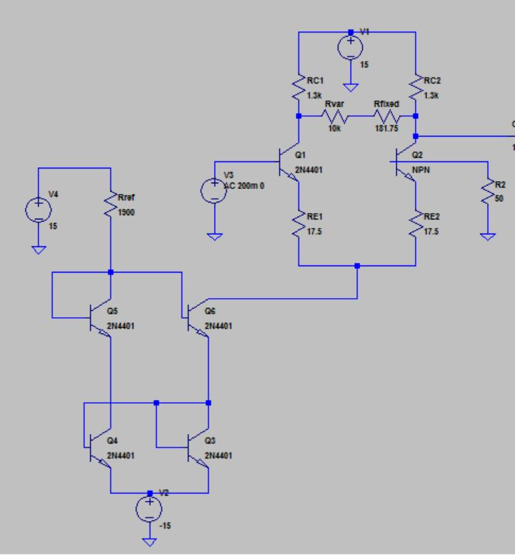

Figure 3: Circuit Schematic for Active Filters with LED drivers

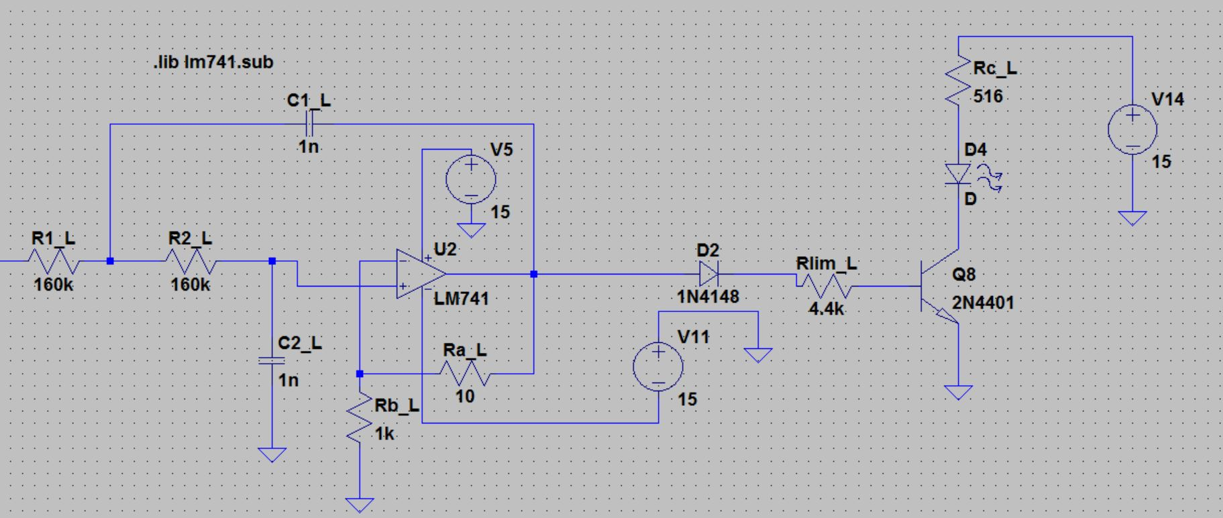

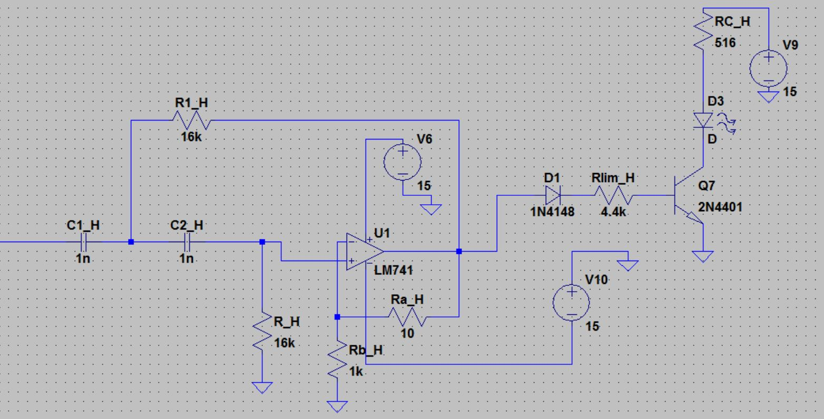

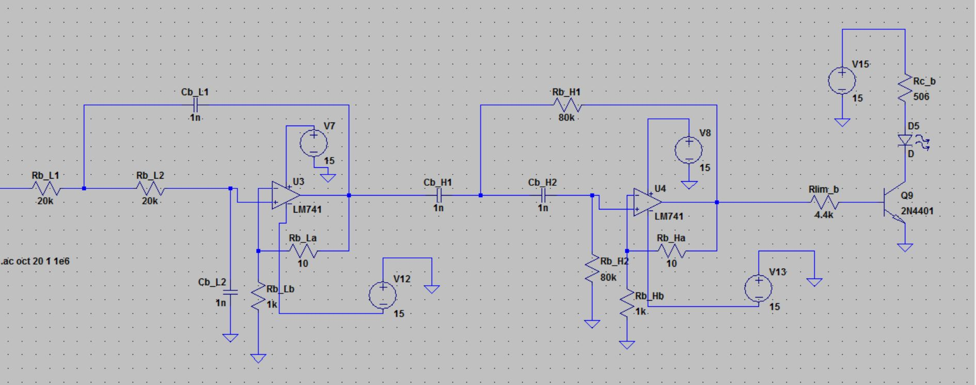

Figure 4: Voltage across a 10 k $Ω$ resistor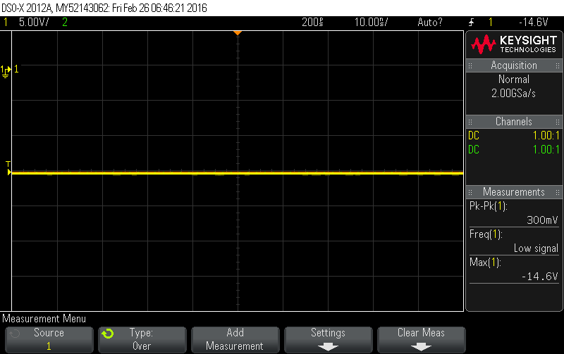

Figure 5: Differntial Amplifer Output Voltage at Various $R_{var}$

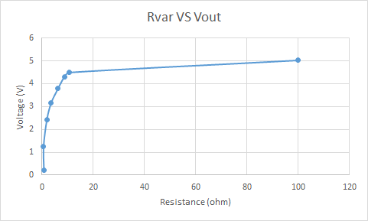

Figure 6: Low Pass Filter Output Voltage at Various Frequencies

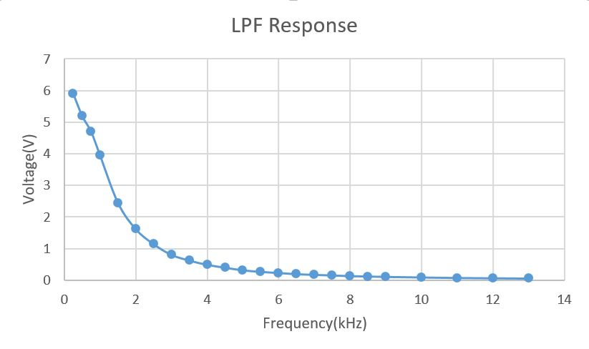

Figure 7: High Pass Filter Output Voltage at Various Frequencies

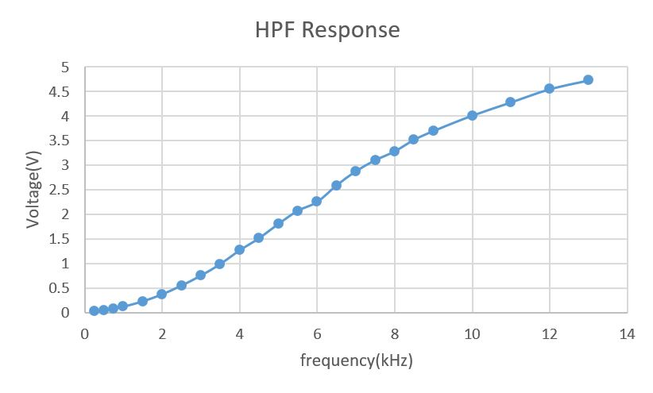

Figure 8: Band Pass Filter Output Voltage at Various Frequencies

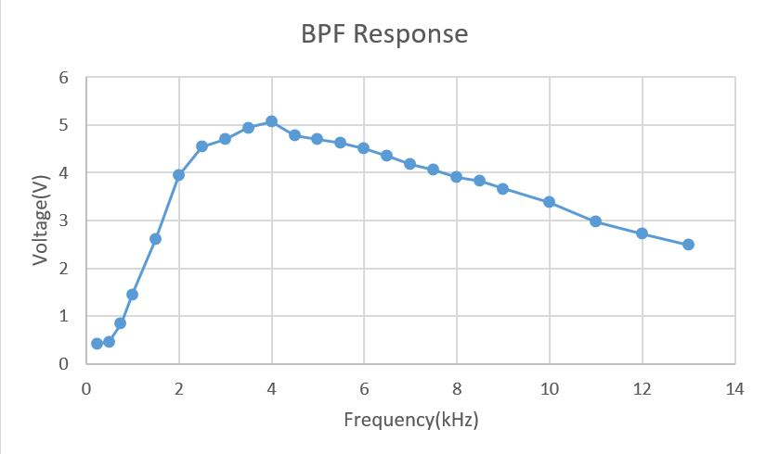

Figure 9: differential amplifier maximum gain

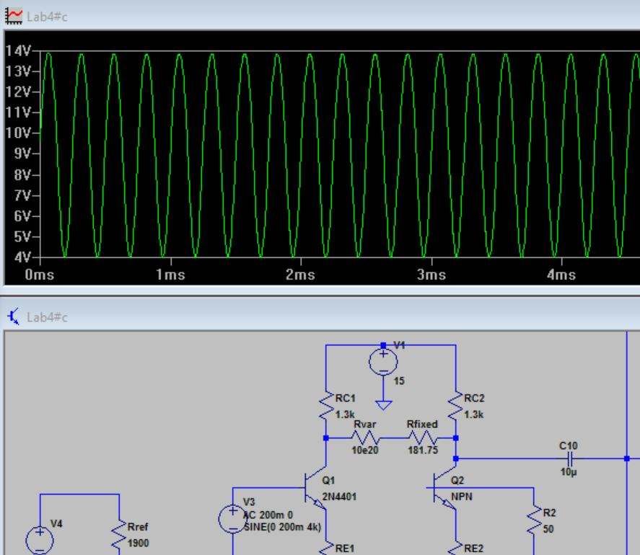

Figure 10: differential amplifier minimum gain

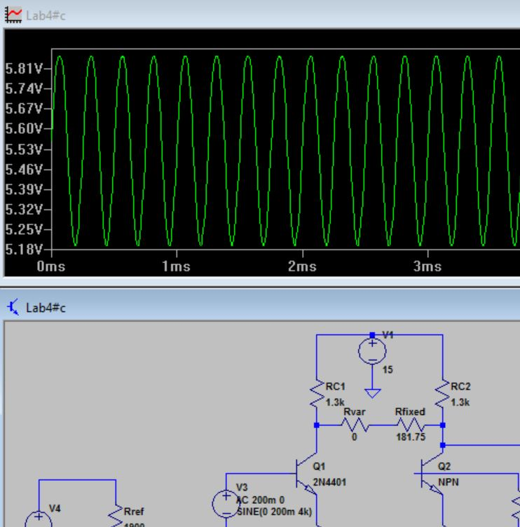

Figure 11: frequency response of active filters