**课程名称： Java EE 平台技术**

**项目名称： Java编程（提高练习）**

1. **实验目的**

学生通过使用Java语言进行程序开发的提高练习，在掌握Java通用IDE的基础上，练习类的继承使用、接口的使用、GUI编程、事件驱动编程、利用UML进行简单建模。

1. **实验内容**

Project #5 Design Classes with Inheritance (covers Chapter 8)

CSCI 1302 Introduction to Programming

Armstrong Atlantic State University

What to submit? the source code and the screen shot of a sample run.

Design a class named Triangle that extends GeometricObject. The class contains:

* Three double data fields named side1, side2, and side3 with default values 1.0 to denote three sides of the triangle.
* A no-arg constructor that creates a default triangle.
* A constructor that creates a rectangle with the specified side1, side2, and side3.
* The accessor methods for all three data fields.
* A method named getArea() that returns the area of this triangle.
* A method named getPerimeter() that returns the perimeter of this triangle.
* A method named toString() that returns a string description for the triangle.

For the formula to compute the area of a triangle, see Exercise 5.19. The toString() method is implemented as follows:

return "Triangle: side1 = " + side1 + " side2 = " + side2 +

" side3 = " + side3;

Draw the UML diagram that involving the classes Triangle and GeometricObject. Implement the class. Write a test program that creates a Triangle object with sides 1, 1.5, 1, setting color yellow and filled true, and displaying the area, perimeter, color, and whether filled or not.

Project #6 Design Classes with Abstract Classes and Interfaces (covers Chapter 9)

CSCI 1302 Introduction to Programming

Armstrong Atlantic State University

This project consists of two separate problems. For each, print the source code and the screen shot of a sample run.

1. Design an interface named Colorable with a void method named howToColor(). Every class of a colorable object must implement the Colorable interface. Design a class named Square that extends GeometricObject and implements Colorable. Implement howToColor to display a message on how to color the square.

Draw a UML diagram that involves Colorable, Square, and GeometricObject.

Write a test program that creates an array of five GeometricObject. For each object in the array, invoke its howToColor method if it is colorable.

2. Develop a class named Octagon that extends GeometricObject and implements the Comparable and Cloneable interfaces. Assume that all eight sides of the octagon are of equal size. The area can be computed using the following formula:



Draw the UML diagram that involves Octagon, GeometricObject, Comparable, and Cloneable.

Write a test program that creates an Octagon object with side value 5 and displays its area and perimeter. Create a new object using the clone method and compare the two objects using the compareTo method.

Project #7 GUI, Graphics, and Event-Driven Programming (covers Chapters 11-13)

CSCI 1302 Introduction to Programming

Armstrong Atlantic State University

Develop a GUI application that simulates four cars racing, as shown in the following figure. You can set the speed for each car with 1 the highest.

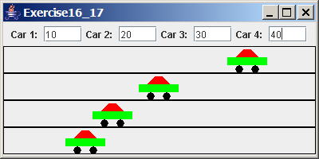

Design:

1. Draw a sketch of the user interface that shows the components, containers, and the layout managers.
2. Design a class named Car for illustrating one racing car with appropriate data fields, constructors, and methods. Car should extend JPanel.
3. Draw a UML diagram that involves the main frame class, its superclass, and the Car class.

Implementation:

1. Implement the Car class.
2. Implement the main application class.
3. **实验环境**
   1. Windows XP，Windows 7
   2. Eclipse
   3. NetBean
4. **实验结果**

Project 5:

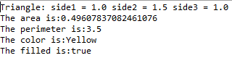

Project 6:

1: Color the sides为有接口的square();

Not colorable没有Colorable接口

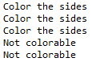

2：



Project 7:

（跑道和车将随窗口扩大而扩大）

1、开始界面：

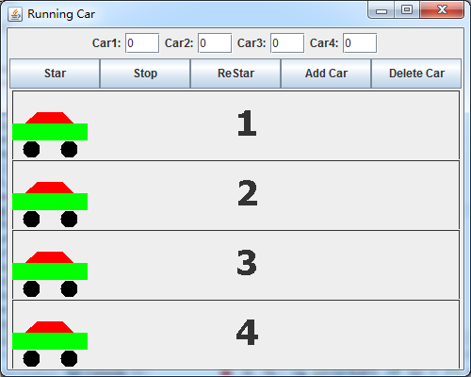

2、移动（需点击“Star”按钮使车移动，再次点击“Stop”使车停下）：

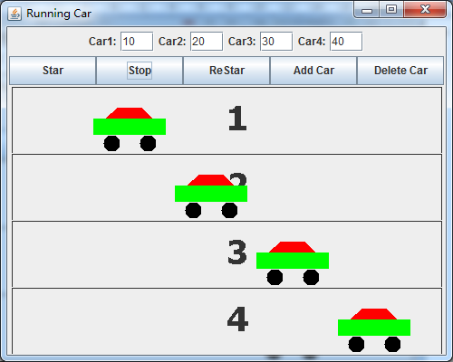

3、结束：

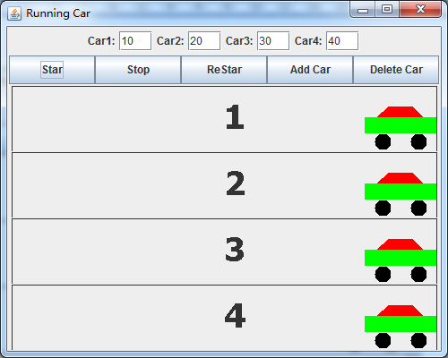

4、重新开始（“ReStar”效果）：

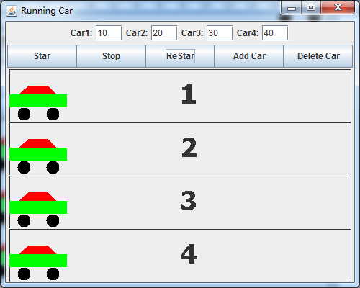

5、增加小车：

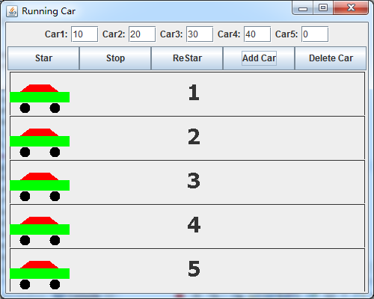

6、删除小车：

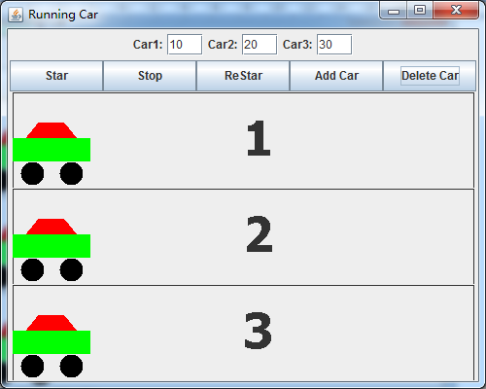

1. **附录**

（一）、UML

Project5：

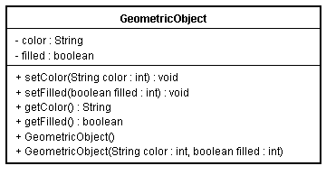

Project6：

1、

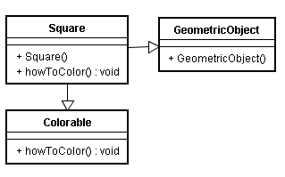

2、

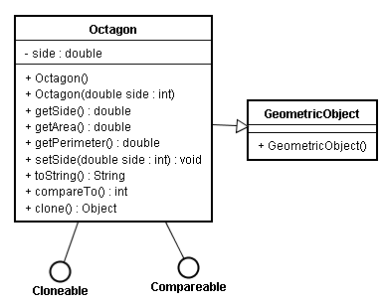

Project7：

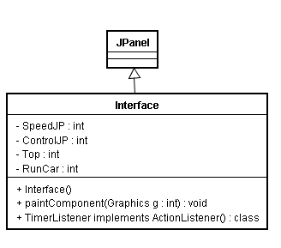

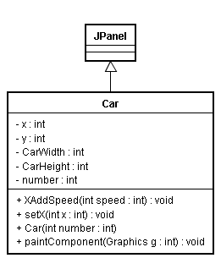

（二）、调试心得：

1.继承接口注意函数重写；

2.区分好父类和接口；

3.Cloneable.clone()要处理好try{}catch{}；

4.画窗口时要注意各种布局，不同布局显示的效果不同；

5.注意监听器的使用。