ECE445
SENIOR DESIGN LABORATORY
DESIGN DOCUMENT

______________________________________________________________________________

Automated Table Tennis Ball Sorter

______________________________________________________________________________

Team #50
Junway Lin [3220300390]

Advisor: Timothy Lee

April 4, 2026
Table of Contents
1. Introduction 3
1.1 Problem Statement 3
1.2 Solution Overview 3
1.3 High-Level Requirements 5
2. Design 6
2.1 Block Diagram 6
2.2 Feeding System 7
2.3 Sorting System 10
2.4 Power System 15
2.5 Control System 18
3. Cost and Schedule 23
3.1 Cost 23
3.2 Schedule 26
4. Ethics & Safety 26
4.1 Ethics 26
4.1.1 Honest Representation of Performance 26
4.1.2 Appropriate Use of Technology 27
4.1.3 Transparency of Design 27
4.1.4 Environmental Responsibility 27
4.2 Safety 28
4.2.1 Electrical Safety 28
4.2.2 Mechanical Safety 29
4.2.3 Jam and Malfunction Handling 29
4.2.4 Safe Operation Guidelines 30
4.2.5 Material Safety 31
References 32

Introduction

Problem Statement
Table tennis balls exhibit varying sizes, weight, color, material composition, and surface markings due to evolving manufacturing standards and regulations. The current ITTF ruling specifies that a standard ball legal for play must meet the requirements of 40mm in diameter, 2.7g in weight, abs plastic construction, with a white or orange matte appearance [7]. Prior to the regulation changes in October 2000, the table tennis balls legal for play were 38mm in diameter, 2.5g in weight, and made of celluloid (a highly flammable and lightweight synthetic plastic). These changes were implemented to slow down the game and improve visibility for spectators and television audiences. Notably, the existence of visually indiscernible features across the different regulations of table tennis balls introduces inconsistencies that complicate manual sorting processes. In training, storage, and equipment management contexts, these variations can lead to inefficiencies and classification errors when sorting is performed manually.

Solution Overview
This project addresses the problem by designing and developing an automated system capable of accurately identifying and sorting table tennis balls based on their diameter and color, utilizing a two-step sorting approach. The system feeds a continuous stream of balls using an Archimedes’ screw-based dispenser. The first phase of sorting starts with mechanical sorting where the balls are moved along a tapered roller which splits the 38mm and 40mm balls into two separate tubes. Subsequently, the balls pass through an integrated color sensing module. These measurements, along with other control signals, are processed by an embedded controller to classify each ball, actuate single blade diverters, and instruct the start/stop of the system. The system architecture combines mechanical design, multimodal sensing, embedded processing, and controlled actuation. Compared to manual sorting, the proposed solution improves accuracy, consistency, and efficiency while reducing human effort. In contrast to vision-only systems, the use of multiple sensing modalities enables more robust and reliable classification, particularly in cases where visual ambiguity or environmental variability may degrade performance.

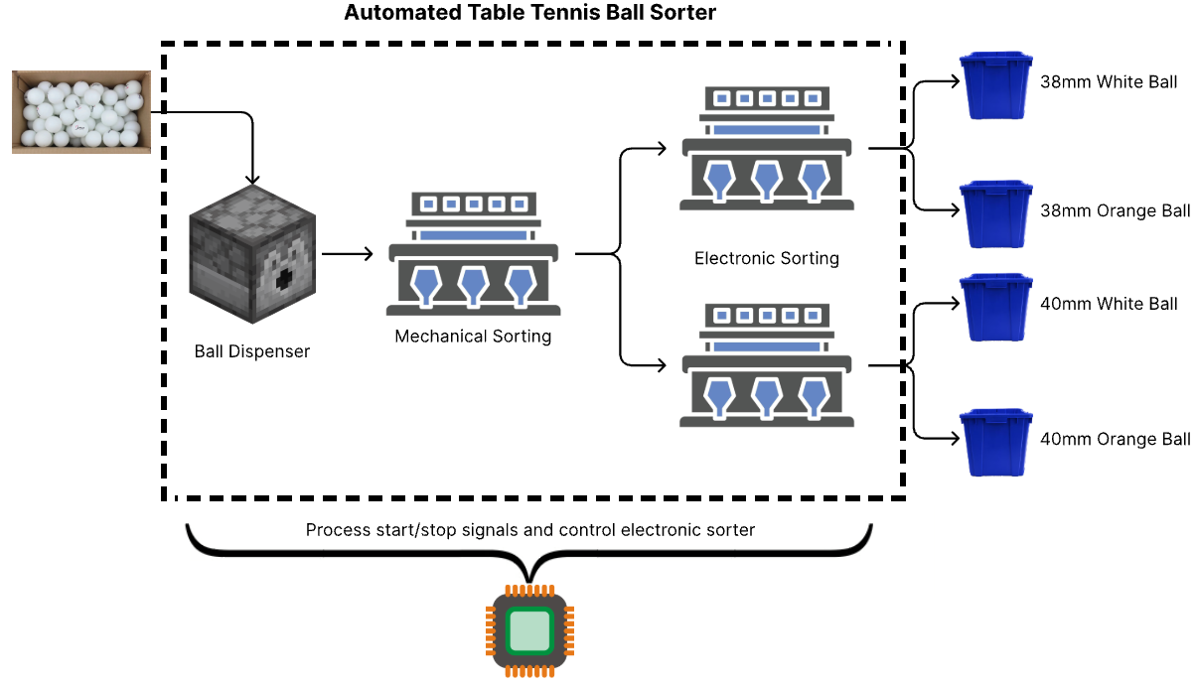
Figure 1: Overview of Solution System

1.3 High-Level Requirements
The Automated Table Tennis Ball Sorter shall meet the following requirements:
- Accuracy Requirement:
- The system shall achieve ≥95% accuracy in distinguishing 38mm diameter balls from 40mm diameter balls when tested with a batch containing equal numbers of each size.
- The system shall achieve ≥90% accuracy in identifying white vs orange ping pong balls under consistent indoor ambient lighting (200-500 lux) when the ball is stationary in the detection tube.

- Throughput Requirement:
- The system shall process a batch of at least 20 mixed ping pong balls within 5 minutes of a single button press, with no manual intervention during operation.
- The system shall complete a full sorting cycle (hopper feed → diameter separation → color detection → diversion to bin) within 10 seconds per ball.

- Reliability Requirement:
- The system shall prevent ball jamming for ≥95% of balls processed during continuous operation of a 20-ball batch, with no manual clearance required.

Design

2.1 Block Diagram
The Automated Table Tennis Ball Sorter is intended to entail four main subsystems: Feeding, Sorting, Power, and Control. Each subsystem specializes in different functions and their relation to each other is shown in the following high-level block diagram.
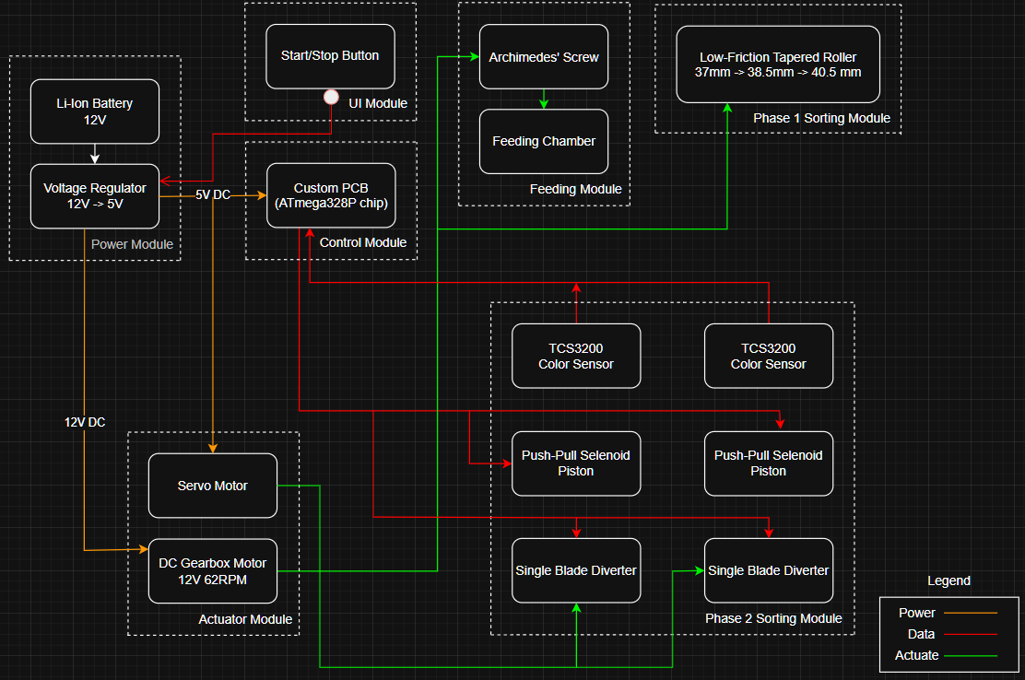
Figure 2: Block Diagram of the Automated Table Tennis Ball Sorter

2.2 Feeding System
Subsystem Description
The feeding system is responsible for holding a batch of mixed ping pong balls (38mm and 40mm, orange and white) and releasing them one at a time into the sorting system. The design uses an Archimedes screw driven by a DC gear motor, which acts as both an agitator (preventing jams) and a feeder (releasing balls individually) [1]. The screw is enclosed in a hopper-like housing that ensures that gravity keeps the balls moving downwards and remain in contact with the Archimedes screw. When the motor rotates the screw, balls are carried along the screw channel and fed through a small tube opening which connects into the sorting system. This sequence is initiated by the press of the start button and runs continuously until the hopper is detected to be empty.
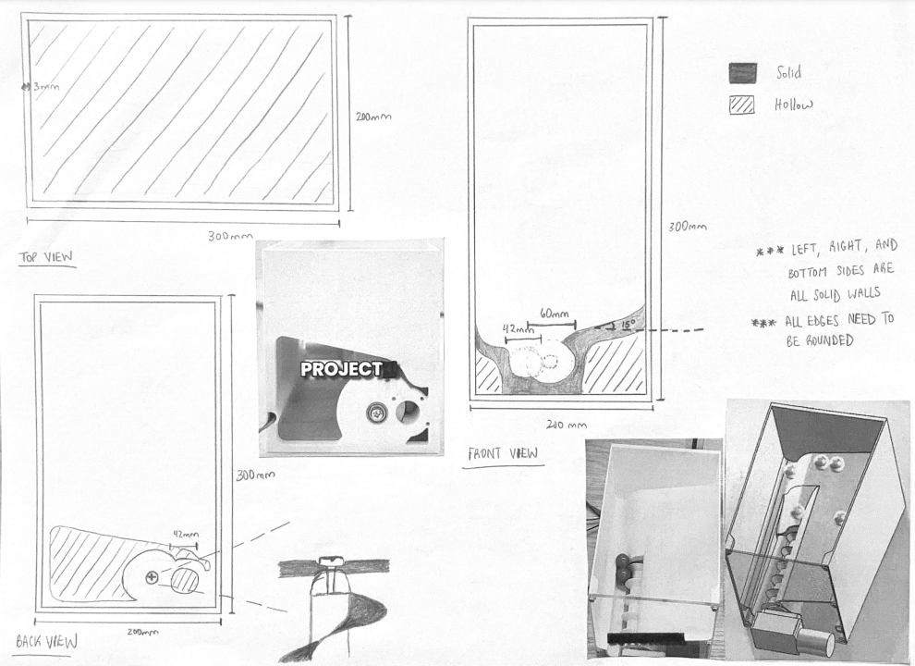
Figure 3: 2D Sketch of Hopper Housing
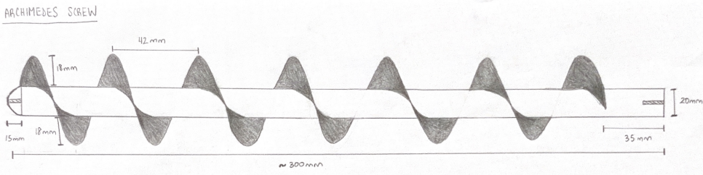
Figure 4: 2D Sketch of Archimedes Screw

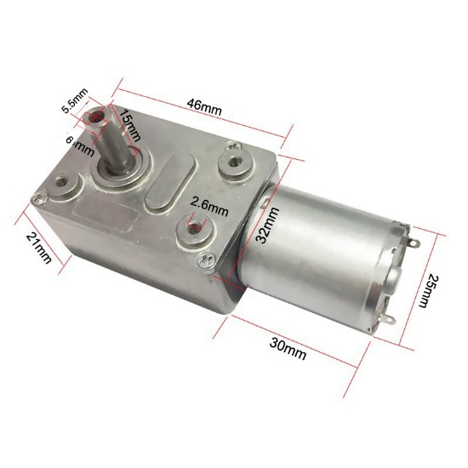
Figure 5: JGY-370 5V 68RPM Worm Gear DC Motor

Supporting Material
Component | Specification
Archimedes screw | 3D printed (PLA), 42mm flight spacing, 200mm length
Hopper-like housing | 3D printed (PLA), inclined bottom (minimum 15-degree slope) surrounding screw inlet, output tube diameter 45mm, capacity of minimum 20 balls
DC gear motor | 12V, 30-60 RPM, torque ≥5 kg·cm
IR presence sensor | FC-51 IR obstacle avoidance sensor
Requirements and Verifications
Requirement | Verifications
The feeding system shall release balls one at a time without jamming for at least 20 consecutive balls. | During a test run of 20 balls, there should be zero jams requiring manual clearance.
The Archimedes screw motor shall activate only after the start button is pressed and deactivate when the hopper is empty. | Based on code logic check and sensor feedback, the motor shall only run when balls remain in hopper.
The inclined hopper base shall eliminate dead zones, ensuring all balls roll toward the screw inlet without manual assistance. | A single ball placed at the farthest corner of hopper should rolls to the screw inlet within 3 seconds without user intervention.
The hopper-feeder unit shall store a minimum of 20 mixed ping pong balls prior to operation. | Via visual inspection, all 20 balls should fit without overflow or jamming.
The feeding rate shall be between 6 and 12 balls per minute. | Over a 20-ball batch, the average cycle time, from start to finish, shall be no more 10 seconds per ball.

2.3 Sorting System
Subsystem Description
The sorting system is the core of the machine, performing both diameter and color-based separation. It consists of two main stages:
Stage 1 - Diameter Sorting (Tapered Rollers):
Two parallel rollers with a gap that tapers from 37mm to 38.5mm to 40.5mm over their length. All balls will roll past the 37mm section and upon contact with the 38.5mm section, the 38mm balls fall through the gap between the rollers. Then, the 40mm balls continue to the wider 40.5mm section before falling into a separate tube. This design is based on industrial ball-sorting principles and eliminates accuracy and jamming issues common with sensor-based and fixed-hole designs.
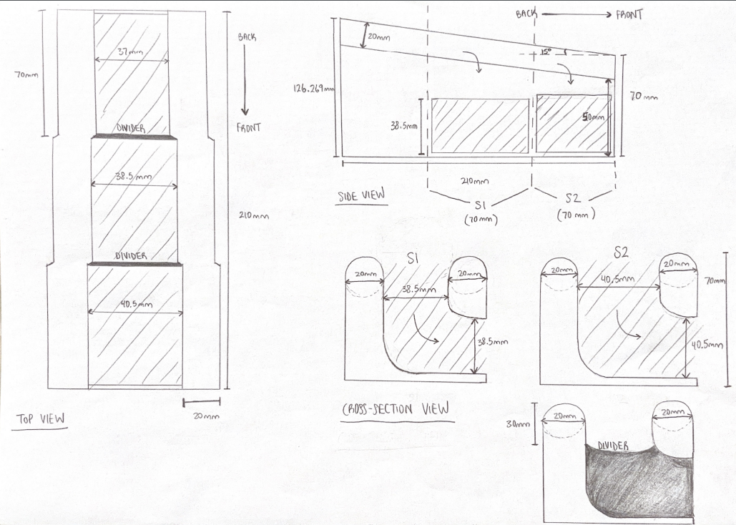
Figure 6: 2D Sketch of Tapered Roller Sorter
Stage 2 - Color Detection Stations:
Two vertical tubes (one for each diameter stream) receive balls after they drop from the rollers. Each tube has:
- A fixed stop ledge where the ball comes to rest [2]
- A TCS34725 color sensor mounted in a dark chamber
- A push-type solenoid piston below the ball that lifts it past the stop after color reading [2]
The stationary measurement ensures accurate RGB detection since the TCS34725 is sensitive to motion and ambient light. After the solenoid pushes the ball upward, it rolls out to a single-blade diverter [3] (servo-operated) that directs the ball to one of four bins based on the color detected. Thus, sorting the balls into the following four classifications:
- White 40mm
- Orange 40mm
- White 38mm
- Orange 38mm
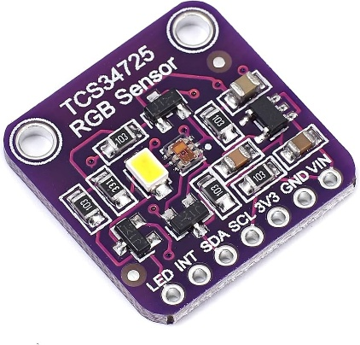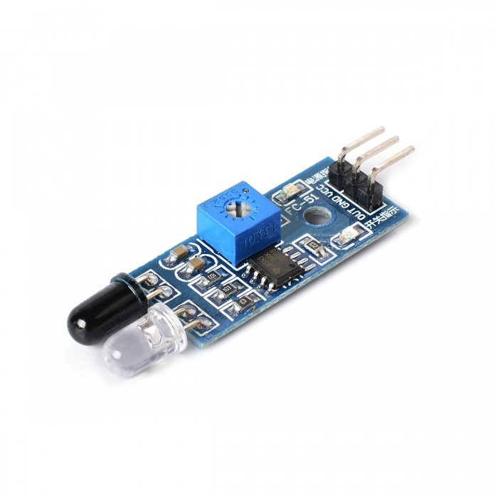
Figure 7: TCS34725 RGB Color Sensor; FC-51 IR Sensor
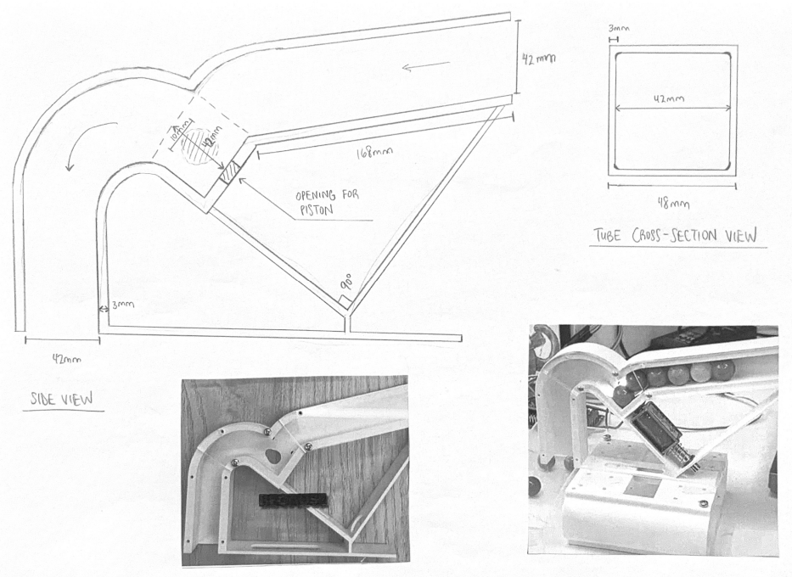
Figure 8: 2D Sketch of Stop-Ledge Color Sorter

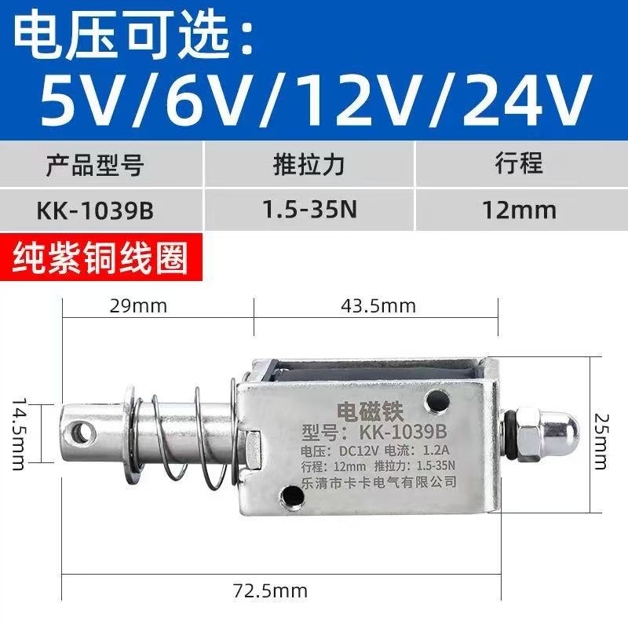
Figure 9: KK-1039B Solenoid 12V, 1.5-35N, 12mm
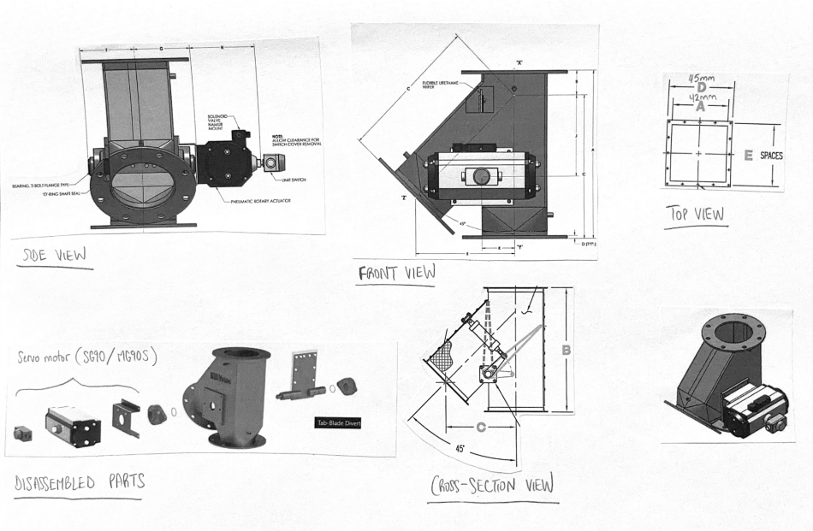
Figure 10: 2D and 3D Schematics of 60º Single-Blade Diverter

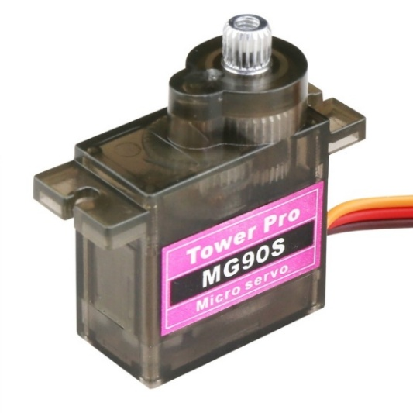
Figure 11: MG90S 5V Micro Servo Motor

Supporting Material
Component | Specification
Tapered rollers (pair) | 3D printed (PLA), 37-38.5-40.5mm taper, 300mm length
Detection tube with stop ledge and dark chamber enclosure | 3D printed tube, 45mm diameter, 150mm length, black PLA for the dark enclosure
Color sensor | TCS34725 color-to-frequency converter module
Push-type solenoid piston | 12V DC, 10-15mm stroke, ~10N force
Diverter servo | MG90S, 5V
Diverter gate blade | 3D printed (PLA)
Collection bin | Store-bought 25x17x15cm bin lined with soft padding

Requirements and Verifications
Requirement | Verification
The tapered rollers, at each section, shall not have more than 0.3mm in variance from desired width. | Measure the width using high-precision calibrated calipers.
The solenoid piston shall fully extend and retract within 0.5 seconds when activated. | Measure using oscilloscope or manual timing, where a complete cycle shall take <0.5 seconds.
The solenoid shall generate ≥0.5 N (approximately 50 grams-force) to reliably lift a 2.7g ping pong ball past stop ledge | A measured force ≥0.5 N at 5mm stroke (12V actuation) shall be obtained when solenoid plunger is placed in line with force gauge or load cell.
The diverter servo shall generate ≥1.5 kg·cm at 5V to consistently move the diverter blade. (MG90S rated for 2.5 kg·cm; 1.5 kg·cm provides safety margin) | A measured torque ≥1.5 kg·cm shall be obtained when tested with a torque gauge.
The system shall process balls without jamming in the detection tube for ≥95% of balls. | During a trial run of 40 balls, there shall be <2 jams which require manual clearance.

2.4 Power System
Subsystem Description
The power system provides regulated voltage to all electronic components. A 12V DC wall adapter supplies main power which gets distributed to:
- DC motor (for the Archimedes screw) through the motor driver
- Two solenoids (for the pistons) through MOSFET/relay switching circuits
- 5V regulator (LM2596-5) to power the microcontroller, sensors, and servos
The power system includes protection features: a fuse on the main input, reverse polarity protection (diode), and separate power paths for high-current devices (motor, solenoids) versus logic devices (sensors, MCU). This separation prevents voltage spikes from the motors from affecting sensor readings.
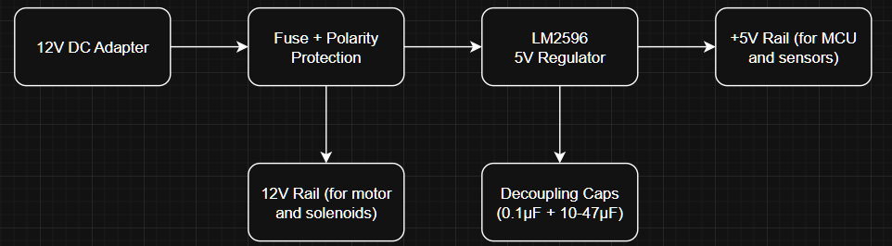
Figure 12: High-Level Block Diagram of Power System

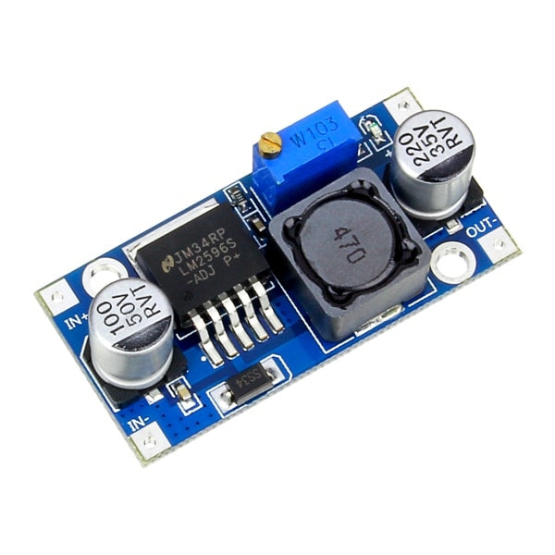
Figure 13: LM2596 Step-Down Adjustable DC-DC Switching Buck Converter

Supporting Material
Component | Specification
12V DC adapter | 12V, 3A minimum output, wall plug type
DC power jack | Panel mount, 2.5mm x 5.5mm
Fuse holder + 2A fuse | 5x20mm fuse, 2A slow-blow
Resettable Fuse | TLC-MSMD200, 1812/2A/12V
Reverse polarity diode | 1N4007, 1A rating
5V regulator | LM2596S-5.0 (switching)
Power indicator LED | 0805 Single Color
Wire and connectors | Various gauges (28/22 AWG for logic, 20 AWG for power)

Requirements and Verifications
Requirement | Verification
The power system shall supply stable 5V ±5% to the microcontroller and sensors under all operating conditions. | Measurement of the voltage at MCU pins while all motors/solenoids running shall return a range of 4.75V - 5.25V.
The power system shall include overcurrent protection on the main input. | Under a controlled short circuit test, the 2A fuse shall open before damage occurs.
The solenoids and motor shall not cause the 5V rail to drop below 4.5V during activation. | During operation of the actuators, the oscilloscope reading shall show a minimum voltage no lower than 4.5V.

2.5 Control System
Subsystem Description
The control system is the “brain” of the sorter, consisting of a custom PCB with an ATmega328P microcontroller (Arduino-compatible), all necessary support circuitry, and the code that orchestrates the sorting sequence. The control system:
- Reads inputs: start button, IR presence sensors (screw exit, tube arrival)
- Processes decisions: determines color from TCS34725 sensor readings, tracks system state
- Controls outputs: DC motor (screw), solenoids (2x), diverter servos (2x), status LED/buzzer
The software uses a state machine architecture with these states: IDLE → START → FEEDING → DETECTING_COLOR → DIVERTING → COMPLETE → DONE.
The custom PCB integrates:
- Microcontroller (ATmega328P-PU) with crystal oscillator and decoupling capacitors
- LM2596 for voltage regulation
- H-bridge (TB6612FNG) for DC motor control
- MOSFET circuits (with flyback diodes) for solenoid control
- TCA9548A multiplexer to communicate with color sensors
- Headers for all sensors, servos, and power connections
- Status LEDs
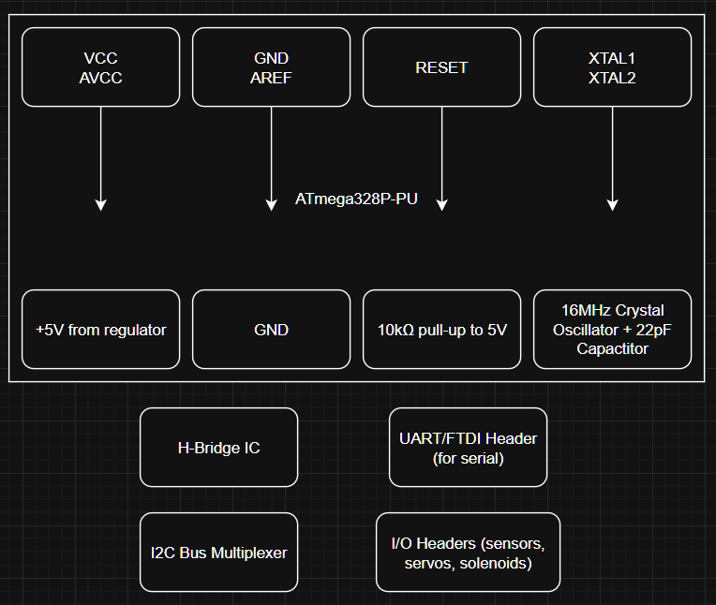
Figure 14: High-Level Block Diagram of Controller Module
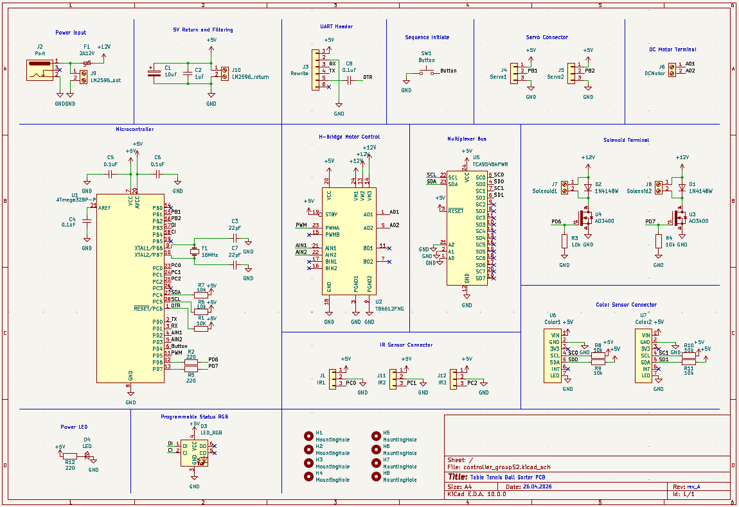
Figure 15: KiCAD Schematic Design of Custom PCB
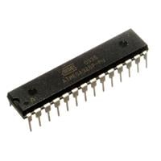
Figure 16: Atmega328P-PU (DIP-28) Microcontroller

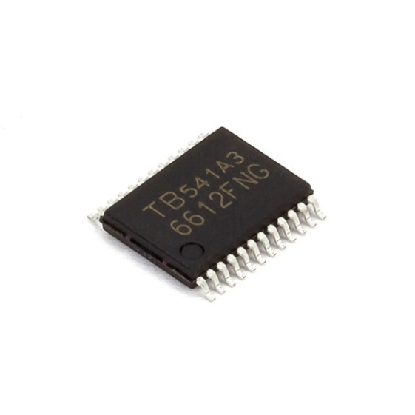
Figure 17: TB6612FNG H-Bridge IC

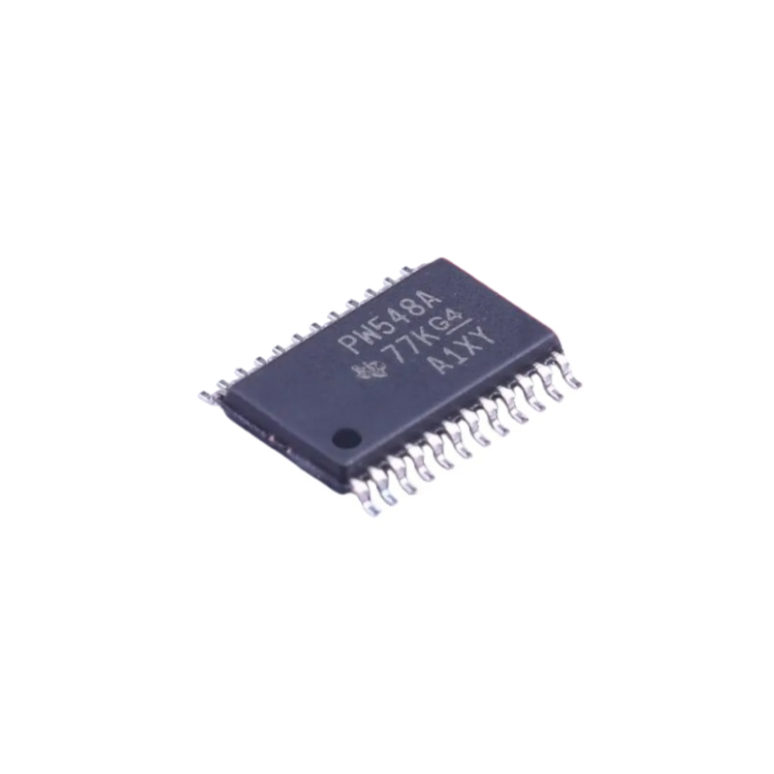
Figure 18: TCA9548APWR TSSOP24 Multiplexer

Supporting Material
Component | Specification
Microcontroller | ATmega328P with Arduino bootloader
Crystal oscillator | 16 MHz, HC-49 package
Ceramic capacitors | 22pF (for crystal), 0.1µF (decoupling), 1uF (filtering)
Voltage regulator (on PCB) | LM2596-5
H-bridge IC | TB6612FNG
MOSFET | IRLZ44N/AO3400
Multiplexer Bus | TCA9548APWR TSSOP24
Flyback diode | 1N4148
Resistor kit | Various values (220Ω, 10k)
Headers (male/female) | Pin headers for connectors
Status LED | 5mm RGB
Button (start) | Momentary push button, panel mount

Requirements and Verifications
Requirement | Verification
The time interval between receiving the IR presence sensor signal (ball arrived in detection tube) and sending the solenoid actuation signal shall be less than 10ms. | An average interval of <10ms (maximum interval ≤15ms) shall be measured with an oscilloscope by triggering on IR sensor rising edge and measuring to solenoid control pin transition.
The time interval between completing the TCS34725 color frequency measurement and sending the diverter servo position command shall be less than 5ms. | An average interval <5ms (maximum interval ≤8ms) shall be measured with a logic analyzer by capturing color sensor reading completion to servo PWM pin update.
The TCS34725 color sensor frequency measurement shall achieve a resolution sufficient to distinguish white from orange with a signal-to-noise ratio of at least 10dB. | The frequency output for orange and white balls (10 samples each) shall be measured and then the SNR, mean, and standard deviation shall be computed. SNR = 20 × log₁₀(μ/σ), where SNR ≥10dB for both colors.
The control system shall run 1000 consecutive ball sorting cycles (feed → detect → divert) without crashing or stalling. | The complete sorting sequence shall be simulated 1000 times without crashes or stalls.
The servo control PWM signal shall maintain stable frequency of 50Hz ±2% with pulse width resolution of 10µs. | The record frequency and pulse width stability over 60 seconds of the servo output pins shall be measured using an oscilloscope. The results shall show frequency = 50Hz ±1Hz and pulse width increments/decrements in steps ≤10µs.
The solenoid control signal (MOSFET gate drive) shall have a rise time of less than 1ms and fall time of less than 1ms when actuated. | The solenoid control pin shall be measured using an oscilloscope to capture rising and falling edges with rise time <1ms (10% to 90% of VCC) and fall time <1ms (90% to 10% of VCC).
The control system shall respond to the start button press and begin the feeding sequence within 50ms of button debounce completion. | Over a trial of 20 button presses, the delay measured from button press (after 20ms debounce) to motor control pin activation shall be ≤50ms.

Cost and Schedule

3.1 Cost
Part | Quantity | Cost
Archimedes Screw (3D printed) | 1 | TBD
Feeding Hopper Housing (3D printed) | 1 | TBD
JGY370 DC Gear Motor 12V, 68 RPM, torque 2.8 kg·cm | 1 | 18.50
FC-51 IR Obstacle Avoidance Sensor | 5 | 8.04
Tapered Roller Module (3D printed) | 1 | NA
Connecting Tubes (3D printed) | 5 | TBD
TCS3200 Color Sensor | 2 | 52.03
TCS34725 Color Sensor | 2 | 23.57
1039B Solenoid Piston 12V DC, 12mm stroke, 1.5-35N force | 2 | 39.96
MG90S Servo Motor 5V | 3 | 37.20 + 13.70
Single blade diverter (3D printed) | 2 | TBD
38mm Ping Pong Balls (White and Orange) | 22 | 125.40
40mm Ping Pong Balls (White and Orange) | 20 | 13.60
25x17x15cm Bins | 4 | 27.20
60x200cm Soft Foam Padding | 1 | 28.15
2D Schematics to 3D Model Service | 1 | 400.00
DC Wall adapter (12V, 3A, 5.5x2.5mm) | 1 | 14.50
DC005 Power Jack Panel Mount (2.5x5.5mm) | 5 | 2.50
KF301 Screw Terminal (2-pin) | 10 | 3.59
250V, T3.15AL 5x20mm Fuse | 10 | 4.98
Fuse Holder (5x20mm) | 10 | 1.37
Resettable Fuse (TLC-MSMD200, 1812/2A/12V) | 10 | 25.50
1N5822 3A40V Schottky Diode | 20 | 3.00
ATmega328P with Arduino bootloader (pre-burned) | 2 | 18.00
Arduino UNO R3 Starter Kit (for testing) | 1 | 75.80
TCA9548APWR TSSOP24 Multiplexer | 2 | 7.50
HC-49S Crystal oscillator 16 MHz | 5 | 1.02
0805 Ceramic Capacitors 22pF (for crystal),  0.1µF (25V 104K X7R) (decoupling),  1uF (filtering) | 10  20  10 | 1.98 + 4.48 + 1.98
Polarized Capacitor 25V10uF (4*5.4mm) | 10 | 2.67
LM2596 Voltage regulator (Breakout board for testing) | 1 | 21.90
LM2596 Voltage regulator (simplified board) | 1 | 6.75
TB6612FNG H-bridge IC | 2 | 6.80
TB6612FNG (Breakout board for testing) | 1 | 11.88
AO3400 (A09T) MOSFET | 10 | 1.65
Flyback diode 1N4148W (SOD-123) | 50 | 2.56
0805 Resistor 220Ω,  10kΩ | 20  20 | 1.20 +  1.20
22AWG Wire (0.3m²,2m)  20AWG Wire (05m², 2m) | 1  1 | 3.00 + 3.60
RS232 6-pin USB to TTL | 1 | 24.96
XH2.54 6-pin Header (Horizontal) | 20 | 3.10
XH2.54 3-pin Header (Vertical) | 20 | 2.00
0805 LED Single Color | 100 | 2.80
5050-6 LED RGB (5x5mm) | 30 | 12.00
Button and Mount | 5 | 1.21
Atmega chip mount | 5 | 2.10
PCB Board | 5 | 70.00
PCB Enclosure | 1 | TBD
Solder Paste 183º 100g | 1 | 65.00
1N4007 SOD-123 | 100 | 0.40
Female to Female Connectors (40cm) | 40 | 18.80
Total
Price of One Assembled System

3.2 Schedule
Week | Task Description
03/04 | Finalize system and solution design.
10/04 | Draft 2D schematics, convert to 3D models, and complete design document.
17/04
24/01 | Design controller and build in KiCAD. Order mechanical and electronic parts. Write code to handle signals and instructions. Prepare for 3D printing and PCB printing.
01/05
08/05 | Solder components on PCB and test subsystems. Assemble prototype for mock demo.
15/05 | Resolve bugs and refine final product.
22/05 | Final demo.

Ethics & Safety

4.1 Ethics

4.1.1 Honest Representation of Performance
The system described in this report is designed to sort ping pong balls based on diameter (38mm vs 40mm) and color (white vs orange). Performance claims, including accuracy rates of ≥95% for diameter sorting and ≥90% for color detection, represent realistic targets based on the selected components (tapered rollers, TCS34725 color sensor) and operating conditions. No claim is made that this system can sort balls of other sizes, materials, or colors without recalibration or hardware modification.

4.1.2 Appropriate Use of Technology
This sorting system is intended for educational and hobbyist applications only. It is not designed or certified for:
- Medical or pharmaceutical sorting applications where misclassification could harm human health
- Industrial production lines requiring continuous 24/7 operation
- Sorting hazardous or sharp objects
The Archimedes screw feeder and solenoid piston mechanisms are designed specifically for lightweight, non-fragile ping pong balls. Using this system with heavier or more fragile objects could result in damage to the objects or the machine.

4.1.3 Transparency of Design
All design decisions, including the choice to use a custom PCB, the selection of the motors and sensors, and the implementation of the tapered roller diameter sorter, are documented in this report. No proprietary or confidential components are used without disclosure. Third-party resources, including reference designs from online sources, have been credited where applicable.

4.1.4 Environmental Responsibility
The system is constructed primarily from
- 3D-printed PLA filament (biodegradable under industrial composting conditions)
- Common electronic components
- Recyclable metal hardware
At the end of its useful life, the system can be disassembled. Electronic components should be disposed of at appropriate e-waste collection facilities rather than general waste.

4.2 Safety

4.2.1 Electrical Safety
Hazard | Mitigation
Short circuit or overheating | The custom PCB includes a fuse (rated for 2A) on the main 12V input line. All high-current paths (motor, solenoid) are separated from low-current logic paths on the PCB layout.
Exposed live components | The completed system is enclosed within a 3D-printed housing. Only the start button, power inlet, and ball input/output openings remain accessible to the user.
Power supply misuse | The system accepts only 12V DC input from a standard wall adapter. The power connector is keyed to prevent reverse polarity connection. A status LED indicates when power is applied.

4.2.2 Mechanical Safety
Hazard | Mitigation
Pinching or crushing from solenoid piston | The piston stroke is limited to 10mm, and the force (approximately 5-10N) is insufficient to cause injury but sufficient to move a ping pong ball.
Rotating Archimedes screw | The screw is fully enclosed within its housing. The only opening is the ball input hopper, which is positioned above the screw.
Moving diverter gates (servos) | The gate arm moves slowly (approx. 0.2 sec per 60°) and with low torque (SG90: 2.5 kg·cm at 5V).

4.2.3 Jam and Malfunction Handling
The system includes the following fail-safes:
Condition | System Response
Ball remains in detection tube for >10 seconds | Solenoid stops firing, status LED blinks. The user must press reset button to clear fault.
Motor overcurrent (screw jammed) | TB6612FNG motor driver has built-in thermal shutdown. The motor will stop automatically and resume when cooled.
Servo stall (gate jammed) | Servo will attempt to return to closed position. After 3 failed attempts, system pauses and alerts user.
No ball detected after screw runs for 15 seconds | Controller assumes hopper is empty. Completes current ball sorting, then enters DONE state with green LED solid.

4.2.4 Safe Operation Guidelines
The following instructions shall be included with the final system:
- Do not insert fingers, tools, or foreign objects into the hopper or any opening while the system is powered.
- Do not use balls that are wet, sticky, or larger than 40mm in diameter.
- Do not disassemble the housing while the power supply is connected.
- Always place the system on a stable, flat surface before operation.
- Unplug the system before cleaning or clearing a visible jam that does not clear automatically.

4.2.5 Material Safety
Material | Safety Consideration
3D-printed PLA parts | Non-toxic, food-safe in solid form. However, do not place in mouth or allow small children to handle unattached printed parts (small pieces present choking hazard).
Soldered PCB | Lead-free solder (Sn99.3/Cu0.7) is used to reduce toxic material exposure. Wash hands after handling the bare PCB.
Ping pong balls | Standard celluloid or plastic balls are non-toxic. Do not burn (celluloid is flammable).

References
[1] Engineezy, “Archimedes Screw Feeder Design,” YouTube, 2021. [Online]. Available: https://www.youtube.com/@Engineezy
[2] Engineezy, “Color Sorting Mechanism with Stop-Ledge Design,” YouTube, 2021. [Online]. Available: https://www.youtube.com/@Engineezy
[3] Industrial Motion Systems, “Single-Blade Diverter Gate Mechanism Design and Applications,” 2020. [Online].
[4] :contentReference[oaicite:0]{index=0}, “TCS34725 Color Light-to-Digital Converter Datasheet,” 2013.
[5] :contentReference[oaicite:1]{index=1}, “LM2596 SIMPLE SWITCHER® Power Converter Datasheet,” 2016.
[6] :contentReference[oaicite:2]{index=2}, “ATmega328P Microcontroller Datasheet,” 2018.
[7] :contentReference[oaicite:3]{index=3}, “Technical Leaflet T3: Ball Regulations,” 2020.
[8] :contentReference[oaicite:4]{index=4}, “TCS34725 Color Sensor Hookup Guide,” 2022.
[9] :contentReference[oaicite:5]{index=5}, “TB6612FNG Motor Driver Carrier Documentation,” 2021.

