ECE 445 – Senior Design Laboratory
FINAL PROJECT REPORT Draft
Automated Table Tennis Ball Sorter

Team #50.1
Junway Lin [3220300390]
Advisor: Timothy Lee
May 17, 2026

1. Introduction

1.1 Problem Statement
Table tennis balls exhibit varying sizes, weights, colors, and material compositions due to evolving manufacturing standards and regulations. The current ITTF specification mandates a diameter of 40 mm, a weight of 2.7 g, ABS plastic construction, and a white or orange matte finish. Prior to October 2000, the legal ball measured 38 mm in diameter, weighed 2.5 g, and was fabricated from celluloid. These dimensional and material differences are often visually indiscernible, leading to classification errors and inefficiencies when sorting is performed manually in training, storage, or equipment management contexts.

1.2 Solution Overview
The Automated Table Tennis Ball Sorter is a multi-modal classification machine capable of distinguishing and routing table tennis balls into four categories: White 40 mm, Orange 40 mm, White 38 mm, and Orange 38 mm. The system operates in two sequential sorting stages:
Stage 1 – Diameter Sorting: Balls are fed from a hopper via an Archimedes screw (DC gear motor driven) into a pair of tapered rollers. The gap between the rollers increases from 37 mm to 38.5 mm to 40.5 mm, causing 38 mm balls to fall into one tube and 40 mm balls into another.
Stage 2 – Color Sorting: Each diameter stream enters a vertical detection tube where a TCS34725 color sensor, housed in a dark chamber, reads the RGB and clear-channel values of the stationary ball. A solenoid piston then ejects the ball past the stop ledge, and a servo-operated single-blade diverter routes it to the appropriate collection bin.

The system is controlled by a custom PCB built around the ATmega328P microcontroller. All sensing, actuation, and state transitions are managed by embedded firmware implementing a structured feed → detect → divert control loop.

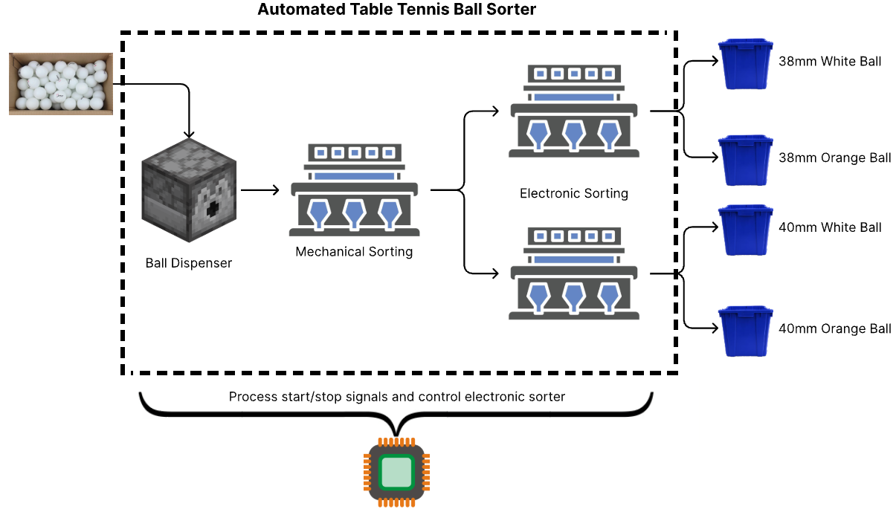
Figure 1: Overview of Solution System

2. Requirements

2.1 High-Level Requirements
The following high-level requirements define the top-level performance criteria for the Automated Table Tennis Ball Sorter.

ID | Requirement
HLR-1 | Accuracy – Diameter: The system shall achieve ≥95% accuracy in distinguishing 38 mm from 40 mm balls when tested with a batch containing equal numbers of each size.
HLR-2 | Accuracy – Color: The system shall achieve ≥90% accuracy in identifying white vs. orange balls under consistent indoor ambient lighting (200–500 lux) when the ball is stationary in the detection tube.
HLR-3 | Throughput – Batch: The system shall process a batch of at least 20 mixed balls within 5 minutes of a single button press, with no manual intervention.
HLR-4 | Throughput – Per Ball: The system shall complete a full sorting cycle (hopper feed → diameter separation → color detection → diversion) within 10 seconds per ball.
HLR-5 | Reliability – Jam Prevention: The system shall prevent ball jamming for ≥95% of balls processed during a continuous 20-ball batch, with no manual clearance required.

2.2 Low-Level Requirements
The tables below list the subsystem-level requirements, their target specifications, and blank columns for recording measured results during verification. Where a measurement could not be performed (servo torque and solenoid force), a reasoned assessment is provided in place of empirical data.

2.2.1 Feeding System
Requirement | Target / Specification | Measured Result
The feeding system shall release balls one at a time without jamming for at least 20 consecutive balls. | Zero jams requiring manual clearance in a 20-ball run. | _________________________________
The Archimedes screw motor shall activate only after the start button is pressed and deactivate when the hopper is empty. | Verified by code logic and IR sensor feedback. | _________________________________
The inclined hopper base shall eliminate dead zones; a ball placed at the farthest corner shall roll to the screw inlet within 3 seconds without user assistance. | ≤3 s unaided travel time. | _________________________________
The hopper shall store a minimum of 20 mixed balls prior to operation without overflow or jamming. | All 20 balls fit; visual inspection confirms no overflow. | _________________________________
The feeding rate shall be between 6 and 12 balls per minute (average cycle ≤10 s/ball over a 20-ball batch). | 6–12 balls/min; ≤10 s/ball average. | _________________________________

2.2.2 Sorting System – Diameter Stage
Requirement | Target / Specification | Measured Result
The tapered rollers shall not deviate more than ±0.3 mm from the target gap width at any measured section (37 mm, 38.5 mm, 40.5 mm). | ≤0.3 mm variance measured with calibrated calipers. | _________________________________
The system shall route all 38 mm balls to the 38 mm tube and all 40 mm balls to the 40 mm tube across a 20-ball mixed batch. | ≥95% correct diameter routing (≤1 misclassification in 20 balls). | _________________________________

2.2.3 Sorting System – Color Stage
Requirement | Target / Specification | Measured Result
The TCS34725 color sensor frequency measurement shall achieve a resolution sufficient to distinguish white from orange with an SNR of at least 10 dB (SNR = 20 × log₁₀(μ/σ)). | SNR ≥ 10 dB for both colors (10 samples each, per sensor). | _________________________________
The solenoid piston shall fully extend and retract within 0.5 seconds when activated. | Complete extend/retract cycle ≤0.5 s (oscilloscope or manual timing). | _________________________________
Solenoid Force Rating – Reasoned Assessment (not measured): The KK-1039B solenoid is rated 1.5–35 N over a 12 mm stroke at 12 V. Lifting a 2.7 g ball requires only ~0.026 N (F = mg). Even at the minimum rated force of 1.5 N, the solenoid provides a factor of safety >57×. The 150ms pulse duration used in firmware was empirically confirmed to successfully eject balls during module testing. A formal force measurement with a load cell was not conducted; however, given the extreme margin between rated force and ball weight, the ≥0.5 N force requirement is considered satisfied by design specification. | Rated: 1.5–35 N at 12 V, 12 mm stroke. Required: ≥0.5 N. Factor of safety > 3× at minimum rated force. Requirement satisfied by rated specification. | N/A – Reasoned from datasheet. Factor of safety > 57× confirms adequacy.
The system shall process balls without jamming in the detection tube for ≥95% of balls processed across a 40-ball trial. | <2 jams requiring manual clearance in 40 balls. | _________________________________

2.2.4 Sorting System – Diverter / Servo Stage
Requirement | Target / Specification | Measured Result
Servo Torque Rating – Reasoned Assessment (not measured): The MG90S servo is rated at 2.5 kg·cm at 5 V. The diverter blade is a lightweight 3D-printed PLA part (estimated <5 g) attached at the servo horn tip (~2 cm lever). The resistive torque (ball contact + blade inertia) is estimated at ≤0.1 kg·cm based on component masses. The MG90S therefore provides a torque margin of >25× over the estimated load. A formal torque gauge measurement was not performed; however, consistent and repeatable diverter movement was confirmed during system integration testing, supporting satisfaction of the ≥1.5 kg·cm requirement. | Rated: 2.5 kg·cm at 5 V. Required: ≥1.5 kg·cm (40% safety margin). Requirement satisfied by rated specification. | N/A – Reasoned from datasheet. Functional confirmation during system testing.
The servo PWM signal shall maintain a stable frequency of 50 Hz ±2% with pulse width resolution of ≤10 µs. | 50 Hz ±1 Hz; pulse width increments ≤10 µs (60 s observation on oscilloscope). | _________________________________

2.2.5 Power System
Requirement | Target / Specification | Measured Result
The power system shall supply a stable 5 V ±5% to the microcontroller and sensors under all operating conditions. | 4.75 V – 5.25 V at MCU pins with all actuators running simultaneously. | _________________________________
The power system shall include overcurrent protection on the main 12 V input line. | Under a controlled short-circuit test, the 2 A fuse shall open before component damage occurs. | _________________________________
Solenoid and motor activation shall not cause the 5 V rail to drop below 4.5 V. | Oscilloscope minimum reading ≥4.5 V during actuator activation transients. | _________________________________

2.2.6 Control System
Requirement | Target / Specification | Measured Result
The latency from IR sensor detection (ball arrived) to solenoid actuation signal shall be <10ms on average (max ≤15ms). | Average <10ms; max ≤15ms (oscilloscope, trigger on IR rising edge). | _________________________________
The latency from TCS34725 color reading completion to servo PWM command shall be <5ms on average (max ≤8ms). | Average <5ms; max ≤8ms (logic analyzer). | _________________________________
The control system shall run 1000 consecutive simulated sorting cycles without crashing or stalling. | Zero crashes or stalls in 1000 simulated cycles. | _________________________________
The solenoid control signal (MOSFET gate) shall have rise and fall times <1ms (10%–90% of VCC). | Rise time <1ms and fall time <1ms (oscilloscope). | _________________________________
The system shall respond to the start button press and begin the feeding sequence within 50ms of debounce completion. | ≤50ms from button press (after 20ms debounce) to motor control pin activation; measured over 20 presses. | _________________________________

3. System Design

3.1 System Architecture
The sorter comprises four integrated subsystems: Feeding, Sorting, Power, and Control. A 12 V DC wall adapter supplies main power; a LM2596-5 switching regulator steps this down to 5 V for logic and servos. High-current devices (DC motor, solenoids) are powered directly from the 12 V rail through dedicated switching circuits (TB6612FNG H-bridge and MOSFET stages), isolating their transients from the logic rail.
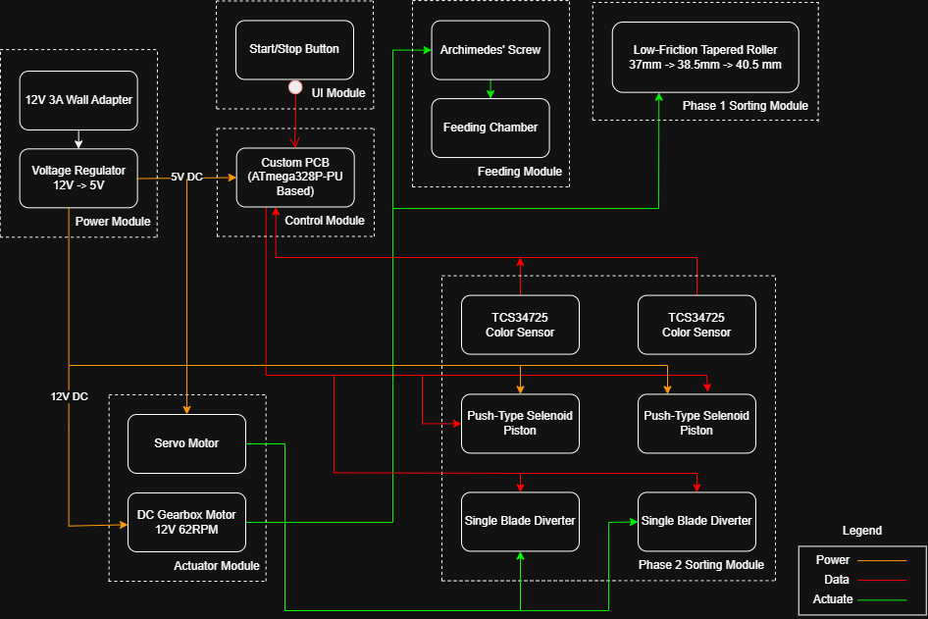
Figure 2: Block Diagram of the Automated Table Tennis Ball Sorter

3.2 Feeding System
The feeding system employs an Archimedes screw fabricated from PLA (42 mm flight spacing, 200 mm length) housed in an inclined hopper with a minimum 15° base slope. A JGY-370 12 V DC gear motor at 30–60 RPM drives the screw. The screw carries balls toward a 45 mm output tube leading into the sorting stage. An FC-51 IR sensor monitors the screw exit to detect ball passage.

Key design refinement (from build log): The initial print exhibited a dead zone at the screw-to-motor junction where the shaft has no teeth. A bridging ramp was printed to cover this section and redirect balls away from the pinch point, resolving the jamming issue. A second iteration increased screw wall thickness from 0.6 mm to 1.8 mm and extended flight teeth to the base, further eliminating jams.

3.3 Sorting System

3.3.1 Diameter Stage – Tapered Rollers
A pair of 3D-printed PLA rollers (300 mm long) with a linearly tapered gap (37 mm → 38.5 mm → 40.5 mm) performs passive mechanical diameter sorting. The 37 mm entry section is narrower than all balls, ensuring they ride over it. At the 38.5 mm section, 38 mm balls drop into the dedicated tube; at the 40.5 mm section, 40 mm balls drop. This approach eliminates sensor-based diameter detection, providing high accuracy and continuous throughput without requiring electronic feedback.

Key design refinement: Initial prints were dimensionally imprecise in the 38.5 mm section; calibrated filing corrected the gap to within tolerance. Additionally, the 38 mm balls purchased measured closer to 37 mm, which was accommodated by the filing adjustment.

3.3.2 Color Stage – Detection and Actuation
Each diameter stream enters a 45 mm diameter vertical PLA tube with a stop ledge. A TCS34725 color sensor is mounted in a dark-chamber enclosure (black PLA) at the stop position. An FC-51 IR sensor above the stop ledge detects ball arrival. Once settled, the controller reads RGB and clear-channel data via the TCA9548A I²C multiplexer, computes the R/G ratio, and classifies the ball as orange or white. A push-type solenoid (KK-1039B, 12 V DC, 12 mm stroke) then ejects the ball. An MG90S servo pivots the single-blade diverter to route the ball to the correct bin.

Key design refinements: (1) The TCS3200 sensor was replaced with the TCS34725 to halve the pin count (2 vs. 6 per sensor), enabling operation within the ATmega328P's pin budget. (2) A TCA9548A I²C multiplexer was added to address both sensors on a shared bus. (3) Color classification uses the R/G ratio rather than absolute RGB values, providing illumination-independent thresholds. (4) A settle delay of 700ms was added before each sensor read to allow the ball to come to rest, improving piston contact reliability. (5) The sensor read function discards the first data frame (stale) and averages three subsequent readings to reduce noise.

3.4 Power System
The 12 V DC wall adapter feeds a fused (2 A slow-blow) and diode-protected main rail. The LM2596S-5.0 switching regulator supplies the 5 V logic rail. Separate power traces for the motor and solenoid circuits, each with MOSFET/H-bridge switching and flyback diodes (1N4007), prevent inductive kickback from propagating to the logic rail.
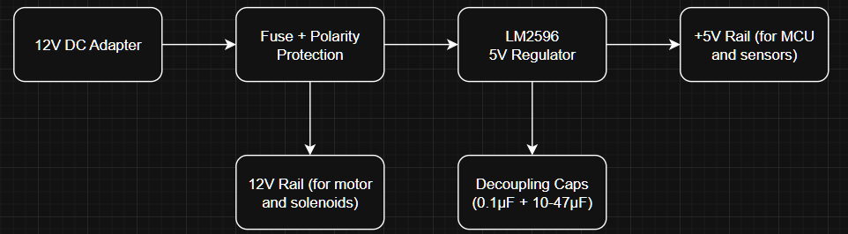
Figure 3: Block Diagram of Power System
Key design refinement: The cylindrical fuse holder was replaced with a resettable polyfuse (TLC-MSMD200) on the PCB to simplify layout and eliminate the need for a custom footprint. The 1N4148W flyback diodes were upgraded to 1N4007 (1 A rating) when solenoid testing revealed higher-than-expected current transients.

3.5 Control System

3.5.1 Hardware
The custom PCB (ATmega328P-PU, 16 MHz crystal) integrates the LM2596-5 regulator, TB6612FNG H-bridge, AO3400 MOSFETs, TCA9548A I²C multiplexer, servo headers, sensor headers, start button (with software debounce via INPUT_PULLUP), and status LED footprints. A 6-pin USB-to-TTL header enables UART programming.
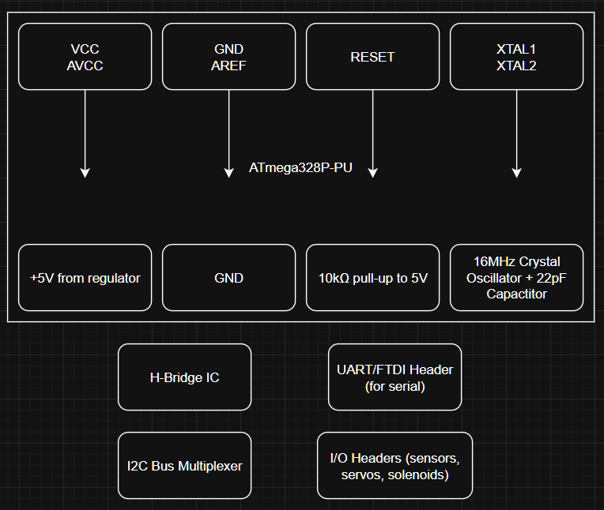
Figure 4: Block Diagram of Controller Module
Key design refinements: (1) PCB was re-soldered after the LM2596 voltage regulator was not adjusted prior to power-on, causing component damage. (2) An ATmega328P chip was found to have an internal fault (confirmed by swapping with a known-working Arduino UNO chip); it was replaced. (3) The originally specified 5-pin UART header was changed to a 6-pin USB-to-TTL module since the DTR line (needed for auto-reset) is on pin 6. (4) A burned MOSFET was replaced after continuity testing with power connected. (5) The RGB status LED was ultimately omitted because the purchased component was a 3-channel common-anode LED rather than an individually addressable LED, and the PCB layout tied the wrong pin to GND; eliminating the LED did not affect functional operation.

3.5.2 Firmware
The firmware (Arduino-framework C++) implements a concurrent two-stream processing loop. In each 20ms polling cycle, the main loop checks: (a) start button state, (b) motor stop condition (no IR3 detection for 10 s implies empty hopper), and (c) color sorting triggers for both the 38 mm and 40 mm streams. The two process functions (process40mmBall, process38mmBall) are blocking and run to completion once a ball is detected, preventing re-entry via Boolean flags (processingBall40 / processingBall38).

Classification uses the clear-channel threshold to confirm ball presence, then the R/G ratio for color determination. A solenoid cooldown (2000ms minimum between fires) prevents MOSFET overheating. Servo positions are only updated when a direction change is required, reducing unnecessary movement and wear.

4. Build, Integration, and Testing Log
This section summarizes the chronological development record, highlighting key decisions, deviations from the original design, and the rationale for each change.

Date | Activity / Decision
Apr 4 | Robotic arm concept omitted per advisor feedback (reduced project complexity). Pivoted from ToF + dual-gate diameter sensing to mechanical tapered-roller approach for improved accuracy and throughput.
Apr 9 | Proof-of-concept tapered roller prototyped with chopsticks. Validated 37 mm → 38.5 mm → 40.5 mm gap progression for ball segregation.
Apr 17 | All 2D drawings and dimensions finalized.
Apr 24 | TCS3200 color sensor tested; notable issues with white-color stability and 6-pin overhead. IR sensor tested; noted variability in sensitivity between units. Button configuration decided: software debounce with INPUT_PULLUP, pin 4.
Apr 25 | Swapped cylindrical T2A fuse for PCB resettable polyfuse. DC motor verified working (initial TB6612FNG issue traced to faulty breadboard). Servo angle imprecision and power-rail noise noted; power filtering considered. Solenoid verified at 5 V (pull-in confirmed; push confirmed at 12 V in later tests).
Apr 26 | Pin budget exceeded when using TCS3200 (6 pins/sensor × 2 = 12 pins). Switched to TCS34725 (I²C, 2 pins/sensor). Added TCA9548A I²C multiplexer for dual-sensor addressing. Custom sensor schematic symbol was created.
Apr 28 | UART header re-configured to 6-pin USB-to-TTL module for DTR access. PCB footprint assignment and layout started. Design document completed.
May 1 | PCB routing in KiCAD progressed; wire gauges selected (10 mil for signal, 30 mil for power).
May 2 | All 3D models and PCB design completed. Custom enclosure order placed. Color calibration code and control flow completed. PCB order placed (70 CNY / 5 boards).
May 4 | 3D-printed tapered rollers had dimensional errors at the exit slope; sanded and filed to correct dimensions. Actual 38 mm ball stock measured ~37 mm; roller gap adjusted accordingly.
May 6 | Feeding chamber jam resolved by adding a bridging ramp over the toothless motor-shaft section of the screw. Servo1 calibrated (straight: 162°, shift: 117°). One servo was damaged during blade-attachment attempt.
May 8 | Hopper and screw reprinted with increased wall thickness (0.6 → 1.8 mm), wider flight spacing, and extended teeth to base. Jamming resolved. 1N4148W flyback diodes replaced with 1N4007 for higher solenoid current tolerance. Sensor mounts drilled and fitted. Piston-sensor module and feeding chamber assembly completed.
May 10 | PCB re-soldered after LM2596 voltage regulator damaged components on first power-on. ATmega328P chip fault identified (internal short suspected); replaced with chip from Arduino UNO.
May 12 | Replacement servo ordered and received. Servo re-calibrated: Servo1 (black cap): straight 176°, shift 133°; Servo2 (white cap): straight 88°, shift 137°. Burned MOSFET replaced; MOSFET operation verified. Solenoid pin naming discrepancy corrected in firmware.
May 13 | DC motor and TB6612FNG driver verified (forward, reverse, 0–68 RPM). Diverter blades attached to servos via screw + hot-glue mold + super glue. Dual TCS34725 sensors communicating via TCA9548A; color data acquired. LED pin repaired by wire-cutting the GND-tied pin.
May 14 | Full color calibration was performed under ambient indoor lighting. R/G ratio thresholds established: orange (R/G > 1.7 for 40 mm, > 1.5 for 38 mm), white (R/G < 1.35 for both). Clear-channel thresholds set for presence detection.
May 15 | Full system integration testing began. IR sensor at feeding module exit was repositioned outward to avoid housing wall false reads. Thermal note: avoid extended 12 V power-on during inactivity.
May 16 | Full assembly completed using tape, glue, wood panels, and acrylic panels on a constructed stand. All wires connected to PCB controller.
May 17 | RGB status LED omitted (wrong LED type purchased; PCB GND-tied LED pin non-functional; omission does not affect sorting operation). Firmware tuned: added sensor delays to account for settling time and stale-frame discard in readStableColor() to resolve stale-data classification errors. Identified overshoot issue (ball missing stop ledge at high inertia); mitigated by adjusting tilt of base plate.

5. Color Sensor Calibration
Color calibration was conducted on May 14, 2026, under ambient indoor room lighting. The TCS34725 was configured at 101ms integration time and 4× gain. Two readings were taken per ball per sensor: one with the ball seated farther from the sensor ("Far") and one seated closest ("Near"), corresponding to the natural range of ball positions at the stop ledge.

Condition | S1 R | S1 G | S1 B | S1 C | S2 R | S2 G | S2 B | S2 C
Empty Tube | 109 | 104 | 60 | 291 | 111 | 114 | 66 | 300
40mm Orange (Far) | 752 | 358 | 175 | 1334 | 662 | 372 | 190 | 1246
40mm Orange (Near) | 3321 | 1636 | 739 | 5939 | 1925 | 977 | 477 | 3419
40mm White (Far) | 889 | 710 | 396 | 2081 | 802 | 709 | 418 | 1968
40mm White (Near) | 4161 | 3622 | 1974 | 10255 | 2474 | 2069 | 1209 | 5839
38mm Orange (Far) | 782 | 423 | 196 | 1467 | 453 | 291 | 149 | 913
38mm Orange (Near) | 4223 | 2366 | 980 | 7988 | 1143 | 623 | 303 | 2098
38mm White (Far) | 770 | 593 | 314 | 1753 | 489 | 420 | 238 | 1170
38mm White (Near) | 4289 | 3643 | 1856 | 10308 | 1309 | 1038 | 585 | 2967

Note: Sensor 1 (Channel 0) services the 40 mm tube; its ball positions tend to be closer to the sensor face, yielding higher absolute counts. Sensor 2 (Channel 1) services the 38 mm tube.

Final Classification Thresholds (implemented in firmware):
Parameter | 40mm (Sensor 1) | 38mm (Sensor 2)
Ball-present threshold (Clear) | C > 1000 | C < 9200
Orange classification | R/G > 1.7 | R/G > 1.5
White classification | R/G < 1.35 | R/G < 1.35
Empty tube | C < 400 | C < 400

6. Results and Verification Summary
This section summarizes the outcome of each high-level requirement and the overall system demonstration. Detailed verification data for each low-level requirement should be inserted into Section 2.2 using the blank "Measured Result" columns provided.

ID | High-Level Requirement | Target | Outcome
HLR-1 | Diameter sorting accuracy | ≥95% | _______________________
HLR-2 | Color detection accuracy | ≥90% | _______________________
HLR-3 | 20-ball batch within 5 minutes | ≤5 min | _______________________
HLR-4 | Per-ball cycle time | ≤10 s/ball | _______________________
HLR-5 | Jam prevention | ≥95% jam-free | _______________________

Key functional behaviors confirmed during integration testing:
- Start button initiates motor and feeding sequence after software debounce.
- Both TCS34725 sensors communicate correctly via TCA9548A multiplexer.
- DC motor operates across full 0–68 RPM range under TB6612FNG control.
- Both solenoids fire and retract correctly; 2-second cooldown prevents MOSFET overheating.
- Both servo-diverter assemblies produce repeatable directional switching.
- Motor auto-stops after 10 seconds of no ball detection at the IR exit sensor.
- Stale-frame discard and 3-frame averaging in firmware resolved color misclassification errors.

7. Challenges and Design Deviations
The table below consolidates all significant challenges encountered during development and the design changes made in response.

Component / System | Challenge | Resolution
Diameter Sorting | Original ToF + gated diverter approach deemed inaccurate and inefficient. | Replaced with passive tapered-roller mechanical sorter inspired by industrial ball-bearing sorting.
Tapered Rollers | 3D-printed dimensions deviated from target; exit slope miscalculated; 38mm balls measured ~37mm. | Post-print calibrated filing; gap widths adjusted to match actual ball stock.
Archimedes Screw | Dead zone at motor-shaft junction caused jams; thin walls (0.6mm) prone to deformation. | Added bridging ramp over dead zone. Reprinted screw with 1.8mm wall thickness, wider flights, and teeth extended to base.
Color Sensor | TCS3200 required 6 pins per sensor; pin budget exceeded for two sensors on ATmega328P. White-color detection also unstable. | Switched to TCS34725 (I²C, 2 pins per sensor). Added TCA9548A I²C multiplexer for dual-sensor bus.
Color Classification | Absolute RGB thresholds sensitive to ball position variation (near/far from sensor). | Adopted R/G ratio classification. Added stale-frame discard and 3-frame averaging for improved stability.
PCB – Voltage Regulator | LM2596 output not pre-adjusted before power-on; components damaged on first test. | Resolder and replace damaged components. Added pre-power-on voltage check to commissioning procedure.
PCB – ATmega328P | Controller chip exhibited internal faults (short-circuit-like behavior confirmed by elimination). | Replaced with chip harvested from Arduino UNO; confirmed correct operation.
MOSFET | MOSFET burned during continuity test (power not disconnected first). | Replaced. Test procedure updated to always disconnect power before continuity checks.
Servo Attachment | Servo horn-to-blade connector had excessive play; first servo glued shut during attachment attempt. | Drive screw into horn for grip, then secure blade with hot-glue mold and super glue. Replacement servo ordered.
Servo Calibration | Servo positions required recalibration after hardware reassembly. | Recalibrated empirically: S1 straight 176° / shift 133°; S2 straight 88° / shift 137°.
Flyback Diodes | 1N4148W diodes were insufficient for solenoid inductive kick. | Replaced with 1N4007 (1A, 1000V) throughout solenoid switching circuit.
Status LED | Purchased 3-channel RGB LED instead of addressable LED; PCB tied LED pin to GND. | Omitted status LED from final design. Does not affect functional sorting operation.
IR Sensor Placement | IR sensor at feeding module exit placed too close to housing wall; caused false reads. | Diode leads bent outward to achieve correct standoff distance from wall.
Ball Overshoot | Balls entering detection tube at high inertia occasionally overshoot stop ledge. | Adjusted base plate tilt to reduce ball speed. Noted as an ongoing marginal issue.
Unstable Readings | Readings done on balls before it settled resulted in erratic readings which deviated from the experimental thresholds. | Added settle delay (700ms) before sensor read.
UART Header | 5-pin header lacked DTR line required for auto-reset during programming. | Redesigned to use 6-pin USB-to-TTL module; bottom pin left unconnected.

8. Ethics and Safety

8.1 Ethical Considerations
Honest Representation of Performance: Performance claims (≥95% diameter accuracy, ≥90% color accuracy) are realistic targets derived from component datasheets and operating conditions. The system is not claimed to sort balls of other sizes, colors, or materials without recalibration.

Appropriate Use: The system is intended for educational and hobbyist applications only and is not certified for medical, pharmaceutical, or continuous industrial operation. The Archimedes screw and solenoid mechanisms are designed specifically for lightweight, non-fragile ping pong balls.

Transparency: All design decisions, component selections, and third-party references are documented. No proprietary components are used without disclosure.

Environmental Responsibility: The system is constructed from PLA (industrially compostable), common electronic components, and recyclable metal hardware. Electronic components should be disposed of at appropriate e-waste facilities at end-of-life.

8.2 Safety Measures
Electrical: 2A fuse on main 12 V input; polyfuse resettable protection; reverse-polarity diode; separation of high-current (motor, solenoid) and low-current (logic) power paths.

Mechanical: Solenoid stroke limited to 10–12 mm; force insufficient for human injury. Archimedes screw fully enclosed; user access limited to ball hopper opening. Diverter servo moves at low speed and low torque.

Fault Handling: Ball stuck in detection tube >10 s → solenoid disables, LED alert (when functional). Motor overcurrent → TB6612FNG thermal shutdown. Servo stall → retry and alert. Empty hopper → motor auto-stops after 10 s of no detection.

Operating Guidelines: Do not insert fingers or tools into any opening while powered. Do not use non-standard or wet balls. Unplug before cleaning or manually clearing jams. Operate on a stable, flat surface only.

9. Cost Summary
The table below lists all procured components and their costs as documented in the project records.

Component | Qty | Cost (USD)
JGY-370 DC Gear Motor 12V, 68 RPM | 1 | 18.50
FC-51 IR Obstacle Avoidance Sensor | 5 | 8.04
TCS34725 Color Sensor | 2 | 23.57
KK-1039B Solenoid 12V DC, 12mm stroke | 2 | 39.96
MG90S Servo Motor 5V | 3 | 50.90
38mm Ping Pong Balls (White & Orange) | 22 | 125.40
40mm Ping Pong Balls (White & Orange) | 20 | 13.60
25×17×15 cm Bins | 4 | 27.20
Soft Foam Padding (60×200 cm) | 1 | 28.15
3D Model Design Service | 1 | 400.00
12V DC Wall Adapter (3A) | 1 | 14.50
PCB Board (×5) | 5 | 70.00
ATmega328P with Arduino Bootloader | 2 | 18.00
Arduino UNO R3 Starter Kit (testing) | 1 | 75.80
TCA9548APWR I²C Multiplexer | 2 | 7.50
TB6612FNG H-Bridge IC | 2 | 6.80
LM2596 Voltage Regulator (module) | 2 | 28.65
AO3400 MOSFET | 10 | 1.65
1N4007 Diode | 100 | 0.40
Resettable Fuse TLC-MSMD200 | 10 | 25.50
Passive Components (resistors, capacitors, connectors, wire, LEDs, headers, misc.) | - | ~80.00
Solder Paste | 1 | 65.00
RS232 6-pin USB-to-TTL | 1 | 24.96
TOTAL (approximate) |  | ~$1,155

10. Conclusion
The Automated Table Tennis Ball Sorter was successfully designed, built, and integrated over approximately seven weeks. The final system accepts a batch of mixed 38 mm and 40 mm balls in either white or orange and routes each ball into one of four labeled collection bins using a two-stage mechanical and electronic sorting pipeline.

The key design evolution from the initial proposal to the completed system includes the adoption of a tapered-roller mechanical diameter sorter (replacing a sensor-based approach), the transition to the TCS34725 color sensor with I²C multiplexing (replacing the pin-intensive TCS3200), and extensive firmware refinements to achieve stable color classification under varying ball positions.
Notable unresolved issues at the time of demonstration include marginal ball overshoot into the detection tube at high entry velocities, and the absence of a functional status LED. Neither issue impacts the core classification and routing functionality.

Future improvements to the system would target: (1) tighter mechanical tolerances in the detection tube inlet to control ball entry velocity; (2) a redesigned PCB with a correctly wired addressable LED; (3) formal measurement of solenoid force and servo torque to provide empirical verification data for the currently reasoned requirements; and (4) additional throughput optimization by reducing the ball settle delay through improved mechanical alignment.

Schematics
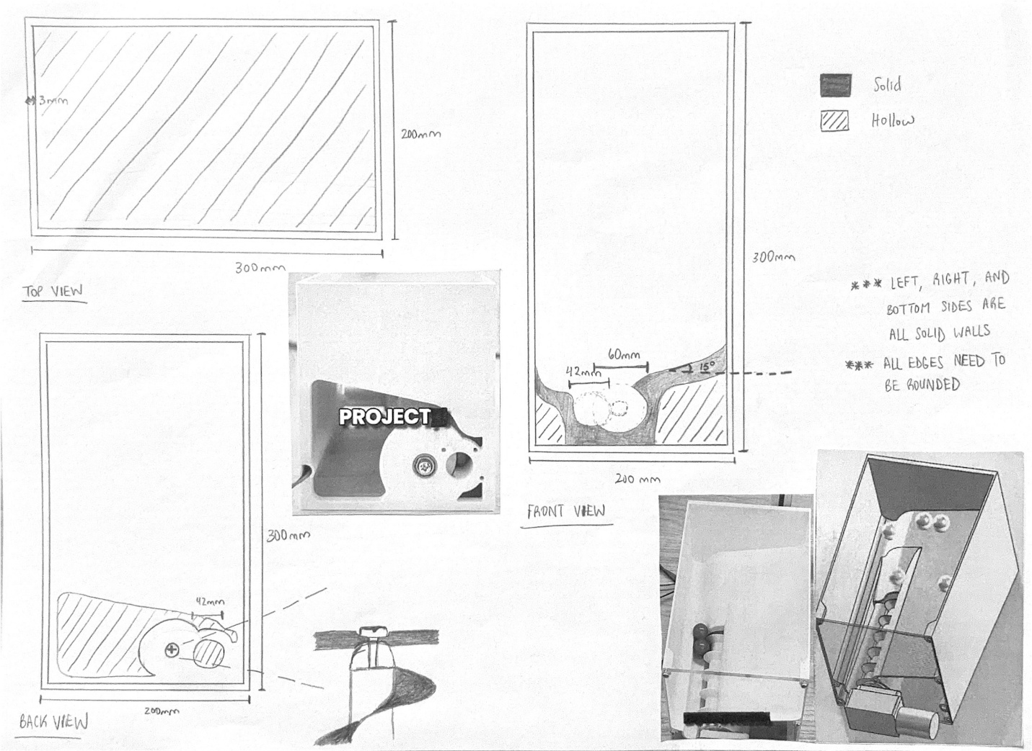
Figure 5: 2D Sketch of Hopper Housing

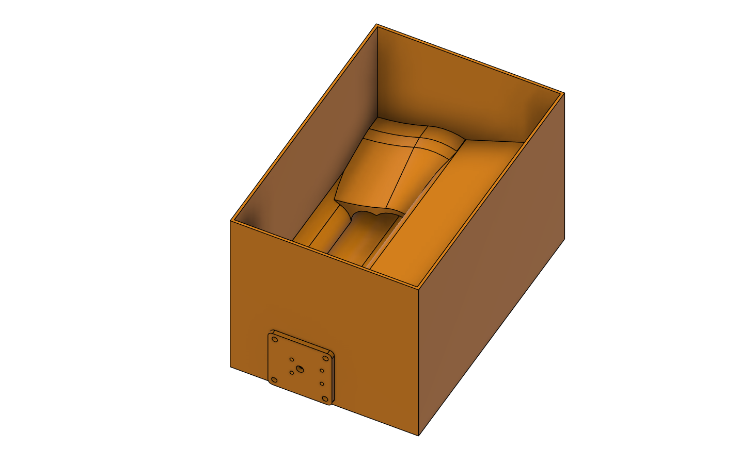
Figure 6: 3D Model of Hopper Housing
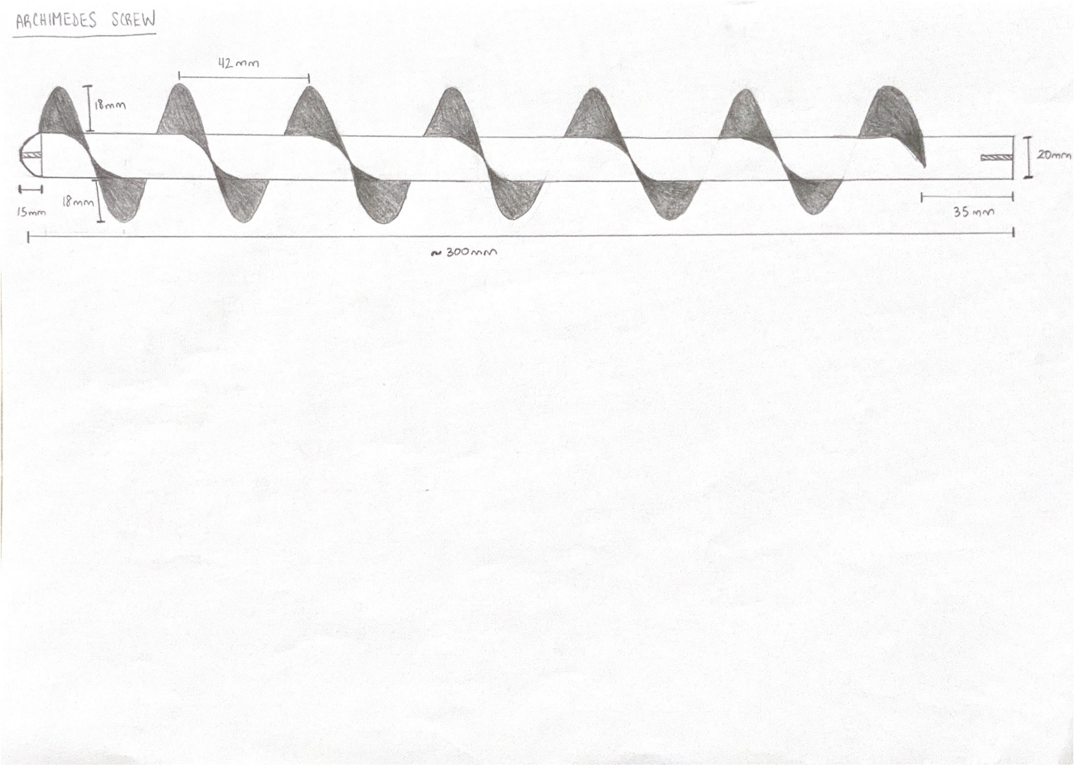
Figure 7: 2D Sketch of Archimedes Screw

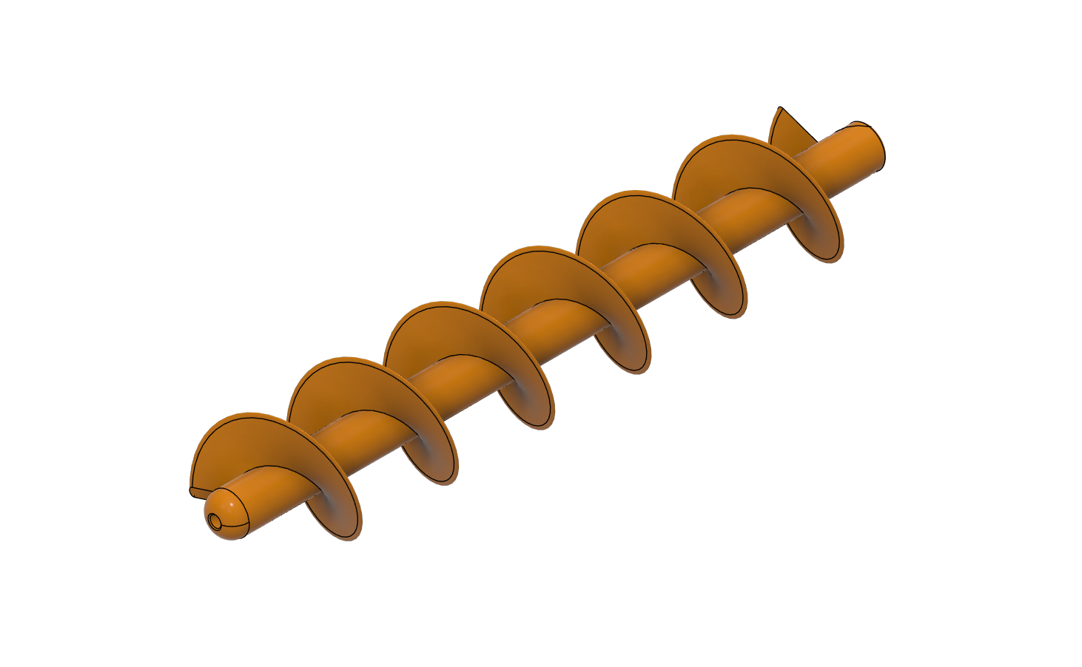
Figure 8: 3D Model of Archimedes Screw

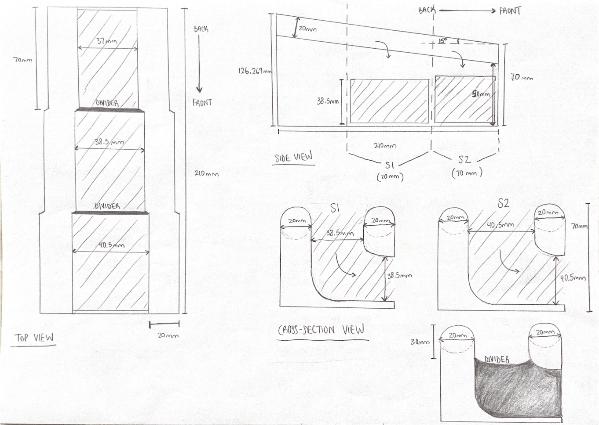
Figure 9: 2D Sketch of Tapered Roller Sorter
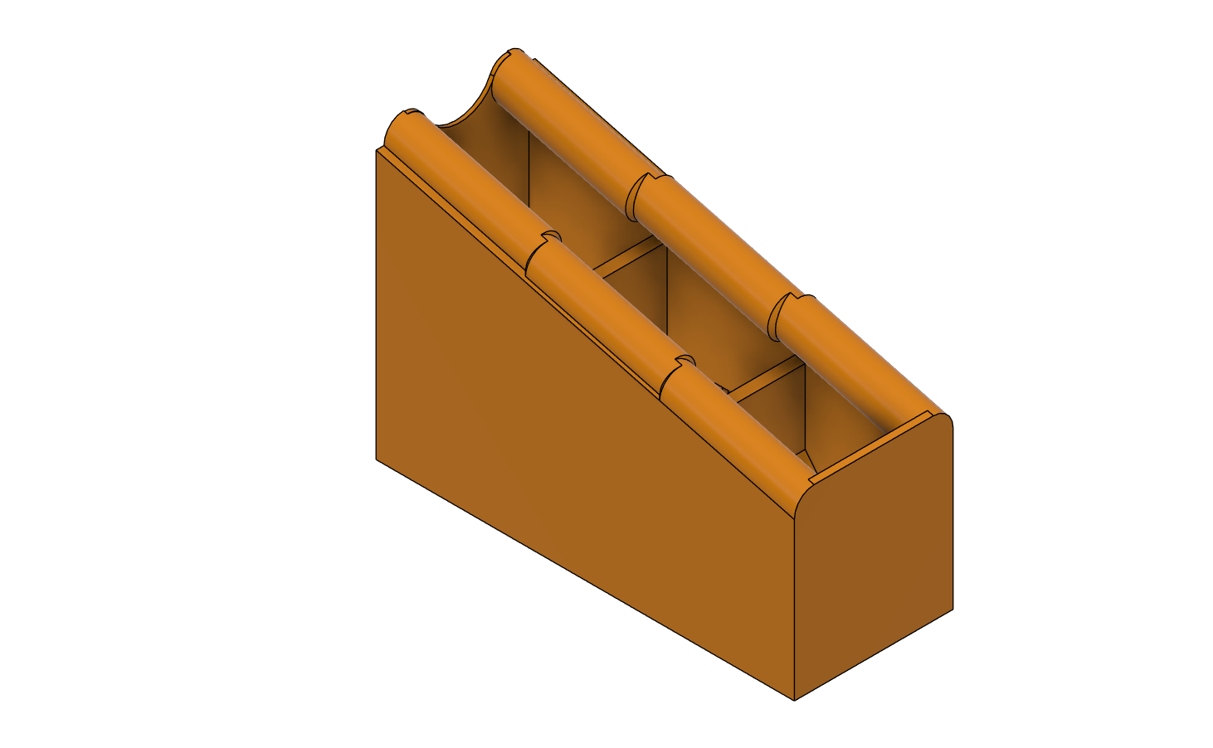
Figure 10: 3D Model of Tapered Roller Sorter
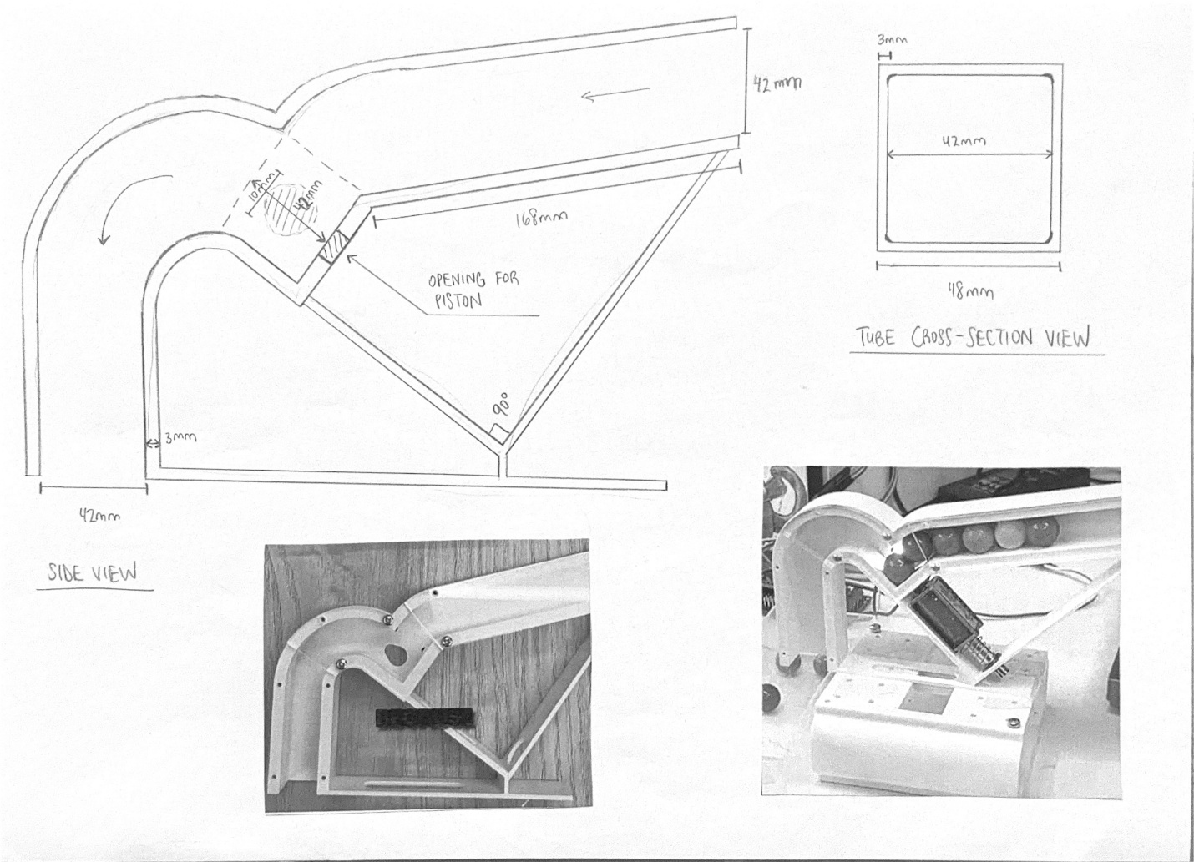
Figure 11: 2D Sketch of Stop-Ledge Color Sorter

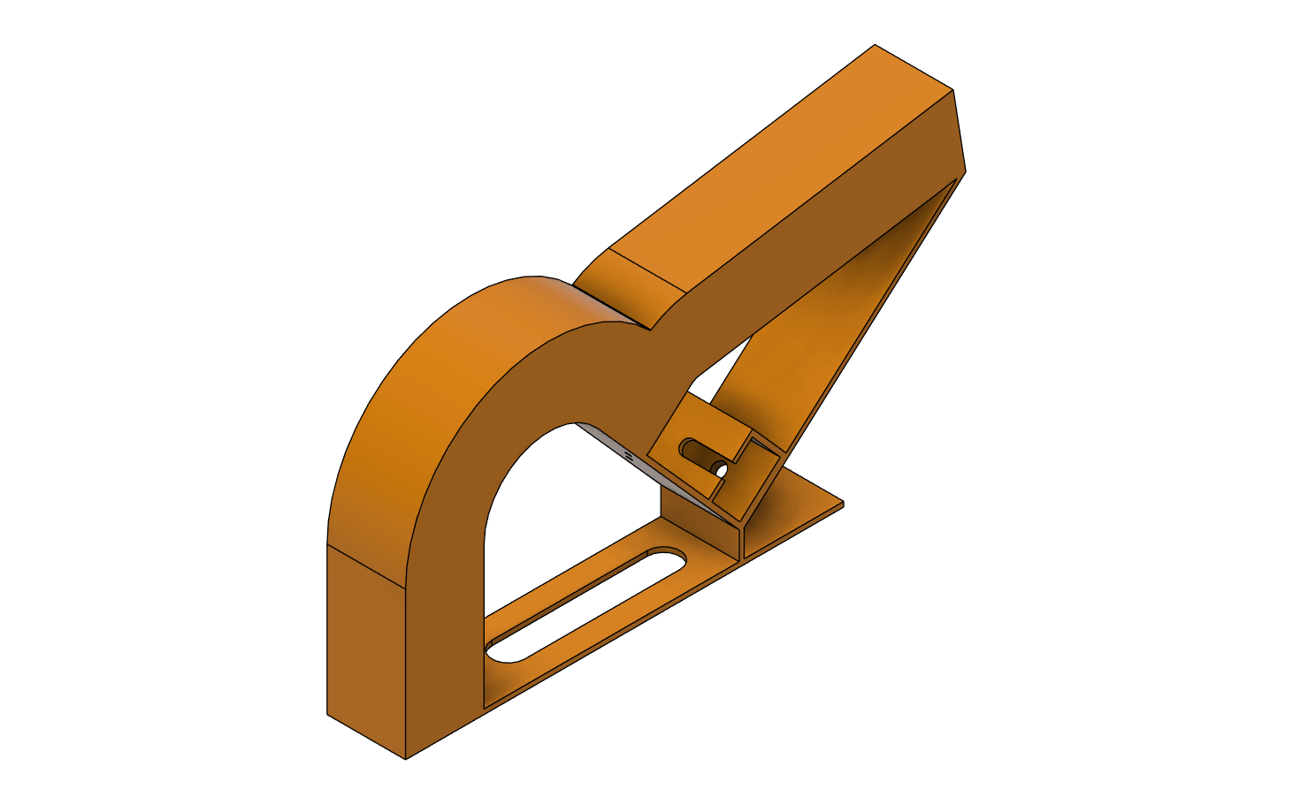
Figure 12: 3D Model of Stop-Ledge Color Sorter
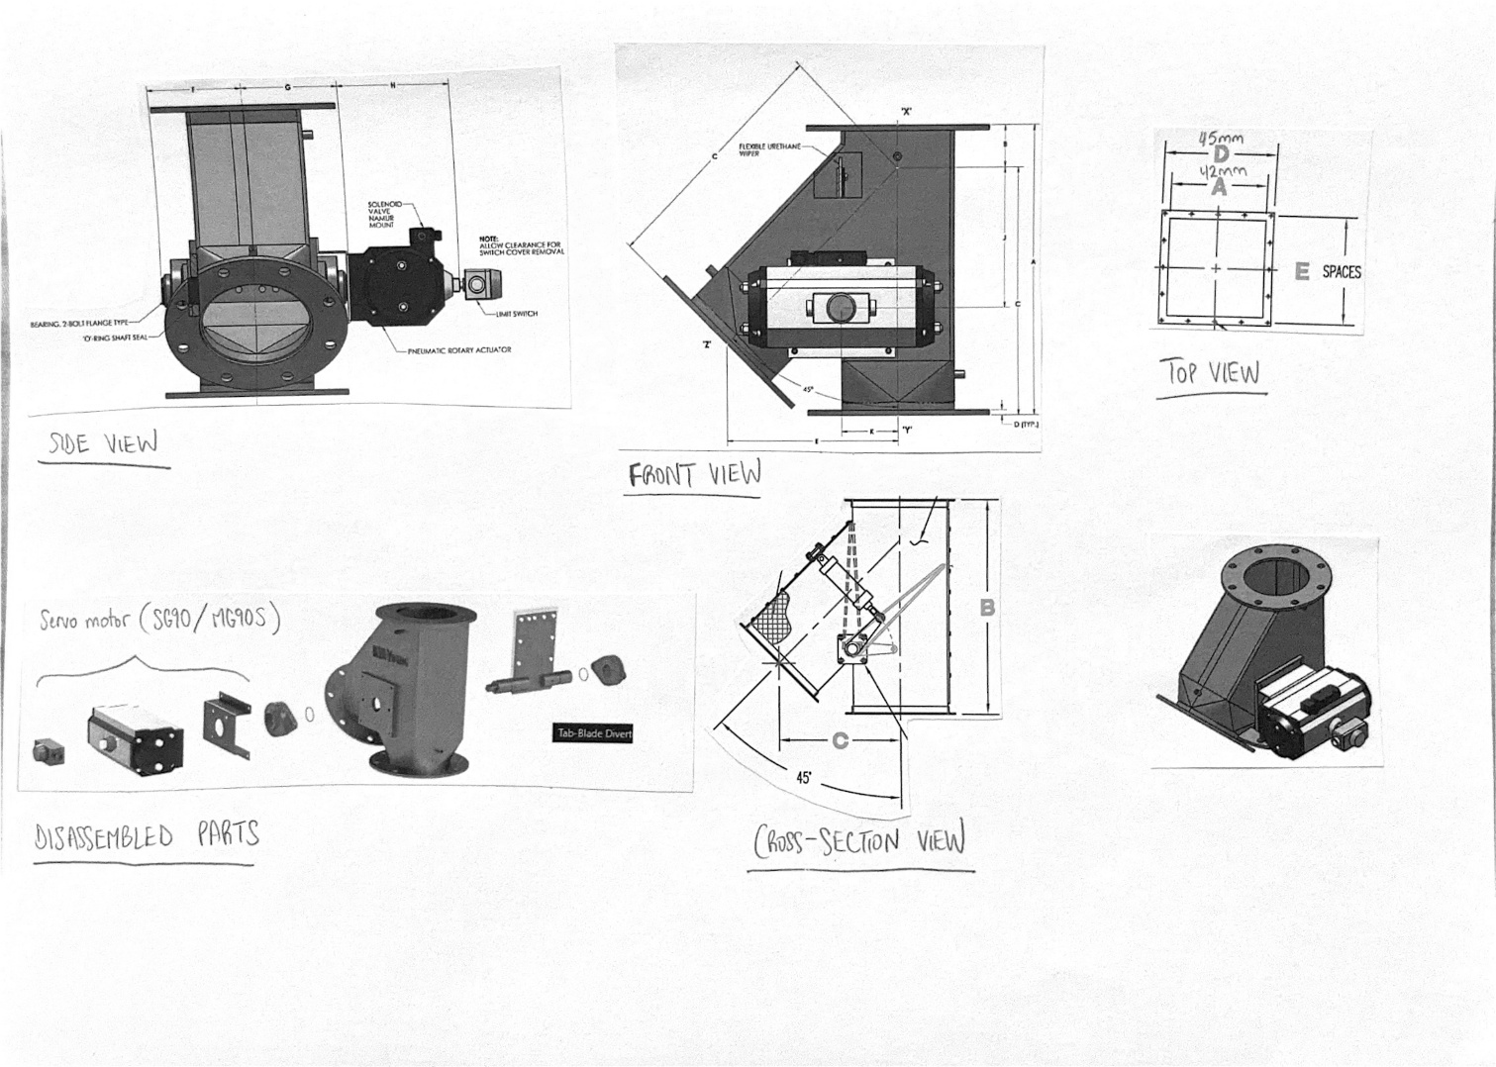
Figure 13: Reference 2D Schematics of 60º Single-Blade Diverter Driven by Hydraulic Piston

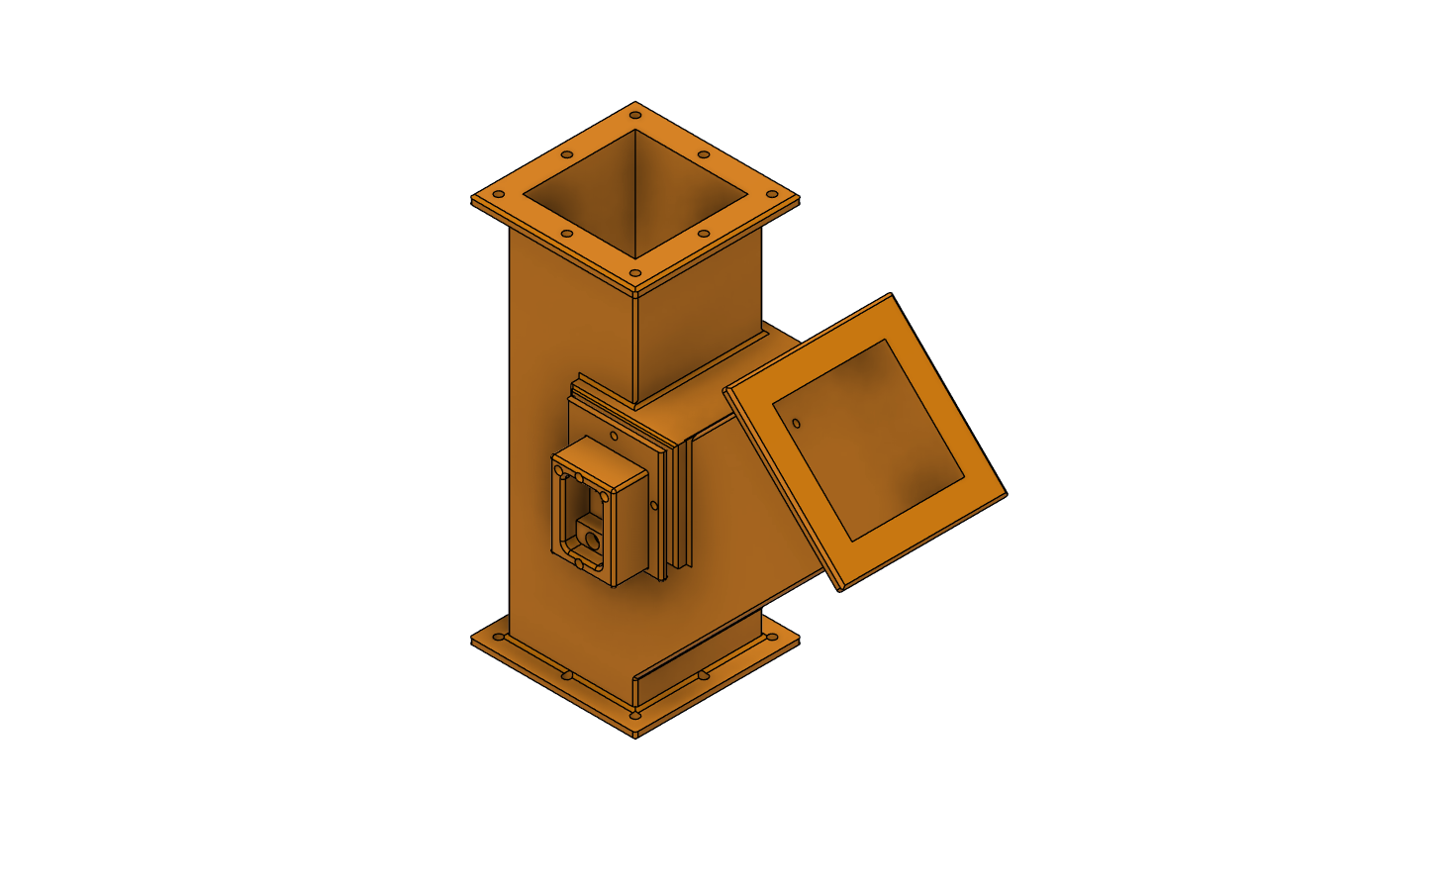
Figure 14: 3D Model of 60º Single-Blade Diverter

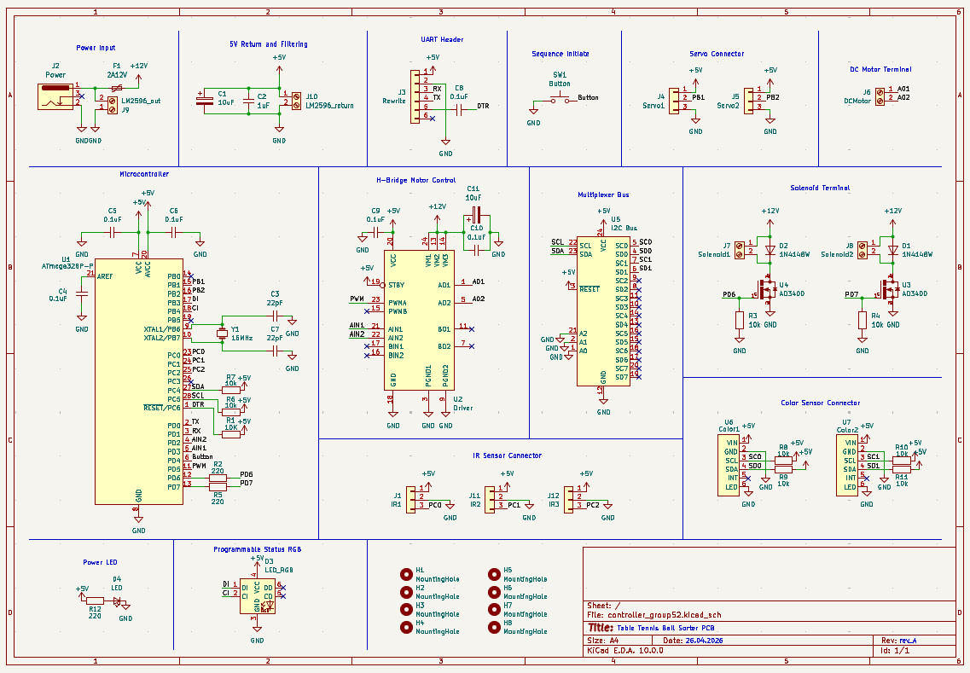
Figure 15: Circuit Schematic of Controller and Power Regulator
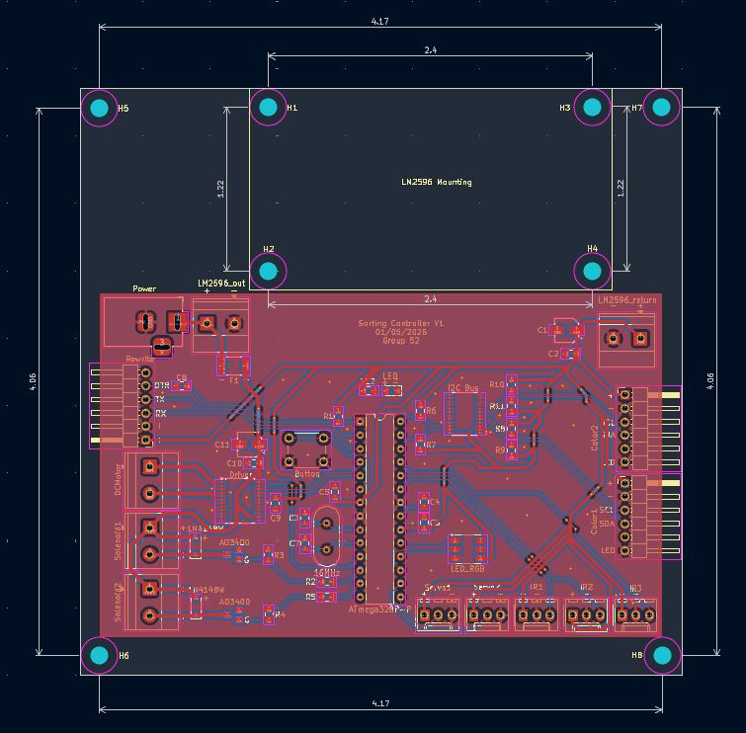
Figure 16: PCB Editor Schematic of Controller and Power Regulator
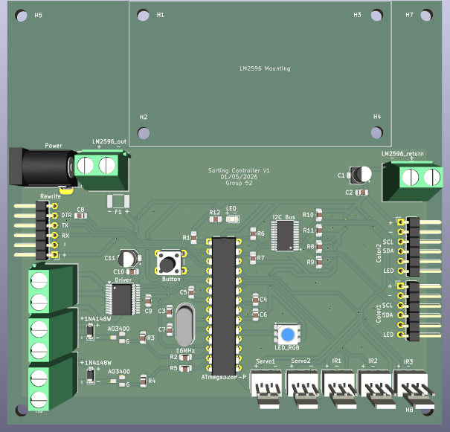
Figure 17: Generated 3D Model of Completed PCB

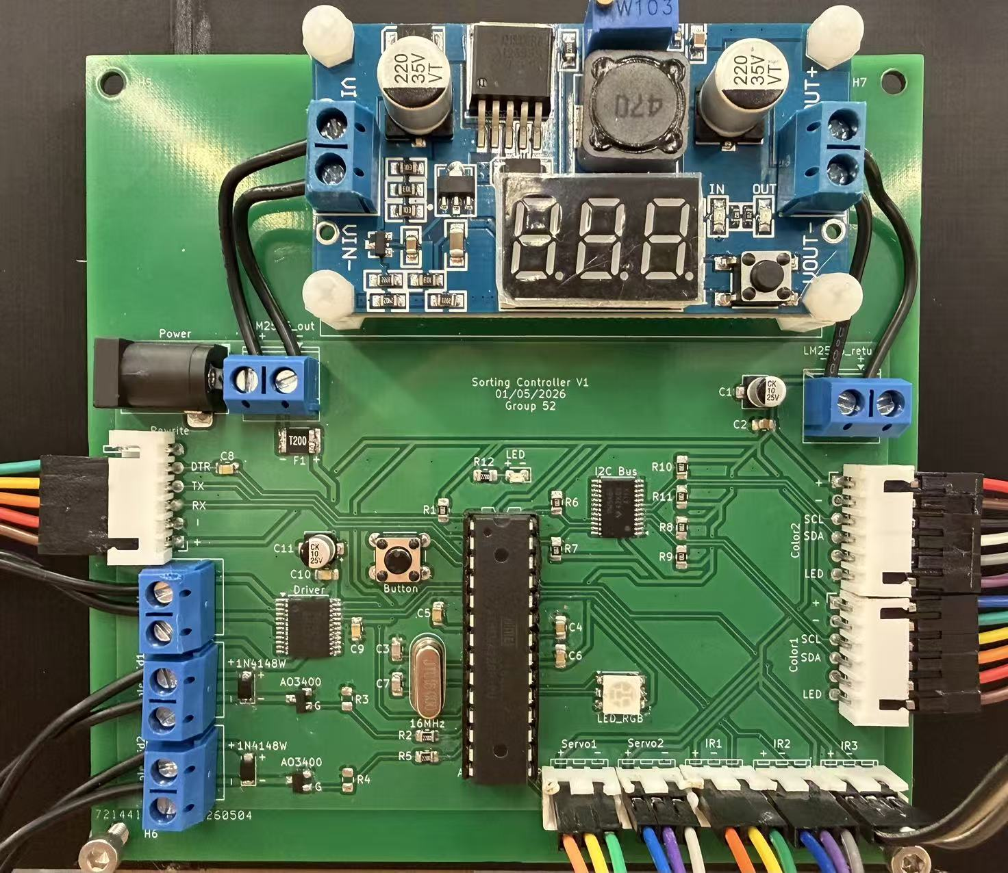
Figure 18: Actual Snapshot of Completed PCB

Datasheets
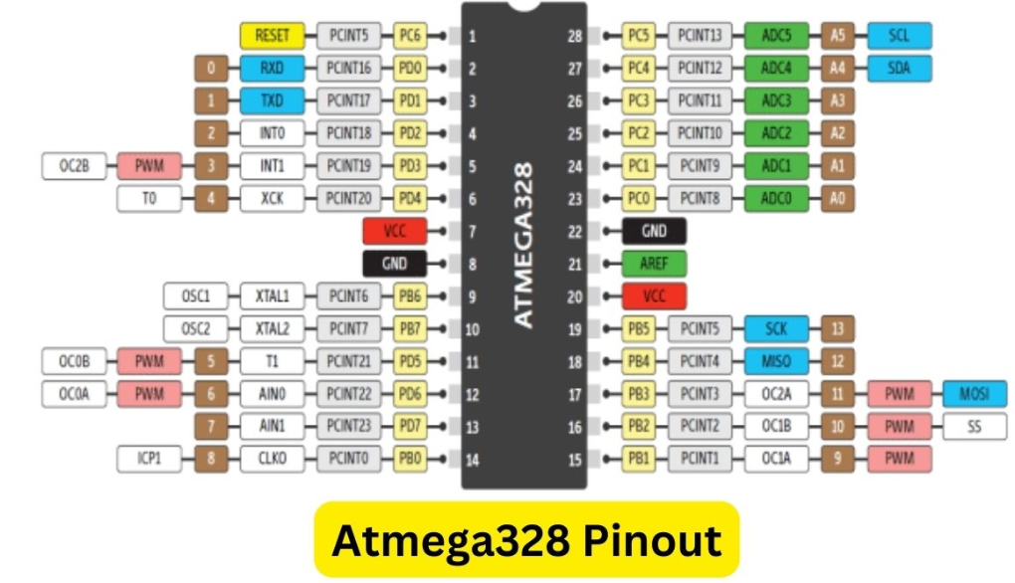
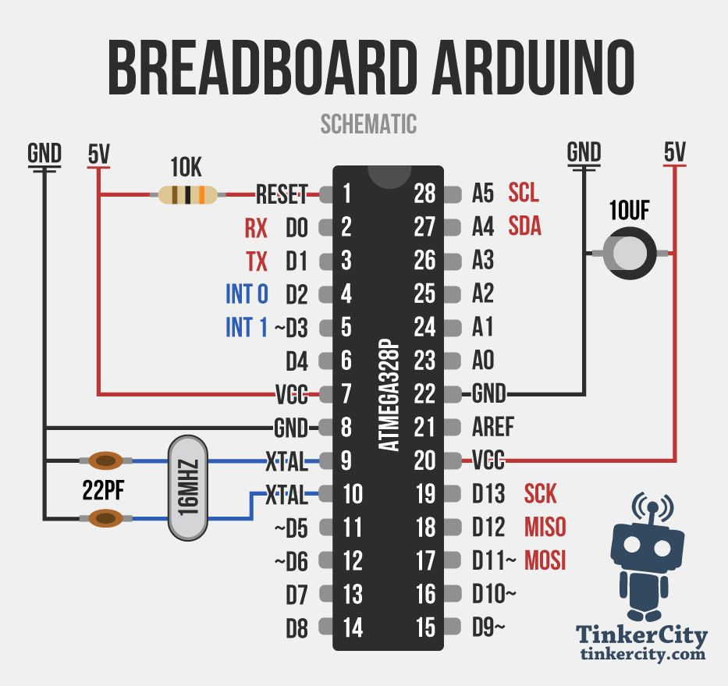
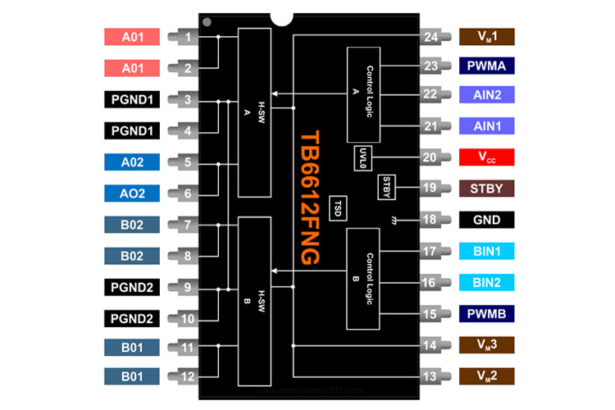
https://components101.com/ics/tb6612fng-motor-driver-ic-pinout-datasheet-equivalent-circuit-specs

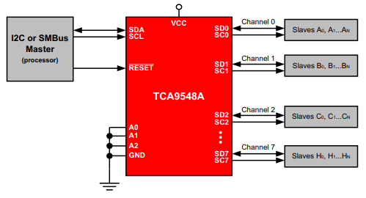
https://www.utmel.com/components/tca9548apwr-i2c-switch-circuit-pinout-and-datasheet?id=1628

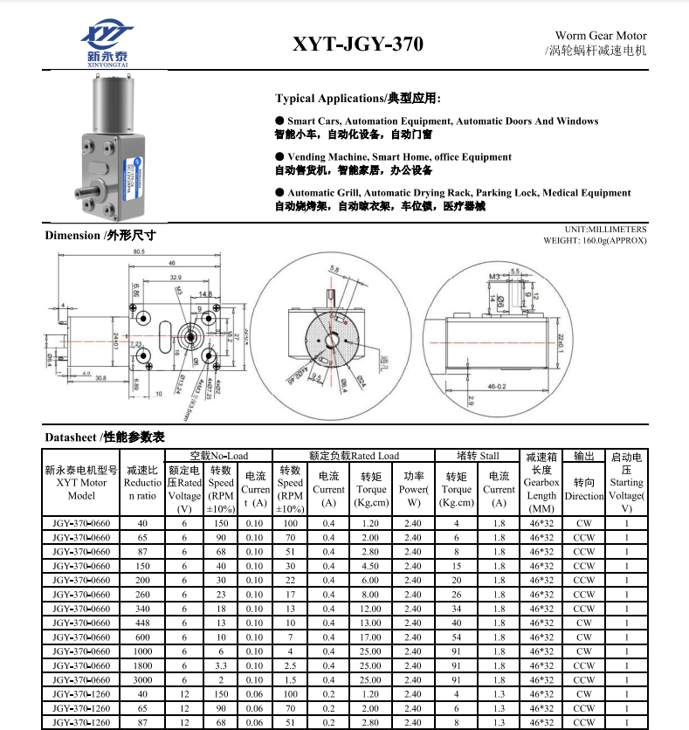

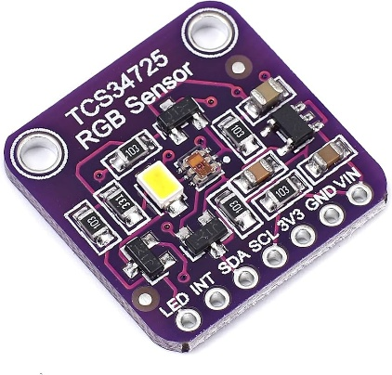

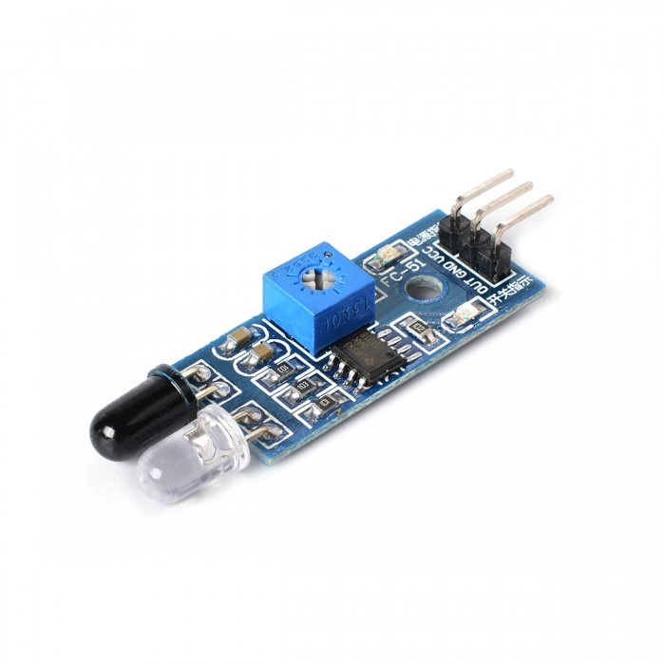

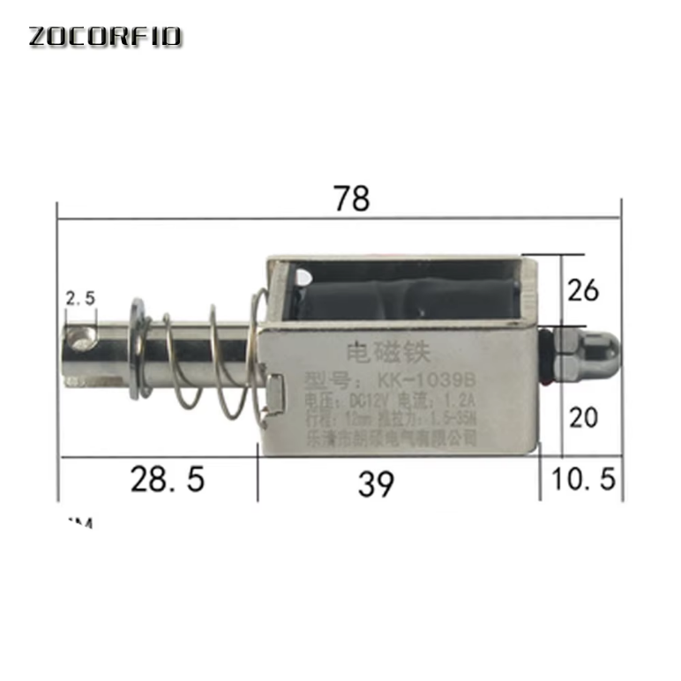

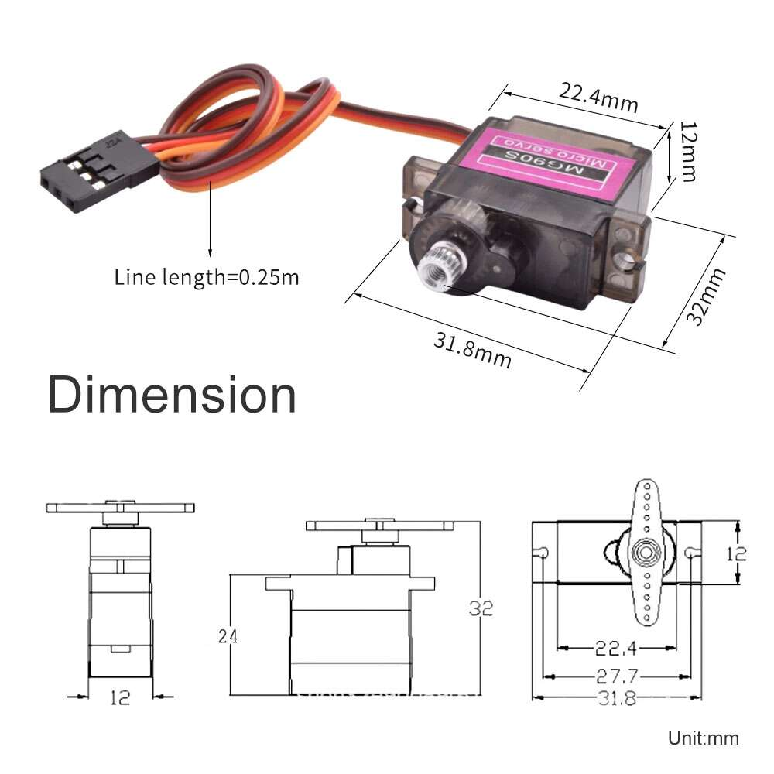

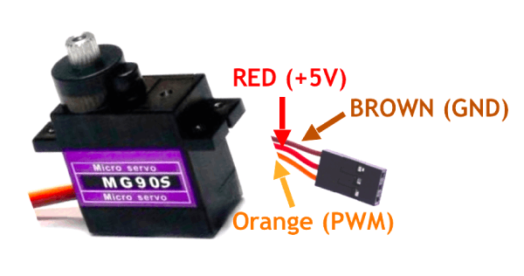

References
[1] Engineezy, "Archimedes Screw Feeder Design," YouTube, 2021. [Online]. Available: https://www.youtube.com/@Engineezy
[2] Engineezy, "Color Sorting Mechanism with Stop-Ledge Design," YouTube, 2021. [Online]. Available: https://www.youtube.com/@Engineezy
[3] Industrial Motion Systems, "Single-Blade Diverter Gate Mechanism Design and Applications," 2020.
[4] ams OSRAM, "TCS34725 Color Light-to-Digital Converter Datasheet," 2013.
[5] Texas Instruments, "LM2596 SIMPLE SWITCHER® Power Converter Datasheet," 2016.
[6] Microchip Technology, "ATmega328P Microcontroller Datasheet," 2018.
[7] ITTF, "Technical Leaflet T3: Ball Regulations," 2020.
[8] SparkFun Electronics, "TCS34725 Color Sensor Hookup Guide," 2022.
[9] Pololu Robotics, "TB6612FNG Motor Driver Carrier Documentation," 2021.
[10] components101.com, "TB6612FNG Motor Driver IC Pinout, Datasheet & Equivalent," 2021. [Online]. Available: https://components101.com/ics/tb6612fng-motor-driver-ic-pinout-datasheet-equivalent-circuit-specs
[11] UTMEL Electronics, "TCA9548APWR I2C Switch Circuit Pinout and Datasheet," 2021. [Online]. Available: https://www.utmel.com/components/tca9548apwr-i2c-switch-circuit-pinout-and-datasheet

