**CALLING ALL EARLY BIRDS** - Complete exhibitor form below and payment form on page 2 by 8/1/2015: $750

Participating in Exhibit Hall includes:

* One 8x10 booth with pipe and drape on three sides
* 2 full-conference badges. Option to audit all CE Programming. Meals and social events for 2.
* Text listing on NJPhA website
* Text listing in October convention program

Notes:

* Exhibit booth hours: 5 – 9pm October 17 during Boardwalk Bash

7:30 – 11:30am October 18 including Breakfast and Morning Break.

* NEW! 4 hours of unobstructed face-time with attendees on Saturday night during the Boardwalk Bash
* NEW! Boardwalk theme and booths with old-time games to increase fun-time with attendees. See Sponsorship Form to add a second “game booth” to your contract today!
* Boardwalk passes to drive attendee booth visits. Full passes entered into prize drawings on Oct. 18

**After 8/1/15** - Complete exhibitor form below and payment form on page 2: $1,000

Company Name: Click here to enter text.

Type of Product or Service: Click here to enter text.

Address: Click here to enter text.

City: Click here to enter text. State: Click here to enter text. Zip: Click here to enter text.

Exhibitor Badge 1 - Name: Click here to enter text. Email: Click here to enter text.

Exhibitor Badge 2 - Name: Click here to enter text. Email: Click here to enter text.

**Additional Badges at $100 each**

Exhibitor Badge 3 - Name: Click here to enter text. Email: Click here to enter text.

Exhibitor Badge 4 - Name: Click here to enter text. Email: Click here to enter text.

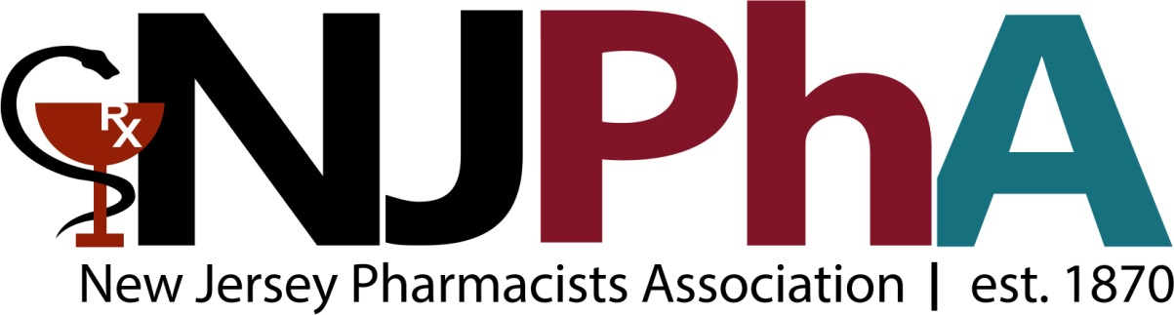

Exhibitor Handbook with additional details to follow payment. In the interim, please provide us with special notes regarding booth placement, attendees, etc.

Special notes: Click here to enter text.

**QUESTIONS? PLEASE CALL THE NJPHA OFFICE AT 609.275.4246**

**OR EMAIL LISA SARACHMAN AT LSARACHMAN@NJPHARMA.ORG**

Payment Information: Total purchase: Click here to enter text.

**This box must be checked in order to process credit card payment & accept registration form**

**☐** I authorize the New Jersey Pharmacists Association to charge my credit card for the amount indicated directly below. Signature:____________________________________________________

☐VISA ☐Master Card ☐American Express ☐ Discover

Card Number: Click here to enter text. 

Security Code: Click here to enter text. Expiration date: Click here to enter text.

Amount of charge: Click here to enter text. Signature: Click here to enter text.

☐Check enclosed: Payable to NJPhA; Check # Click here to enter text. Amount: Click here to enter text.

**Cancellation Policy:**

Exhibitors canceling booth space prior to August 1 will receive 100% refund less a $50 administration fee. Cancellations between August 1 and September 1 will receive a 50% refund less a $50 administration fee. Cancellations after September 1 will not receive a refund.

**\*\* Increase your awareness and access to qualified sales leads by adding an**

**event sponsorship to your exhibit booth contract. Download information on almost a dozen unique sponsorship opportunities at www.npharmacists.org. \*\***