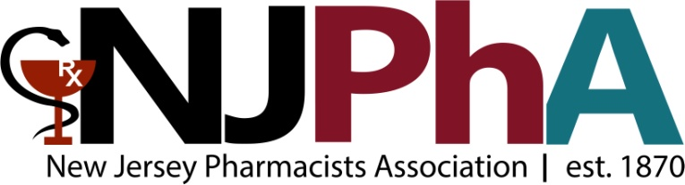

| NEW JERSEY pHARMACISTS aSSOCIATION Membership Application 2015 760 ALEXANDER ROAD, PRINCETON, NEW JERSEY 08543; PHONE: 609-275-4246 FAX 609-275-4066  www.njpharmacists.org | | | | | | | | |
| --- | --- | --- | --- | --- | --- | --- | --- | --- |
| Contact Information: Please help us enter an accurate membership record by providing your contact information on this form.All fields marked in RED are required. | | | | | | | | |
| **First Name:** | | **Last Name:** | | | | **License #:** | | |
| **Current Address:** | | | | Home Phone #: | | | | **Cell Phone #:** |
| **City:** | | **State:** | | | | **Zip Code:** | | |
| **NABP ID#:** | | **Birthday mm/day:** | | | | **Preferred E-mail Address:** | | |
| **University:** | | | **Year of Graduation:** | | | | **Years of Residency/Fellowship:** | |
| Other Home or Work information? Please add here: | | | | | | | | |
| mEMBERSHIP CATEGORY (SELECT ONE) | | | | | | | | |
| Active Pharmacists: $230yr.  2 year renewal: $425 | First Year Pharmacist: $125 | | | | | Associate Member $250 | | |
| Retired Pharmacists $110 | Pharmacy Technician $50 | | | | | Student Pharmacists $10 | | |
| Resident/Fellow $100 | | | | | | | | |
| PRACTICE SETTING (SELECT ONE) | | | | | | | | |
| COMMUNITY PRACTICE | | ACADEMIA | | | | INDUSTRY | | |
| HEALTH SYSTEM | | CONSULTANT | | | | COMPOUNDING | | |
| RETAIL/CHAIN | | OTHER______________________ | | | | College Attended: | | |
| REGION (SELECT ONE): *please select your regional affiliation* | | | | | | | | |
| REGION 1 (BERGEN COUNTY) | | REGION 3 (HUNTERDON, MIDDLESEX, SOMERSET, WARREN COUNTIES) | | | | REGION 5 (CUMBERLAND, SALEM, ATLANTIC, CAPE MAY COUNTIES) | | |
| REGION 2 (ESSEX, HUDSON, MORRIS, PASSAIC, SUSSEX, UNION COUNTIES) | | REGION 4 (MERCER, MONMOUTH, OCEAN, EASTERN BURLINGTON COUNTIES) | | | | REGION 6 (GLOUCESTER, CAMDEN, WESTERN BURLINGTON COUNTIES) | | |
| mETHOD OF pAYMENT * | | | | | | | | |
| CHECK MADE PAYABLE TO **NJPHA** CHECK NUMBER: | | | | | | | | |
| vOLUNTARY pac CONTRIBUTION **YOUR CONTRIBUTION ALLOWS njpHA TO be involved in legislative initiatives that impact PHARMACY IN NEW JERSEY | | | | | | | | |
| CONTRIBUTIONS: min. $10 recommended. $____________ | | | | | | | | |
| **SEPARATE** CHECK MADE PAYABLE TO: **NJPhA PAC** | | | | | CHECK NUMBER: | | | |
| **Signature of applicant (or representative):** | | | | | | | | **Date:** |

*NJPhA dues are not deductible for income tax purposes. They may be deductible as ordinary and necessary business expenses, subject to restrictions as a result of organization lobbying activities. NJPhA estimates that 18% is the nondeductible portion of your 2015 dues.

**PAC contributions are not deductible for income tax purposes. Contributions to NJPhA PAC are voluntary and used for political purposes. You may refuse to contribute without reprisal, and the association will not favor or disfavor any member because of the amount contributed.