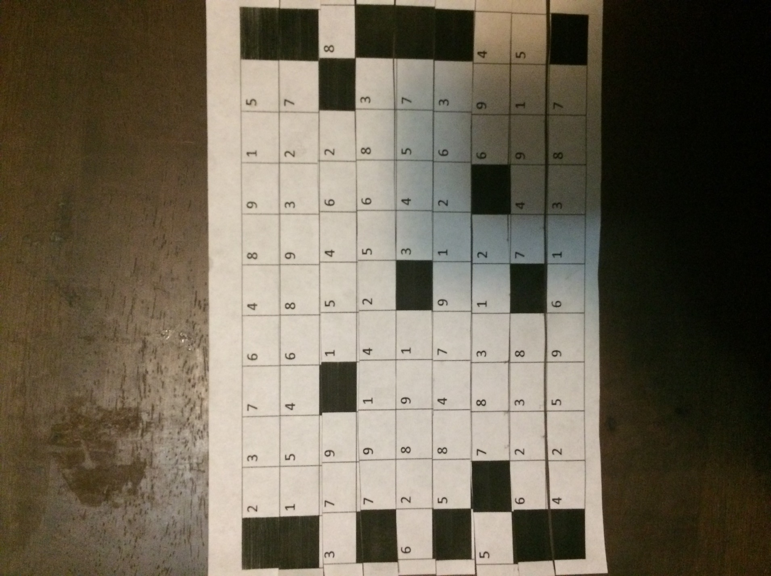

Setup:

Numbers on back of columns, Place from 1-9. 1 on top down to 9 on bottom

Playing:

Slide each piece right or left to create one of each digit in a column

Each row can move up to 2 slots to the side

column

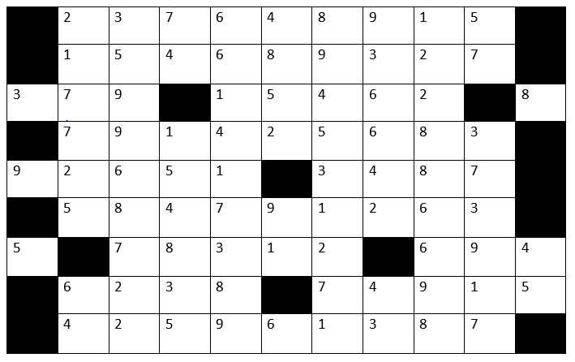

row

Empty Square

(don’t fill)

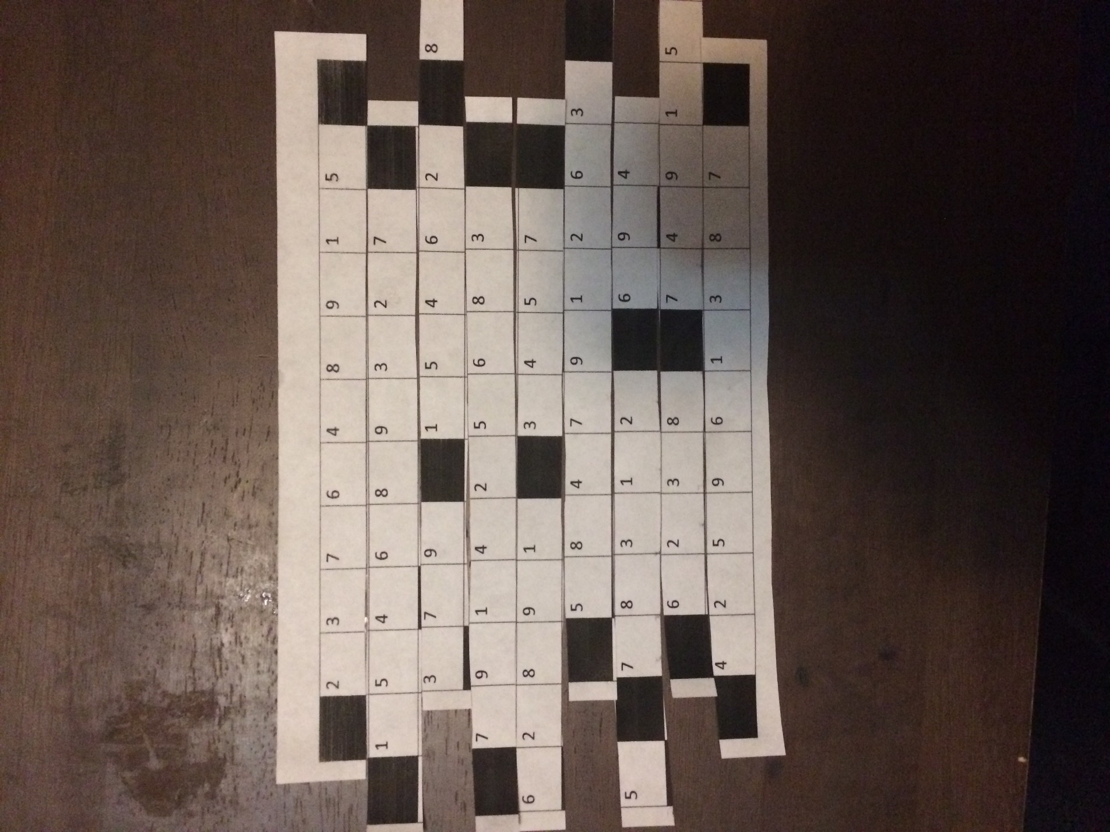

|  |  |  |  |  |  |  |  |  |  |  |
| --- | --- | --- | --- | --- | --- | --- | --- | --- | --- | --- |
|  | 5 |  |  |  |  |  |  |  |  |  |
|  |  |  | 7 |  |  |  | 9 |  | 5 |  |
|  |  | 5 |  | 6 |  |  |  |  |  |  |
| 3 |  | 9 |  |  | 5 | 4 |  | 2 |  | 8 |
|  | 7 |  | 1 |  | 2 |  | 6 |  |  |  |
| 9 | 2 |  |  | 1 |  | 3 |  |  | 7 |  |
|  |  |  | 4 |  | 9 |  | 2 |  | 3 |  |
| 5 |  | 7 |  | 3 | 1 |  |  | 6 |  | 4 |
|  |  |  |  |  |  | 7 |  | 9 |  | 5 |
|  | 4 |  | 5 |  |  |  | 3 |  |  |  |
|  |  |  |  |  |  |  |  |  |  |  |

|  |  |  |  |  |  |  |  |  |  |  |
| --- | --- | --- | --- | --- | --- | --- | --- | --- | --- | --- |
|  | 5 |  |  |  |  |  |  |  |  |  |
|  | 2 | 3 | 7 | 6 | 4 | 8 | 9 | 1 | 5 |  |
|  | 1 | 5 | 4 | 6 | 8 | 9 | 3 | 2 | 7 |  |
| 3 | 7 | 9 |  | 1 | 5 | 4 | 6 | 2 |  | 8 |
|  | 7 | 9 | 1 | 4 | 2 | 5 | 6 | 8 | 3 |  |
| 9 | 2 | 6 | 5 | 1 |  | 3 | 4 | 8 | 7 |  |
|  | 5 | 8 | 4 | 7 | 9 | 1 | 2 | 6 | 3 |  |
| 5 |  | 7 | 8 | 3 | 1 | 2 |  | 6 | 9 | 4 |
|  | 6 | 2 | 3 | 8 |  | 7 | 4 | 9 | 1 | 5 |
|  | 4 | 2 | 5 | 9 | 6 | 1 | 3 | 8 | 7 |  |
|  |  |  |  |  |  |  |  |  |  |  |

Then I cut them into rows and there was the final version of the prototype.

Sadako is the puzzle that I started with. I had to figure out what rules and different ways to change it.

Word searches gave me the idea of the blank spots that give free spots.

I got my inspiration from sudoku. I like playing sudoku in my free time sometimes and thought how I could make a new version.

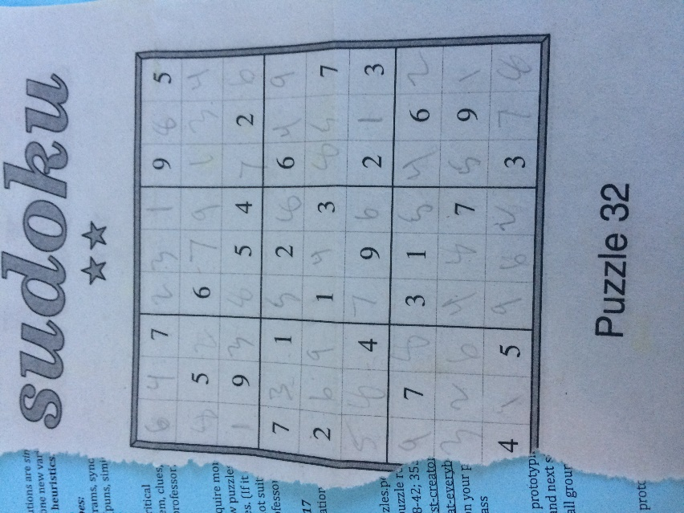

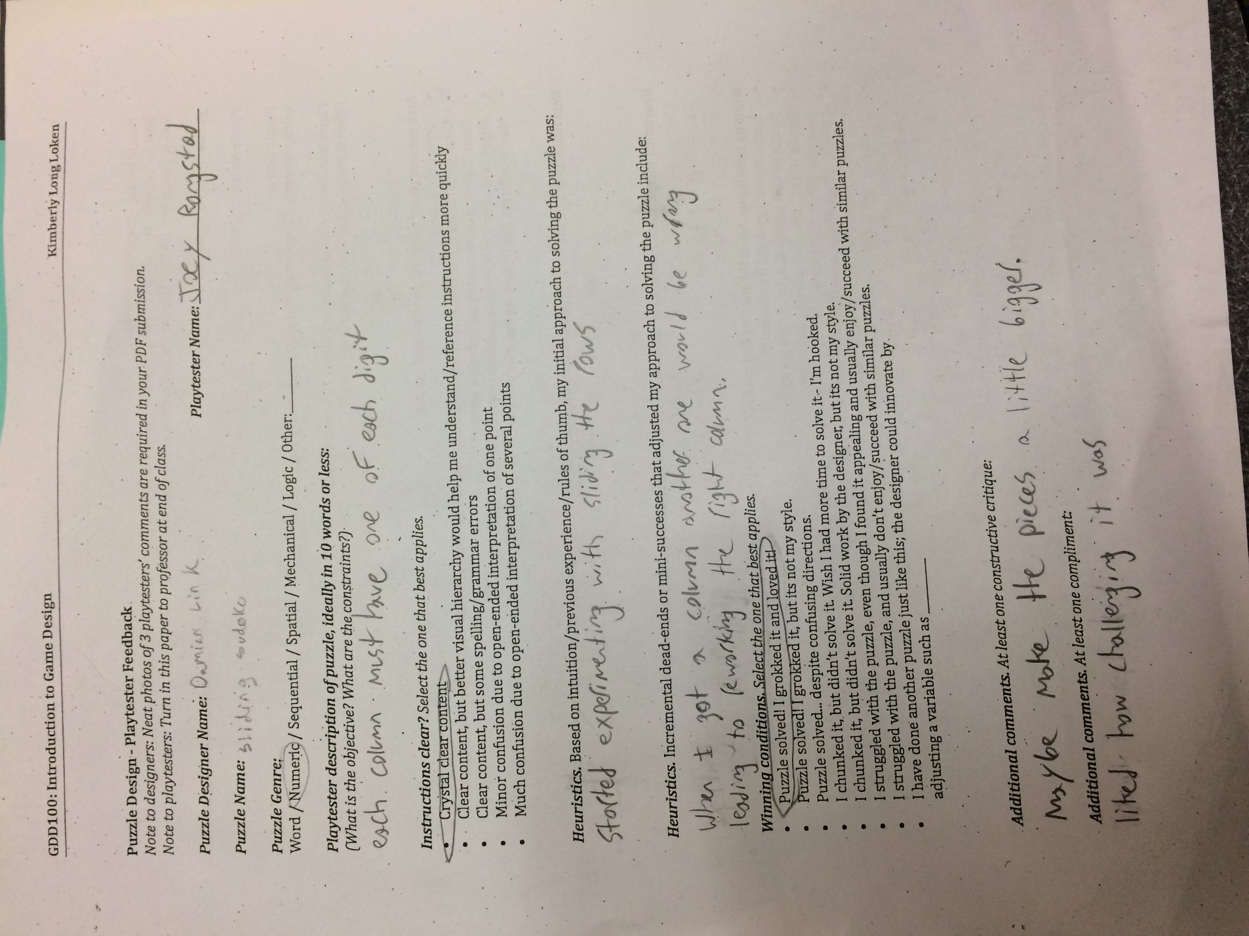

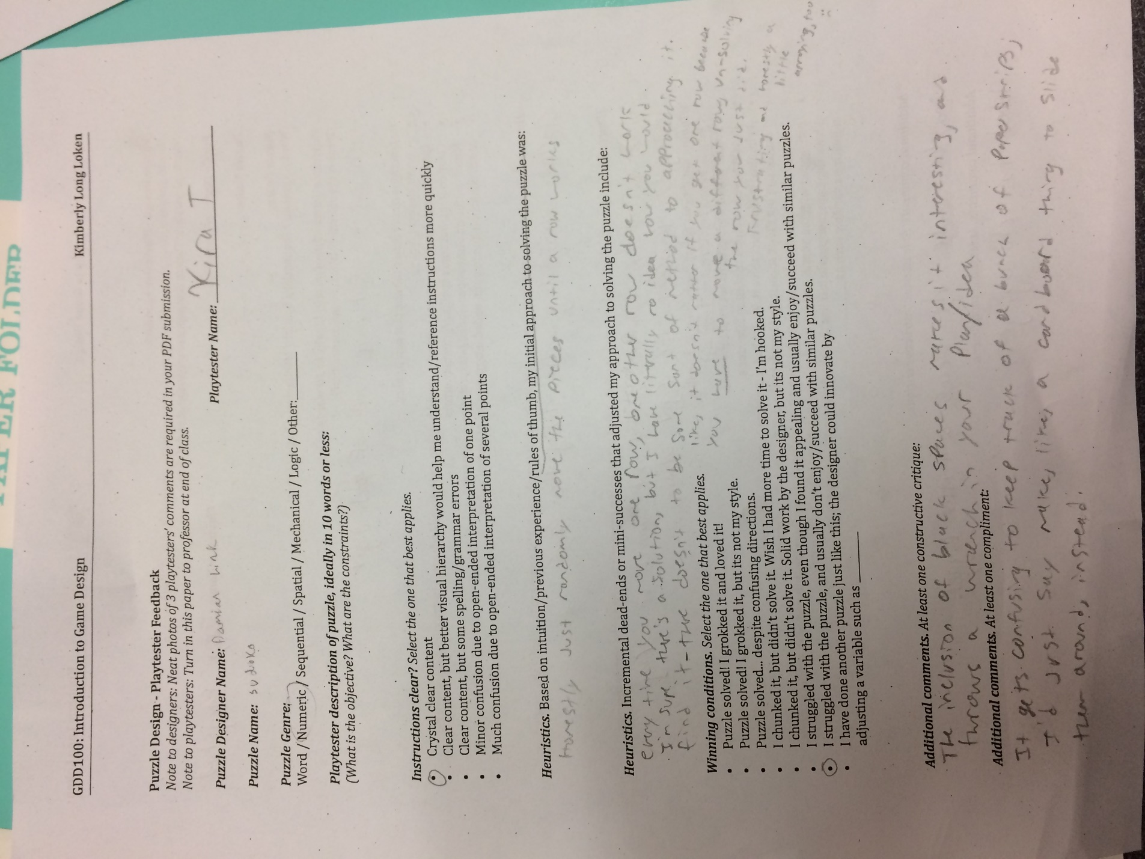

I started with normal Sadako and then chose to add blank squares as free spots and make rows not all nine squares long. After this I had to make this more unique, so I chose to cut them into rows and slide them to solve it. Finally, I chose to have the numbers filled in to make the puzzle making it where there is less solutions adding more skill to it. This was my final prototype. While playtesting one play tester grokked the puzzle and the other didn’t get it. They said the content is clear and one didn’t like the black squares. I think it needs some more balancing and probably some clearer rules on what black squares do and mean. The varables are one player and the board. In the board variable there is rows to move side to side, that made it more unique. The skill level is made for medium, but they must like numeric puzzles and Sadako. The dynamics of the puzzle is good because there is a few ways to find the solution such as one play tester filled one column and then kept checking if there was any duplicate numbers in a column.