**TEST REPORT**

**TESTER NAME : HỒ CÔNG PHÙNG**

**MSSV : 18021014**

**CODE : <https://github.com/egonSchiele/grokking_algorithms>**

**FUNCTION TEST : QUICKSORT**

**PURPOSE : USING QUICKSORT TO SORT AN ARRAY**

Source code :

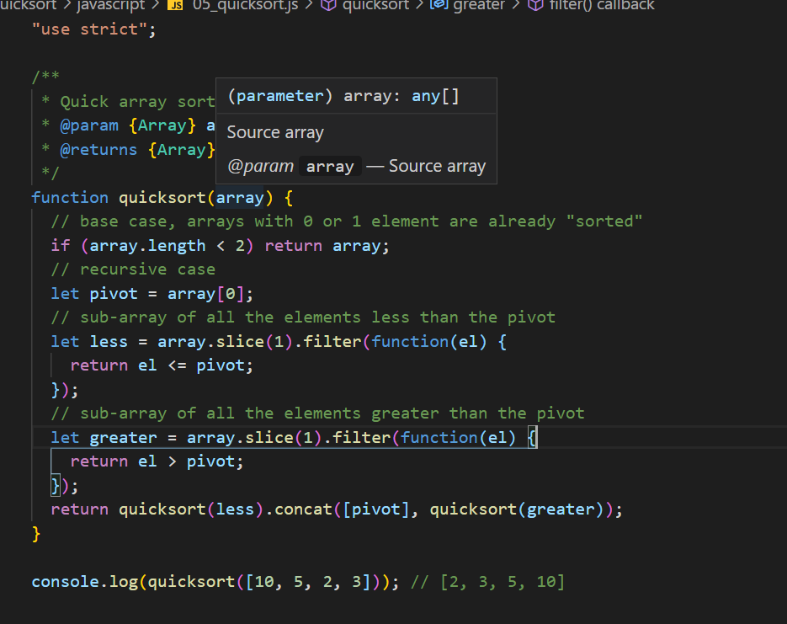

**Graph :**

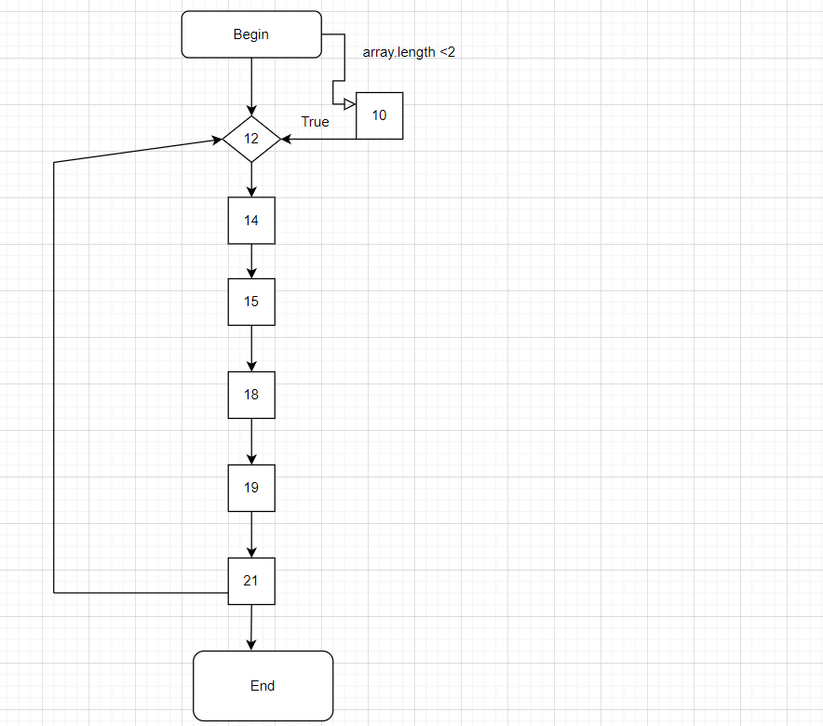

**Control Flow Graph**

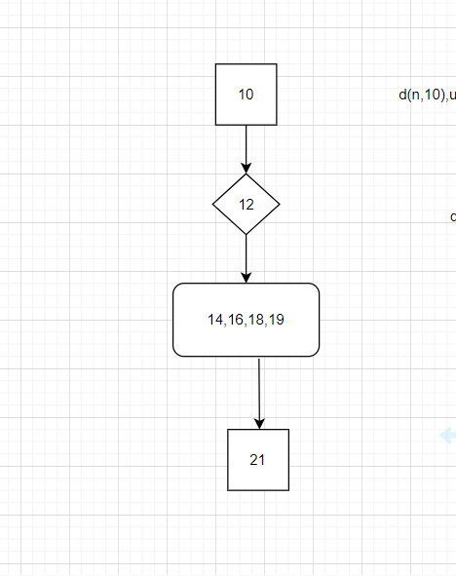

**Data Flow Graph**

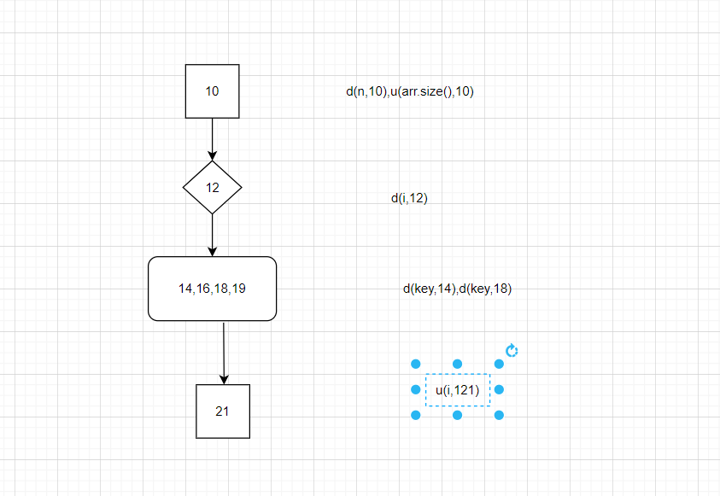

**All-DU-Paths coverage testcases :**

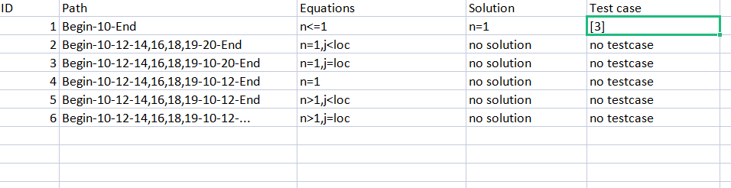

**Test cases :**

