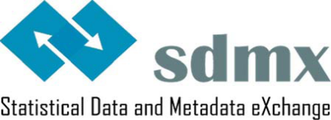
Statistical Working Group
Statistical Guidelines

CL_SEASONAL_ADJUST
Code list for Seasonal Adjustment
Version 1.0 - 4/07/2014

CL_SEASONAL_ADJUST
Name: Code list for Seasonal Adjustment.
Definition: Seasonal adjustment is a statistical technique used to remove the effects of seasonal and calendar influences operating on a data series.
The concept to be used for CL_SEASONAL_ADJUST is SEASONAL_ADJUST.
Established international standard(s) used as input for the code list: None.
Version: 1.0, 4 July 2014
Recommended codes  values descriptions |  | Annotations
T | Trend
C | Trend-cycle data, calendar adjusted
R | Trend-cycle data, not calendar adjusted
K | Calendar component | Synonyms: Calendar effects; calendar factors
X | Seasonal component | Synonyms: Seasonal effects; seasonal factors
M | Seasonal and calendar components | Synonyms: Seasonal and calendar effects; seasonal and calendar factors
I | Irregular component | Synonym: Irregular effects
N | Neither seasonally adjusted nor calendar adjusted data | Synonyms: Raw data; unadjusted data
S | Seasonally adjusted data, not calendar adjusted
W | Calendar adjusted data, not seasonally adjusted
Y | Calendar and seasonally adjusted data
Remark
Further recommended code values for expressing general statistical concepts like "not applicable", etc., can be found in section “Generic codes” of the "Guidelines for the creation and management of SDMX Cross-Domain Code Lists" (to be found under “Guidelines” on the official SDMX website).

http://sdmx.org/

