- Databus
- Motivation
Modern Internet-based systems are increasingly facing the difficult challenges of performing complex processing over large amounts of valuable data with strict upper bounds on latency. For example, at LinkedIn, we have to continuously maintain indexes and statistical models over many aspects of the online professional identity of our constantly increasing user base of 120+ million. These indexes and models facilitate the discovery of new opportunities for our members. Other use cases include database replication for read scalability, data standardization, and query result pre-computation and caching.
Throughout the rest of this section, we are going to describe how Databus, a system for change data capture, is being used to help solve the problem of performing complex online and near-line computations at LinkedIn under strict latency bounds. First, we will describe the computational model that will set the context for the rest of the discussion. Then, we will have a more detailed definition of the problem. Next, we will describe of Databus and how it addresses the problem. Finally, we will briefly talk about other similar systems.
- Computational model
Let us consider a typical three-tier Internet application architecture. The business logic tier obtains the user input I from the presentation tier and the current data model state M for the user from the backend tier. It computes the new data model state M' = F(M, I) and stores it back in the backend tier. Finally, it returns the result R = G(M') to the presentation tier.
In the above model, most of the complexity is in the computation of M’. At the same time, there is a latency budget on the entire end-to-end interaction with the user and consequently on the computation of M’. To alleviate this, we can decompose the computation of the new state M’ = (M’_{R}, M’_{A}) into M’_{R} = F_{R}(M, I) which is sufficient to compute R, i.e. R = G(M’_{R}), and remaining computation M’_{A} = F_{A}(M, M’_{R}, I)) which can be outside the online serving part.
For example, if the user added a new connection, M’ can include updating her list of connections, updating her peer’s list of connections (for bi-directional connections), updating the social graph index, updating the email queue with the notification emails, etc. In this case, R will most likely just include a confirmation that the user’s connection list has been updated.
Further, we can even decompose the computation of M’_{A} = (M’_{A1}, …, M’_{An}) = (F_{A1}(M, M’_{R}, I), …, F_{An}(M, M’_{R}, I)) into independent computations that can be done in parallel. In the above example, the update to the email notification queue and the update to the social graph index need not be done sequentially. The asynchronous computations can be triggered by the M’_{R} update in the backend tier rather than having those be explicitly called by the business logic tier. Thus, we can add new computations that are triggered by user interaction with minimal impact on the business logic tier.

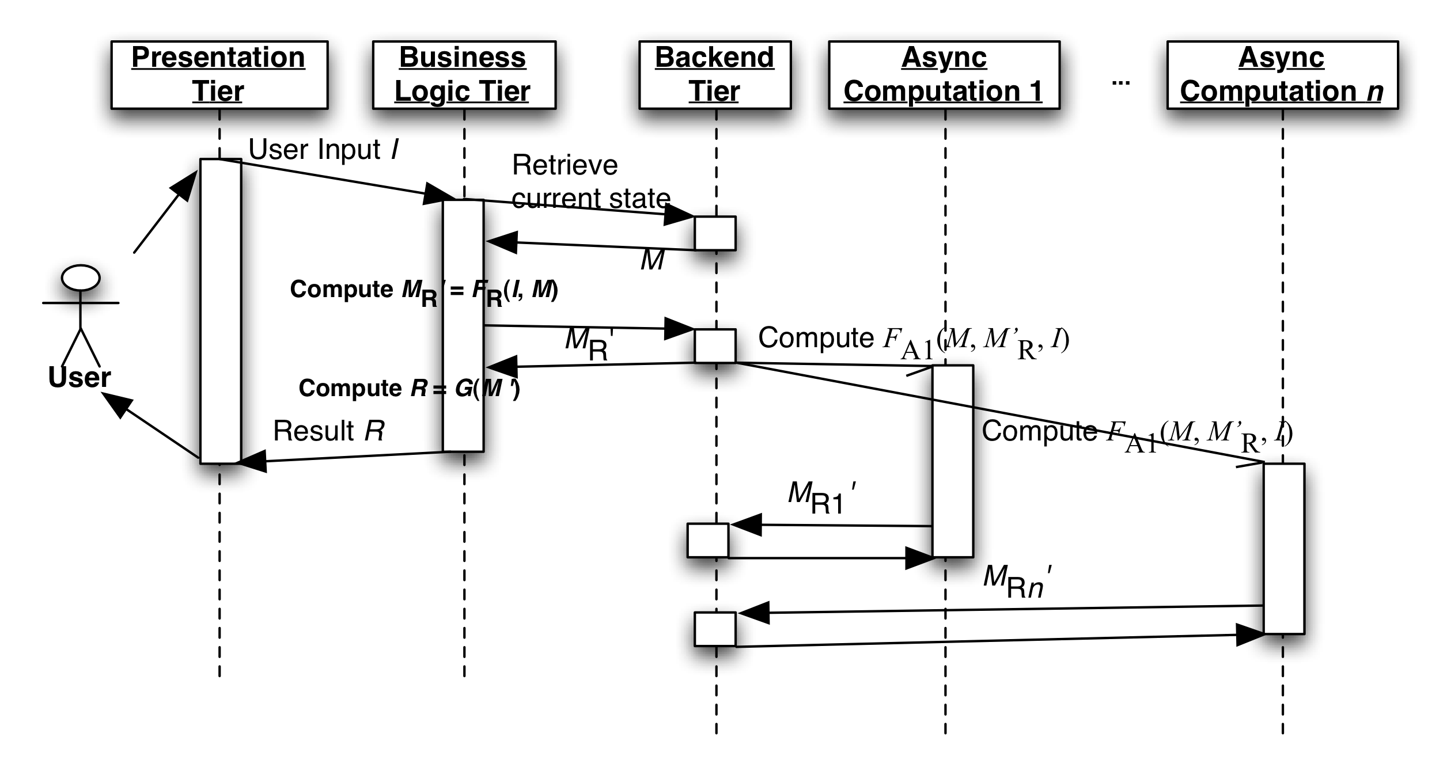
Figure 1 Online computation model with CDC
The ability to trigger external computations based on changes to the data in the backed databases is commonly known as Change Data Capture (CDC). CDC usually follows a publish-subscribe model where applications subscribe to the changes from one or more data sources. We will refer to the mechanism of capturing the change data and transporting it to the CDC subscribers as the CDC pipeline.
- Problem Definition
Next, let us discuss what the important requirements of a CDC-based solution are.
- Strong timeline consistency
To avoid having the CDC subscribers see partial and/or inconsistent data we need to capture:
- Transaction boundaries -- a single user’s action can trigger atomic updates to multiple stores/tables; e.g., adding a bidirectional connection between user A and user B can trigger updates to the connections lists of both users.
- The commit order of the primary database
- All changes
- User-space processing
Here, by “user-space processing”, we mean the ability to perform the CDC computation outside the database server. This is in contrast to traditional database triggers that are run in the database server.
Moving the computation to user space has the following benefits:
- Reduces the load on the database server
- Decouples the CDC subscriber implementation from the specifics of the database server implementation
- Enables independent scaling of the CDC subscribers
- Support for long look-back queries
Typically, CDC subscribers are interested only in recent changes that they have not processed yet. Yet, there are occasions when subscribers may want to read older changes.
- If they have suffered a performance hiccup or they have been taken down for maintenance;
- New subscribers are added to increase capacity might need to initialize their state and get a recent snapshot of the database;
- All clients need to re-initialize their state because of adopting a new schema from the source database.
- Data source / CDC subscriber isolation
As discussed above, CDC subscribers often perform complex computations that may not allow a single instance to keep up with the trigger rate. In those cases, a standard solution is to distribute the computation among multiple instances.
Therefore, the CDC pipeline should
- Allow multiple CDC subscribers to process the changes as a group; i.e. support partitioning;
- Support different types of partitioning for computation tasks with different scalability requirements;
- Isolate the source database from the number of CDC subscribers so that increasing the number of the latter should not impact the performance of the former;
- Isolate the source database from slow or failing CDC subscribers that should not negatively impact the database performance;
- Isolate subscribers from the operational aspects of the source database: database system choice, partitioning, schema evolution, etc.
- Low latency of the CDC pipeline
Any overhead introduced by the CDC pipeline may introduce risk of inconsistencies, affect negatively performance, or decrease the available time for the computations. For example, any latency in updating a secondary index structures (like the previously mentioned LinkedIn social graph index) increases the risk of serving stale or inconsistent data. In the case of read replication, CDC pipeline latency can lead to higher latencies since more traffic will go to the master for the freshest results.
- Architecture
Here, we will describe the architecture of Databus, a CDC system that has been developed at LinkedIn. We will also show how it addresses the requirements from the previous sub-section.
- High-level overview
Below is a high-level representation of Databus architecture.

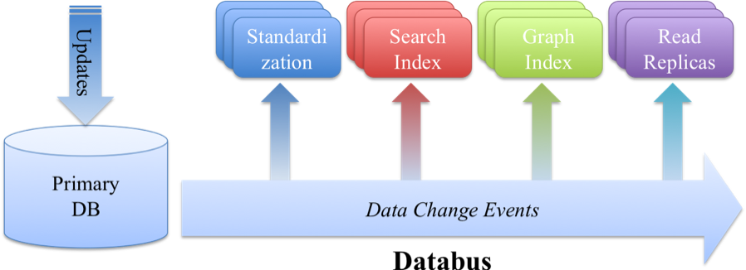
Figure 2 Databus at LinkedIn
Databus provides a common pipeline for transporting CDC events from LinkedIn primary databases to various applications. Among these applications are the Social Graph Index, the People Search Index, Read Scalability Replicas, and near-line processors like the Company Name and Position Standardization.
Databus features include:
- Implemented in Java
- Transport independent of data source: Oracle, MySQL, …
- Portable change event serialization and versioning
- CDC consumption from arbitrary point in the stream of CDC events
Databus guarantees:
- Timeline consistency with the data source with transactional semantics and at-least-once delivery
- Durability (provided by data source)
- High availability and reliability
- Low latency
The Databus pipeline consists of three main components: the Relay, the Bootstrap Server, and the Databus Client Library. The Relay captures changes in the source database, serializes them to a common binary format and buffers those. Each change is represented by a Databus CDC event which contains a sequence number in the commit order of the source database, metadata, and payload with the serialized change. Relays serve Databus events to both clients and the Bootstrap servers. Bootstrap servers provide clients with arbitrary long look-back queries in Databus event stream.

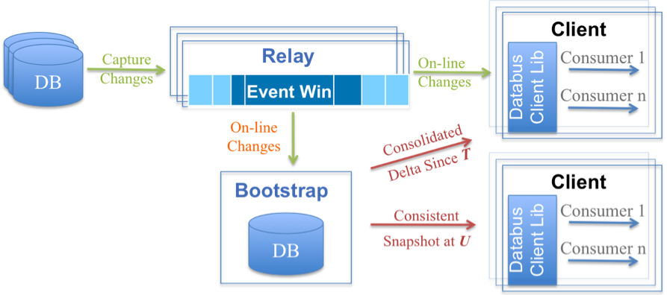
Figure 3 Detailed Databus Architecture
Next, we will describe the three main components in greater detail.
- Relay
As mentioned above, the first task of the relay is to capture changes from the source database. At LinkedIn, we employ two capture approaches, triggers or consuming from the database replication log.
Once captured, the changes are serialized to a data source-independent binary format. We chose Avro because it is an open format with multiple language bindings. Further, unlike other formats like Protocol Buffers, Avro allows serialization in the relay without generation of source-schema specific code.
The serialized events are stored in a circular in-memory buffer that is used to serve events to the Databus clients.
The relay with an in-memory circular buffer provides:
- Default serving path with very low latency (<1 ms)
- Efficient buffering of tens of GB of data with hundreds of millions of Databus events
- Index structures to efficiently serve to Databus clients events from a given sequence number S
- Server-side filtering for support of multiple partitioning schemes to the clients
- Support of hundreds of consumers per relay with no additional impact on the source database
- Bootstrap server
The main task of the Bootstrap server is to listen to the stream of Databus events and provide long-term storage for them. It serves all requests from clients that cannot be processed by the relay because of its limited memory. Thus, the Bootstrap server isolates the primary database from having to serve those clients.
There are two types of queries supported:
- Consolidated delta since sequence number T
- Consistent snapshot at sequence number U
The first query is used from clients that have some state but have fallen behind the time span of events stored in the relay. Instead of replaying all changes since T, the bootstrap server will return what we refer to as consolidated delta: only the last of multiple updates to the same row/key are returned. This has the effect of “fast playback” of time and allows the client to return faster to consumption from the relay.
The second type query is used when the client does not have any state (e.g. a new client). In that case, the Bootstrap server will serve a recent consistent snapshot of the database and a sequence number U that is the sequence number of the last transaction applied in the snapshot. The client can then use the number U to continue consumption from the relay.
The main challenge is the ability to provide consistent results for the above query types without interruption of the events from the relay. We achieve this by using two separate storages: a log and snapshot storage.
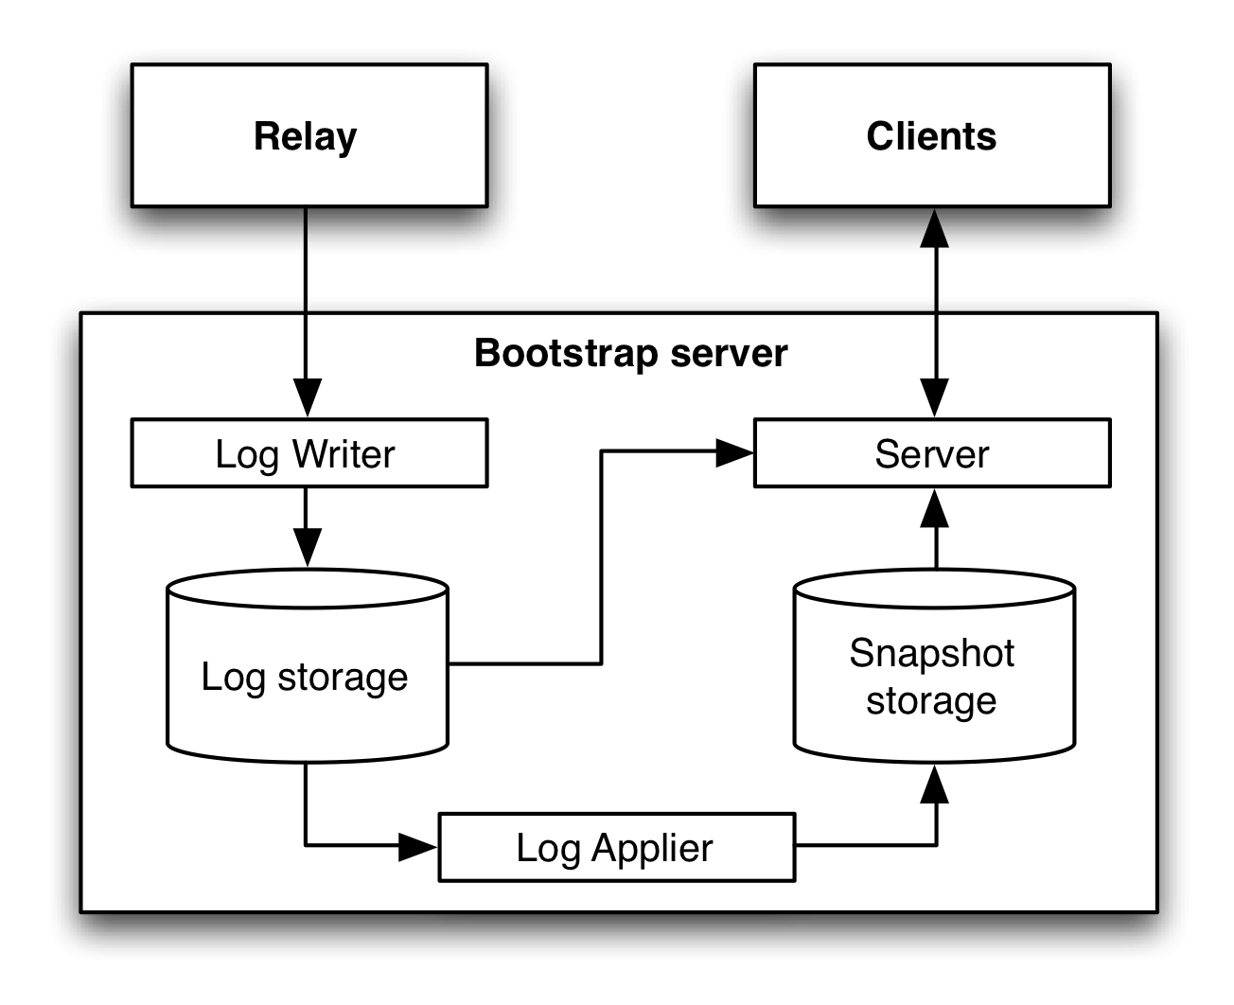
Figure 4 Bootstrap server design
The Log writer listens for Databus events from the relay and adds those to an append-only Log storage. The Log applier monitors for new rows in the Log storage and applies those to the Snapshot storage where only the last event for a given row/key is stored. On requests, the Server determines the optimal path. For clients whose request sequence number T is recent, it will serve directly from the Log storage. The append-only nature of the Log storage guarantees that the result is consistent. All other requests are first served from the Snapshot storage. This may return inconsistent results, as some of the rows may be modified during the snapshot serving (which can take a long time). To guarantee consistency, the Server replays all changes that have happened since the start of the snapshot phase.
Like the relay, the Bootstrap server also supports server-side filters that are pushed down to the storage if possible.
- Databus client library
The Databus client library is the glue between the Relays and Bootstrap servers and the business logic of the Databus consumers. It provides:
- Tracking of progress in the Databus event stream with automatic switchover between the Relays and Bootstrap servers when necessary;
- Push (callbacks) or pull interface
- Local buffering and flow control to ensure continuous stream of Databus events to the consumers
- Support for multi-thread processing
- Retry logic if consumers fail to process some events
- Related Systems
The related systems can be classified in three categories: generic pub/sub systems, database replication systems, and other CDC systems. Generic pub/sub systems like JMS implementations, Kafka or Hedwig generally have little knowledge about the structure of the messages they transport. Therefore, they cannot provide strong consistency guarantees. Further, since in the general case the message producers may not provide persistence, the task of the message ordering and persistence is delegated to the broker, i.e. they are not aware of the commit order. Finally, generic pub/sub systems provide only limited-size log storage and do not support snapshots and consolidated deltas. Database replication systems are often database vendor specific (with some exceptions like Tungsten Replicator) and have limited capabilities for user-space processing. Many of the CDC systems are also database vendor specific and to the best of our knowledge do not have support for consistent snapshot or consolidated deltas.

