Data Infrastructures at LinkedIn
First Author^{#1}, Second Author^{*2}, Third Author^{#3}
#First-Third Department, First-Third University
Address Including Country Name
¹first.author@first-third.edu
³third.author@first-third.edu

Abstract— LinkedIn is the largest professional social network site in the world. As the company has grown, our core data sets and request processing capabilities have grown as well. In this paper, we describe a few selected data infrastructure projects at LinkedIn that have helped us to accommodate this increasing scale. Most of those projects build on existing open source projects and are themselves available as open source. The projects covered in this paper include: (1) Voldemort: a scalable and fault tolerant key-value store; (2) Databus: a framework for delivering database changes to downstream applications; (3) Espresso: a distributed data store that supports flexible schemas and secondary indexing; (4) Kafka: a scalable and efficient messaging system for collecting various user activity events and log data.
- Introduction
This document is a template. An electronic copy can be downloaded from the conference website. For questions on paper guidelines, please contact the conference publications committee as indicated on the conference website. Information about final paper submission is available from the conference website.
- Voldemort
Project Voldemort is a highly availably, low-latency distributed data store. It was initially developed at LinkedIn in 2008, in order to provide key-value based storage for read-write data products like “Who viewed my profile”. Over time it has also been adapted to serve static read-only data produced in offline bulk systems like Hadoop. Voldemort was open-sourced in January 2009 and has been adopted by various other companies for applications that require high availability and low latency. At LinkedIn, Voldemort powers various components of our real time recommendation products, network updates, and rate limiting system. We currently house around ten clusters, spanning more than a hundred nodes. Some of the new additions to the system also allow Voldemort to work on nodes sitting in multiple datacenters. This, along with the ability to add nodes without downtime, has helped us scale Voldemort to handle tens of thousands of requests a second.
Voldemort can best be categorized as a distributed hash table (DHT). But unlike previous DHT works (like Chord [CHORD]), it has been designed to have relatively low node membership churn i.e. few changes in cluster topology. Instead it has been designed for frequent transient and short-term failures, which are very prevalent in production datacenters [FLPSTBGQ]. It’s design and architecture has been heavily inspired from Amazon's Dynamo[DYN], a highly-available and eventually consistent key-value store that powers Amazon’s shopping cart.
- Architecture
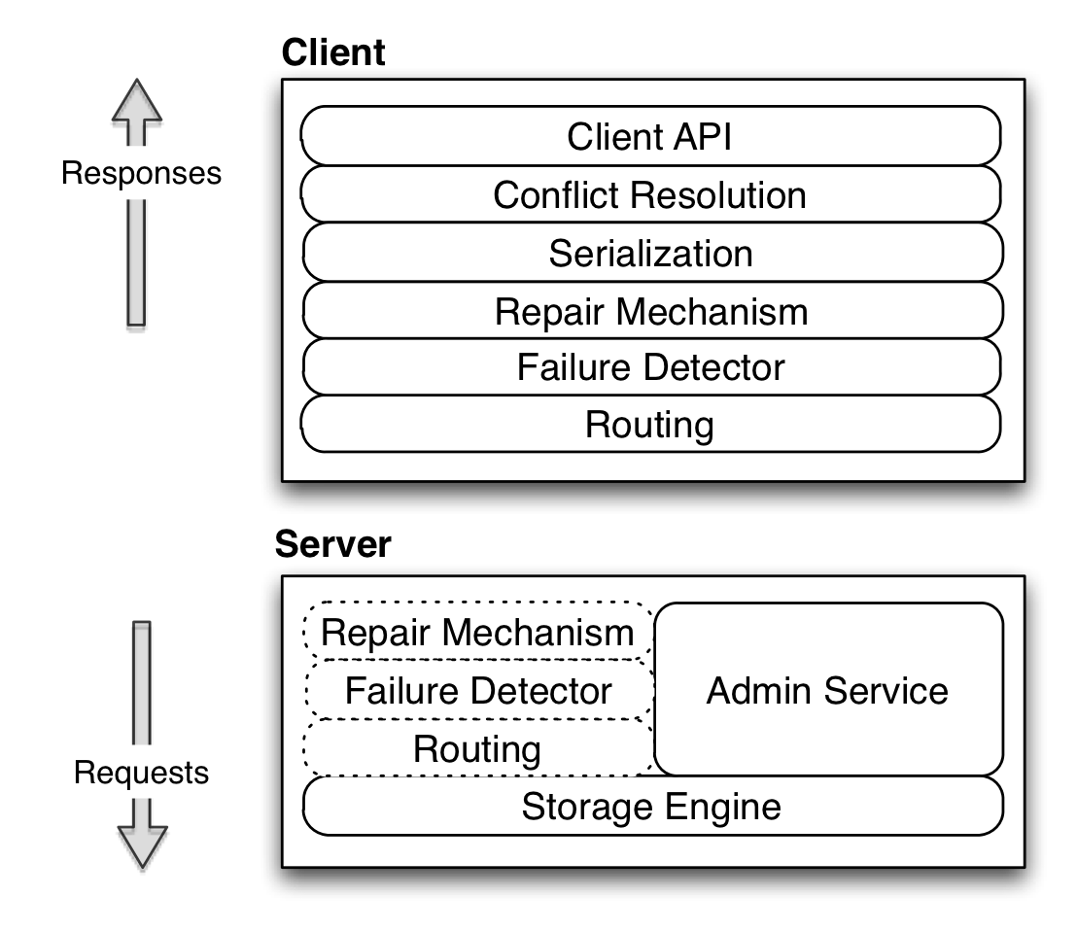
Figure I.1 Pluggable architecture of Voldemort

We will start by explaining some of the key terms used to describe our system. A Voldemort cluster can contain multiple nodes, each with a unique id. All the nodes in the cluster store the same number of stores - which correspond to database tables. Every store has its set of configurations, including - replication factor (N), required number of nodes which should participate in read (R) and writes (W) and finally a schema (key and value serialization formats). Keys for the same store are hashed to a hash ring - a representation of the key space split into equal sized logical partitions. Every node in a cluster is then responsible for a certain set of partitions.
Figure 1 shows the pluggable architecture of Voldemort. Most of the modules have their functionality similar to those described in Amazon's Dynamo paper. Every module in the architecture implements the same code interface thereby making it easy to (a) interchange modules. For example, Voldemort supports both server and client side routing by moving the routing module (b) test code easily by mocking modules.

Client API and Conflict Resolution: Starting from the top of the architecture our client has the API described in Figure I.2. As a Dynamo implementation, Voldemort differs from the conventional master-slave replicated systems, in that any replica of a given partition is able to accept a write. As a result, it is possible for divergent version histories to form on multiple nodes during failures / partitions. As shown in our API, we use vector clocks [LAMPORT] to version our tuples and delegate the conflict resolution of concurrent versions to the application. Methods 3) and 4) of the API allow the user to run a transform on the value on the server side. For example, if the value is a list, we can run a transformed get to retrieve a sub-list or a transformed put to append an entity to your list, thereby saving network bandwidth.

The use of vector clocks also allows us to support some form of optimistic locking on the client side. Two concurrent updates to the same key results in one of the clients failing due to an already written vector clock. This client is thrown a special error, which can trigger a retry with the updated vector clock. This retry logic can be encapsulated in the applyUpdate call and can be used in cases like counters where `read, modify, write if no change' loops are required.

Repair mechanism: This module is responsible for reconciling the inconsistent versions of the same key. We adopted the two repair mechanisms highlighted in the Dynamo paper viz. read repair and hinted handoff. Read repair detects inconsistencies during gets while hinted handoff is triggered during puts.

Routing: This module of Voldemort employs a simple implementation of consistent hashing to perform replication. A key is hashed to a logical partition, after which we jump the ring till we find N-1 other partitions in different nodes to store the replicas. Using this non-order preserving partitioning scheme prevents formation of hot spots.
Since our routing layer is pluggable we also plugged in a variant of consistent hashing algorithm that supports routing in a multiple datacenter environment. For the same, we group nodes into logical clusters called 'zones', which in turn are defined by a proximity list of distances from other zones. The routing algorithm now jumps the consistent hash ring with an extra constraint to satisfy number of zones required for the request.

Storage Engine: Out of the various storage engine implementations, the most commonly used ones are BerkeleyDB Java Edition (BDB) [BDB] and a custom read-only storage engine. We use BDB as the primary storage for all our read-write traffic.
1) VectorClock<V> get (K key)
2) put (K key, VectorClock<V> value)
3) VectorClock<V> get (K key, T transform)
4) put (K key, VectorClock<V> value, T transform)
5) applyUpdate(UpdateAction action, int retries)

Figure I.2 Client API for Voldemort

The custom read-only storage engine consists of compact index and data files that are generated offline in Hadoop. These cater to applications that require a complete refreshing of all the tuples in a store. The complete data pipeline ( in Figure I.3) to get this static data into Voldemort is co-ordinated by a controller and consists of three phases - (a) Build phase - We take the output of complex algorithms and generate multiple sets of data and index files in Hadoop. These files are partitioned by destination nodes and stored in HDFS. An index file is a compact list of sorted MD5 of key and offset to data into the data file. To generate these indices, we leverage Hadoop’s ability to sort its values in the reducers. Finally a search on the Voldemort side is done using binary search. (b) Pull phase – Voldemort gets notified of the location of the output of the build phase and starts a parallel fetch. (c) Swap phase – On completion of the pull the controller co-ordinates an atomic swap across all the nodes by closing the current index files and memory mapping the new index files. By doing this we delegate the caching to the operating system’s page-cache.
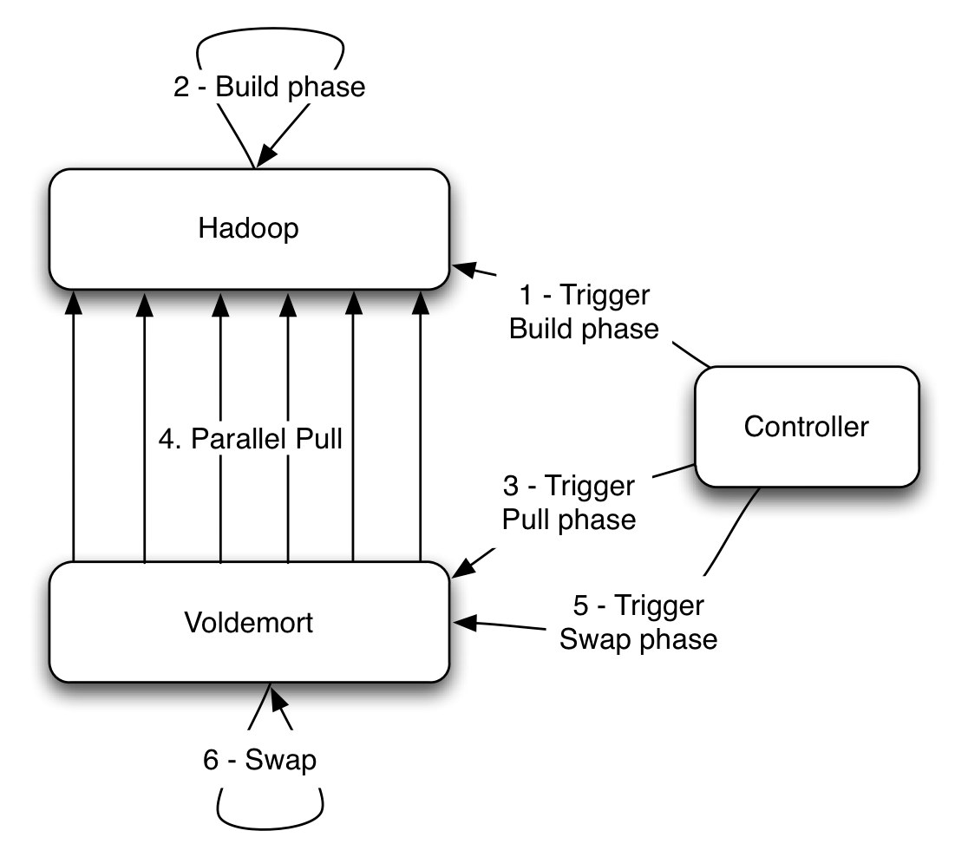
Figure I.3 Data cycle for read-only storage engine

Admin Service: In addition to the above stack, every node also runs an administrative service, which allows the execution of privileged commands without downtime. This includes the ability to add / delete store and rebalance the cluster without downtime. Rebalancing (dynamic cluster membership) is done by changing ownership of partitions to different nodes. We maintain consistency during rebalancing by redirecting requests of moving partitions to their new destination.
- Usage at LinkedIn
At LinkedIn we have ten Voldemort clusters – nine of which serve BDB backed read-write traffic (six of which are running across two data-centers) while one serves custom read-only storage engine backed traffic. The total number of stores, across all these clusters, is around 300. Our largest read-write cluster has a usage pattern of around 60% reads and 40% writes. This cluster does around 10K queries per second at peak with average latency of around 3 ms. Similarly read-only cluster does around 9K reads per second with an average latency of less than a ms.
We will now highlight two applications in LinkedIn that use Voldemort. The first example is that of read-write stores used to run “Company Follow” – a feature on LinkedIn that allows the user to get a feed of company updates. This uses two stores to maintain a cache-like interface on top of our primary storage Oracle – first one stores member id to list of company ids followed by the user and the second one stores company id to list of member ids that follow it. Both stores are fed by a Databus (described in Section III) relay and are populated whenever a user follows a new company. Since it is used as cache, having inconsistent values across stores is not a problem. Both the stores have a Zipfian distribution for their data size, but still manage to retrieve large values with an average latency of 4 ms.
The second example is a link prediction problem used to generate “People You May Know” on LinkedIn. This application is powered by a single store that is backed by the custom read-only storage engine. The store saves, for every member id, a list of recommended member ids, along with a score. Since most of the scores change between runs we re-compute all the recommendations for the complete member-base in Hadoop. By offloading the index construction to Hadoop instead of Voldemort side and throttling the fetches, we achieve average latency in sub-milliseconds. We also try to achieve some cache-locality by fetching the index files after all the data files.
Some of the future work that we will be working on includes – faster rebalancing, an update stream which consumers can listen to and new index formats to optimize the read-only store performance.

- Databus
  - Motivation
Modern Internet-based systems are increasingly facing the difficult challenges of performing complex processing over large amounts of valuable data with strict upper bounds on latency. For example, at LinkedIn, we have to continuously maintain indexes and statistical models over many aspects of the online professional identity of our constantly increasing user base of 120+ million. These indexes and models facilitate the discovery of new opportunities for our members. Other use cases include database replication for read scalability, data standardization, and query result pre-computation and caching.
Throughout the rest of this section, we are going to describe how Databus, a system for change data capture, is being used to help solve the problem of performing complex online and near-line computations at LinkedIn under strict latency bounds. First, we will describe the computational model that will set the context for the rest of the discussion. Then, we will have a more detailed definition of the problem. Next, we will describe of Databus and how it addresses the problem. Finally, we will briefly talk about other similar systems.
- Computational model
Let us consider a typical three-tier Internet application architecture. The business logic tier obtains the user input I from the presentation tier and the current data model state M for the user from the backend tier. It computes the new data model state M' = F(M, I) and stores it back in the backend tier. Finally, it returns the result R = G(M') to the presentation tier.
In the above model, most of the complexity is in the computation of M’. At the same time, there is a latency budget on the entire end-to-end interaction with the user and consequently on the computation of M’. To alleviate this, we can decompose the computation of the new state M’ = (M’_{R}, M’_{A}) into M’_{R} = F_{R}(M, I) which is sufficient to compute R, i.e. R = G(M’_{R}), and remaining computation M’_{A} = F_{A}(M, M’_{R}, I)) which can be outside the online serving part.
For example, if the user added a new connection, M’ can include updating her list of connections, updating her peer’s list of connections (for bi-directional connections), updating the social graph index, updating the email queue with the notification emails, etc. In this case, R will most likely just include a confirmation that the user’s connection list has been updated.
Further, we can even decompose the computation of M’_{A} = (M’_{A1}, …, M’_{An}) = (F_{A1}(M, M’_{R}, I), …, F_{An}(M, M’_{R}, I)) into independent computations that can be done in parallel. In the above example, the update to the email notification queue and the update to the social graph index need not be done sequentially. The asynchronous computations can be triggered by the M’_{R} update in the backend tier rather than having those be explicitly called by the business logic tier. Thus, we can add new computations that are triggered by user interaction with minimal impact on the business logic tier.

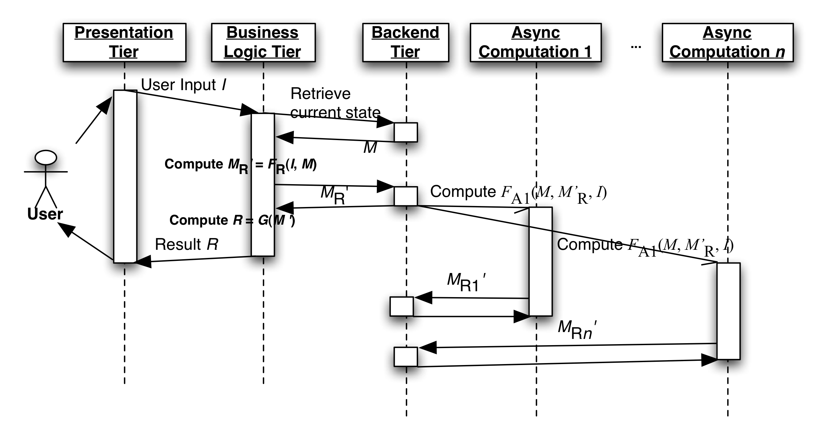
Figure 1 Online computation model with CDC
The ability to trigger external computations based on changes to the data in the backed databases is commonly known as Change Data Capture (CDC). CDC usually follows a publish-subscribe model where applications subscribe to the changes from one or more data sources. We will refer to the mechanism of capturing the change data and transporting it to the CDC subscribers as the CDC pipeline.
- Problem Definition
Next, let us discuss what the important requirements of a CDC-based solution are.
- Strong timeline consistency
To avoid having the CDC subscribers see partial and/or inconsistent data we need to capture:
- Transaction boundaries -- a single user’s action can trigger atomic updates to multiple stores/tables; e.g., adding a bidirectional connection between user A and user B can trigger updates to the connections lists of both users.
- The commit order of the primary database
- All changes
- User-space processing
Here, by “user-space processing”, we mean the ability to perform the CDC computation outside the database server. This is in contrast to traditional database triggers that are run in the database server.
Moving the computation to user space has the following benefits:
- Reduces the load on the database server
- Decouples the CDC subscriber implementation from the specifics of the database server implementation
- Enables independent scaling of the CDC subscribers
- Support for long look-back queries
Typically, CDC subscribers are interested only in recent changes that they have not processed yet. Yet, there are occasions when subscribers may want to read older changes.
- If they have suffered a performance hiccup or they have been taken down for maintenance;
- New subscribers are added to increase capacity might need to initialize their state and get a recent snapshot of the database;
- All clients need to re-initialize their state because of adopting a new schema from the source database.
- Data source / CDC subscriber isolation
As discussed above, CDC subscribers often perform complex computations that may not allow a single instance to keep up with the trigger rate. In those cases, a standard solution is to distribute the computation among multiple instances.
Therefore, the CDC pipeline should
- Allow multiple CDC subscribers to process the changes as a group; i.e. support partitioning;
- Support different types of partitioning for computation tasks with different scalability requirements;
- Isolate the source database from the number of CDC subscribers so that increasing the number of the latter should not impact the performance of the former;
- Isolate the source database from slow or failing CDC subscribers that should not negatively impact the database performance;
- Isolate subscribers from the operational aspects of the source database: database system choice, partitioning, schema evolution, etc.
- Low latency of the CDC pipeline
Any overhead introduced by the CDC pipeline may introduce risk of inconsistencies, affect negatively performance, or decrease the available time for the computations. For example, any latency in updating a secondary index structures (like the previously mentioned LinkedIn social graph index) increases the risk of serving stale or inconsistent data. In the case of read replication, CDC pipeline latency can lead to higher latencies since more traffic will go to the master for the freshest results.
- Architecture
Here, we will describe the architecture of Databus, a CDC system that has been developed at LinkedIn. We will also show how it addresses the requirements from the previous sub-section.
- High-level overview
Below is a high-level representation of Databus architecture.

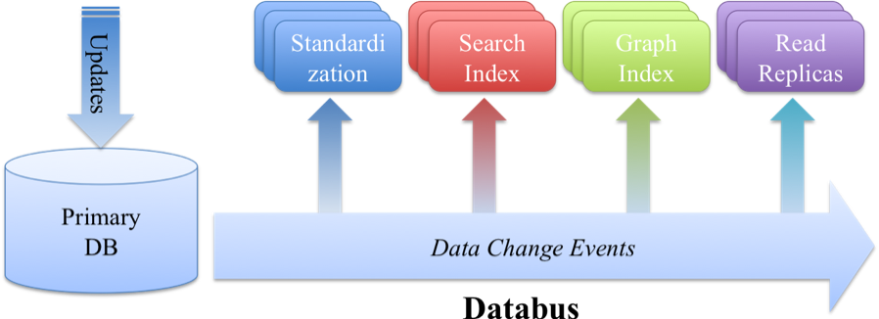
Figure 2 Databus at LinkedIn
Databus provides a common pipeline for transporting CDC events from LinkedIn primary databases to various applications. Among these applications are the Social Graph Index, the People Search Index, Read Scalability Replicas, and near-line processors like the Company Name and Position Standardization.
Databus features include:
- Implemented in Java
- Transport independent of data source: Oracle, MySQL, …
- Portable change event serialization and versioning
- CDC consumption from arbitrary point in the stream of CDC events
Databus guarantees:
- Timeline consistency with the data source with transactional semantics and at-least-once delivery
- Durability (provided by data source)
- High availability and reliability
- Low latency
The Databus pipeline consists of three main components: the Relay, the Bootstrap Server, and the Databus Client Library. The Relay captures changes in the source database, serializes them to a common binary format and buffers those. Each change is represented by a Databus CDC event which contains a sequence number in the commit order of the source database, metadata, and payload with the serialized change. Relays serve Databus events to both clients and the Bootstrap servers. Bootstrap servers provide clients with arbitrary long look-back queries in Databus event stream.

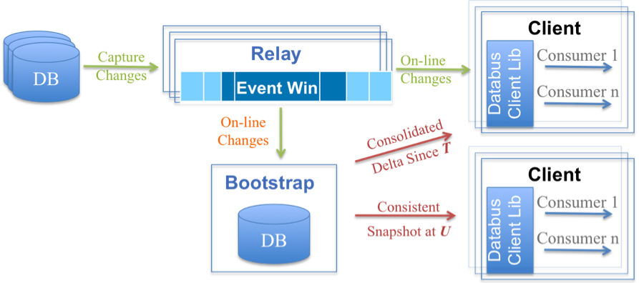
Figure 3 Detailed Databus Architecture
Next, we will describe the three main components in greater detail.
- Relay
As mentioned above, the first task of the relay is to capture changes from the source database. At LinkedIn, we employ two capture approaches, triggers or consuming from the database replication log.
Once captured, the changes are serialized to a data source-independent binary format. We chose Avro because it is an open format with multiple language bindings. Further, unlike other formats like Protocol Buffers, Avro allows serialization in the relay without generation of source-schema specific code.
The serialized events are stored in a circular in-memory buffer that is used to serve events to the Databus clients.
The relay with an in-memory circular buffer provides:
- Default serving path with very low latency (<1 ms)
- Efficient buffering of tens of GB of data with hundreds of millions of Databus events
- Index structures to efficiently serve to Databus clients events from a given sequence number S
- Server-side filtering for support of multiple partitioning schemes to the clients
- Support of hundreds of consumers per relay with no additional impact on the source database
- Bootstrap server
The main task of the Bootstrap server is to listen to the stream of Databus events and provide long-term storage for them. It serves all requests from clients that cannot be processed by the relay because of its limited memory. Thus, the Bootstrap server isolates the primary database from having to serve those clients.
There are two types of queries supported:
- Consolidated delta since sequence number T
- Consistent snapshot at sequence number U
The first query is used from clients that have some state but have fallen behind the time span of events stored in the relay. Instead of replaying all changes since T, the bootstrap server will return what we refer to as consolidated delta: only the last of multiple updates to the same row/key are returned. This has the effect of “fast playback” of time and allows the client to return faster to consumption from the relay.
The second type query is used when the client does not have any state (e.g. a new client). In that case, the Bootstrap server will serve a recent consistent snapshot of the database and a sequence number U that is the sequence number of the last transaction applied in the snapshot. The client can then use the number U to continue consumption from the relay.
The main challenge is the ability to provide consistent results for the above query types without interruption of the events from the relay. We achieve this by using two separate storages: a log and snapshot storage.
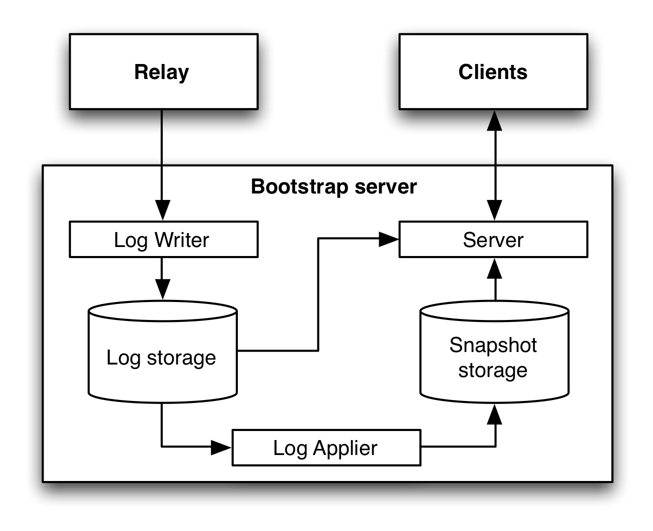
Figure 4 Bootstrap server design
The Log writer listens for Databus events from the relay and adds those to an append-only Log storage. The Log applier monitors for new rows in the Log storage and applies those to the Snapshot storage where only the last event for a given row/key is stored. On requests, the Server determines the optimal path. For clients whose request sequence number T is recent, it will serve directly from the Log storage. The append-only nature of the Log storage guarantees that the result is consistent. All other requests are first served from the Snapshot storage. This may return inconsistent results, as some of the rows may be modified during the snapshot serving (which can take a long time). To guarantee consistency, the Server replays all changes that have happened since the start of the snapshot phase.
Like the relay, the Bootstrap server also supports server-side filters that are pushed down to the storage if possible.
- Databus client library
The Databus client library is the glue between the Relays and Bootstrap servers and the business logic of the Databus consumers. It provides:
- Tracking of progress in the Databus event stream with automatic switchover between the Relays and Bootstrap servers when necessary;
- Push (callbacks) or pull interface
- Local buffering and flow control to ensure continuous stream of Databus events to the consumers
- Support for multi-thread processing
- Retry logic if consumers fail to process some events

- Related Systems
The related systems can be classified in three categories: generic pub/sub systems, database replication systems, and other CDC systems. Generic pub/sub systems like JMS implementations, Kafka or Hedwig generally have little knowledge about the structure of the messages they transport. Therefore, they cannot provide strong consistency guarantees. Further, since in the general case the message producers may not provide persistence, the task of the message ordering and persistence is delegated to the broker, i.e. they are not aware of the commit order. Finally, generic pub/sub systems provide only limited-size log storage and do not support snapshots and consolidated deltas. Database replication systems are often database vendor specific (with some exceptions like Tungsten Replicator) and have limited capabilities for user-space processing. Many of the CDC systems are also database vendor specific and to the best of our knowledge do not have support for consistent snapshot or consolidated deltas.
- Espresso
ESPRESSO is a distributed, timeline consistent, scalable, document store that supports local secondary indexing and local transactions. ESPRSSO relies on Databus for internal replication and therefore provides a Change Data Capture pipeline to downstream consumers.

The development of ESPRESSO was motivated by a desire to migrate LinkedIn’s online serving infrastructure off of monolithic, commercial, RDBMS systems running on high cost specialized hardware to elastic clusters of commodity servers running free software; and to improve agility by enabling rapid development by simplifying the programming model, separating scalability, routing, caching from business logic. ESPRESSO bridges the semantic gap between a simple Key Value store like Voldemort and a full RDBMS.

Data Model: Documents in ESPRESSO are identified by URIs in the following form:
http://<host>[:<port>]/<database>/<table>/<resource_id>[/<subresource_id>…]

In ESPRESSO, a database is a container of tables. A table is a container of documents.

Each database, table, and document has an associated schema. Schemas are represented in JSON in the format specified by the Avro specification [Avro].

A database schema defines how the database is partitioned. At present, the only supported partitioning strategies are hash-based partitioning or un-partitioned (all documents are stored on all nodes). We anticipate adding range based partitioning in the future.

A table schema defines how documents within the table are referenced. When defining the URI schema for a table, the resource_id may designate a single document or a collection of related documents that are identified by further elements of the URI path. For example, the Music database Artists table might contain profiles for recording artists by artist name:

/Music/Artist/Rolling_Stones
/Music/Artist/The_Beatles

whereas the Albums table might contain Albums by Artist

/Music/Album/Cher/Greatest_Hits
/Music/Album/Elton_John/Greatest_Hits

and the Song table might contain songs by artist by album

/Music/Song/Doris_Day/Move_Over_Darling/At_Last
/Music/Song/Etta_James/Gold/At_Last
/Music/Song/Etta_James/Her_Best/At_Last

each of these tables is defined by a table schema that describes the elements of the URI path.

The document schema defines the structure of the documents stored within a table. Document schemas are freely evolvable. To evolve a document schema, one simply posts a new version to the schema URI. For each document, the system stores a serialized version of the document along with the schema version needed to deserialize the stored document.
Fields within the document schema may be annotated with indexing constraints, indicating that documents should be indexed for retrieval via the field’s value. HTTP query parameters allow retrieval of documents via secondary indexes. For example, if the Songs document schema contained an indexed field lyrics with a free text index constraint, a GET for the URI:

/Music/Song/The_Beatles?query=lyrics:”Lucy in the sky”

would return

/Music/Song/The_Beatles/Sgt._Pepper/Lucy_in_the_Sky_with_Diamonds
/Music/Song/The_Beatles/Magical_Mystery_Tour/I_am_the_Walrus

The ESPRESSO system is composed of four major components: routers, storage nodes, relays and cluster managers. Each is described below.

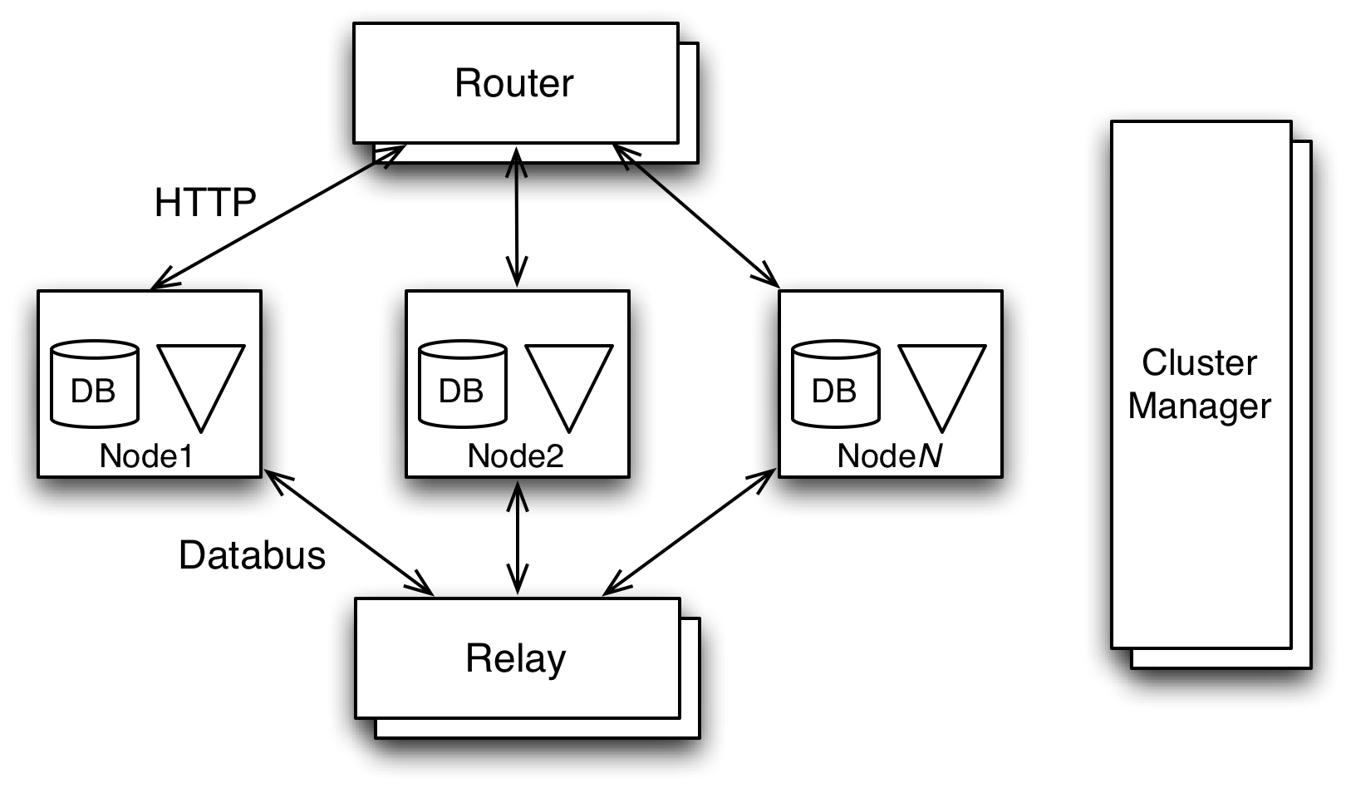

Router: The router accepts HTTP requests, inspects the URI and forwards the request to the appropriate storage node. For a given request, the router examines the database component of the path and retrieves the routing function from the corresponding database schema. It then applies the routing function to the resource_id element of the request URI to compute a partition id. Next it consults the routing table maintained by the cluster manager to determine which storage node is the master for the partition. Finally, the router forwards the HTTP request to the selected storage node.

Storage Node: Requests for a document are routed to the storage node that is the master for the containing partition. The storage node maintains a consistent view of each document in a local data store and optionally indexes each document in a local secondary index based on the index constraints specified in the document schema. The initial implementation stores documents in MySQL as the local data store and Lucene for the local secondary index, though the design allows for alternate implementations via a plugin model. Each document is stored as a serialized byte stream indexed by the URL resource_id and any subresource_ids. In our Song table example, the underlying MySQL table would contain:

+-----------------+--------------+------+-----+
| Field | Type | Null | Key |
+-----------------+--------------+------+-----+
| artist | varchar | NO | PRI |
| album | varchar | NO | PRI |
| song | varchar | NO | PRI |
| timestamp | bigint(20) | NO | |
| etag | varchar(10) | NO | |
| val | blob | YES | |
| schema_version | smallint(6) | NO | |
+-----------------+--------------+------+-----+

The timestamp and etag fields are used to implement conditional HTTP requests.
Requests for specific resources can be satisfied via direct lookup in the local data store. Queries first consult a local secondary index then return the matching documents from the local data store.
Each partition is replicated n ways within the cluster. Each storage node is master for a set of partitions and slave for a disjoint set of partitions.

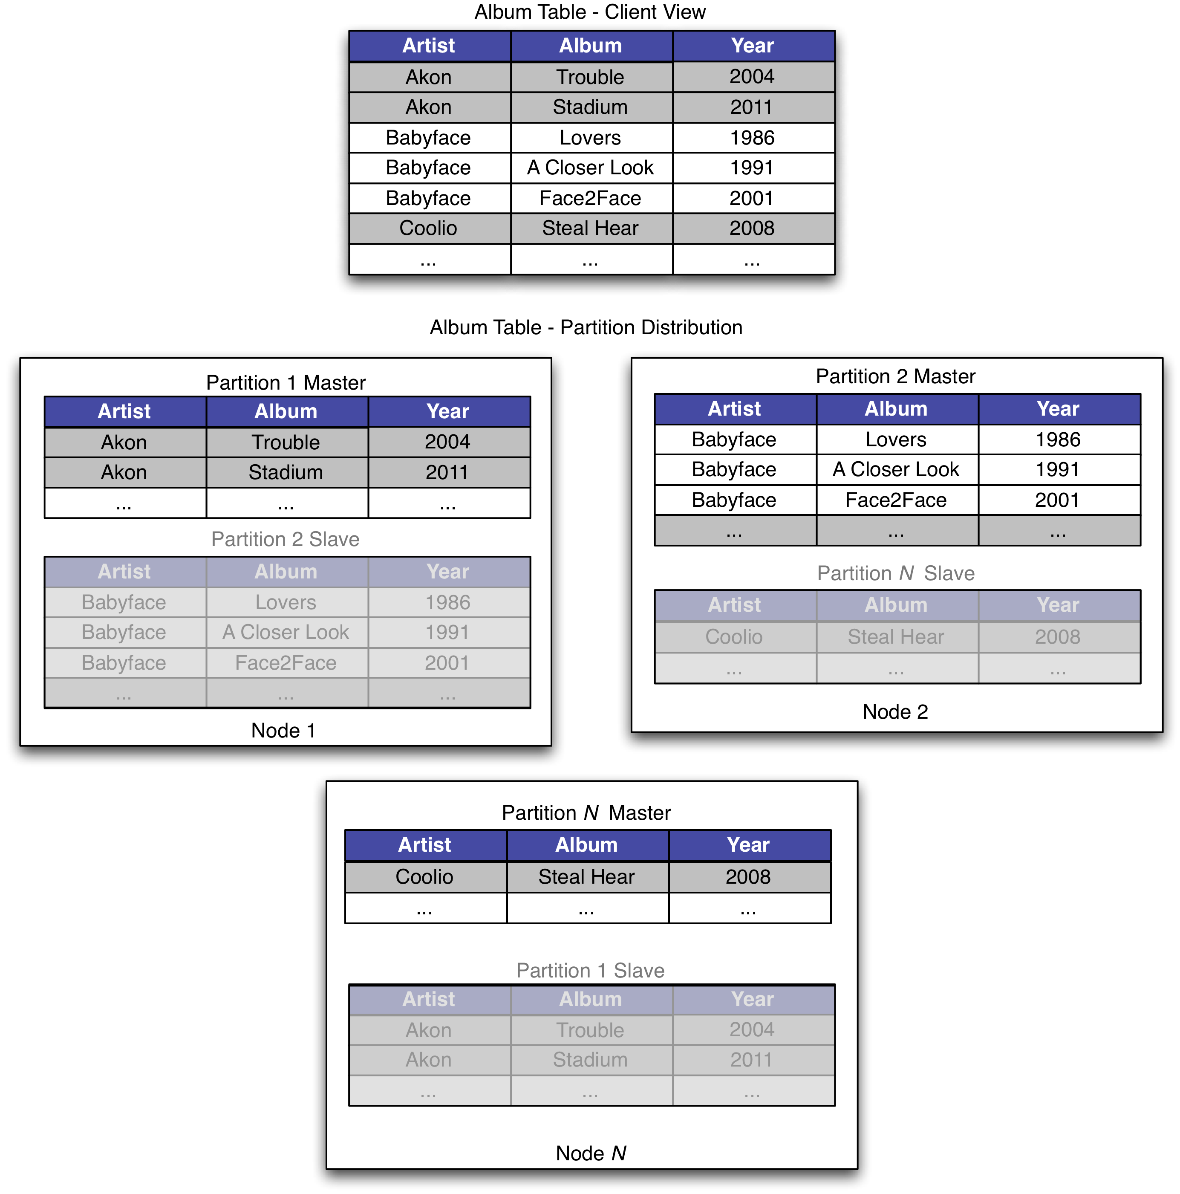

When a node or partition fails, the cluster manager migrates mastership of each affected partition to one of the replicas. During such migration, writes to the partition are temporarily unavailable.

Relay: Espresso replication lays the foundation for its fault-tolerant and elastic solution. For each partition, there is one master copy and one or more copies, each on one storage node. Changes are replicated to slave copies in a time-line consistent manner, i.e. for a given partition, the order that changes are applied on a master copy is the same as the order that changes are applied on slave copies. Each storage node is connected with the databus relay, pushing changes from all master copies to the relay and pulling changes from relay and applying to slave copies.
Espresso replication tier consists of 4 components: 1) MySQL master, 2) MySQL slave, 3) databus relay, and 4) AsyncReplicationEngine. Espresso replication is semi-synchronous. Changes to a master copy are first captured in MySQL binlog. Each change is also tagged with a sequence number – one per transaction. Sequence number in a partition is monotonically increasing when changes are made. All changes from a transaction are replicated from a MySQL master to a MySQL slave synchronously. A transaction commits after its changes are completely replicated to a MySQL slave. A MySQL slave replicates all changes from all partitions on a MySQL master. We added logic to MySQL slave to shard binlogs into partitions lazily on the slave side, so resources from MySQL master can be saved and hence the replication overhead on the MySQL master side is minimized. MySQL slaves then create databus events for each partition and push events asynchronously to the databus relay. Both MySQL slaves and databus relays run inside the same relay cluster. Espresso AsyncReplicationEngine (ARE) runs on every Espresso node to populate changes to each slave copies. ARE instantiates one databus consumer for each partition that is a slave copy on a storage node, and each databus consumer subscribe to changes from its partition. Databus consumers receive databus events, and apply changes to both MySQL and Lucene index in an Espresso storage node. The slave copies preserve the sequence number when a change is generated. This way, we can measure how behind a slave copy is from the master copy in the case of failover and rebalancing.
When a master copy fails, a slave copy is elected to be a candidate to take over the mastership. The slave copy first catches up all unconsumed changed from the failed master copy from database, then becomes a master copy, which continues to replicate changes to the databus relay.
When adding new nodes to an existing cluster, certain master copies and slave copies are selected to migrate to a new node. For each migrated partition, we first need to bootstrap it from a snapshot taken on the original master copy, then it becomes a slave copy. The new slave copy starts to consume changes from databus since the sequence number of the snapshot. After it exhausts all changes, it becomes a master copy.

Cluster Manager: The cluster manager, aka Helix, is designed to be a generic platform for managing a cluster of nodes, including Espresso storage nodes and databus relays. It provides the following features.
- Auto management of services hosting partitioned, replicated resources
- Automatic load balancing via smart placement of resources on servers(nodes) based on server capacity and resource profile (size of partition, access pattern etc)
- Centralized configuration management and self discovery (Only thing required is zookeeper address)
- Provides fault tolerance and optimized rebalancing during cluster expansion.
- Manages entire operational lifecycle of server. Addition, start, stop, enable/disable without downtime.
- Monitor cluster health and provide alerts on SLA violation.
- Service discovery mechanism to route requests
In storage and relay layer, there are various scenarios like node failures and partition migration where the system must react appropriately to satisfy the requirements of a fault tolerant system. To build such a system, we need a mechanism to co-ordinate between different nodes/components in the system. This mechanism can be achieved with a software that reacts to any change in the cluster and comes up with a set of tasks needed to bring the cluster to a stable state. The set to tasks will be assigned to one or more nodes in the cluster. Cluster Manager serves this purpose of managing the various components in the cluster.
Cluster manager is modelled as state machine. Cluster management problem can be viewed as
- There is an IDEALSTATE for the cluster which is basically the state in which we need the cluster to be in, assuming all nodes are up and running.
- There is a CURRENTSTATE which represents the current state of various nodes in the cluster
- In an ideal world when every node is functioning fine CURRENTSTATE will be same as IDEALSTATE
- During any failure[say one or more nodes go down], its not possible for CURRENTSTATE to be same as IDEALSTATE.
- Cluster manager has to compute the BEST_POSSIBLE_STATE for a given scenario and computes the tasks needed to make the CURRENTSTATE of the cluster same as BEST_POSSIBLE_STATE
Sample producer code:
producer = new Producer(…);
message = new Message(“test msg str”.getBytes());
set = new MessageSet(message);
producer.send(“topic1”, set);
- Assign the computed tasks to nodes.
We need a distributed store to maintain the state of the cluster and a notification system to notify if there is any change in the cluster state. Cluster Manager uses Zookeeper to achieve this functionality.
We use Zookeeper to achieve the following goals by cluster manager: 1) to represent PERSISTENT state which basically remains until its deleted, 2) to represent TRANSIENT/EPHEMERAL state which vanishes when the process that created the STATE dies, and 3) notification mechanism when there is a change in PERSISTENT/EPHEMERAL STATE. The name space provided by ZooKeeper is much like that of a standard file system. A name is a sequence of path elements separated by a slash (/). Every node in ZooKeeper's name space is identified by a path.
- Kafka
There is a large amount of “log” data generated at any sizable internet company. This data typically includes (1) user activity events corresponding to logins, page-views, clicks, “likes”, sharing, comments, and search queries; (2) operational metrics such as service call stack, call latency, errors, and system metrics such as CPU, memory, network, or disk utilization on each machine. Log data has long been a component of analytics used to track user engagement, system utilization, and other metrics. However, an increasing number of applications require online consumption of this data. These include (1) search relevance, (2) recommendations which may be driven by item popularity or co-occurrence in the activity stream, (3) ad targeting and reporting, and (4) security applications that protect against abusive behaviours such as spam or unauthorized data scraping, (5) newsfeed features that aggregate user status updates or actions for their “friends” or “connections” to read, and (6) real time dashboards of various service metrics.
We developed a system called Kafka [KNR11] for collecting and delivering log data. Kafka adopts a messaging API in order to support both real time and offline consumption of log data. Because log data is 2-3 orders magnitude larger than data handled in traditional messaging system, we made a few unconventional yet practical design choices in Kafka to make our system simple, efficient and scalable. We have been using Kafka in production for more than a year and it is processing billions of events each day.
- Kafka API and Architecture
We first introduce the basic concepts in Kafka. A stream of messages of a particular type is defined by a topic. A producer can publish messages to a topic. The published messages are then stored at a set of servers called brokers. A consumer can subscribe to one or more topics from the brokers, and consume the subscribed messages by pulling data from the brokers.
Messaging is conceptually simple, and we have tried to make the Kafka API equally simple to reflect this. Instead of showing the exact API, we present some sample code to show how the API is used. The sample code of the producer is given below. A message is defined to contain just a payload of bytes. A user can choose her favorite serialization method to encode a message. For efficiency, the producer can send a set of messages in a single publish request.
To subscribe to a topic, a consumer first creates one or more message streams for the topic. The messages published to that topic will be evenly distributed into these sub-streams. The details about how Kafka distributes the messages are described later in Section V.C. Each message stream provides an iterator interface over the continual stream of messages being produced. The consumer then iterates over every message in the stream and processes the payload of the message. Unlike traditional iterators, the message stream iterator never terminates. If there are currently no more messages to consume, the iterator blocks until new messages are published to the topic. We support both the point-to-point delivery model in which multiple consumers jointly consume a single copy of all messages in a topic, as well as the publish/subscribe model in which multiple consumers each retrieve its own copy of a topic.

The overall architecture of Kafka is shown in Figure V.1. Since Kafka is distributed in nature, a Kafka cluster typically consists of multiple brokers. To balance load, a topic is divided into multiple partitions and each broker stores one or more of those partitions. Multiple producers and consumers can publish and retrieve messages at the same time.

- Efficiency
In this section, we describe the layout of a single partition on a broker and a few design choices that we made to access a partition efficiently.

Simple storage: Kafka has a very simple storage layout. Each partition of a topic corresponds to a logical log. Physically, a log is implemented as a set of segment files of approximately the same size (e.g., 1GB). Every time a producer publishes a message to a partition, the broker simply appends the message to the last segment file. For better performance, we flush the segment files to disk only after a configurable number of messages have been published or a certain amount of time has elapsed. A message is only exposed to the consumers after it is flushed.
Unlike typical messaging systems, a message stored in Kafka doesn’t have an explicit message id. Instead, each message is addressed by its logical offset in the log. This avoids the overhead of maintaining auxiliary index structures that map the message ids to the actual message locations. Note that our message ids are increasing but not consecutive. To compute the id of the next message, we have to add the length of the current message to its id.
Many traditional messaging systems support out of order delivery of messages. This tends to increase the complexity of the system and is not necessary for log processing. Instead, in Kafka, a consumer always consumes messages from a partition sequentially. If the consumer acknowledges a particular message offset, it implies that the consumer has received all messages prior to that offset in the partition. Under the covers, the consumer is issuing asynchronous pull requests to the broker to have a buffer of data ready for the application to consume. Each pull request contains the offset of the message from which the consumption begins and an acceptable number of bytes to fetch. Each broker keeps in memory a sorted list of offsets, including the offset of the first message in every segment file. The broker locates the segment file where the requested message resides by searching the offset list, and sends the data back to the consumer.

Efficient transfer: We are very careful about transferring data in and out of Kafka. Earlier, we have shown that the producer can submit a set of messages in a single send request. Although the end consumer API iterates one message at a time, under the covers, each pull request from a consumer also retrieves multiple messages up to a certain size, typically hundreds of kilobytes.
Sample consumer code:
streams[] = Consumer.createMessageStreams(“topic1”, 1)
for (message : streams[0]) {
bytes = message.payload();
// do something with the bytes
}
Another unconventional choice that we made is to avoid explicitly caching messages in memory at the Kafka layer. Instead, we rely on the underlying file system page cache. This has the main benefit of avoiding double buffering---messages are only cached in the page cache. This has the additional benefit of retaining warm cache even when a broker process is restarted. Since Kafka doesn’t cache messages in process at all, it has very little overhead in garbage collecting its memory, making efficient implementation in a VM-based language feasible. Finally, since both the producer and the consumer access the segment files sequentially, with the consumer often lagging the producer by a small amount, normal operating system caching heuristics are very effective (e.g., write-through caching and read-ahead).
In addition we optimize the network access for consumers. A typical approach to sending bytes from a local file to a remote socket involves the following steps: (1) read data from the storage media to the page cache in an OS, (2) copy data in the page cache to an application buffer, (3) copy application buffer to another kernel buffer, (4) send the kernel buffer to the socket. This includes 4 data copying and 2 system calls. On Linux and other Unix operating systems, there exists a sendfile API [ZC] that can directly transfer bytes from a file channel to a socket channel. This typically avoids 2 of the copies and 1 system call introduced in steps (2) and (3). Kafka exploits the sendfile API to efficiently deliver bytes in a log segment file from a broker to a consumer.

Stateless broker: Unlike most other messaging systems, in Kafka, the information about how much each consumer has consumed is not maintained by the broker, but by the consumer itself. Such a design reduces a lot of the complexity and the overhead on the broker. However, this makes it tricky to delete a message, since a broker doesn’t know whether all subscribers have consumed the message. Kafka solves this problem by using a simple time-based SLA for the retention policy. A message is automatically deleted if it has been retained in the broker longer than a certain period (e.g., 7 days). This solution works well in practice. Most consumers, including the offline ones, finish consuming either daily, hourly, or in real-time.
There is an important side benefit of this design. A consumer can deliberately rewind back to an old offset and re-consume data. This violates the common contract of a queue, but proves to be an essential feature for many consumers. For example, when there is an error in application logic, the application can re-play certain messages after the error is fixed. As another example, the consumed data may be flushed to a persistent store only periodically (e.g, a full-text indexer). If the consumer crashes, the unflushed data is lost. In this case, the consumer can checkpoint the smallest offset of the unflushed messages and re-consume from that offset when it’s restarted.
- Distributed Coordination
We now describe how the producers and the consumers behave in a distributed setting. Each producer can publish a message to either a randomly selected partition or a partition semantically determined by a partitioning key and a partitioning function. We will focus on how the consumers interact with the brokers.
Kafka has the concept of consumer groups. Each consumer group consists of one or more consumers that jointly consume a set of subscribed topics, i.e., each message is delivered to only one of the consumers within the group. Different consumer groups each independently consume the full set of subscribed messages and no coordination is needed across consumer groups. The consumers within the same group can be in different processes or on different machines. Our goal is to divide the messages stored in the brokers evenly among the consumers, without introducing too much coordination overhead.
In Kafka, the smallest unit of parallelism for consumption is a partition within a topic. This means that at any given time, all messages from one partition are consumed only by a single consumer within each consumer group. Had we allowed multiple consumers to simultaneously consume a single partition, they would have to coordinate who consumes what messages, which necessitates locking and state maintenance overhead. In contrast, in our design consuming processes only need coordinate when the consumers rebalance the load, an infrequent event. In order for the load to be balanced, we require many more partitions in a topic than the consumers in each group. We can achieve this by over partitioning a topic.
To facilitate the coordination, we employ a highly available consensus service Zookeeper [Zoo]. Kafka uses Zookeeper for the following tasks: (1) detecting the addition and the removal of brokers and consumers, (2) triggering a rebalance process in each consumer when the above events happen, and (3) maintaining the consumption relationship and keeping track of the consumed offset of each partition. When a rebalance is triggered, each consumer reads the current information in Zookeeper and selects a subset of partitions to consume from.
- Kafka Deployment at LinkedIn
In this section, we describe how we use Kafka at LinkedIn. We have one Kafka cluster co-located with each datacenter where our user-facing services run. The frontend services generate various kinds of log data and publish it to the local Kafka brokers in batches. The online consumers of Kafka run in services within the same datacenter.
We also deploy a cluster of Kafka in a separate datacenter for offline analysis, located geographically close to our Hadoop cluster and other data warehouse infrastructure. This instance of Kafka runs a set of embedded consumers to pull data from the Kafka instances in the live datacenters. We then run data load jobs to pull data from this replica cluster of Kafka into Hadoop and our data warehouse, where we run various reporting jobs and analytical process on the data. We also use this Kafka cluster for prototyping and have the ability to run simple scripts against the raw event streams for ad hoc querying. Without too much tuning, the end-to-end latency for the complete pipeline is about 10 seconds on average, good enough for our requirements.
producer
BROKER 1
topic1/part1
/part2
topic2/part1
producer
consumer
consumer
Figure V.1. Kafka Architecture
BROKER 2
topic1/part1
/part2
topic2/part1
BROKER 3
topic1/part1
/part2
topic2/part1
Our tracking also includes an auditing system to verify that there is no data loss along the whole pipeline. To facilitate that, each message carries the timestamp and the server name when they are generated. We instrument each producer such that it periodically generates a monitoring event, which records the number of messages published by that producer for each topic within a fixed time window. The producer publishes the monitoring events to Kafka in a separate topic. The consumers can then count the number of messages that they have received from a given topic and validate those counts with the monitoring events to validate the correctness of data.
Kafka has been an Apache incubator project [KA] since Jul 2011. Since then, we have seen more and more companies outside of LinkedIn adopting Kafka. One of the most important features that we plan to add in the future is intra-cluster replication.
- Conclusions
Conclusion goes here.
Acknowledgment
The heading of the Acknowledgment section and the References section must not be numbered.
References
[Avro] | http://avro.apache.org/docs/current/spec.html
[KA] | http://incubator.apache.org/kafka/
[KNR11] | Jay Kreps, Neha Narkhede and Jun Rao Kafka: A Distributed Messaging System for Log Processing. NetDB 2011
[ZC] | Efficient data transfer through zero copy: https://www.ibm.com/developerworks/linux/library/j-zerocopy/
[Zoo] | http://hadoop.apache.org/zookeeper/
[FLPSTBGQ] | Daniel Ford, Francois Labelle, Florentina Popovici, Murray Stokely, Van-Anh Truong, Luiz Barroso, Carrie Grimes, Sean Quinlan. Availability in Globally Distributed Storage Systems. Proceedings of the 9th USENIX Symposium on Operating Systems Design and Implementation, 2010
[DYN] | Giuseppe DeCandia, Deniz Hastorun, Madan Jampani, Gunavardhan Kakulapati, Avinash Lakshman, Alex Pilchin, Swaminathan Sivasubramanian, Peter Vosshall, and Werner Vogels. Dynamo: Amazon's Highly Available Key-Value Store. In Proceedings of twenty-first ACM SIGOPS symposium on Operating systems principles, 2007
[CHORD] | Ion Stoica, Robert Morris, David Karger, M. Frans Kaashoek, and Hari Balakrishnan. Chord: A scalable peer-to-peer lookup service for internet applications. SIGCOMM 2001
[LAMPORT] | Leslie Lamport. Time, clocks, and the ordering of events in a distributed system. ACM Communications, 21(7), pp. 558-  565, 1978
[BDB] | Michael A. Olson, Keith Bostic, and Margo Seltzer. Berkeley DB. USENIX1999

