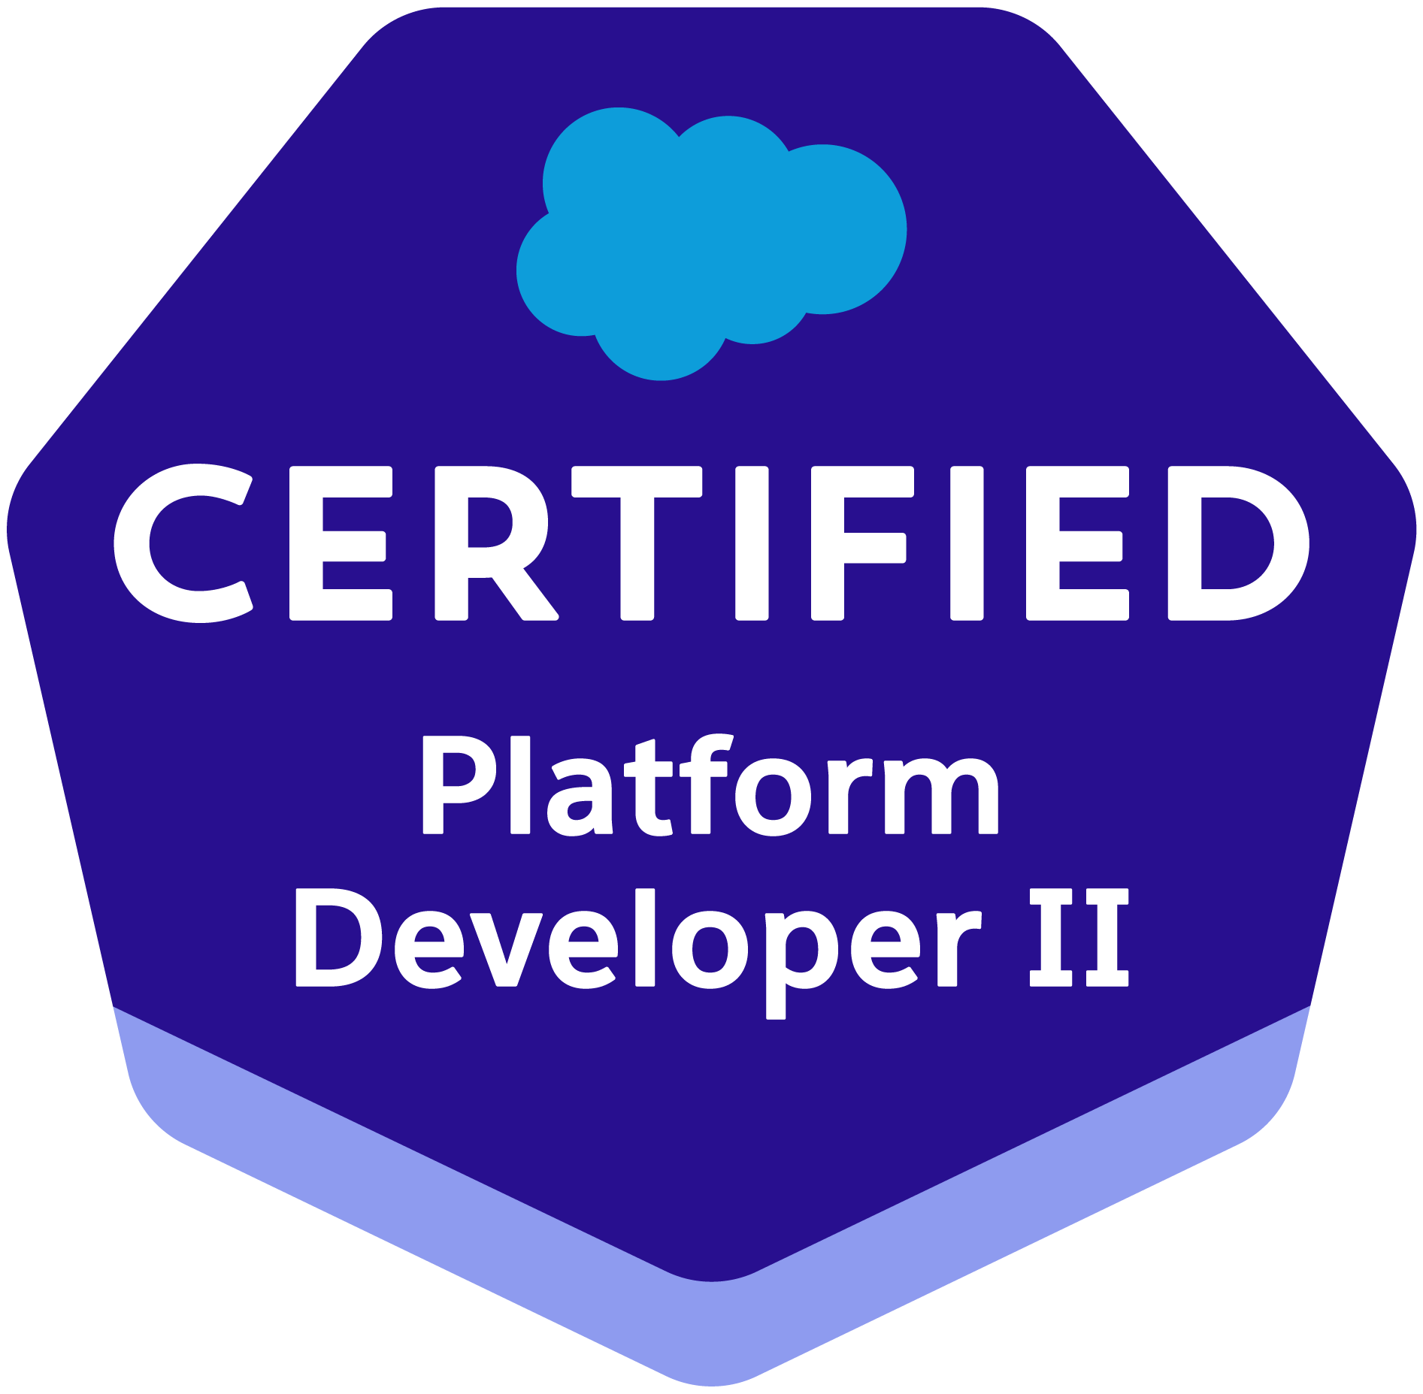
Surya Malathi Chinta
Reading, Pennsylvania

Salesforce Developer with around 11+ years of professional IT experience with strong Object-Oriented Analysis, Designing and Programming skills which includes 9 years of experience in Development, System Administration, and Implementation in Salesforce.com CRM and Force.com systems.

Professional Summary
- 11+ years of overall professional IT experience and specializing in Salesforce for over 9 years as a Developer and Consultant.
- Extensive expertise in APEX programming, including developing custom APEX classes, triggers, and integration with SOAP and REST APIs.
- Proficient in creating and managing Lightning Components (using Aura and LWC), enhancing user experience through custom UI with Salesforce Lightning Design System (SLDS).
- Designed and implemented Salesforce solutions, including Lightning Flows, Custom Objects, Reports, Analytic Snapshots and Dashboards, Profiles, Creating Roles, Page Layouts, Org - Wide default, Sharing rules.
- Skilled in data manipulation using SOQL/SOSL, custom workflows, and validation rules, ensuring robust Salesforce solutions that meet business needs.
- Architected scalable solutions with a deep understanding of Salesforce platform capabilities and constraints, ensuring long-term maintainability and performance.
- Deployment experience using Force.com IDE, Change sets and Copado tool and as well as hands on Sandbox management experience.

EDUCATION: Masters in Information Systems & Management, 2017 - Marist College, Poughkeepsie, NY
Bachelors in Computer Science Engineering, 2014 – JNTUK, INDIA

CERTIFICATION:
- Salesforce Certified Platform Developer I
- Salesforce Certified Platform Developer II
- Salesforce Administrator
- Salesforce Platform App Builder
- Salesforce Certified Agentforce Specialist

TECHNICAL SKILLS:

Salesforce Technologies: | Salesforce CRM, Salesforce SFA, Apex Language, Apex Classes/Controllers, Batch Apex, Apex Triggers, SOSL, SOQL, Lightning Flows, Visual force (pages, controllers & components), Lightning, Apex Web Services, Workflow & Approvals, Reports & Dashboards, Analytic Snapshots, Custom Objects, Change Sets and Case Management Automation.
Salesforce Tools | Force.com Eclipse IDE Plug-in, Data Loader, Force.com platform (Sandbox, Production) and Sandbox loading & Testing, Force.com Migration Tool, Excel Connector, SOQL Xplorer, Salesforce Inspector, Workbench
Technologies: | C, C++, Java, Javascript, SQL, HTML,XML, AngularJs, SOAP, REST
OS | Windows NT/2000/XP/Vista/7, Windows Server 2000/2003/2008

Professional Experience

Citizens Bank August 2019 - Present
Location: Johnston, RI
Role: Salesforce Developer

Responsibilities:

- Gathered and analyzed complex business requirements, translating them into scalable Salesforce solutions that align with long-term organizational goals in the Financial Services Cloud and core Salesforce platform.
- Designed and developed Apex classes, triggers, Lightning Components, SOQL queries, and flows to deliver custom business logic and reusable automation across multiple business units.
- Migrated legacy Visualforce pages to Lightning Experience, modernizing user interfaces, improving performance, and enhancing advisor productivity in Financial Services Cloud (FSC).
- Automated business processes using Flows, Approval Processes, Validation Rules, and Workflow Rules, while implementing robust security models with Profiles, Roles, Permission Sets, and Sharing Rules.
- Led ETL data migration projects, handling large-scale datasets with cleansing, transformation, and validation, ensuring 100% accuracy and referential integrity across client, household, and financial account records.
- Implemented integrations with enterprise systems and third-party platforms (Pardot, Seismic, DocuSign, banking systems) using REST and SOAP APIs for real-time synchronization of customer and financial data.
- Configured Financial Services Cloud data models (Households, Financial Accounts, Assets & Liabilities, Goals, Relationship Groups) and delivered Actionable Relationship Center (ARC) visualizations to provide a unified 360° client view.
- Developed Einstein Analytics (CRM Analytics) dashboards by optimizing Dataflows, building datasets, and applying SAQL queries, empowering wealth advisors and business users with actionable insights on financial performance and client engagement.
- Utilized Copado for version control and metadata deployments, ensuring compliant and traceable release management across sandbox and production environments.
- Created dynamic reports, dashboards, and KPIs tailored to different financial lines of business to drive data-driven decision-making.
- Served as a Subject Matter Expert (SME) on Salesforce platform capabilities, Financial Services Cloud features, and AppExchange solutions, guiding stakeholders on best practices and solution design.
- Collaborated in Agile environments, managing competing priorities, leading deployment activities, and ensuring deliverables met quality, compliance, and business expectations.

Merrill Lynch Bank of America October 2018- April 2019
Location: Pennington, NJ
Role: Salesforce Developer/Admin

Responsibilities:
- Partnered with finance business stakeholders to gather requirements and design scalable Salesforce solutions aligned with regulatory and compliance standards.
- Managed user access and security by configuring Roles, Profiles, Permission Sets, and Sharing Rules to safeguard sensitive financial data.
- Developed Apex triggers, classes, and Visualforce pages adhering to Salesforce best practices to automate complex financial processes and workflows.
- Created Visualforce pages with dynamic geographic filters to provide real-time customer and portfolio insights into sales and executive teams.
- Migrated legacy Visualforce pages to Lightning Components using the Aura framework to enhance UI performance and improve user experience for financial advisors and client service teams.
- Integrated Salesforce with external financial systems via RESTful web services, retrieving real-time transactional and account data for seamless CRM updates.
- Customized financial reports and dashboards in Lightning Experience to monitor key performance indicators such as loan processing times, client portfolios, and sales pipelines.
- Automated compliance and approval workflows with Validation Rules, Workflow Rules, Approval Processes, and Auto-response Rules to ensure audit readiness.
- Designed and configured custom financial data models using Custom Objects, Formula Fields, Roll-Up Summary Fields, and Dependent Picklists.
- Developed Lightning Components and deployed them in Experience Cloud portals to improve client engagement and provide secure self-service options.
- Executed data migrations using Apex Data Loader, ensuring accuracy and integrity of critical financial data including accounts, quotes, and forecasts.
- Leveraged sandbox environments for development and testing and performed deployments using GIT version control and CI/CD pipelines.
- Worked within Agile/Scrum frameworks, actively participating in sprint planning, daily stand-ups, and retrospectives using JIRA and Rally.
- Applied client-side and server-side validations to optimize system performance and maintain code quality.
- Delivered end-to-end Salesforce solutions, from requirement analysis through development, testing, and production deployment, supporting finance-specific CRM objectives.

Point72 August 2017- October 2018
Location: Stamford CT
Role: Salesforce Developer/Administrator

Responsibilities:
- Managed customer access and security in the Customer Portal by configuring Profiles, Permission Sets, Roles, and Sharing Rules.
- Developed, debugged, and tested Apex classes, triggers, Visualforce pages, and Lightning Components using Eclipse, Developer Console, Force.com IDE, and Anonymous Apex.
- Led migration of applications from Salesforce Classic to Lightning Experience, replacing JavaScript buttons with Quick Actions and Lightning Components for enhanced UI and performance.
- Designed and deployed custom objects, entity-relationship data models, validation rules, page layouts, tabs, Visualforce pages, and Lightning Components aligned with business requirements.
- Developed front-end functionality using Visualforce, JavaScript, jQuery, and AngularJS, including optimizing error handling for minified AngularJS JavaScript code.
- Implemented Batch Apex and Apex sharing rules to fulfill complex business logic and maintain data security.
- Built refined global search capabilities in Lightning via Apex classes and controllers.
- Created efficient SOQL and SOSL queries within governor limits to support application data needs.
- Managed application development lifecycle, including configuration, customization, testing, and deployment from sandbox to production environments.
- Experienced in release management, ensuring smooth production deployments and adherence to Salesforce best practices.

Environments: Salesforce CRM, Apex Language, Visualforce Pages, Workflow & Approvals, Reports, Custom Objects, Data Loader, Custom Tabs, Email Services, Sandbox Data loading, Eclipse IDE Plug-in, HTML, Javascript, CSS, XHTML, DHTML, XML, Angular Js, Agile Scrum, Web Services, SOAP, UI, Eclipse, Oracle, SOQL, SQL SharePoint, Web services, Service cloud and Sales cloud, Lightning Components, SVN, Jenkins.

PepsiCo February 2016- July 2017
Location: White Plains, New York
Role: Salesforce Developer/Administrator

Responsibilities:
- Assisted in integrating Salesforce with legacy systems using Force.com SOAP and REST APIs.
- Participated in Agile sprints, supporting requirements gathering, design, testing, and deployment activities.
- Developed Apex triggers, classes, and test methods following best practices to automate workflows and ensure code coverage.
- Built Visualforce pages and controller extensions using Salesforce and AJAX toolkits, including custom components with JavaScript validations.
- Worked extensively with standard objects like Accounts, Contacts, Cases, Opportunities, Leads, and Campaigns.
- Designed Lightning components and customized page layouts for both desktop and mobile platforms.
- Supported custom integrations involving outbound messages, email services, custom objects, and AppExchange packages.
- Configured object relationships (lookup and master-detail) to model business data hierarchies effectively.
- Created SOQL and SOSL queries optimized within governor limits for data operations.
- Performed data migration using Apex Data Loader to create test data in sandbox environments for UAT.
- Developed Roll-Up Summary fields, Formula fields, and Validation Rules to maintain data quality and automate business logic.

Environments: Saleforce.com, Platform Data Model, Service Cloud Console, Sales Cloud Service-Related Data Model, Data Loader, Reports, Apex Visualforce, Custom Objects, Custom Tabs, Email Templates, Workflows, Approval Processes.

Amazon May 2014 – December 2015
Location: Bangalore, India
Role: Java Developer

- Developed Java applications using core concepts like OOP, collections, exception handling, and multithreading.
- Built RESTful APIs with Spring Boot to support backend services and data exchange.
- Integrated applications with MySQL databases using JDBC and wrote efficient SQL queries.
- Implemented unit testing using JUnit and performed debugging to ensure code quality.
- Used Maven for building automation and dependency management.
- Managed source code with Git and participated in Agile development processes using Jira.
- Worked on optimizing application performance and managing memory effectively.
- Created utilities for file handling and data processing to automate tasks.

