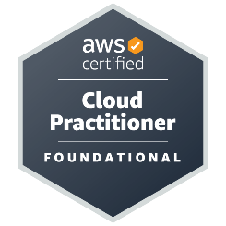
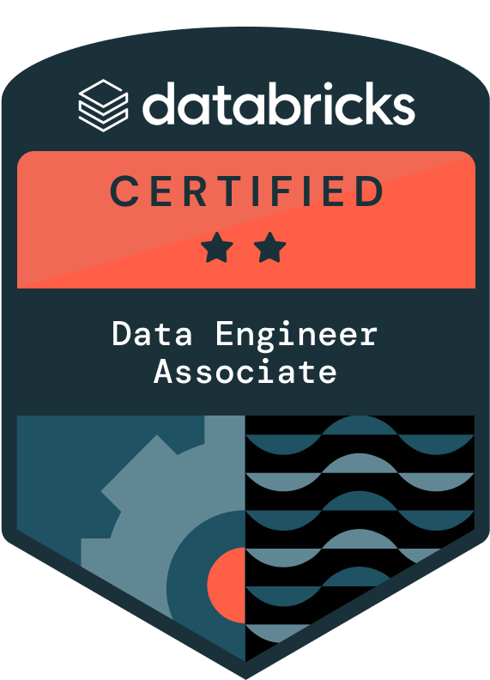
Abhinav B
AI Engineer

PROFESSIONAL SUMMARY:
- Machine Learning & AI Engineer with 6+ years of experience building and deploying production-grade ML/AI systems, intelligent applications, and real-time pipelines for healthcare and pharma clients.
- Expertise in LLMs, RAG, and Generative AI using OpenAI, Hugging Face, LangChain, Pinecone, and FAISS to create searchable knowledge bases, chatbots, and domain-specific AI assistants.
- Strong full ML lifecycle skills — from data ingestion and preprocessing to feature engineering, model development, hyperparameter tuning, and deployment.
- Proficient in NLP, computer vision, and predictive analytics with experience in medical image classification, healthcare chatbot automation, sentiment analysis, and anomaly detection.
- Skilled in Python ML stack: TensorFlow, PyTorch, scikit-learn, XGBoost, with focus on model optimization for inference speed, memory efficiency, and cloud scaling.
- Designed and implemented real-time AI pipelines integrating Kafka, Databricks (Delta Lake, MLflow), and cloud AI services for continuous model training and serving.
- Experienced in MLOps best practices: automated retraining workflows, experiment tracking, CI/CD for ML, and model versioning.
- Built REST and gRPC APIs for serving ML models at scale, integrating AI features into existing web and mobile platforms.
- Developed custom embeddings and vector search solutions for semantic similarity, recommendation systems, and context-aware retrieval.
- Familiar with A/B testing and offline/online evaluation for measuring model impact in production.
- Strong understanding of cloud AI ecosystems: AWS SageMaker, Vertex AI, Azure Cognitive Services for training, tuning, and deployment.
- Adept at optimizing data pipelines for large datasets using Spark, Pandas, and SQL, reducing model training and inference times significantly.
- Experienced in compliance-driven AI development ensuring adherence to HIPAA and other regulatory frameworks.
- Built end-to-end data pipelines that seamlessly connect preprocessing, model training, evaluation, and deployment into a single automated workflow.
- Collaborated with frontend and backend teams to integrate AI models into user-facing applications, ensuring smooth API performance and low latency.
- Optimized SQL and Spark queries to accelerate feature extraction and reduce overall model training time in large-scale datasets.
- Strong collaborative skills, working closely with business teams, data engineers, and developers to align technology solutions with business goals.
- Proactively identified bottlenecks in workflows and suggested improvements, increasing system efficiency and reducing delays in project deliverables.
- Strong interpersonal and analytical skills as a team player with a problem-solving mindset, dedicated to delivering quality results under tight deadlines and high-pressure environments.
- Proficient in analytical and critical thinking, translating technical requirements into actionable test plans and maintaining clear communication with onshore/offshore teams.
- Effective communicator and team collaborator with the ability to work independently, ensuring high-quality deliverables with minimal supervision.

TECHNICAL SKILLS:
Languages | Python, C#, SQL, Core Java, JavaScript
Data Science & Machine Learning | TensorFlow, PyTorch, scikit-learn, XGBoost, Hugging Face Transformers, LangChain, OpenAI API, spaCy, NLTK, Pandas, NumPy, Spark SQL, Feature Engineering
Generative AI & Search | RAG, FAISS, Pinecone, Vector Embeddings, Semantic Search, LLM Fine-Tuning
Data Engineering | MLflow, Databricks, Delta Lake, PySpark, Apache Kafka, ETL Pipelines, Airflow, Spark Streaming, Data Quality Frameworks, Data Migration, Real-Time Data Processing, Hive, Oozie, HDFS
Data Visualization & Analytics | Power BI, Excel, Power Query, KPI Reporting, Trend Analysis, Dashboard Development
Databases | MySQL, Oracle, MongoDB, Redis, PL/SQL, Azure SQL Database, Query Optimization, Stored Procedures, Triggers, Database normalization, Functions.
Cloud Services | AWS (S3, EC2, ECR, EKS, Lambda, Glue, Kinesis, Cloud Formation, Sage Maker, Lex), Azure (Data Lake, Functions, Virtual Machines, Blob Storage, Bot Framework, LUIS, QnA Maker, Event Hubs, SignalR), Google Cloud (Vertex AI, Google Cloud Storage, Google Kubernetes Engine, Cloud Build, KMS)
Tools & Software | Jenkins, Git, Docker, gRPC APIs, Postman, IBM DataStage, IBM Integration Bus (IIB), Boomi Atmosphere, Visual Studio 2015/2017/2019, TFS, SharePoint, Selenium
Security & Compliance | RBAC, Data Encryption, Azure Key Vault, HIPAA Compliance
Operating Systems | Windows 10/8, Linux/Unix-like systems

PROFESSIONAL EXPERIENCE:
Client: Pfizer, OH Apr’24 – Present
Role: AI Solutions Developer
Responsibilities:
- Designed and implemented a real-time AI serialization data pipeline to associate unique drug serial codes with manufacturing batches, enabling proactive counterfeit detection and compliance verification.
- Developed and deployed a serialization chatbot using OpenAI GPT API and LangChain, integrated with the serialization data pipeline to provide instant, AI-generated responses to queries from manufacturing and compliance teams.
- Built feature engineering workflows in Databricks (PySpark, Delta Lake) to prepare high-quality datasets for ML models predicting serialization anomalies and batch quality issues.
- Integrated MLflow for experiment tracking, hyperparameter tuning, and model versioning, ensuring reproducibility and streamlined deployment.
- Created and deployed REST and gRPC APIs to serve trained ML models for real-time serialization data validation in downstream systems.
- Developed NLP-based data validation scripts using spaCy to detect irregular patterns in serialization data, reducing manual inspection effort by 40%.
- Optimized Spark SQL queries for large-volume serialization datasets, improving ETL throughput by 30% and enabling near-real-time analytics.
- Automated model retraining workflows triggered by data drift detection, ensuring predictive accuracy over time.
- Conducted batch inference jobs on historical serialization data to uncover hidden trends and generate compliance insights.
- Built data quality dashboards with Databricks SQL and Power BI to visualize ML predictions, false positives, and anomaly patterns.
- Partnered with manufacturing and supply chain teams to design predictive maintenance and batch quality forecasting models.
- Ensured GxP and HIPAA compliance with encrypted storage, role-based access control, and auditable ML pipeline logging.
Environment: Databricks, PySpark, Delta Lake, MLflow, OpenAI GPT API, LangChain, Apache Kafka, Spark SQL, Python, spaCy, Power BI, REST APIs, gRPC, AWS S3, AWS Lambda, Docker, Kubernetes, GitHub Actions, Jenkins, HIPAA-compliant architecture.

Client: McKesson, TX Apr ’23 – Mar ‘24
Role: AI/ML Developer
Responsibilities:
- Developed and deployed ML-powered APIs using Vertex AI to support predictive analytics for inventory management, demand forecasting, and supply chain optimization.
- Designed real-time data ingestion pipelines in Databricks (PySpark, Delta Lake) integrating data from multiple healthcare and logistics systems to feed AI models.
- Built NLP-based data classification and entity extraction workflows to standardize medical terminology across disparate datasets, improving model accuracy in downstream analytics.
- Implemented data preprocessing and feature engineering scripts in Python to prepare structured and unstructured data for predictive modeling and anomaly detection.
- Integrated MLflow for experiment tracking, model evaluation, and version control, ensuring consistent deployment across environments.
- Created and deployed REST APIs for serving trained models, enabling real-time inference and integration with McKesson’s operational dashboards.
- Developed automated retraining pipelines triggered by new incoming data to keep models up-to-date and maintain prediction accuracy.
- Optimized Spark SQL queries and Delta Lake operations to improve feature generation performance, reducing training time for large-scale datasets.
- Collaborated with cross-functional teams to identify AI use cases in drug distribution, warehouse optimization, and fraud detection.
- Designed data validation layers that leveraged ML anomaly detection models to proactively flag operational risks in the distribution process.
- Built interactive analytics dashboards combining ML model outputs with operational KPIs to support data-driven decision-making for supply chain managers.
- Performed A/B testing on model outputs to measure impact on operational efficiency before full-scale deployment.
- Ensured HIPAA compliance and implemented secure access controls for all AI/ML workflows handling sensitive healthcare data.
Environment: Databricks, PySpark, Delta Lake, MLflow, Vertex AI, Spark SQL, Python, Pandas, NumPy, REST APIs, Docker, Kubernetes, Jenkins, GitHub Actions, GCP Cloud Storage, HIPAA-compliant architecture.

Client: Tata Consultancy Services, India Jun ’21 – Jul ‘22
Role: Software Engineer
Responsibilities:
- Designed and developed an AI-powered Customs Chatbot for Infineon using Microsoft Bot Framework (C#), integrated with Azure Cognitive Services (LUIS, QnA Maker) to deliver 97% accurate responses, reducing manual query handling by 50%.
- Built NLP pipelines to classify and route customer queries to the correct knowledge base section, improving query resolution speed and accuracy.
- Developed context-aware response generation modules leveraging pre-trained language models for more natural, human-like chatbot interactions.
- Created analytics dashboards to monitor chatbot usage, query categories, and AI model accuracy, enabling continuous improvement cycles.
- Deployed and maintained the chatbot on Azure, integrating it with Infineon’s internal systems via secure REST APIs.
- Enhanced database performance by optimizing SQL Server queries and implementing stored procedures for faster data retrieval in AI-assisted workflows.
- Led client workshops to gather conversational AI requirements, translating them into entity extraction, intent recognition, and dialog flow design.
- Conducted A/B testing on chatbot responses to evaluate improvements after NLP model fine-tuning.
- Integrated chatbot APIs with third-party services for real-time policy lookups and dynamic content delivery.
- Developed custom text preprocessing modules in Python to clean, normalize, and tokenize user queries, boosting NLP model accuracy.
- Implemented multi-language support in the chatbot using Azure Translator and intent classification models, expanding reach to global users.
- Collaborated with QA teams to build automated test suites for regression testing of AI conversation flows.
- Ensured security and compliance by implementing role-based access controls and encrypted data storage for conversation logs.
Environment: Microsoft Bot Framework (C#), Azure Cognitive Services (LUIS, QnA Maker), .NET Core, ReactJS, SQL Server, REST APIs, NLP, Python, spaCy, Docker, Azure DevOps, Agile/Scrum.

Client: ZSoft Technologies Aug ’19 – May ‘21
Role: Python Developer, Analyst
Responsibilities:
- Developed a chatbot using Python, Azure LUIS, and QnA Maker, automating responses to customer queries and improving service efficiency.
- Integrated LUIS NLP models to enhance chatbot understanding, enabling better user interactions and automated responses.
- Built data pipelines using Python and Pandas to process chatbot interactions, customer feedback, and service logs for analysis.
- Automated data extraction and processing using Python, SQL, and Flask APIs, reducing manual work and improving reporting speed.
- Designed SQL databases in Azure SQL to store chatbot data, optimizing queries for performance and faster reporting.
- Developed and deployed Flask-based APIs to connect chatbot interactions with backend databases, ensuring real-time access to customer data.
- Created interactive dashboards in Power BI, providing insights into chatbot performance, customer interactions, and user engagement.
- Used sentiment analysis in Python NLP to assess chatbot responses and improve accuracy based on user feedback.
- Conducted A/B testing on chatbot interactions, refining responses and improving accuracy over time.
- Built KPI reports to track chatbot usage, customer satisfaction, and resolution times, helping business teams improve automation strategies.
- Used Power Query in Power BI to clean and prepare chatbot data for visualization and analysis.
- Developed scheduled scripts using Python and CRON jobs to automate chatbot logs and analytics processing.
- Managed code versioning using GitHub and TFS, maintaining a structured workflow for chatbot development and data analysis scripts.
- Deployed and monitored chatbot services using Flask, ensuring uptime and performance efficiency.
- Implemented data security in Azure SQL, applying encryption and role-based access controls (RBAC) for controlled access.
- Resolved multiple production issues including API failures and data inconsistencies, ensuring 99.9% uptime and timely incident response.
- Collaborated with business teams and developers to align chatbot functionalities with business needs and optimize reporting strategies.
- Documented chatbot workflows, API usage, and data analysis steps, ensuring clear guidelines for future improvements and team onboarding.
Environment: Python, SQL, Flask, Power BI, Azure SQL, Azure Data Factory, Azure LUIS, QnA Maker, NLP, Pandas, Power Query, Data Visualization, KPI Reporting, API Development, GitHub, TFS, CRON Jobs.

EDUCATION DETAILS:
Degree | Major | Institution / University | Year Graduated
Master’s | Computer Science – AI/ML Specialization | University at Buffalo (SUNY) | 2023

CERTIFICATIONS:
Databricks Certified, Data Engineer Associate
AWS Certified, Cloud Practitioner

