Kelvin Lin
ECE410: Radar & Array Processing
Project II: Pulse & Doppler Processing

To fully understand the effect of the three-pulse-canceler, a study of the effects of clutter on the system must first be conducted. In the first series of experiments a function 'mclutter' is created which will allow the specification of a CNR value for Richards' clutter generation code. Generating a histogram of the newly created clutter, the amplitudes of the clutter vary exactly as expected with increasing CNR. The the 25%, 50% and 75% lines are stationary relative to the clutter, shifts upward with increasing CNR values.
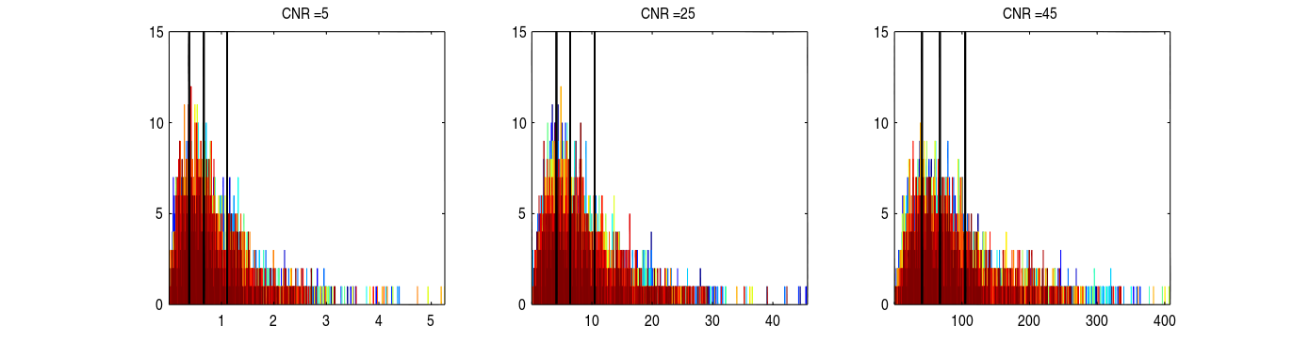Fig. 1: clutter distribution with varying CNR
In the next experiment, a study of the effects of the pulse-canceler itself on the successful detection of targets is performed. First, the data was generated at a CNR where the pulse-canceler was not necessary. In our case, this was a CNR value of 7dB. Data was then generated for increasing CNR in increments of 1dB until it was observed that MTI processing was necessary. A failure occurred at a CNR value of 10dB. There are many false positives. While the Range Doppler plot of this example shows four distinct peaks, the algorithm interprets the interference as smaller peaks occurring around the actual targets.
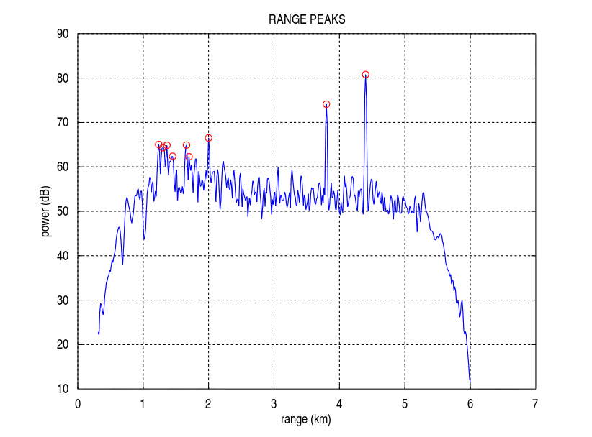Fig. 2: false alarms of MTI disabled processing at CNR = 10dB

At 10dB, MTI processing was enabled, and CNR was incremented by 10dB until it was discovered that MTI processing could not preserve the targets. The CNR was then decremented by 1dB until the threshold value was determined for when MTI is successful. In this example, this occurs at a CNR value of 49dB. At this CNR, we see that the slowest target (4.4km, -30m/s) was the first to suffer, MTI actually suppresses the slower moving targets. At a CNR value of 50, we actually see that both targets moving at the slowest velocity (±30m/s) are not detected.

It is worth noting that at a lower CNR value, it was actually the closer target which was undetected. This unexpected result allows us to formulate a hypothesis about the nature of both MTI processing and the clutter as CNR is increased. The closer target was the first to be affected, but it can also be seen that slower targets are the first to suffer. A new experiment is generated to determine the effects of clutter, range, and velocity on the performance of the system.

16 targets were generated with the same SNR at varying distances and velocities. The CNR was then increased until some targets could no longer be detected with our radar system. As CNR increased, MTI processing actually removed lower ranged targets before removing targets at higher ranges. In fact, although all targets were detected for ranges of 2km and greater, every target was undetected for the 1km case.

The effect of clutter on close targets becomes obvious upon closer inspection of Richards' clutter generating code: the clutter is actually weighted with the distance. This represents the drop in signal power as it range increases.
% Now weight the clutter power in range for assume R^2 (beam-limited) loss
cweight = T_out(1)*((T_out(1) + (0:My-1)'*(1/fs)).^(-1));
cweight = cweight*ones(1,Np);
ncc = ncc.*cweight;
Closer targets suffer first because the clutter is simply larger at lower targets; MTI processing suppresses closer targets more heavily. While a well defined relationship cannot be stated about whether range or velocity causes a target to suffer first, for a given range, slower targets suffer first; for a given velocity, closer targets suffer first. (see appendix)

The previously stated effects of CNR on range and velocities were obtained under extremely high values of CNR – values at which the clutter grows in Doppler (MTI processing suppresses more elements). It is then desirable to obtain a result for reasonable values of CNR. In this test, the targets from the previous result were slowed and the CNR was set to its default value of 20dB. When the absolute velocities of the slower targets starts to fall below 15 m/s, the radar system is no longer able to properly detect the closer targets. Setting the velocity below 7.5m/s results in no detection of the slower targets. These results are consistent with the conclusions drawn in the previous experiment: for a given range, the slower moving targets are the first to suffer.
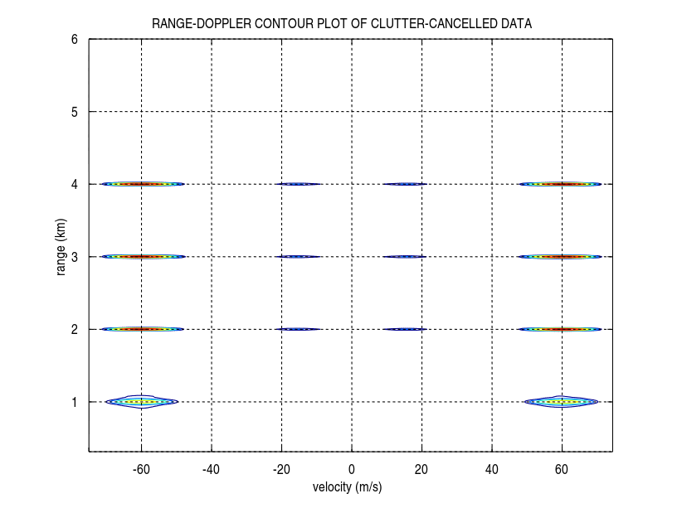Fig. 3: the targets at 1km,15m/s were the first to be removed by MTI

In addition to the clutter, another factor affecting the performance of this system is the interpolation technique used. Richards' algorithm uses a quadratic interpolation of the peaks for the clutter canceled data. Replacing this with a step function results in always evaluating to the central value with zero offset. This does not impact performance in any significant manner. There is a small (less than one range bin) difference between the quadratic and step interpolation. The linear interpolation, however, will always result in evaluating to either the left most or right most data point in the data spike. This will result in a maximum offset of 1 range bin for the peak when compared to quadratic interpolation. Again, this is not enough to significantly impact the results of the processed output.

Chirp bandwidth is also another important factor in determining the performance for the radar system. Acquiring data on how performance is affected by the chirp bandwidth could potentially optimize the system (both in terms of circuit design and computational complexity). As seen in the accompanying figure, decreasing the bandwidth increases the range ambiguity. The increased ambiguity decreases the value of the peak. At an order of magnitude bandwidth reduction, this peak is still large enough to resolve four of the targets Richards generates for CNR values of up to 46dB. This is a 3dB loss in performance, but is much more computationally efficient.
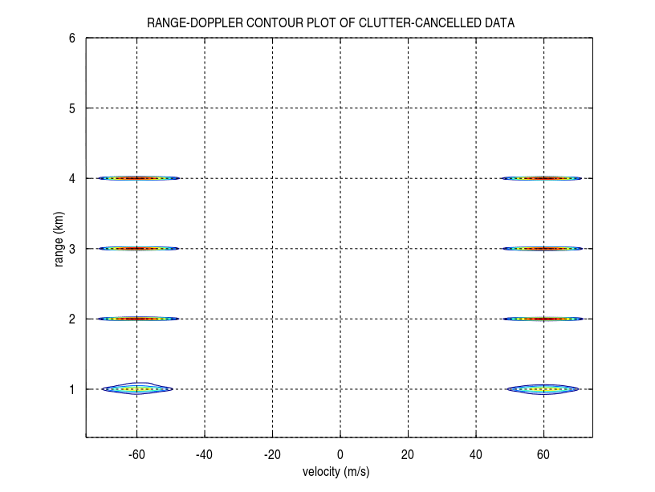Fig. 4: at 7.5m/s all targets are undetected regardless of range
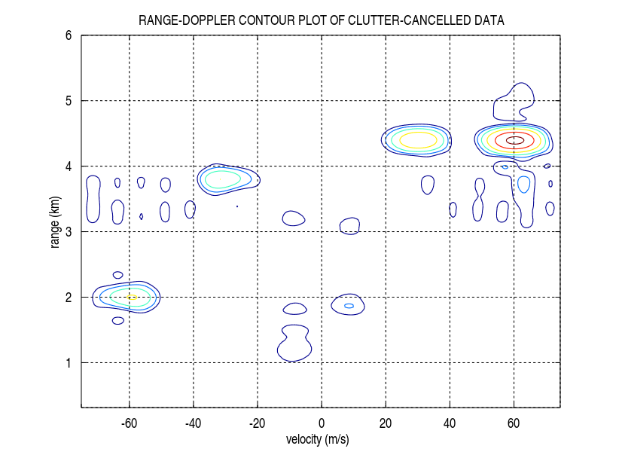Fig. 5: Range-Dopper plot chirpBW =10^6, CNR=45
Increasing the bandwidth will lower the range ambiguity and result in a higher peak. The increased peak value allows for detection at higher CNR values. Increasing the bandwidth by an order of magnitude allows for detection of targets at a CNR value of 50dB. While this is technically a 1dB increase in performance, the computational time increases significantly – too much to justify the performance gain.

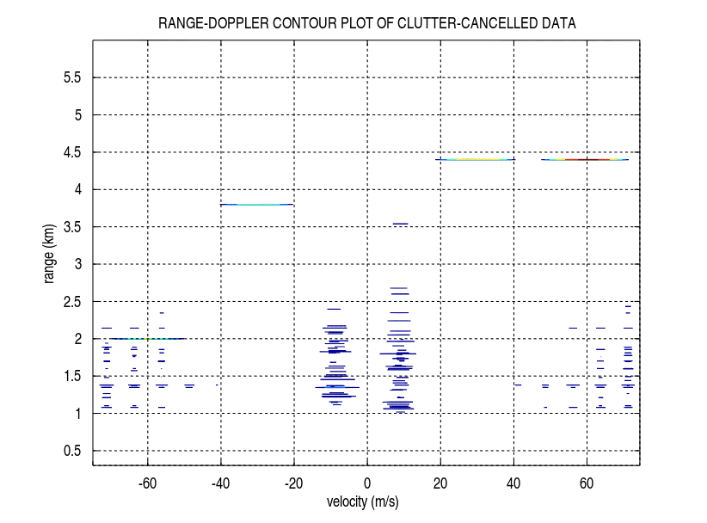Fig. 6: Range-Doppler plot chirpBW=10^8, CNR=50

Appendix

Clutter Effect on Range and Velocity
ESTIMATED PARAMETERS OF DETECTED TARGETS: CNR = 10
Number Rel RCS (dB) Range (km) Vel (m/s)
1 -31.3 1 -60.32
2 -31.5 1 -30.34
3 -31.4 1 30.38
4 -31.3 1 60.31
5 -12 2 -60.31
6 -12.2 2 -30.41
7 -12.3 2 30.43
8 -12.2 2 60.34
9 -5.07 3 -60.43
10 -5.24 3 -30.44
11 -5.24 3 30.5
12 -5.02 3 60.42
13 0 4 -60.41
14 -0.156 4 -30.45
15 -0.328 4 30.46
16 -0.088 4 60.52

ESTIMATED PARAMETERS OF DETECTED TARGETS: CNR = 55
Number Rel RCS (dB) Range (km) Vel (m/s)
1 -31.5 1 -60.44
2 -31.2 1 58.68
3 -12.3 2 -60.11
4 -12.3 2 59.98
5 -4.69 3 -61.87
6 -4.95 3 -32.28
7 -5.18 3 32.17
8 -5.04 3 61.61
9 0 4 -61.4
10 -0.334 4 -31.82
11 -0.413 4 31.84
12 -0.0657 4 61.45

