Gen Con Event Planner

Documentation for v4

linkgannon

2022

Table of Contents

Overview 2

Usage 3

Functions 3

Manage 3

Export 4

Themes 6

Ribbon Customization 6

Layout 7

Event Grids 8

Schedule 9

# Overview

The Gen Con Event Planner is an application that helps you plan and schedule your Gen Con events for you and your group. With some years having nearly 20,000 events, it can be difficult to find which ones you are interested in, or to be able to schedule them with a large group. This software is meant to solve these issues.

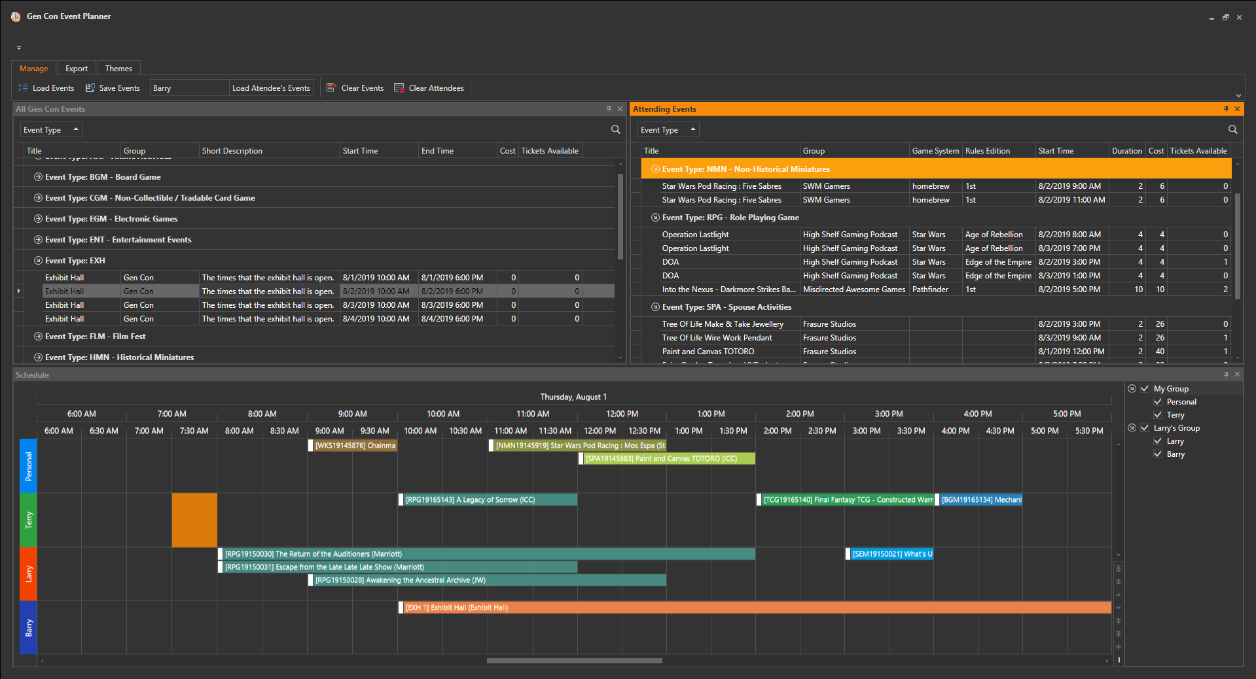

Upon startup, the application will attempt to grab the Gen Con events from online. If for some reason there are no events (Gen Con has not uploaded them yet), the application will prompt the user for an Excel file that contains the events. Once loaded, the application will open a window, similar to the one in the picture above. Every Gen Con event available will be displayed in the “All Gen Con Events” panel. From here, users can select the events they wish to attend, then drag and drop them over to the “Attending Events” panel. This will cause the events to show up in the “Schedule” panel. The user can save and load their event list, to work on over multiple sessions. If an event gets updated on Gen Con’s site, the application will reload the event with the new data the next time that event list is loaded. Once the user has selected all of their events that they will be attending, they can print their schedules, event list, create an iCalendar of there events to import to their calendar apps, or export the data to a multitude of formats.

# Usage

## Functions

### Manage

#### Load Events



Load a “*.gcel” file from the user’s computer into the application. Any events populating the “Attending Events” panel will be updated based on the “All Gen Con Events” panel, then removed from the “All Gen Con Events” panel. Any additional attendee’s schedules that are contained in the file will also be loaded into the “Schedule” panel.

#### Save Events



Save the user’s personal events and any loaded attendee’s events to a “*.gel” file.

#### Load Attendee’s Events



Load an attendee’s personal event’s, based on their “*.gcel” file. The attendee will be given a name that the user types into the “Attendee’s Name…” textbox.

#### Clear Events



This action will clear the user’s personal events from the “Attending Events” panel and the “Schedule” panel.

#### Clear Attendees



This action will clear other attendee’s events from the “Schedule” panel.

### Export

#### Print Schedule

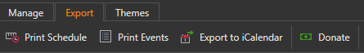

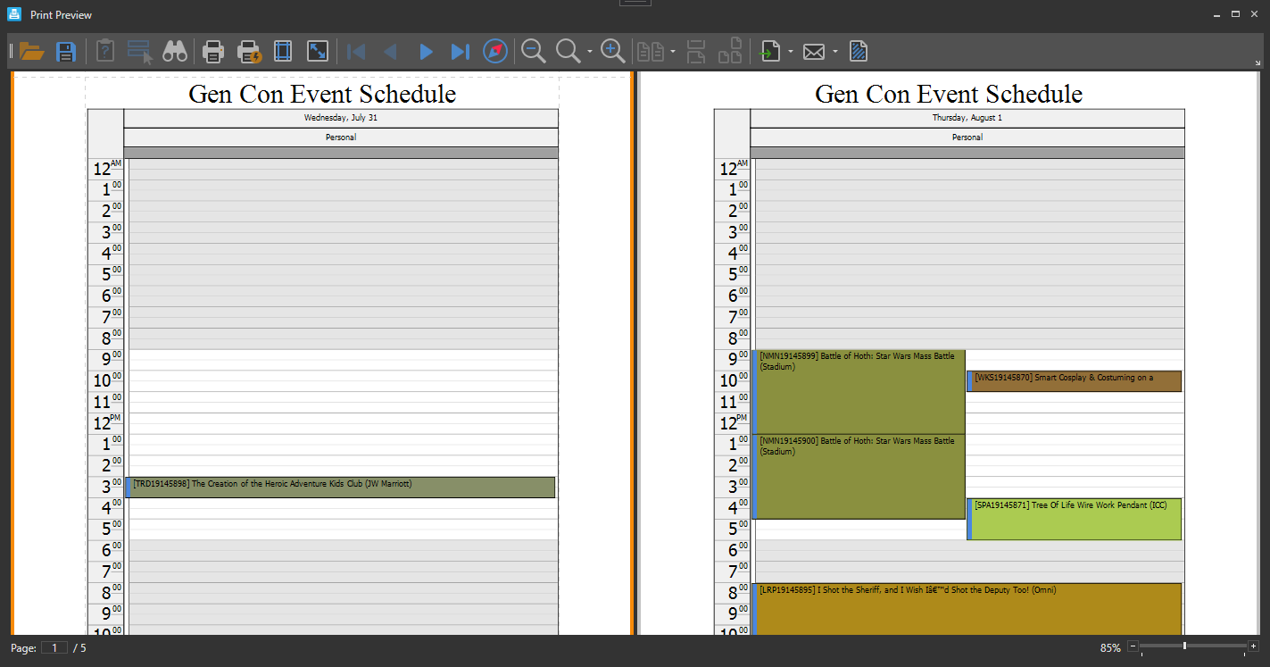

Launches the “Print Preview” window based on the view in the “Schedule” panel, which contains a wealth of printing options, email options, and export options. The export options include the following formats: PDF, HTML, MHT, RTF, DOCX, XLS, XLSX, CSV, Text, and Image. The user can prevent other attendee’s schedules from being printed by hiding their schedules in the “Schedule” panel.

#### Print Events



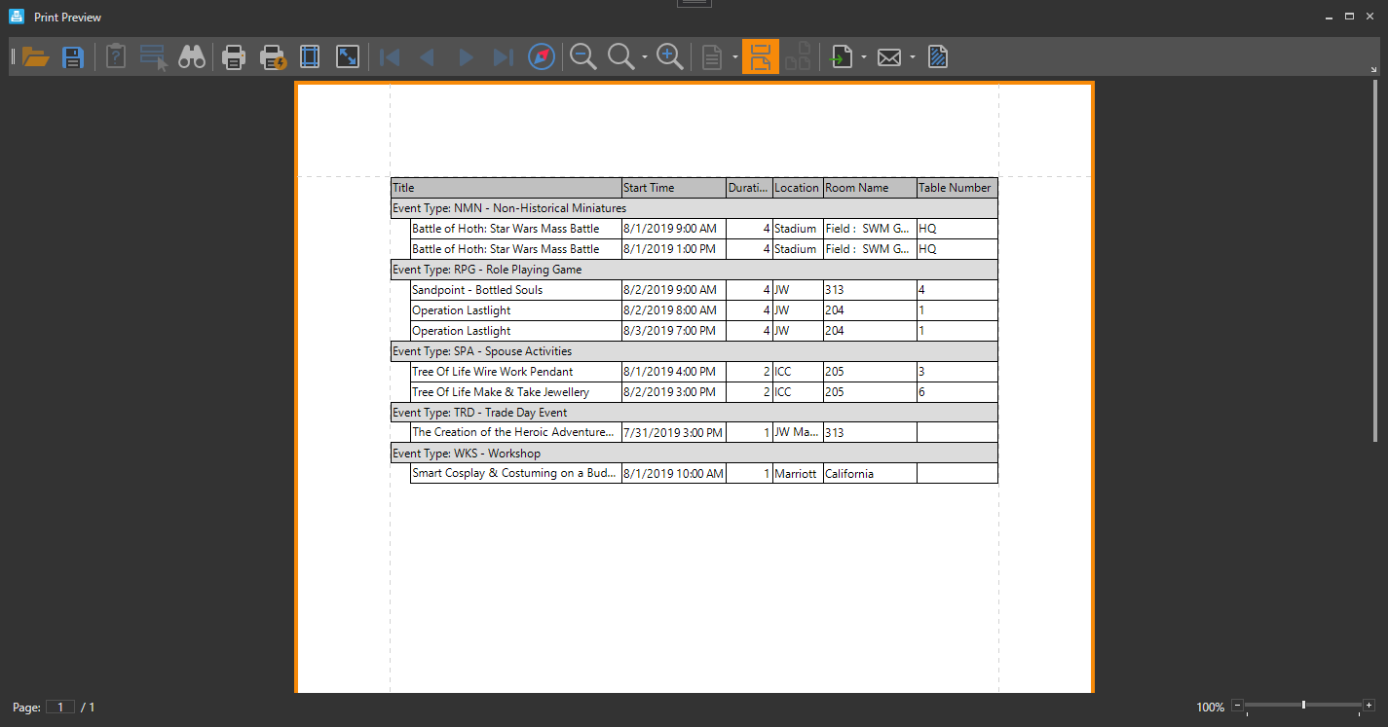

Launches the “Print Preview” window based on the view in the “Attending Events” panel, which contains a wealth of printing options, email options, and export options. The export options include the following formats: PDF, HTML, MHT, RTF, DOCX, XLS, XLSX, CSV, Text, and Image. The grid that is generated to be printed is based on how the user has structured the event grid in the “Attending Events” panel.

#### Export to iCalendar



Exports events in the “Attending Events” panel to an “*.ics” file, which can be imported in many common calendar apps.

#### Donate



Donate to myself if you like this program 😉

### Themes

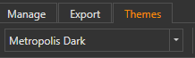

Select a color theme for the application.

### Ribbon Customization

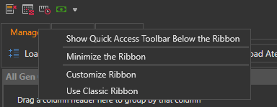

The ribbon containing all of these actions comes with a variety of customizable options, including a quick access tool bar that can be customized as well. These options can be accessed by clicking on any of the ribbon headers any of the action buttons.

## Layout

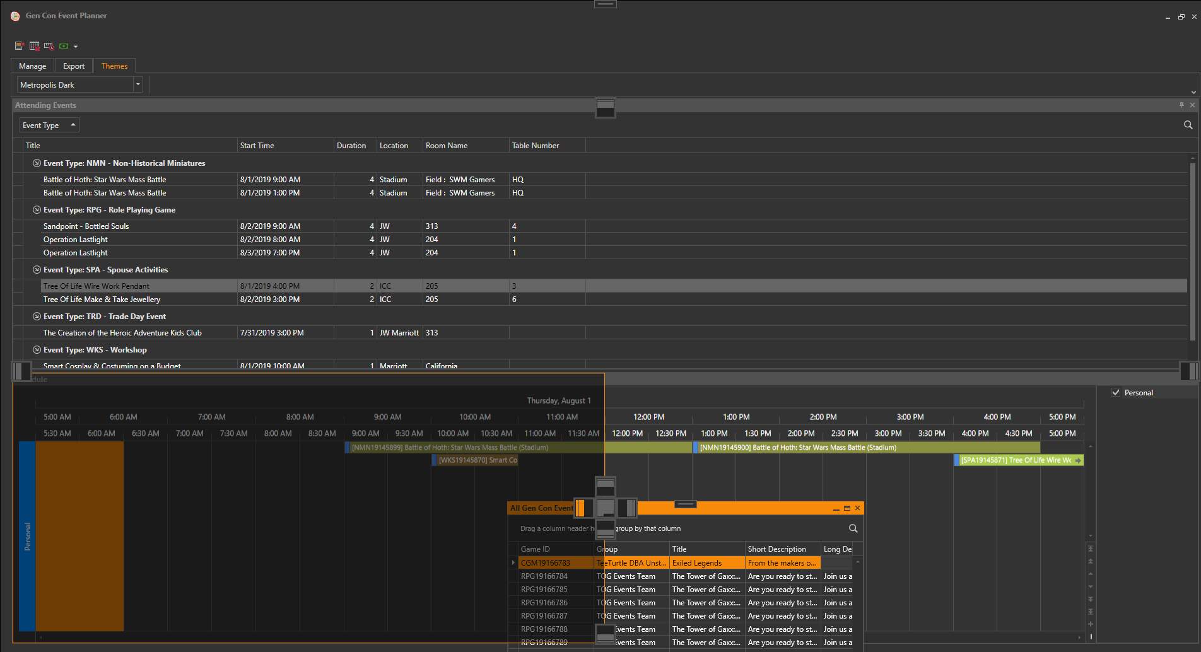

Each of the 3 panels can be fully customized in terms of layout. The features include (but are not limited to) the following:

* Dock the panels within the window (or even drag them outside of the application window) by dragging the panels’ header. By docking a panel to the “center” of another panel, the user can turn the panels into a tabbed group.
* Create a flyout from any of the panels by clicking on the pin icon in the upper right corner of the panel.
* Close panels by clicking the ‘x’ in the upper right corner of the panel. The user can reopen closed panels by clicking on the panels name under the ribbon menu. Note that this menu of closed panels only shows if there are closed panels. If no panels are closed, the user won’t see the menu.
* Save and reloads your current layout when the application is closed and reopened.

## Event Grids

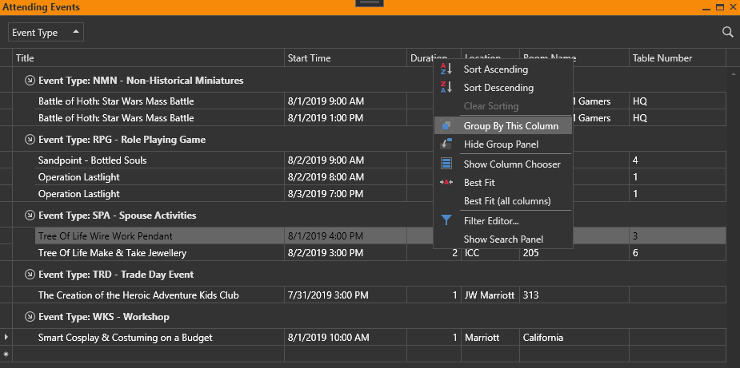

There are two event grids in this application: one in the “All Gen Con Events” panel and one in the “Attending Events” panel. These contain all of the event data that Gen Con provides. The features of the event grid include (but are not limited to) the following:

* Grouping data by columns. Simply drag any column into the group area above the event grid to group events by those columns.
* Multi-level sorting per column.
* The ability to remove any column by simply dragging the columns header out of the event grid.
* A search panel. When searching multiple words, use double quotes to get results with an exact phrase. Otherwise results will contain events with any of the words in the search panel.
* An advanced custom filter editor.

In addition, the “Attending Events” grid has 2 extra features that are not available in the “All Gen Con Events” grid:

* Add custom events by simply starting to fill out the blank row at the bottom of the grid.
* There is an extra field called “Priority”, which can be used to indicate how important an event is to the user. This is particularly useful when comparing attendee’s schedules in the “Schedule” panel.

## Schedule

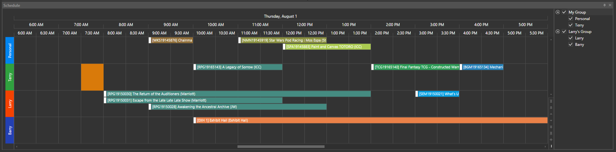

This displays the user’s current schedule of events in conjunction with any other loaded attendees. Loaded attendees can be hidden by deselecting them from the attendee pane. They can also be grouped, reordered, and renamed in this pane. To group them, simply right click anywhere in the pane and select “New Group”, then drag the attendees to the newly created group, in their proper order.

By left clicking on any event in the schedule, that event will automatically be selected in the “Attending Events” panel.

By right clicking anywhere on the schedule you can change timescales, as well as the view of the schedule. The following are the supported views:

#### Timeline View

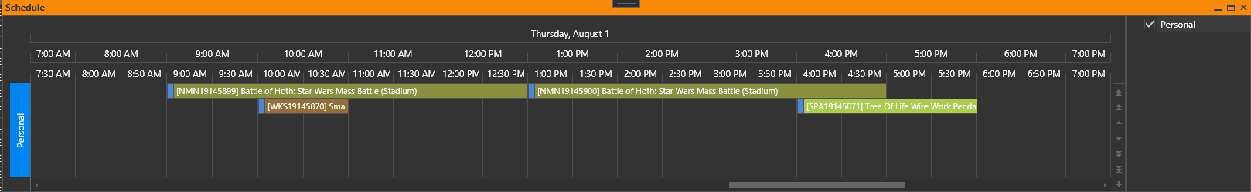

#### List View

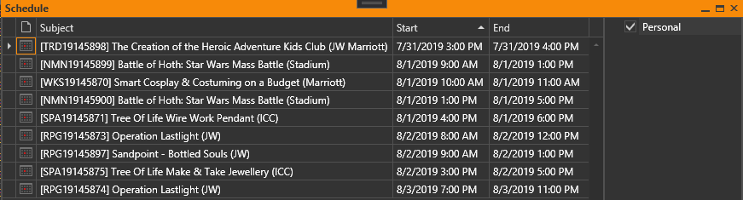

#### Agenda View

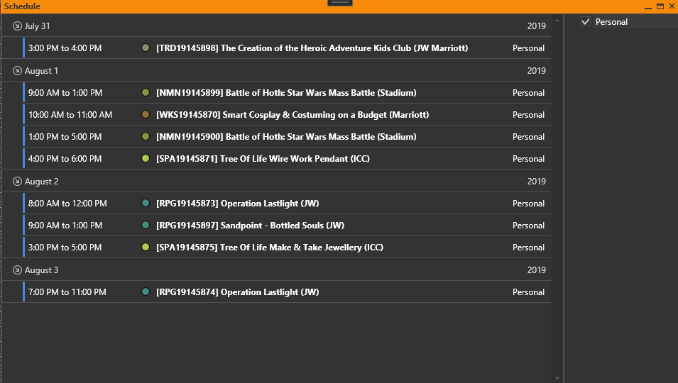

#### Day View

