Emori, Noboru  
CIS 045, Fall 2020

G08125504  
Quiz Week 5

2020/10/01

Quiz-week-5

Due: Thursday OCT-1st 11:59 PM

1. Directory ‘diry’ has 3 files inside listed here: **$HOME/dirx/diry**

**-filex**

**-filey**

**-filez**

1. Write a command to make a directory called ‘new-dir’ in your $HOME directory.

**$ cd $HOME**Assume we will stay in $HOME for this whole sequence

**$ mkdir new-dir**

1. Write a command to copy all files from ‘diry’ into the new directory called ’new-dir’ you just created in your home directory. Assume that you are in your home directory.

**$ mv dirx/diry/* new-dir/**

1. Write a command to rename the ‘diry’ to dir-yy  
    **$ mv dirx/diry dirx/dir-yy**
2. Give the command to create a hard link from a file called ‘filex’.
   1. **$ cal > new-dir/filex**
   2. **$ ln new-dir/filex filex**
3. Give the command to create a symbolic link from filex to a new file called ‘sym-filex’
   1. **$ ln -s new-dir/filex sym-filex**
4. Change the permission of dir-yy so that the owner of the directory has rwx, r-x for the group, and --- for others.
   1. **$ chmod 750 dirx/dir-yy**
5. Set the UID bit on the below script file with the following content.
   1. **$ vi sayit**

**--------------**

#!/bin/bash

echo `date`

echo “how are you”

**--------------**

* 1. Change the permissions of the script file ‘sayit’ to 755.  
     **$ chmod 755 sayit**

* 1. SEt the UID bit on the file script file called ‘sayit’.  
     **$ chmod u+s sayit**

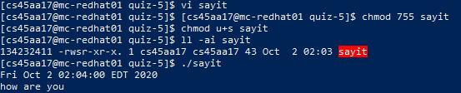

1. Show how you set your PATH so that your path will have the following directories.
   1. **/usr/bin:/usr/sbin:$HOME/bin  
      $ export PATH=/usr/bin:/usr/sbin:$HOME/bin  
      **
2. Set the PATH in your **$HOME/.bashrc** file so that it will always be active when you first log onto the system.  
   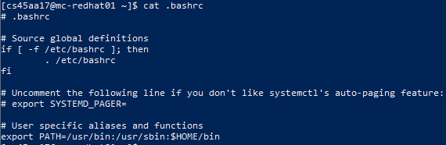
3. Make a directory in your home directory called ‘test-data’
   1. **$ mkdir $HOME/test-data**
   2. Copy all files from the /etc directory that begins with the letter ‘p’ followed by the letter ‘r’ followed any other characters to your $HOME/test-data

**$ cp /etc/pr* $HOME/test-data**

* 1. What is the size of the data in your test-data directory. Use the ‘du’ command with the proper options all the sizes of the files and also the total space used by the directory.  
     **Data size is 16 kB**

$ **du -ah $HOME/test-data**

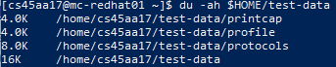

2. Given a directory called ‘diry’ and a file called ‘filex’, please answer the following questions.

1. Write a test command to test if ‘diry’ is a directory
   1. **$ test -d diry**
2. Write a test command to test if ‘filex’ is a file.
   1. **$ test -f filex**
3. Write a test command to test if filex is ‘executible’ . If so, include a logical AND ( &&) clause that echo “Yes - filex is a executable”
   1. **$ test -x filex && echo “Yes - filex is a executable”**
4. Write a test command to test if filex has a size greater than ‘zero’.
   1. **$ test -s filex**
5. A file system ______ is allocated every time you create a file.

inode