POWERED BY YONDU  
PARTNER’S GAMER APIs

Technical Documentation

horizontal line

Document Version 2.0

# 

# 

# 

# **TABLE OF CONTENTS**

**Terminologies…………………………………………………………………………………… 2**

**APIs………………………………………………………………………………………………**

Gamer’s API…………………………………………………………………

Send Consent …………………………………………………………………………………… 3

Verify Code……………………………………………………………………………………….. 3

Charging …………………………………………………………………………………………. 3

MT………....………………………………………………………………………………………. 3

API The We Need From You…………………………………………………

Callback …………………………………………………………………………………………. 4

MO ………………………………………………………………………………………………. 4

**Valid Amount………………………………………………………………………………………. 5**

**Alert Codes………………………………………………………………………………………... 6**

**Sample Flow..…………………………………………………………………………………..**

Pull or Subscription Charging With Consent Flow Through SMS………………………....………………………………………………… 7

Pull or Subscription Charging With Consent Flow Through Your Application………………....………………………………………….……… 8

Pull Charging……………....………………………………………….…….… 9

Simple Registration Through Your Application....……………....………………………………………….…….… 10

## TERMINOLOGIES

|  |  |
| --- | --- |
| **Term** | **Definition** |
| URL | URL of the server where the api resides. |
| token | Identifier provided by Yondu to access the API |
| msisdn | Mobile number |
| amount | Amount value to be use for charging |
| response: code | Alert code value |
| response: message | Alert code description value |
| code | Transaction code sent from Send Consent API |
| transid | Transaction identifier |
| timestamp | Current date and time |
| status_code | Charging status. 0 as successful; 1 as failed |
| message | Actual message sent by subscriber |
| content | Your message to be sent to subscriber limit to 160 characters |

## 

## APIs

### Gamer’s API

#### Send Consent

**API URL:** {URL}/m360api/v1/consent/{msisdn}/{amount}

**Description:** To send transaction code as consent before charging the subscriber

**Method:** GET

**Headers:** Authorization: Bearer {token}

**Required parameters:** msisdn, amount

**Sample Response:** *{"response":{"message":"verification sent","code":"2001"}}*

**Sample Request:** *{URL}/m360api/v1/consent/9171234567/P1*

#### Verify TransCode

**API URL:** {URL}/m360api/v1/verify/{msisdn}/{code}

**Description:** To verify transaction code sent to subscriber if input is not through SMS

**Method:** GET

**Headers:** Authorization: Bearer {token}

**Required parameters:** msisdn, code

**Sample Response:** *{"response":{"message":"verification successful","code":"2003"}}* **Sample Request:** *{URL}/m360api/v1/verify/9171234567/123456*

#### Charging

**API URL:** {URL}/m360api/v1/charging/{msisdn}/{amount}

**Description:** To directly charge the subscriber without sending a consent

**Method:** GET

**Headers:** Authorization: Bearer {token}

**Required parameters:** msisdn, amount

**Response:** *{"response":{"message":"successfully processed","code":"2006"}}*

**Sample Request:** *{URL}/m360api/v1/charging/9171234567/P1*

#### MT

**API URL:** {URL}/m360api/v1/invalid/{msisdn}/{content}

**Description:** To send SMS to the subscriber based from your content

**Method:** GET

**Headers:** Authorization: Bearer {token}

**Required parameters:** msisdn

**Sample Request:** *{URL}/m360api/v1/invalid/9171234567/Hello world!*

### API That We Need From You

#### Callback

**API URL:** {YourURL}/{msisdn}/{transid}/{timestamp}/{status_code}

**Description:** Where we will send charging status of each transaction

**Method:** GET

**Required Parameters:** msisdn, transid, timestamp, status_code

**Sample Request:**

*{YourURL}/?msisdn=9171234567&transid=123456&timestamp=20160628024446&status_code=1*

#### 

#### MO

**API URL:** {YourURL}/{msisdn}/{message}/{transid}/{timestamp}

**Description:** Where we will send actual message sent by subscriber to 2910

**Method:** GET

**Required Parameters:** msisdn, message, transid, timestamp

**Sample Request:**

*{YourURL}/?msisdn=9171234567&message=Yourkeyword5 26633&transid=123456&timestamp=20160628024446*

## VALID AMOUNT

|  |  |  |  |  |
| --- | --- | --- | --- | --- |
| **value** | **tariff** |  | **value** | **tariff** |
| P1 | 1.00 |  | 150 | 150.00 |
| P250 | 2.50 |  | 200 | 200.00 |
| P5 | 5.00 |  | 250 | 250.00 |
| 10 | 10.00 |  | 300 | 300.00 |
| 15 | 15.00 |  | 350 | 350.00 |
| 20 | 20.00 |  | 400 | 400.00 |
| 25 | 25.00 |  | 450 | 450.00 |
| 30 | 30.00 |  | 500 | 500.00 |
| 35 | 35.00 |  | 550 | 550.00 |
| 40 | 40.00 |  | 600 | 600.00 |
| 45 | 45.00 |  | 650 | 650.00 |
| 50 | 50.00 |  | 700 | 700.00 |
| 55 | 55.00 |  | 750 | 750.00 |
| 60 | 60.00 |  | 800 | 800.00 |
| 65 | 65.00 |  | 850 | 850.00 |
| 70 | 70.00 |  | 900 | 900.00 |
| 75 | 75.00 |  | 950 | 950.00 |
| 80 | 80.00 |  | 1000 | 1000.00 |
| 85 | 85.00 |  |  |  |
| 90 | 95.00 |  |  |  |
| 100 | 100.00 |  |  |  |

## ALERT CODES

|  |  |
| --- | --- |
| **Code** | **Description** |
| 2001 | verification sent |
| 2002 | invalid mobile number |
| 2003 | verification successful |
| 2004 | invalid code combination |
| 2005 | charged failed |
| 2006 | successfully processed |
| 2007 | invalid tariff |

## SAMPLE FLOW

### Pull or Subscription Charging With Consent Flow Through SMS:

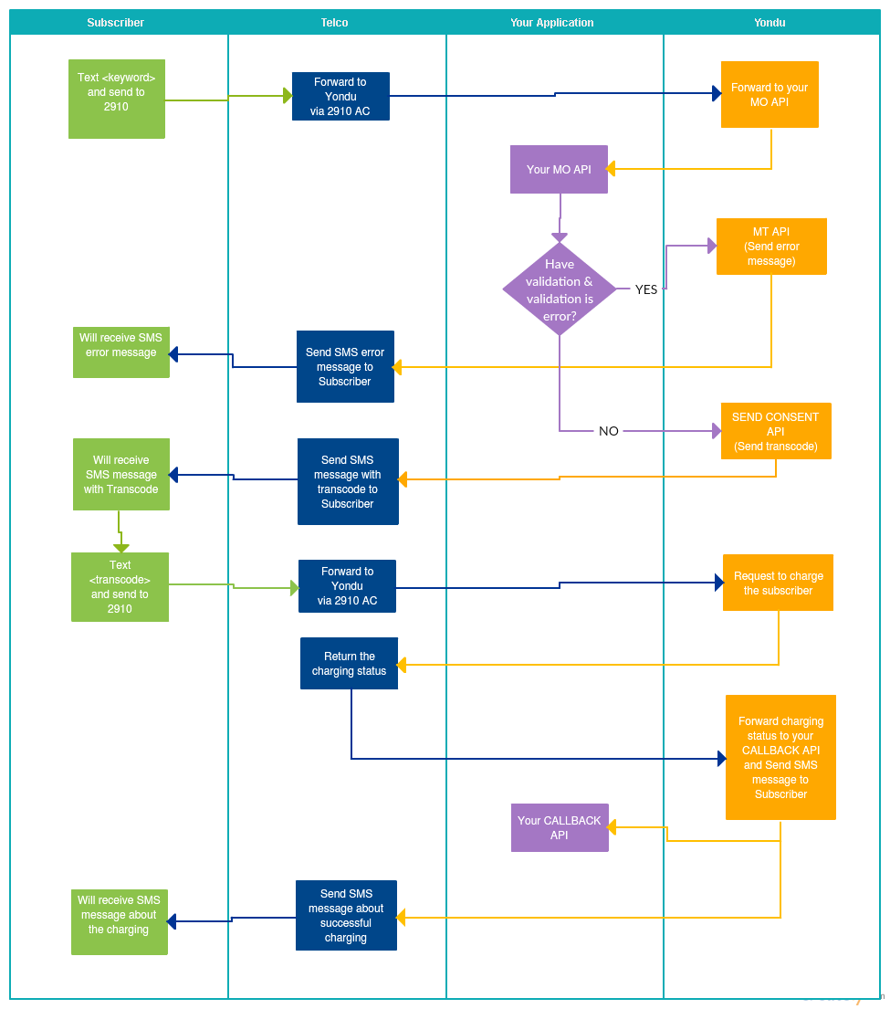

### Pull or Subscription Charging With Consent Flow Through Your Application:

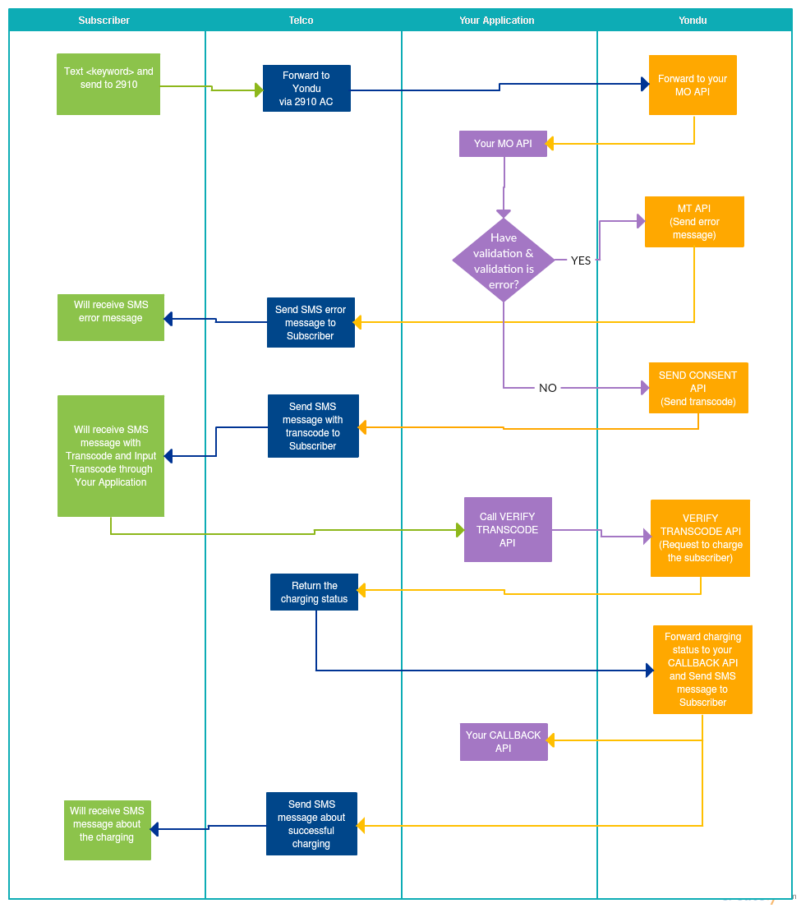

### Push Charging:

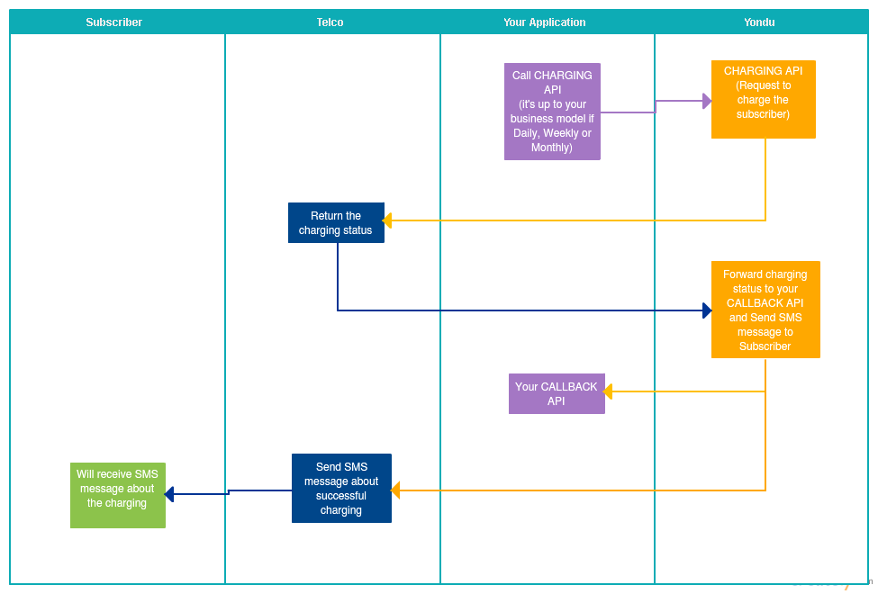

### Simple Registration Through Your Application:

