**

***Project Report***

Course name: Database Management System

Course code: CSC-433

Project Name: Rent A Car

Submitted To:

Nusrath Tabassum

Department of Computer Science and Engineering

Submitted by:

01. Md. Abdul Ahad Linkon (Id: 21203059)

02. Marzia Mostafa (Id: 21203031)

Program: BCSE

Semester: Spring -2023

Sec: A

**Introduction:** Rent a Car is a Car Rental System project that is designed to aid the car rental company to enable renting of cars through an online system. It helps the users to search for available cars view profile and book the cars for the time period. It has a user-friendly interface which helps the user to check for cars and rent them for the period specified. They could also make payment online. The rental cars shall be categorized into economy, premium etc. Based on the type of car required by the customer, the user shall be able to make bookings. The use of internet technology has made it easy for the customers to rent a car any time. The tool shall ask the user for information such as the date and time of journey, type of car etc. Also, it will need an identification number. Using these details, the tool shall help the customer to book a car for the journey.

**Objective:** The objective of this project is to develop a web based system that will help manage the business transactions of car renting; to help in advertising the car rental services of a company, through the availability of the system online. To make Car Rental System and bookings easy so that It can save time and labor.

**User requirements**:

1. The system will have two levels of access:
2. Admin
3. Required User/ Customer
4. Featured for Admin :
5. Login as Admin
6. Admin can add vehicle, delete and update
7. Admin Can manage users and user details
8. For admin dashboard will have order details, amount of money details.
9. Featured for Users:
10. Order the vehicles
11. Login and register
12. Check booking status

ERD:

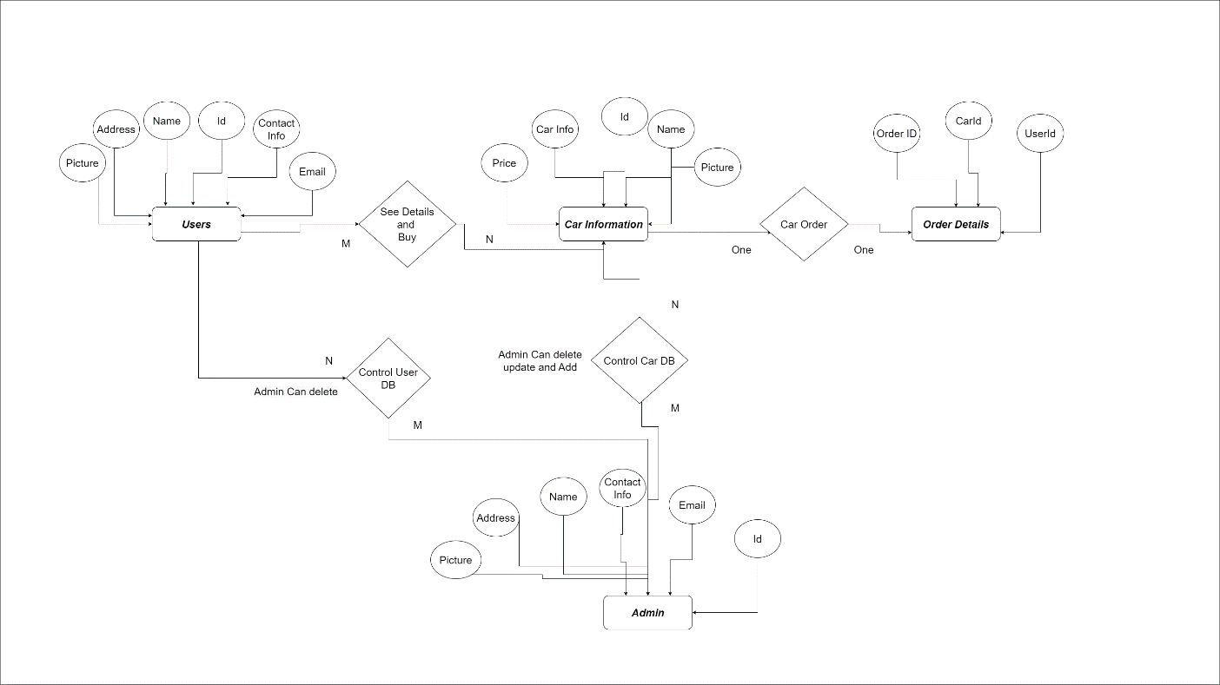

|  |
| --- |
| See |
| User-Id  Car-Id |

|  |
| --- |
| Car Information |
| Car-Id  Cat-info  Name  Price  Picture |

Schema diagram:

|  |
| --- |
| User |
| User-Id  Picture  Address  Name  Contact No  Email |

|  |
| --- |
| Order |
| User-Id  Order-Id |

|  |
| --- |
| Control |
| User-Id  Car-Id  Admin-Id |

|  |
| --- |
| Admin |
| Admin-Id  Name  Address  Picture  Contact-Info  Email |

|  |
| --- |
| Order Details |
| Order-Id  Car-Id  User-Id  Amount  Duration |

**Limitation:**

Technical risks or performance risk which means this technical risk mainly associated with functionality of product or performance part of the software product. Renting duration is not more than 1 day. If a vehicle is booked another user have to wait for next schedule.

**Future work:**

To develop a system of CAR RENTAL MANAGEMENT by completely focusing on customer, our employees, growth, innovation and efficiency. All of these elements will drive us toward success. The process on searching the client’s details is slow if it uses manual system and there are thousands of clients. Besides that, staffs have to record the booking manually and it is difficult to improve a monthly report or an annual report. However, this project has strategic backup system for any eventually. Vehicles are well maintained and tested for delivering optimum and uninterrupted performance

**Conclusion:**

We will be a growth-oriented car rental association by efficiently serving value-conscious clients for all of their car rental events. We will constantly deliver a quality product, friendly service and great value that makes customers assured that Cost-effective is their best car rental choice. The development in Information Technology and internet penetration has greatly improved various corporate processes and communication between services providers and their customers of which car rental market is not left out. No more office visit, No more phone call. Just Open App, browse through cars, select and book. This would save the customer time and provide them best service in their range.