中国石油大学（北京）远程教育学院
宋体，三号，加粗，居中
毕业设计（论文）

黑体，小一，居中，注意：汉语标题中副标题用“——”

诗歌翻译刍议
——认知语境与翻译策略

姓 名：
学 号：
性 别：
专 业:
批 次：
电子邮箱：
联系方式：
学习中心：
指导教师：
2XXX年X月X日

A Tentative Study on Poetry Translation: Cognitive Context and Translation Strategy
Times New Roman， 小一， 加粗，居中，实词首字母大写，注意：英语标题中副标题用“：”，标题中不应出现如“&”、“C-E/E-C”、“EFL”、“SLA”等符号或缩略语

by
Xx Xxx

Under the Supervision of
Xx Xxx

Submitted
to
School of Foreign Studies
in Partial Fulfillment of the Requirement for
the Bachelor's Degree of Arts in English
China University of Petroleum
Beijing
June 15th, 2009

Acknowledgements
Times New Roman， 三号， 加粗，居中，与其后内容空一行

First and foremost, I would like to express…
Times New Roman， 四号，两端对齐；注意：本句只作为格式示例，不可照抄照搬

诗歌翻译刍议
黑体， 二号，居中
——认知语境与翻译策略
黑体，三号，居中；上下空行

摘 要

在这篇论文中，我们介绍了D.Sperber 和D.Wilson的关联理论及由之衍生出来的关联翻译理论，着重阐明了译文读者的认知语境及最佳关联问题。强语境文化与弱语境文化间的文化缺省导致了译文读者与原文作者间的语境差异，并由此致使作者意图不能有效传递，即未达到最佳关联。为了解决诗歌翻译中的此类问题，在尽量不损害原诗语境效果的前提下，我们认为译者应试图采用加注、意译等策略，以期弥补文化图式的缺省，达到译文读者与译文间的最佳关联，即译文读者与原语意图间的最佳关联。
空一行
关键词：语境；文化缺省；最佳关联；诗歌翻译

宋体，小四号，“关键词”一词与其后内容之间用冒号“：”，关键词之间用分号“；”，末尾关键词之后不用标点，两端对齐

A Tentative Study on Poetry Translation: Cognitive Context and Translation Strategy
Times New Roman， 二号，加粗，居中，实词首字母大写
Times New Roman， 三号， 加粗,居中，实词首字母大写，上下空行
Abstract

We introduced the relevance theory proposed by D. Sperber and D. Wilson and the relevance translation theory deriving from it in this paper, and we focus on the cognitive context of version reader and optimal relevance. The cultural default between high context culture and low context culture causes the differences between version reader and original writer, and then impedes the translation of writer’s intention…
空一行
Key Words: context; cultural default; optimal relevance;
poetry translation
Times New Roman， 四号， 两端对齐，关键词首字母不大写，关键词之间用分号“;”
换行对齐
Key Words两词首字母大写， Times New Roman四号， 不加粗，与其后内容之间用冒号“:” 末尾关键词之后不用标点，两端对齐，关键词3-5个，如需换行，则新行与第一个关键词首字母对齐（如上）

Table of Contents
Times New Roman, 三号, 加粗，居中，实词首字母大写，跟其后内容空一行

Introduction………………………………………………………….1
Chapter One The First Step of the Journey: A Panoramic Survey of Relevance Theory.…..………………………………..3
1.1 Brief Introduction…………………..………………………3
各级标题换行后，新行应与前一行第一个单词对齐
1.2 Relevance………………………..……………………...…..4
1.3 Principles in Relevance Theory…….….……………...…....5
Times New Roman, 四号，实词首字母大写；chapter一级标题顶格，其余各级小标题依次向右缩进2英文字符
Chapter Two Context…………………………….……………..……6

2.1 Contextual Effects…...…...…………………………………6
2.1.1 Essence and application of Mutual Knowledge and Mutual Manifestness………………………………..6
2.1.2……………….………………………………………6

2.2 Cultural Model……...……………………………….…….…7
2.2.1…………………………………………...…………..7
2.2.2…………………………………………………….….8
标题的右侧要注明页码，标题和页码之间加圆点，并用格式→制表位对齐右侧页码
Conclusion………………..………………………………………...32
Bibliography………..………………………………………………34
Appendices…（可缺）………………………………………………38

Times New Roman, 四号，左对齐，实词首字母大写

A Tentative Study of Poetry Translation: Cognitive Context and Translation Strategy
Times New Roman，二号加粗，居中；下空一行

Introduction
Times New Roman，使用自动生成标题，三号加粗，居中；下空一行

The relevance theory proposed by D.Sperber and D.Wilson in their book Relevance: Communication and Cognition contributed greatly to the cognitive pragmatic study. It is not a translation theory but it can effectively explain and direct translation activity. Wilson’s student E.A.Gutt published his Dr. Paper Translation and Relevance: Cognition and Context in 1991, in which he proposed the relevance translation theory, which has become the most important new theory in translation practice.
限于毕业论文篇幅，Introduction和Conclusion部分不再分出如0.1 Topic of the Study、0.2 Status Quo at Home & Abroad、0.3 Theoretical Rationales之类的小节
…
Times New Roman，四号，两端对齐，双倍行距，注意：Introduction和Conclusion正文部分字数要求约200词左右

Chapter One The First Step of the Journey: A Panoramic Survey of Relevance Theory
一级标题，Times New Roman，三号加粗，使用自动生成标题，自动换行居中，下空一行
Chapter序号跟其后内容之间空一格

1.1 Brief Introduction
二级标题，Times New Roman，小三加粗，实词首字母大写，使用自动生成标题，跟其上下内容之间不再空行，左边顶格书写
In 1986, D. Sperber and D. Wilson developed a cognitive approach to the interpretation of human communication. In their book Relevance: Communication and Cognition, they studied three aspects of the traditional objects in pragmatic research: (a) how the process of human interpretation is achieved. (b) the importance of context in comprehension. And (c) the rejection of the notion of mutual knowledge and the proposal of an alterative concept of mutually manifest assumptions (Sperber and Wilson 89).

1.2 Relevance
二级标题，Times New Roman，小三加粗，实词首字母大写，使用自动生成标题，跟其上下内容之间不再空行，左边顶格书写

In this section, we will introduce the basic cognitive notions of relevance and the Cognitive Principle of Relevance.

1.3 Principles in Relevance Theory
三级标题，Times New Roman，四号加粗，实词首字母大写，使用自动生成标题，跟其上下内容之间不再空行，左边顶格书写

1.3.1 Cognitive Principle

Chapter Two Context
一级标题，Times New Roman，三号加粗，使用自动生成标题，自动换行居中，下空一行

2.1 Context
Different from the commonly accepted assumption that the context for the comprehension of an utterance is given before hand, Sperber and Wilson (92) propose a much more dynamic view of context. A context is a construct that has to be established and developed in the course of interaction in order to select the correct interpretation. The determination of context is seen as a matter of choice and as part of the interpretation process itself. A context is a psychological construct, a subset of the hearer’s assumptions about the world.

2.2 Contextual Effects
二级标题和三级标题之间应有相应文字论述，不可标题下直接嵌套标题
Contextual effects, in essence, are…

2.2.1 Essence and application of Mutual Knowledge and Mutual Manifestness
各级标题换行后，新行应与前一行第一个单词对齐

Conclusion
Times New Roman，使用自动生成标题，三号加粗，居中；下空一行

The purpose of this thesis has been to examine some of the basic assumptions and to apply the theory to an interpretation of poetry. The essential purpose of this thesis is an attempt to find the optimal relevance in poetry. In poetry, the intention to produce specific contextual effects in version reader’s cognitive environment turns out to be a significant factor in the creation of the whole poem. Thus a writer lacking an accurate estimate of the contextual environment of a typical member of the target readers will have problems in attaining effective communication of desired message.
Relevance theory is such a type of economics of communication theory and defines a possible point of equilibrium between efforts and effect. Optimal relevance is said to be achieved at the point where maximum yield of information is attained with minimum effort. A type of dynamic equilibrium can be attained at the point of optimal relevance in poetic language, where maximum yield of contextual implication is achieved with an acceptable amount of effort…
Times New Roman，四号，两端对齐，双倍行距，注意：Introduction和Conclusion正文部分字数要求约200词左右

Bibliography
文献序号用方括号加数字如[1]等表示，按字母顺序排列。注意：此处为了分类展示文献写法，未按字母顺序，参考文献实际写作时要按字母顺序排列。
Times New Roman，使用自动生成标题，三号加粗，居中；下空一行

[1] Gutt, Ernst-August. Translation and Relevance: Cognition and Context [M]. Beijing: China Translation Publishing Company, 1991: 52-54.（专著：包含“编著”）
Times New Roman，四号；换行后，新行应与前一行第一个单词对齐
[2] Halliday, Michael. Linguistic Function and Literary Style: An Inquiry into the Language of William Golding’s The Inheritors [A]. S. Chatman, ed. Literary Style: A Symposium [C]. Oxford: Oxford University. Press, 1971: 45-47. （专著、论文集内文章；注意：若只有一名编者，编者的名和姓后用逗号，加“ed.”(表示editor)。两名或以上编者，在最后一名编者的姓名后加“eds.”。集体编著，在第一位编者的名和姓后+逗号+“et al.”+逗号+“eds.”。）
[3] Freed, Barbara F., ed. Foreign Language Acquisition Research and the Classroom [C]. Proc. of Consortium for Lang. Teaching and Learning Conf., Oct. 1989, U of Pennsylvania. Lexinton: Health, 1991. （会议论文集）
[4] Miller, Hillis J. and Jin Huimin. The Permanent Rhetorical Reading [J]. Foreign Literature Review 12. 1 (2001): 141-143.（期刊文章）
[5] Barthelme, Frederick. Architecture [J]. Kansas Quarterly 13. 3-4 (1981): 77-80.（13. 3-4是指13卷3、4期合刊）
[5] Welker, Kant. Plans in the Common Ground: Toward a Generative Account of Implicature [D]. Columbus: Ohio State University, 1994: 22-25.（博士论文）
[6] Anthonissen, C. On the Effectiveness of Media Censorship：Linguistic, Paralinguistic and Other Communicative Devices of Media Regulation. [MA]. Oxford: Oxford University, 2001: 40-42. （硕士论文）
[7] Intraub, Anna Jinagwang. How I Learned to Read [N]. New York Times. 13 January 2002, Section 4, Column 6, Page 16. （报纸文章）
[8] Freud, Sigmund. Civilization and Its Discontents [M]. Trans. James Strachey. New York: Norton, 1961: 60-62. （翻译著作）
[9] Frye, Northrop, ed. Romanticism Reconsidered [C]. New York: Columbia University Press, 1963: 89-92. （编辑出版）
[10] Iwanska, Long. Toward a Formal Account of Context –Dependency and Underspecificity of Natural Language [P]. Paper given at AAAI Symposium on Computational Implicature. Berkeley Linguistics Soc., 19-21 Jan. 1996.（尚未出版的会议论文）
[11] Plato. Laws [M]. 2 vols. Trans. R. G. Bury. Leob Classical Libery. New York: G. P. Putnam’s Sons, 1926: 11-15.（多卷或多册著作。书名后注明第几册或第几卷，格式为：姓, 名. 书名. 卷目 vols. (其他信息). 出版地: 出版社, 出版年代: 页码范围. ）
[12] Barsky, Robert F. Noam Chomsky: A Life of Dissent [EB/OL]. Cambridge: MIT P, 1997. 8 May 1998 <http://www.pembrley. Com/janeinfo/pridpref.html>.（网络著作：注意有两个时间，前者是作品发表时间，后者是参考者登陆时间；下同）
[13] Fischer, Michael F. Worthless Words for the Day [EB/OL]. 21 November 2005. 8 May 2007 <http://www. answers. com/topic/paronomasia>. （网络文章；注意：网上资源慎用）
[14] Browning, Tonya. Embedded Visuals: Student Design in Web Spaces [J/OL]. Kairos: A Journal for Teacher of Writing. 2. 1 (1997). 9 Oct. 1997 <http://english.ttu.edu/kairos/ toc.html>.（网络期刊；注意：网上资源慎用）
[15] France. Encyclopedia Britannica Online [DB/OL]. 2003. Encyclopedia Britannica. 13 Mar. 2003 <http://search.eb.com>. （网络数据库；注意：网上资源慎用）
[16] It’s a Wonderful Life [V/CD]. Dir. Frank Capra. Perf. James Stewart, Donna Reed, Lionel Barrymore, and Thomas Mitch. 1946. DVD. Republic, 1998. （电影、电视、广播、录像、DVD等格式如下：Name of Film. Director’s/Producer’s last name (可加上Performer’s last name), given name. Place of publication, year (or date of showing)；下同）
[17] Face/Off [V/CD]. Dir. John Woo. Perf. John Travolta and Nicolas Cage. Paramount, 1997.
[18] Hornby, A.S.. Oxford Advanced Learner’s Dictionary of Current English [Z] (6th edition) ed. Sally Wehmeier. Oxford: Oxford University Press, 2000: 112-116. （其他未说明文献[Z]<包含“编”的各种教材、教程、词典等>）
[19] GB/T16159-1996, 汉语拼音正词法基本规则 [S].（国际/家标准）
[20] 申丹. 文学文体学与小说翻译 [M]. 北京: 北京大学出版社, 1995: 60-65. （专著：包含“编著”）
[22] 徐盛桓. 逻辑与实据—英语IF条件句研究的一种理论框架 [J]. 现代外语 28. 4 (2004): 331-339. （期刊文章）
[23] 冯庆华. 论译者的风格 [A]. 谢天振.翻译的理论建构与文化透视 [C]. 上海: 上海外语教育出版社, 2000: 329-338. （专著、论文集内文章）
[24] 谢希德. 创造学习的新思路 [N]. 人民日报. 25 Dec. 1998: 10.（若无栏目等详细信息，可写到页码；汉语书目可考虑使用1998-12-25: 10）
[25] 莎士比亚. 莎士比亚全集 [M]. 朱生豪译. 北京: 人民文学出版社, 1989: 130-126. （翻译著作）
[26] 李红岩、范旭伦. 钱钟书评论（卷一） [C]. 北京: 社会科学文献出版社, 1996: 20-22. （编辑出版）
[27] 陆敬严. 中国古代机器人 [A]. 第七届国际中国科学史会议文集 [C]. Ed. 王渝生. Proc. of. 第七届国际中国科学史 Conf., Jan. 1996, 深圳大学. 河南: 大众出版社, 1999: 501-506. （会议论文集）
[28] 辞海 [Z]. 上海: 上海辞书出版社, 1999: 120-122. （其他未说明文献[Z]<包含“编”的各种教材、教程、词典等>）
[29] 王明亮. 关于中国学术期刊标准化数据库系统工程的进展[EB/OL]. 8 August 1998. 4 October 1998 <http://www. cajcd.edu.cn/pub/wml.txt/980810-2.html>. （网络文章；注意：网上资源慎用）
[30] 中国大百科全书 [DB/OL]. 2007. 中国大百科全书出版社. 6 January 2008 <http://www.ecph.com.cn>. （网络数据库；注意：网上资源慎用）
文献中标点统一使用半角状态英文标点，文献标识英文字母、年代、页码统一使用Times New Roman，文献标识前空一格，标点后统一空一格

注意：（参阅GB 3469-83 《文献类型与文献载体代码》著录文献类型标识。）
① 文献类型标识：M—专著，C—论文集，J—期刊，D—学位论文，R—报告，S—标准，P—专利，汇编—G， 档案—B， 古籍—O， 参考工具—K。② 电子文献类型标识：BD—数据库，CP—计算机程序，EB—公告。③ 载体类型标识：MT—磁带，DK—磁盘，CD—光盘，OL—联机网络。④ 缩微制品、录音制品、录像制品的文献类型标识分别为“ M ”、“ A ”、“ V ”。印刷型文献不著录此项。⑤ 其它未说明文献[Z]（包含“编”的各种教材、教程、词典等）
Appendices

Appendix A

1. Level of Analysis

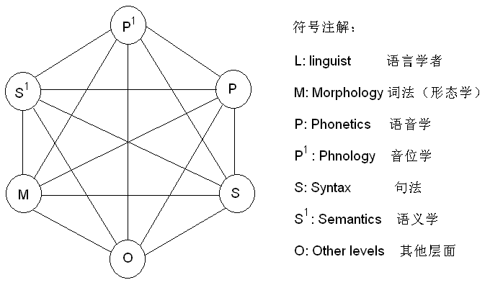
Figuire A1: Space-station Liguistics

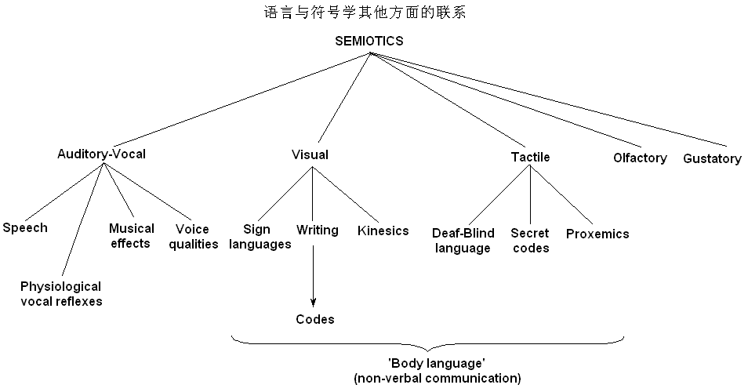
Figuire A2: Relationship Between Linguistics and Semiotics
2. Dialect
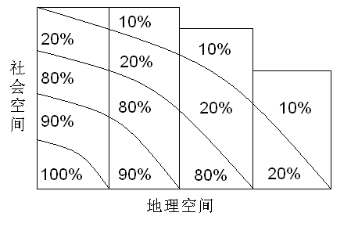
Figuire A3: Wave Theory
Appendix B
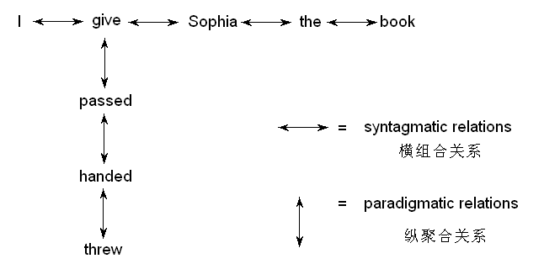
Figure B1: Syntagmatic & Paradigmatic Relations
Times New Roman，小三加粗，实词首字母大写，使用自动生成标题，跟其后内容之间不再空行

