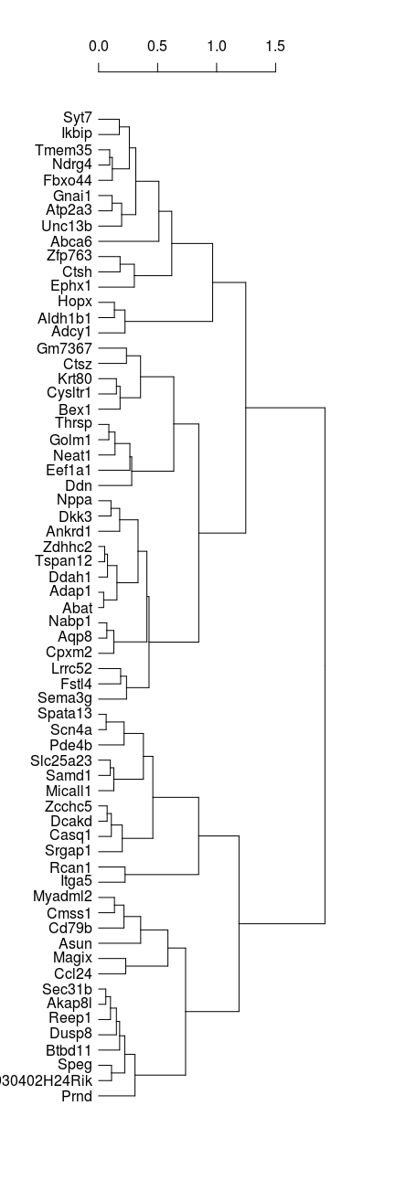
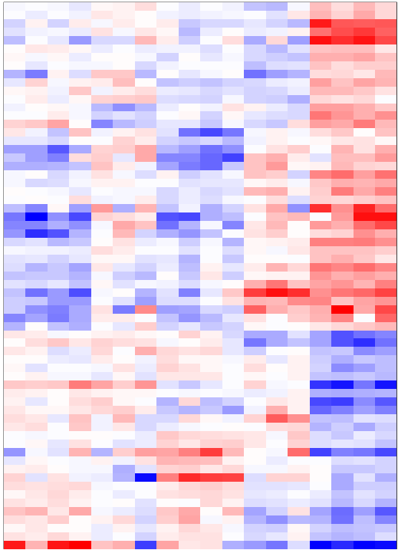
Sham 4 | DOCA 4 | Sham 8 | DOCA 8 | ITF 8
Heatmap of EdgeR’s QLF-test for DE genes

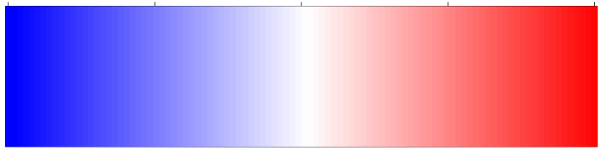
-2 -1 0 1 -2
Log2 Fold vs The Median

