Cross Validation Web Tutorial

Lin Lee Cheong

January 26, 2016

The data that we are using is Auto dataset, as shown below.

## Loading required package: ISLR

## Warning: package 'ISLR' was built under R version 3.2.3

## Loading required package: boot

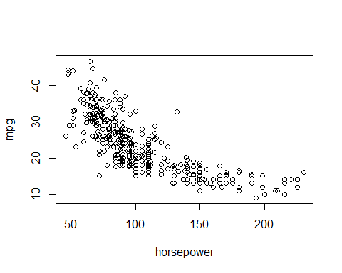

Leave-one-out-cross-validation(LOOCV) - glm can be used for linear regression! Just remove the logistic regression *family='binomial'* requirement - first is raw leave-one-out, second is bias-corrected version of it (training set is slightly smaller)

glm.fit<-glm(mpg~horsepower,data=Auto)  
cv.glm(Auto,glm.fit)$delta

## [1] 24.23151 24.23114